Atikokan Hydro Inc.
OEB Staff Questions
EB-2021-0007
Atikokan Hydro Inc.
EB-2021-0007

Please note, Atikokan Hydro Inc. (Atikokan Hydro) is responsible for ensuring that all documents it files with the OEB, including responses to OEB staff questions and any other supporting documentation, do not include personal information (as that phrase is defined in the Freedom of Information and Protection of Privacy Act), unless filed in accordance with rule 9A of the OEB’s Rules of Practice and Procedure.

Please also note, OEB staff has identified that the Non-RPP Retailer Average Price and Average IESO Wholesale Market Price used at the above reference were incorrectly entered as $0.2689. OEB staff has updated the attached model the pricing to reflect the correct amount of $0.1060.

Staff Question-1
Ref: Rate Generator Model - Tab 12 “RTSR – Historical Wholesale”

The IRM model calculates the historical wholesale RTSR rates using the “Units Billed”
and “Amount” data entered on Tab 12. These calculated rates should match the
approved Hydro One Sub-transmission rates on tab 11.

a) Cells E19 - E30 January to December
The approved network rate for 2020 is $3.92

b) Cells M19 – M30 January to December. The approved transformation connection rate for 2020 is $2.33

Please provide explanation for the following discrepancies.
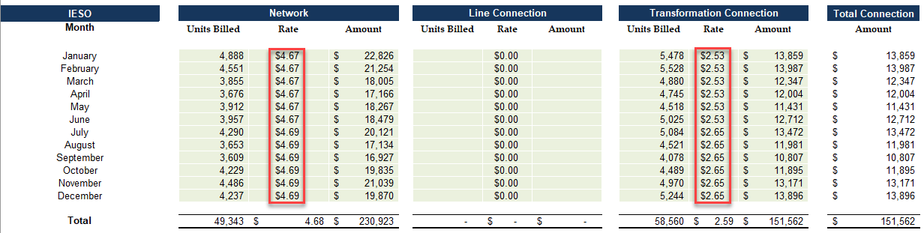

RESPONSE:
Atikokan is billed directly from the IESO and as such does not have applicable Hydro One Sub-Transmission Rates. Therefore, Atikokan’s Tab 12 RTSR rates should match the approved Uniform Transmission Rates on tab 11. Atikokan did make a clerical error in Tab 12; Cells E25 to E30 for the network rate. The correction has been made to the model.

Staff Question-2
Ref: Rate Generator Model Tab 3 - Continuity Schedule: Account 1595 (2017)
Ref: OEB-approved disposition in 2020 IRM Decision and Rate Order (EB-2019-0020)
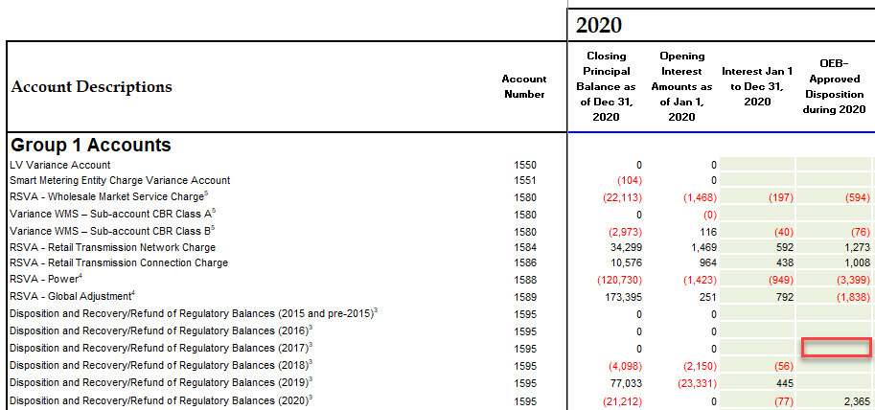

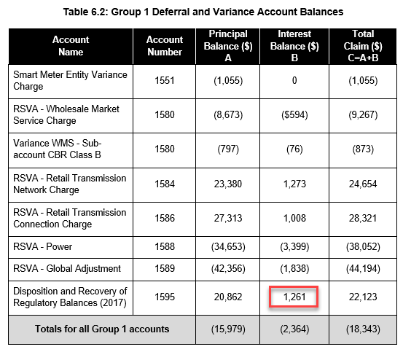
On the continuity schedule of the 2020 IRM model, Atikokan Hydro reported $0 balances in Cell BJ33 Account 1595 (2017) OEB-Approved Interest Disposition during 2020.
As per Atikokan Hydro’s 2020 IRM Decision and Rate Order, this account should have a balance of $1,261 in Cell BJ33.
- Please provide explanation for the above discrepancy.

RESPONSE:
Atikokan confirms, per the 2020 IRM Decision and Rate Order, cell BJ33 should have a balance of $1261 entered in the continuity schedule. Respectively, cell BA33 should have an input of $1110 and cell BI33 should have an input of $152.

Staff Question-3
Ref: (i) LRAMVA Workform, Tab 1 (LRAMVA Summary)
(ii) IRM Rate Generator Model, Tab 3 (Continuity Schedule)

There is a discrepancy in the Total LRAMVA balance to be disposed of in the following schedules:
- Cell H22, Cell R85 and Cell G43 of Tab 1 of the LRAMVA Workform ($1,910)
- Applicant Manager’s Summary ($1,924)
- Cell BT46 of Tab 3 of the IRM Rate Generator Model ($1,924)

Please confirm the LRAMVA balance to be disposed and update Tab 1 of the LRAMVA Workform with details and calculations to arrive at the LRAMVA balance.

RESPONSE:
Atikokan confirms the utility is requesting a claim of $1,924 as per the manager’s summary. The claim includes projected interest from January 1, 2021 to April 30, 2022.
LRAMVA Workform Model shows claim amount of $1,910; this includes principal and interest to December 31, 2020.
Cell BT46 shows $1,924 this includes the claim per the LRAMVA workform plus projected interest to April 30, 2022 bringing the total claim amount to $1,924.

OEB Staff-4
Ref: (i) LRAMVA Workform, Tab 3 (Distribution Rates)
(ii) Draft Rate Order (EB-2014-0056)

Distribution Rates per Tab 3 of current LRAMVA Workform could not be reconciled to the Draft Rate Order for EB-2014-0056 for the following classes:
- Streetlighting

Please explain the difference and how the values were calculated. Where necessary, please update Tab 3 of the LRAMVA Workform with the corrected values.

RESPONSE:
Tab 3 of the LRAMVA Workform has been revised to exclude and reconcile the values for EB-2014-0056 Streetlighting class. There should be no values reported.
OEB Staff-5
Ref: LRAMVA Workform, Tab 5 (2015-2020 LRAM)

The energy savings reported for 2018 in Tab 5 of the LRAMVA Workform were reconciled to the IESO Participation and Cost report (LDC Progress tab). However, the persisting energy savings could not be tied to any reports provided. Please provide the details and calculations used to arrive at the persisting energy savings from 2018.

RESPONSE:
The energy savings reported for 2018 in Tab 5 of the LRAMVA Workform reconcile with to the IESO Participation and Cost report (LDC Progress tab) column BD. Atikokan notes that this methodology has been accepted in other application. If Board Staff deems it incorrect, please provide the correct information the utility should be using instead.

EB-2019-0020

