Orangeville Hydro Limited
OEB Staff Questions
EB-2021-0049

Orangeville Hydro Limited
EB-2021-0049

Please note, Orangeville Hydro Limited (Orangeville Hydro) is responsible for ensuring that all documents it files with the OEB, including responses to OEB staff questions and any other supporting documentation, do not include personal information (as that phrase is defined in the Freedom of Information and Protection of Privacy Act), unless filed in accordance with rule 9A of the OEB’s Rules of Practice and Procedure.
OEB Staff-1
Reference: (1) 2022 IRM Rate Generator Model, Tab 3 (Continuity Schedule)
Orangeville Hydro has not provided inputs at Reference 1 for the “Principal Disposition during 2020- instructed by OEB” and the “Interest Disposition during 2020- instructed by OEB” in Account 1580 Variance WMS- Sub-account CBR Class B. OEB staff notes that as per the 2020 IRM Decision and Rate Order, the principal and interest disposition in this account was a credit balance of $5,001 and a debit balance of $117, respectively.
Questions:
- Please review the Account 1580 Variance WMS- Sub-account CBR Class B disposition amounts in 2020 and provide an explanation for the noted discrepancies.
Response
Orangeville Hydro incorrectly omitted the amounts of $5,001 credit balance for the “Principal Disposition during 2020- instructed by OEB” and $117 debit balance for the “Interest Disposition during 2020- instructed by OEB” in Account 1580 Variance WMS- Sub-account CBR Class B. This has been corrected in the updated Continuity Schedule in the 2022 IRM Rate Generator Model.
- If required, please make any necessary adjustments to the Continuity Schedule in the 2022 IRM Rate Generator Model.
Response
This has been corrected in the updated Continuity Schedule in the 2022 IRM Rate Generator Model.

OEB Staff-2
Reference: (1) 2022 IRM Rate Generator Model, Tab 6 (Class A Consumption Data)
At Reference 1, Orangeville Hydro identified that it had eight transition customers during the period the Account 1589 GA or Account 1580 CBR B balance accumulated. OEB staff notes that customers one through six were full year Class A customers in 2020, as shown below.
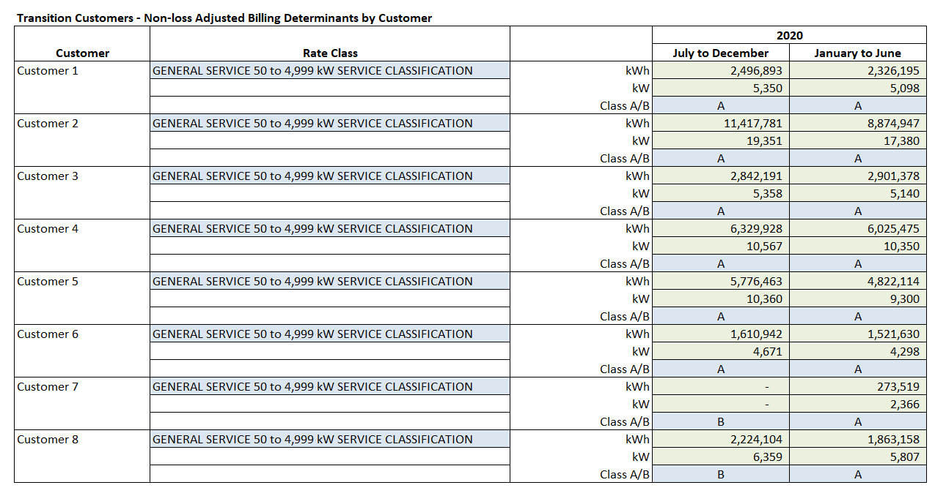Questions:
- Please confirm the following or provide further explanations:
  - Customers one through six were inputted to calculate the total Class A consumption for full year customers at 3b at Reference 1.
Response
OHL confirms Customers one through six were inputted to calculate the total Class A consumption for full year customers at 3b at Reference 1.

- Customer seven was no longer a customer from July to December of 2020
Response
OHL confirms customer seven was no longer a customer from July to December of 2020.

- Customer eight was the only transition customer in 2020
Response
OHL confirms customer eight was the only transition customer in 2020.

- If required, please make any necessary adjustments to Tab 6 (Class A Consumption Data) in the 2022 IRM Rate Generator Model, so that only customers that have consumption as both Class A and Class B customers are reflected.
Response
OHL has updated Tab 6, section 3b, so that only one transition customer (Customer eight) is included.
OEB Staff-3
Reference: (1) EB-2018-0060, 2019 IRM Decision and Rate Order, March 28, 2019, page 11
(2) EB-2020-0046, 2021 IRM Decision and Rate Order, March 25, 2021, page 13
As per Reference #1, the OEB ordered a compliance review to be conducted by the OEB relating to a Class A Global Adjustment (GA) administrative error.
As per Reference #2, the OEB ordered an additional inspection to be conducted by the OEB relating to Account 1588 and Account 1589.
In the question below, OEB staff has referred to the OEB’s compliance review (as per the 2019 IRM decision) and the additional OEB inspection (as per the 2021 IRM decision) collectively as “the Inspection”.
Question:
- Given that the commodity account balances may be impacted by the outcomes of the Inspection, would Orangeville Hydro be agreeable to withdrawing its request to clear any Account 1588 and Account 1589 balances (or alternatively, all Group 1 accounts) in the current proceeding, in the event that the Inspection is not completed before the issuance of the decision?
Response
Orangeville Hydro agrees to withdraw its request to clear any Account 1588 and Account 1589 balances in the current proceeding, in the event that the Inspection is not completed before the issuance of the decision. Orangeville Hydro does not agree to remove remaining Group 1 balances as these accounts are not specifically within the scope of the Inspection and therefore should remain within the application to be disposed of. This includes accounts 1550, 1551, 1580, 1584, 1586, 1595, and 1568.
OEB Staff-4
Reference: (1) EB-2019-0060, 2020 IRM Rate Generator Model, Tab 3, February 19, 2020
(2) EB-2019-0060, 2020 IRM Decision and Rate Order, April 16, 2020, page 9
(3) EB-2020-0046, 2021 IRM Rate Generator Model, Tab 3, March 25, 2021
(4) 2022 IRM Rate Generator Model, Tab 3, October 13, 2021
In the 2020 IRM Rate Generator Model and decision, the OEB disposed of the December 31, 2016 Account 1588 and Account 1589 balances (on a final basis), while deferring disposition of the 2017 and 2018 balances.
OEB staff notes discrepancies between the Account 1588 and Account 1589 December 31, 2016 principal balances in the 2022 IRM Rate Generator Model (Reference #4), and each of the 2020 and 2021 IRM Rate Generator Models (References #1 and #3).
OEB Staff Table 1 –
Discrepancies in December 31, 2016
Account 1588 and Account 1589 Principal Balances
OEB staff further notes that Orangeville Hydro confirmed the balances above (in Column B), in response to Staff Question-8 in its 2021 IRM proceeding, and that the current Manager’s Summary (October 13, 2021, page 12) confirmed no adjustments have been made to DVA balances previously disposed on a final basis.
Questions:
- Please confirm whether Orangeville Hydro is in agreement with OEB staff’s calculations in OEB Staff Table 1.

Response
Orangeville Hydro confirms their agreement with OEB staff calculations in OEB Staff Table 1.

- If this is the case, please update the 2022 IRM Rate Generator Model to reflect the balances in Column B, or explain why that is not appropriate, including the discrepancy in Column C.
Response
Orangeville Hydro confirms that it has removed the request to dispose of accounts 1588 and 1589 in this rate proceeding (see response to OEB Staff 3a), pending the completion of the Inspection review. Because of this, Orangeville Hydro has made no further changes to the DVA balances on Accounts 1588 and 1589 in the 2022 IRM Rate Generator Model.
OEB Staff-5
Reference: (1) EB-2020-0046, 2021 IRM Decision and Rate Order, March 25, 2021
(2) 2022 IRM Rate Generator Model, Tab 3, October 13, 2021
OEB staff notes the following discrepancies between the Account 1589 2021 OEB-approved interest balance in the 2022 IRM Rate Generator Model (Reference #2), and the 2021 IRM Decision and Rate Order (Reference #1).
OEB Staff Table 2 –
Discrepancies in 2021 OEB-Approved
Account 1589 Interest Balance
Questions:
- Please confirm whether Orangeville Hydro is in agreement with the calculations in OEB Staff Table 2.
Response
Orangeville Hydro is in agreement with the calculations in OEB Staff Table 2.

- If so, please update the 2022 IRM Rate Generator Model to reflect the balances in Column E.
Response
Orangeville Hydro has updated the 2022 IRM Rate Generator Model to reflect the balances in Column E.

- If not, please explain the discrepancy in Column F.

OEB Staff-6
Reference: (1) 2022 IRM Rate Generator Model, Tab 3, October 13, 2021
(2) GA Analysis Workform, October 13, 2021, Tab GA 2020
At Reference #1, Orangeville Hydro has included an Account 1589 debit of $377,958 in cell BD29 “Transactions Debit / (Credit) during 2020.” However, at Reference #2, Orangeville Hydro has included a debit of $392,999 in cell C75 for the Account 1589 “Net Change in Principal Balance in the GL (i.e. Transactions in the Year)”.
Question:
- Please clarify which should be the correct number.
Response
OHL confirms the correct number is a debit of $377,958 in cell BD29 “Transactions Debit / (Credit) during 2020 for Account 1589. The GA Workform incorrectly included the 2020 disposition balance. The Net Change in Principal Balance in the 2020 GA workform has been corrected to $377,958.

OEB Staff-7
Reference: (1) LRAMVA Workform, Tab 5 (2015-2020 LRAM)
2018
The energy savings and persisting energy savings reported for 2018 & 2019 in Tab 5 of the LRAMVA Workform could not be reconciled to the IESO Participation and Cost report, however, is consistent with the prior year LRAMVA Workform without exception. The energy savings for 2019 also reconcile to the “OHL_2019 CDM Project List_No Customer Info” excel filed with Orangeville Hydro’s 2021 IRM application.
Please clarify why the 2018 data cannot be reconciled to the IESO Participation and Cost report and provide details and calculations used to arrive at the energy savings and persisting energy savings from 2018 for the following programs:
- Save on Energy Coupon Program
- Save on Energy Retrofit Program
- Save on Energy Small Business Lighting Program
- Business Refrigeration Local Program
Response
For the 2019 Save on Energy Retrofit Program, Save on Energy Small Business Lighting Program and the Business Refrigeration Local Program, the information for the file “OHL_2019 CDM Project Project List_No Customer Info” was gathered using the IESO’s CDM Program Reported Results website https://online.ieso.ca/suite/tempo/news/all and the Retrofit LDC portals. The projects had to be pulled one by one from this IESO portal in order to attribute the savings to the correct customer classes. Orangeville Hydro had no access to the “Participation and Cost Report – Orangeville Hydro Limited” for 2019. If the OEB has a more up-to-date report, Orangeville Hydro would appreciate having a copy of this report for 2019.
For the 2018 Save on Energy Coupon Program, this corresponds to the value for Save on Energy Instant Discount Program of 380,397*1.290419. The 380,397 comes from the P&C Report from April 2019 (included with this response). This was in response to EB-2019-0060 Staff Question 4a.
For the 2018 Save on Energy Retrofit Program, Save on Energy Small Business Lighting Program and the Business Refrigeration Local Program, the information for the files “OHL_2018 CDM Project Project List_No Customer Info” was gathered using the same methodology as 2019 above. This file was never provided to the OEB during EB-2019-0060 (included with this response). Orangeville Hydro only had access to the “Participation and Cost Report – Orangeville Hydro Limited – 2019 04” which at best is an incomplete product, as it was not the Final Verified results report. If the OEB has a more up-to-date report, Orangeville Hydro would appreciate having a copy of this report for 2018.
2020
The energy savings reported for 2020 in Tab 5 of the LRAMVA Workform reconcile to the “OHL_2020 CDM Project List_No Customer Info” excel filed in the current proceeding. Please clarify why the contents of the working paper include data pertaining to programs led by Toronto Hydro-Electric System Limited.
Response
Orangeville Hydro included the energy savings for these customers in its claim, as although the program was led by Toronto Hydro, the savings were generated from a location that is within Orangeville Hydro’s service territory and therefore relates to Orangeville Hydro’s LRAM claim.

