February 2, 2022

The Registrar
Ontario Energy Board
P.O. Box 2319
27th Floor – 2300 Yonge Street
Toronto, ON M4P 1E4

Re: SYNERGY NORTH CORPORATION - 2022 Electricity Distribution Rate Application EB-2021-0058

Dear Board Registrar:

Synergy North respectfully requests and extension to February 7, 2022, for providing responses to the OEB Staff questions on the above noted Rate Application.

Due to staffing changes, best efforts have been made to complete the replies to Staff questions, however, additional time is required to provide fulsome responses.

If you require any further information, please contact the undersigned at (807) 467-8014.

Sincerely,

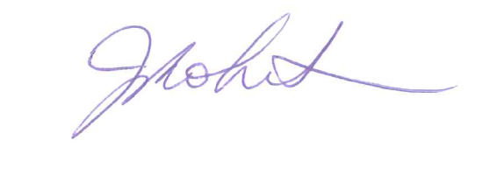
Janice Robertson
Regulatory and Financial Assurance Manager
SYNERGY NORTH CORPORATION
34 Cumberland Street North
Thunder Bay, Ontario
P7A 4L4

Phone: (807) 467-8014
Email: jrobertson@synergynorth.ca

Cc Aaron Blazina, VP Finance

