Synergy North Corporation
EB-2021-0058

Please note, Synergy North Corporation (Synergy North) is responsible for ensuring that all documents it files with the OEB, including responses to OEB staff questions and any other supporting documentation, do not include personal information (as that phrase is defined in the Freedom of Information and Protection of Privacy Act), unless filed in accordance with rule 9A of the OEB’s Rules of Practice and Procedure.

OEB staff has made the following generic updates in Rate Generator Models attached:
- Updated the IPI Inflation Factor to 3.30% in Tab 16 and Tab 17-Retail Service Charges
- Updated the Ontario Electricity Rebate in Tab 20 to 17% (as of November 1, 2021)
- Updated the Wireline Pole Attachment Charge to $34.76 in Tab 17
- Updated the 2022 UTRs and Hydro One Sub-transmission rates in Tab 15

Staff Question – 1
Ref 1: Kenora GA Analysis Workform
Ref 2: Kenora Rate Generator Model, Tab 3 Continuity Schedule
Staff notes that Net Change in Principal Balance in the GL (cell C75) of ($14,511) in the GA Analysis Workform does not agree to the transaction debit/(credit) during 2020 of $($8,317) on the continuity schedule of the rate generator model.
Question(s):
- Please explain the discrepancy noted above.

SYNERGY NORTH RESPONSE:
The amount reported in the Continuity Schedule as Net Change in Principal Balance in the GL of $(8,317) is correct. The input into GA Workform Cell C75 was an error at $(14,511), it should be $(8,317). Correction has been made in the GA Workform. The unresolved impact went from -0.5% to -0.4% in the GA Form as a result of this correction.

Staff Question – 2
Ref 1: Kenora GA Analysis Workform
Tab “GA 2020” on GA Analysis Workform has one reconciling item: #6 of $12,076. Synergy North explain that this is added to the GA analysis workform because not all customers are on calendar monthly billing.
Staff notes that there is no reconciling item #5 for impact of GA deferral.
Questions:
- Please elaborate further of the reconciling item #6, specifically why and how not all customers being on calendar monthly billing impacts the GA variances recorded in Account 1588.
- Please provide the reconciling item #5 in accordance with the GA instructions.

SYNERGY NORTH RESPONSE:

- Synergy North’s billing system does not have the capability to split the monthly GA pricing and apply it to the daily consumption during the billing process.
Customers not on calendar month billing cycles are billed on a weighted average GA pricing for the period of their billing, calculated in the system using the monthly GA rates.
The GA Workform applies the monthly GA rate to the monthly consumption on a calendar month basis. The adjustment on Line 6 is done to represent the amount calculated on a calendar month’s GA rate (as in the GA Analysis Workform “Note 4” Table) closer to the actual results in the GL, which have billings based on the weighted average rates for customers with consumption spanning a month end.

- The difference between the Column M Actual rate paid for the three-month period vs the Net IESO CT 148 Line expense for the period is $39,548 Expenses being greater than Column N expected expense.
The updated Unresolved Difference is 0.6%.

Staff Question – 3
Ref 1: Kenora GA Analysis Workform
Staff notes from Tab “Account 1588” of the GA analysis workform that Account 1588’s 2020 balance is greater than 1% of Account 4705 Power Purchased.
Synergy North explained the reason: “In 2020, the Kenora Rate District realized the full impact of transferring its settlement processes”.
Question:
- Please elaborate further how Kenora realized the full impact of transferring its settlement processes in 2020.
- Please explain whether Kenora has recorded the adjustments due to this transfer, if so, please provide the details of the adjustments (period it pertains to and the adjustment amount).
SYNERGY NORTH RESPONSE:
After the merger of Kenora Hydro into Synergy North, Kenora Hydro processes were transferred into the former Thunder Bay Hydro methods for calculating Form 1598 settlements and true-up settlements. The transition was completed in 2020.
An audit of the process and entries performed in that transition has revealed two errors.
- When populating Kenora’s data into an internal “life-to-date” true up calculation for “1598 Fixed Rate” settlements, which is done monthly as a double check of all filings to date, the 2019 gross regulated price plan (RPP) revenue less the associated cost of power (COP) for the year was overstated, resulting in an overpayment to the IESO. The 2019 revenue was not reduced by the 2018 unbilled revenue less COP amount associated with the 2018 “1598 Fixed Rate” claims. The 2019 annual revenue less cost of power used to recalculate the RPP settlement claims to date was thereby overstated by $363,414.66, the amount of the 2018 unbilled RPP less associated COP.

The result of this error was an overpayment to the IESO in the June 2020 IESO filing, which was posted to the GMBA in June 2020. Correcting this error reduces the Kenora Account 1588 debit balance by $363,414.66. This adjustment has been posted to the 2020 Principal adjustments column (BF) in the Kenora model. This amount, along with the below noted error, will be claimed as a due from the IESO on the March 2022 “1598 Fixed Rate” filing. Correcting entries will be done in the GL in December 2021.

- In the life-to-date true-up working paper, the balances previously trued up with the IESO on quarterly settlements was incorrectly input as $39,502, the correct input was $(52,587).

The total impact of these two noted items is a reduction of the Kenora zone Account 1588 balance to $(57,521) and adjusted carrying charges to $(299) on December 31, 2020.
Staff Question – 3 (continued)

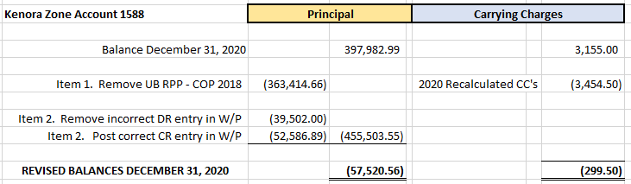

Total revised Kenora zone Account 1588 “Total Claim”, including the impact of the 2021 OEB approved disposals for Principal and carrying charges (column BM and BN total of $81,024), plus anticipated carrying charges into 2022, is $23,375 (column BT).
On Tab 4 of the Model, as adjusted, the revised total Group 1 Accounts for disposition is $12,902, and, as the claim does not meet the materiality threshold, Synergy North does not wish to dispose of the Group 1 balance in the Kenora zone in this rate application.
The impact of removing the claim for the Kenora zone Group 1 Account balances flows through to the bill impacts by class as follows:

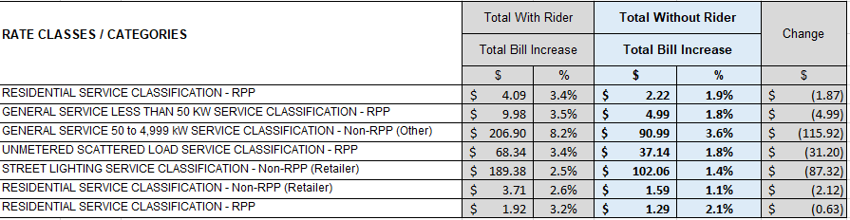

Residential customers will have a 1.9%, $2.22 per month total bill increase.

Staff Question – 4
Ref 1: Thunder Bay GA Analysis Workform
Staff notes from Tab “GA 2020” of Thunder Bay’s GA Analysis Workform of the two reconciling items below:
Question:
- Please explain if the reconciling item #6 of ($69,645) refers to reconciling item #5 impacts of GA deferral. If so, please update the GA analysis workform.

SYNERGY NORTH RESPONSE:
The amount and description on Item 6 were input from a working copy of the model into the final model incorrectly. Synergy North confirms that the amount and description should have been included as Item 5, Impacts of GA Deferral. It has been corrected in the Model.

Staff Question – 5
Ref 1: Manager’s Summary, page 17
Synergy North stated for Kenora rate zone that:
A two-year disposition period is requested for the Group 1 Deferral and Variance Accounts, with rate riders effective May 1, 2022, until April 30, 2024. Annual disposition of Group 1 Accounts results in less risk for intergenerational gaps in disposition amounts to/from customers.
.
Question:
- Please explain why Synergy North proposed a two-year disposition period for Kenora rate zone’s group 1 DVAs.

SYNERGY NORTH RESPONSE:
Synergy North will not be disposing of the Group 1 DVA’s in this application.

Staff Question – 6
Ref 1: Manager’s Summary, page 21
Synergy North stated that:
Synergy North has chosen to populate the GA Analysis Workform with its Non- RPP Class B consumption with losses for both Rate Zones. A billing system query produces a report of the monthly “consumed” kWh for each Non-RPP customer. The system pulls the consumption billed between meter read dates, and based on consumption by day, provides a calendar month “consumed” amount. Synergy North uses the results of this report to true up its estimates once all billing cycles for the quarter have fully billed out volumes for the period.

Question:
- Please confirm that the monthly “consumed” kWh for each Non-RPP customers from the billing report represents the actual consumptions in the calendar month, rather than the billed consumption in the calendar month. If it is the latter, please explain how this process complies with the Accounting Guidance for the Commodity accounts issued in February 2019.

SYNERGY NORTH RESPONSE:
Synergy North confirms that the data populated in the GA Workform is the consumed kWh each month, not billed kWh for each month. We are able to generate a report that prorates the billed consumption into the correct month when it was consumed, and this is the report used to populate this Workform.

Staff Question – 7
Ref 1: Thunder Bay’s Account 1595 Analysis Workform
Tab “1595 2018” shows that the residual balance for the 2018 GA rate rider under Account 1595 sub-account 2018 is significantly greater than 10%.
Staff notes that Synergy North has collected $14,999 for the 2018 GA rate riders (Cell G14) while the 2018 approved GA rate riders to be refunded to the customers are totaled $33,253.
In addition, Staff notes that the residual balance for 2018 GA rate riders is ($38,957) while the variance analysis table shows the total calculated variance of ($28,815).
Question(s):
- Please explain why Synergy North has collected $14,999 for the 2018 GA rate riders for Thunder Bay rate zone when the approved GA rate riders were to refund to the customers.

SYNERGY NORTH RESPONSE:
Corrections have been made to the Thunder Bay zone Account 1595 Analysis Workform, based on the following:
- The 2018 IRM journal entry to move the GA disposition of $(36,499) into the 1595 Account, and the journal entry to move the WMS Sub Account CBR Class B amount of $(65,002) into the 1595 Account were incorrectly posted. The GA disposition amount was posted to the 1595 WMS Sub Account, and the WMS Sub Account amount was posted to the 1595 GA disposition account. When completing the working paper for this table, the calculation was done to determine the change in accounts using an incorrect ‘starting’ value as posted in the GL. The resulting value of $14,999 ‘collected’ is an error. The table has been updated with the corrected movement, returns to customers of $37,641.

- The returns to customers for the 2018 GA rider were incorrectly applied on a kW base, rather than a kWh basis, for the General Service 50-999 and General Service Over 1,000 kW classes, from May 2018 to January 2019. Corrections to customer accounts were made in November of 2019, however, the billing corrections were posted in the GL into the 1595 Account (2017). To reallocate the customer account corrections to the correct year, $23,871 Disposition to customers was moved into 2018 from 2017 in the “Principal Adjustments during 2019” column in the Continuity Schedule.

- Please explain the discrepancy between the total residual balance for 2018 GA rate riders of ($38,957) and the calculated variance of ($28,815).

SYNERGY NORTH RESPONSE:
See Part a) response and revised 1595 Analysis Workform.

2022 inflation factor established in the Decision and Order issued on November 18, 2021, EB-2021-0212
EB-2021-0302, Decision and Order, issued December 16, 2021
EB-2021-0276, Decision and Rate Order, issued December 16, 2021
EB-2021-0032, Decision and Rate Order, issued December 14, 2021

