Synergy North Follow-up Question

Staff Follow-up Question – 1
Ref: Response to Staff Question – 3

In Reference 1, Synergy North stated that “An audit of the process and entries performed in that transition has revealed two errors”. Synergy North also provided a table below to summarize the adjustments made in 2020 for these errors:
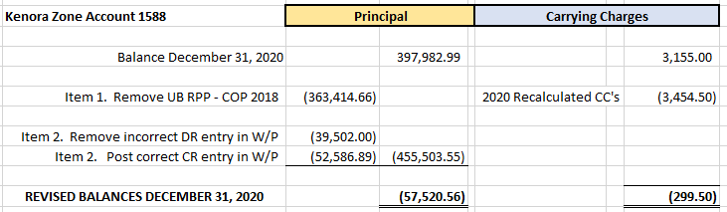
Question(s):
- Please provide the details of the audit (the auditor, when the audit was conducted)
- Please clarify which periods are the adjustment item #1 of $363,414,66 pertaining to.
- Please clarify which periods are the adjustment item #2 pertaining to.
- Please confirm that both adjustments are not impacting the RPP portion of the global adjustments that have been settled with the IESO.

