Synergy North Follow-up Question

Staff Follow-up Question – 1
Ref: Response to Staff Question – 3

In Reference 1, Synergy North stated that “An audit of the process and entries performed in that transition has revealed two errors”. Synergy North also provided a table below to summarize the adjustments made in 2020 for these errors:
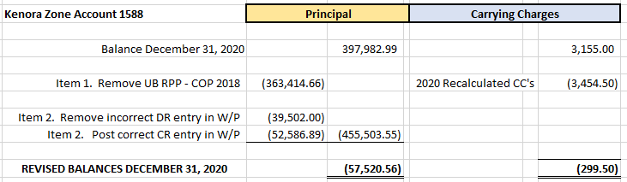
Question(s):
- Please provide the details of the audit (the auditor, when the audit was conducted)
This audit was performed internally by Janice Robertson, CPA, Regulatory & Financial Assurance Manager, and Aaron Blazina, CPA, V.P. Finance. The internal audit was conducted on receipt of the OEB Staff questions on the IRM filing for the Kenora zone, in January 2022.
- Please clarify which periods are the adjustment item #1 of $363,414,66 pertaining to.
This amount is required to adjust the claims and activity in the GL during 2020. In a life-to-date reconciliation calculation of RPP TOU revenue recalculation done in 2020, to mirror the process used by Thunder Bay Hydro for verifying life-to-date IESO claims, this amount was erroneously excluded as a reconciling amount, creating a payment required to the IESO.
- Please clarify which periods are the adjustment item #2 pertaining to.
The two amounts identified were from 2020 GL postings, posted in 2020, as a result of the same Life-to-date true-up process as described.
- Please confirm that both adjustments are not impacting the RPP portion of the global adjustments that have been settled with the IESO.
None of these adjustments impacted the RPP portion of the global adjustments settled with the IESO.

