**North Bay Hydro Distribution Ltd**

**EB-2021-0046**

**RESPONSES to Follow-Up**

**Staff Follow-Up Question -1**

**Ref: Staff Question -7**

North Bay Hydro has revised its unbilled to actual revenue principal adjustments in the principal adjustment tab of the GA Analysis Workform.

1. In the 2017 GA Analysis tab, reconciling item 2a of $70,016 is shown. However, this is not shown as a 2017 principal adjustment in the principal adjustment tab. Please confirm that the reversal is reflected in the $485,369 reversal. If not confirmed, please explain why the $70,016 is a reconciling item but not a principal adjustment.

**Response a)**

The $485,369 represents the other side of the 2016 principal adjustment that was completed as part of EB-2017-0065 (see Attached IRR). This was done when the OEB was directing utilities to reconcile true-up entries to the proper year. The two figures are $409,353 and the $76,016 (typo in above question). See the table below that is in the attached IRR.

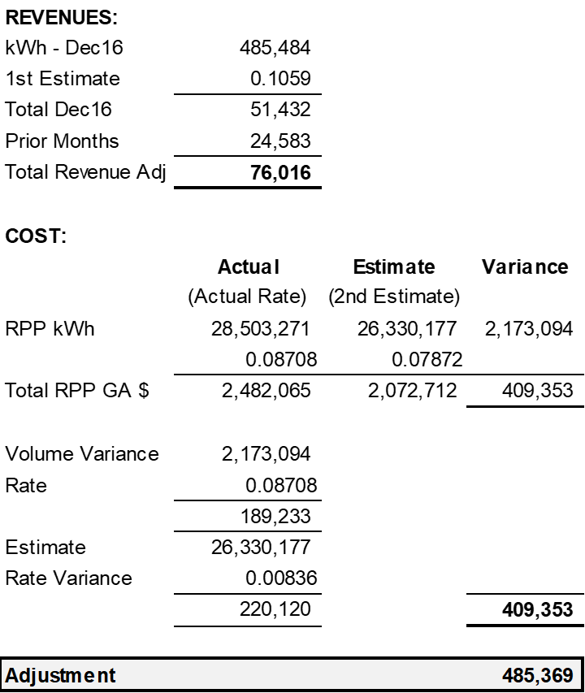

1. Based on the revisions to the principal adjustment tab of the GA Analysis Workform, OEB staff has made the following adjustments to Tab 3 of the IRM Rate Generator Model. Please confirm that the revised principal adjustment amounts for Account 1589 in Tab 3 are appropriate. If not confirmed, please explain.

|  |  |  |
| --- | --- | --- |
| **Year** | **Account 1589 Principal Adjustment** | **Account 1588 Principal Adjustment** |
| 2017 | $642,957 | No change |
| 2018 | ($34,360) | No change |
| 2019 | $51,645 | No change |
| 2020 | ($27,578) | $0 |

**Response b)**

The above table is not accurate. Presumably the OEB is attempting to factor in the Unbilled reconciling items to NBHDL’s prior principal adjustments. Please see the below Table:



Please note that in the prior round of IRs, NBHDL responded incorrectly to previous question #8. NBHDL understood the question incorrectly. The $196,302 should in fact be part of the principal adjustment worksheet as it in the other side of the adjustment from 2017,2018 and 2019 (208,457 + 4,104 – 16,259). This can either be a principal adjustment in 2020 or negated from the year’s activity in order to balance the closing GL.

1. If part b is confirmed, the revised threshold calculation in Tab 4 indicates that the threshold is met. Please confirm whether North Bay Hydro is seeking disposition of Group 1 balances.
   1. If North Bay Hydro is now seeking disposition of Group 1 balances, please discuss how it intends to address the unresolved difference of 1.9% in the 2017 GA Analysis Workform. Please also revise the Account 1588 reasonability test in the GA Analysis Workform and explain any instances where Account 1588 as a percentage of Account 4707 is greater than 1%.

**Response b)**

Part b) is unconfirmed.