John A.D. Vellone  T (416) 367-6730  F 416.367.6749  jvellone@blg.com  Katerina Maragos  T (416) 367-7280  F 416.367.6749  kmaragos@blg.com | Borden Ladner Gervais LLP  Bay Adelaide Centre, East Tower  22 Adelaide Street West  Toronto, ON, Canada M5H 4E3  T 416.367.6000  F 416.367.6749  blg.com | 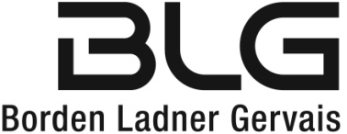
March 31, 2022
Delivered by Email & RESS
Ms. Marconi, Registrar
Ontario Energy Board
P.O. Box 2319, 27th Floor
2300 Yonge Street
Toronto, ON M4P 1E4
Dear Ms. Marconi:

Re: | Sun-Canadian Pipe Line Limited’s Sections 90 and 97 Application for Leave to Construct  Ontario Energy Board File No.: EB-2022-0012
We are counsel to the Applicant in the above-noted proceeding (the “Proceeding”).

Pursuant to the Ontario Energy Board’s (the “OEB”) Procedural Order No. 1 dated March 22, 2022, the Haudenosaunee Development Institute (“HDI”) must file a letter with the OEB by April 1, 2022 providing more information on the areas HDI’s evidence is expected to cover, whether an expert will be retained, the estimated cost of preparing the evidence and the proposed timing for filing the evidence, and any other relevant information (the “Intervenor Letter”).

The Applicant met with HDI on March 29, 2022, and further to that meeting and in response to a request from HDI, the Applicant is willing to consent to an extension to the deadline for HDI to file the Intervenor Letter to April 8, 2022.

The Applicant believes that this should have no impact on the balance of the schedule set out in Procedural Order No. 1.

If you have any questions or concerns, please do not hesitate to contact me.

Yours very truly,
BORDEN LADNER GERVAIS LLP
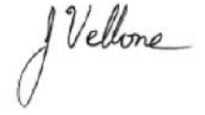
Per:

John Vellone
cc: Peter Martens, Sun-Canadian Pipe Line Limited
Aaron Detlor, Haudenosaunee Development Institute
Tim Gilbert, Haudenosaunee Development Institute
Judith Fernandes, Ontario Energy Board
Michael Millar, Ontario Energy Board

