InnPower Corporation
ED-2002-0520

2023 Incentive Regulation Mechanism
Electricity Distribution Rate Application

Board File EB-2022-0043
For Rates Effective January 1, 2023

InnPower Corporation
ED-2002-0520

2023 Incentive Regulation Mechanism Electricity
Distribution Rate Application
For
January 1, 2023 Rates
EB-2022-0043

InnPower Corporation Manager’s Summary

Table of Contents
1.0 Application 4
1.1 Managers Summary 7
1.2 Contact Information 9
2.0 Elements of the Price Cap IR 10
2.1 Annual Adjustment Mechanism 10
2.2 Revenue to Cost Ratio Adjustments 11
2.3 Rate Design for Residential Electricity Customers 11
2.4 Retail Transmission Service Rates 12
2.5 Group 1 Deferral and Variance Account Balances 13
2.5.1 1595 Analysis 14
2.5.2 Wholesale Market Participants 15
2.5.3 Global Adjustment 15
2.5.4 CBR Class B 16
2.6 Group 2 Deferral and Variance Account Balances 16
2.7 LRAM Variance Account (LRAMVA) 17
2.8 Tax Changes 17
2.9 Z Factor Changes 17
3.0 Rate Change Summary and Bill Impacts 18
Appendices 26
A: OEB Letter Dated January 9, 2018, Re: InnPower Application for Rates Ontario Energy Board (OEB) File Number: EB-2016-0085 27
B: OEB Decision and Order, EB-2016-0085 Section 3.13 Rate Riders 28
C: OEB Letter Dated February 16, 2022, Re: Delay in Filing (OEB) File Number: EB-2022-0043 29
D: OEB Decision and Order, EB-2016-0085 Section 3.7 Revenues and Costs relating to Affiliate InnServices 30
E: OEB Letter Dated April 9, 2019, Re: Audit of Affiliate Transactions (OEB) File Number: EB-2016-0085 31
F: Current Tariff Sheet 32
G: IPC Certification 33

Ontario Energy Board

IN THE MATTER OF the Ontario Energy Board Act, 1998,
C. S.O. 1998, c.15 (Sched. B);

AND IN THE MATTER OF an Application by InnPower Corporation for an Order or Orders pursuant to Section 78 of the Ontario Energy Board Act, 1998, approving or fixing just and reasonable rates and other service charges for the distribution of electricity

Application

- The applicant is InnPower Corporation (“IPC”), an electricity distribution company that is 100% owned by the Town of Innisfil. IPC serves approximately 20,000 mostly residential and commercial electricity customers in the Towns of Alcona, Belle Ewart, Cookstown, Lefroy, Stroud, and south Barrie. IPC, an Ontario corporation with its head office in Innisfil, Ontario, carries on the business of owning and operating electricity distribution facilities under Electricity Distribution License ED-2002-0520.
- IPC hereby applies to the Ontario Energy Board (the “Board” or the “OEB”), pursuant to Section 78 of the Ontario Energy Board Act, 1998 as amended (the “OEB Act”) for an Order or Orders approving its proposed electricity distribution rates and other charges, effective January 1, 2023.

- IPC last appeared before the OEB with a cost of service rebasing application for 2017 rates in the EB-2016-0085 proceeding. A Decision and Order was issued on March 3, 2018 for EB-2016-0085 with an implementation date of May 1, 2018 for rates effective July 1, 2018. To this end, IPC provided notice to the OEB to forgo the 2018 IRM EB-2017-0053. IPC filed a 2019 IRM EB-2018-0045 for rates effective January 1, 2019, a 2020 IRM EB-2019-0047 for rates effective January 1, 2020, a 2021 IRM EB-2020-0033 for rates effective January 1, 2021 and a 2022 IRM EB-2021-0036 for rate effective January 1, 2022.

- IPC is seeking approval for electricity distribution rates effective January 1, 2023. The proposed rates were calculated utilizing the OEB’s 2023 IRM Rate Generator Model. IPC confirms that it has worked with OEB staff to make any necessary adjustments to prepopulated values, and that the billing determinants in the models as filed are accurate.

- IPC requests that, pursuant to Section 34.01 of the OEB’s Rules of Practice and Procedure, this proceeding be conducted by way of written hearing.

- IPC confirms that the application and related documents will be published on its website (www.innpower.ca).

- IPC confirms that the documents filed in support of the herein application do not include any personal information (as that phrase is defined in the Freedom of Information and Protection of Privacy Act), that is not otherwise redacted in accordance with rule 9A of the OEB’s Rules of Practice and Procedure.

- The persons affected by this Application are the ratepayers of InnPower Corporation’s service territory.

- In addition to the written evidence provided herein, the following Excel Models/Appendices have been filed in conjunction with the EB-2022-0043 application:

  - InnPower_2023-IRM-Rate-Generator-Model_20220721
  - InnPower_2023_GA_Analysis_Workform _1.0_20220527
  - InnPower_2023_IRM_Checklist_20220803
  - InnPower_2023_EB-2022-0043_Principal_Adjustments_20220803
  - Appendix A: Letter Dated January 9, 2018, Re: InnPower Application for Rates Ontario Energy Board (OEB) File Number: EB-2016-0085
  - Appendix B: OEB Decision and Order, EB-2016-0085 Section 3.13 Rate Riders
  - Appendix C: OEB Letter Dated February 16, 2022, Re: Delay in Filing (OEB) File Number: EB-2022-0043
  - Appendix D: OEB Decision and Order, EB-2016-0085 Section 3.7 Revenues and Costs relating to Affiliate InnServices
  - Appendix E: OEB Letter Dated April 9, 2019, Re: Audit of Affiliate Transactions (OEB) File Number: EB-2016-0085
  - Appendix F: InnPower Current Tariff Sheet
  - Appendix G: InnPower Certification

Managers Summary

IPC has selected the Price Cap Incentive Rate-setting (“Price Cap IR) option to file its 2022 Distribution Rate Application. In preparing this application, IPC has complied with Chapter 3, Incentive Rate-Setting Applications, of the Board’s Filing Requirements for Electricity Distribution Applications dated May 24, 2022.

All rates referenced in this application and included in the accompanying InnPower Corporation Proposed Tariff of Rates and Charges, are based on the output of the OEB’s 2023 IRM Rate Generator Model posted July 21, 2022.

IPC has not included in this EB-2022-0043 Application any claims, changes, requests or proposals in relation to any of the following items:
- LRAMVA
- Tax Changes
- Z-Factor claim
- Advanced Capital Module
- Incremental Capital Module
- Eligible Investments

Rate Generator Model
Continuity Schedule Variances
- The variance for 1580 RSVA – Wholesale Market Service Charge in the amount of ($39,038), is the result of balances for sub-account 1580 CBR Class B accounted for in the 1580 control account in the 2.1.7 RRR submission form.

- The variance for 1588 Power and 1589 Global Adjustment in the amount of $167,546 and ($46,437) respectively, is the result of the following items not reflected in the 2.1.7 RRR submission form:
  - True-up of GA charges based on actual GA rate – current year
  - True-up of actual kWh sales volumes for RPP settlements – current year
  - True-up of GA charges based on actual Non-RPP volumes – current year

Please refer to the following files for detailed calculations of the variance:
- InnPower_2023_GA_Analysis_Workform _1.0_20220527
- InnPower_2023_EB-2022-0043_Principal_Adjustments_20220803
Please note, the prior year principal adjustments have not been included in the current year’s principal adjustment column (rate generator model), as they have been accounted for in the disposition amounts recorded during 2022. Including them as a reversal in the current year’s balance would duplicate the amounts.

IPC’s current rates, were approved by the Board in its Decision and Order, (dated December 9, 2021), for IPC’s IRM Application EB-2021-0036 for rates effective January 1, 2022.
IPC requests an Order or Orders approving:
- Monthly Service Charge adjusted by the Board’s price cap formula effective January 1, 2023.

- A Rate Rider for Disposition of all Group 1 Accounts for rates effective January 1, 2023.

- A Rate Rider for Disposition of a Group 2 Account for rates effective January 1, 2023.

- Updated Retail Transmission Service Rates effective January 1, 2023.

- An order declaring IPC’s current (i.e. 2022) rates as interim rates effective January 1, 2023, if and only if the preceding approvals cannot be issued in time to implement final approved rates, effective January 1, 2023.

Contact Information

The primary contact for this EB-2022-0043 Application is:

Laura Hampton
Manager, Regulatory Affairs
InnPower Corporation
7251 Yonge Street, Innisfil, Ontario, L9S 0J3
Telephone: 705-431-6870 Ext. 226
E-mail: laurah@innpower.ca

The secondary contact for this application is:

Glen McAllister
CFO
InnPower Corporation
7251 Yonge Street, Innisfil, Ontario, L9S 0J3
Telephone: 705-431-6870 Ext. 236
E-mail: glenm@innpower.ca

Elements of the Price Cap IR

Annual Adjustment Mechanism

The rates and tariffs entered in the Rate Generator Model are taken from the Board approved 2022 Tariff of Rates and Charges, as per the Board Rate Order (EB-2021-0036).
IPC has the following rate classes:
- Residential
- General Service Less Than 50 kW
- General Service 50 to 4,999 kW
- Unmetered Scattered Load
- Street Lighting
- Sentinel Lighting

The price Cap Index of 3.00% is calculated in the Board’s Rate Generator model based on 2021 values and IPC’s Cohort of Group III for 2022.
IPC acknowledges that Board staff will update the Rate Generator model with the 2022 price cap parameters once they are available.

2022 Price Cap Parameters
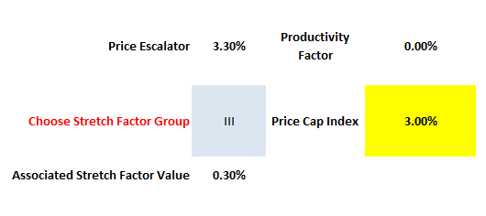

Revenue to Cost Ratio Adjustments

IPC has no Cost Ratio adjustments resulting from the Boards Decision EB-2016-0085, which will affect the outcome of Tab 16. Rev2Cost_GDPIPI, in the Rate Generator model.

Revenue to Cost Ratio Adjustments
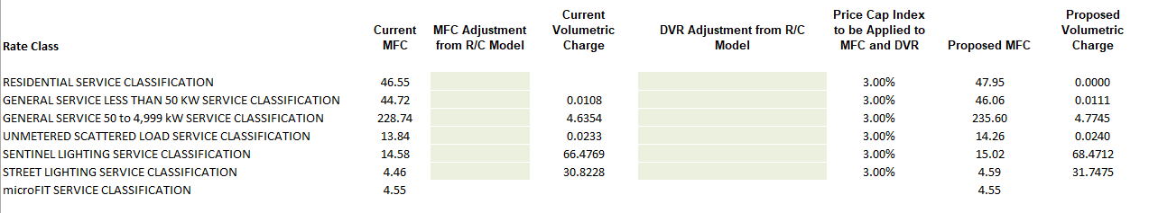

Rate Design for Residential Electricity Customers

The OEB released Board Policy, EB-2014-0210, A New Rate Design for Residential Electricity Customers. The report required that electricity distributor’s transition to a fully fixed monthly distribution service charge for residential customers over a four-year period commencing in 2016.

IPC commenced the transition to a fully fixed month distribution charge effective January 1, 2016 with EB-2015-0081. IPC’s 2016 rates were made interim in 2017 until a Decision was issued on IPC’s COS application EB-2016-0085 and no IRM was submitted for 2018. IPC entered its 4th and final year of transition for the Rate Design for Residential Electricity Customers with IRM EB-2019-0047 rates effective January 1, 2020.

Retail Transmission Service Rates

IPC has calculated the adjustment to the current retail transmission service rates (RTSR) within the Rate Generator model. 2022 RTR rates have been utilized to calculate 2023 RTSR rates. IPC acknowledges that once any January 1, 2023 UTR adjustments have been determined that Board staff will adjust the Rate Generator to incorporate the change.

The proposed RTSR Network and Connection and/or Line and Transformation Connection rates have increased by 10.87% to 31.75% from the current OEB approved rates. IPC’s cost of power in 2021 increased due to a higher volume of consumption than the prior year, as well as double peak billing from Hydro One.

Proposed 2023 RTSR
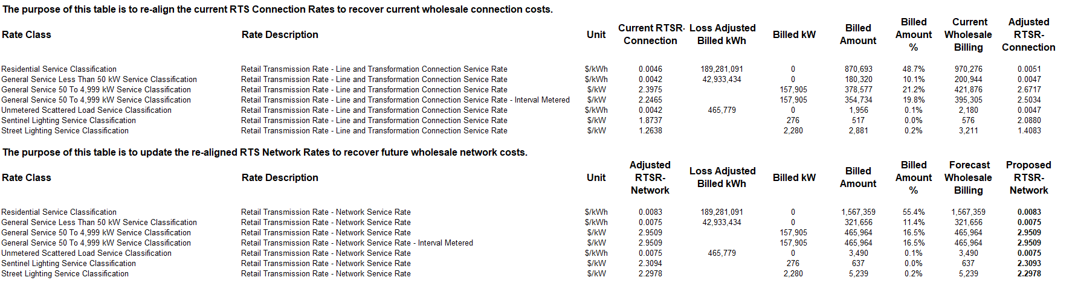

Group 1 Deferral and Variance Account Balances

IPC has completed the DVA worksheets included in the 2023 Rate Generator model. The receivable balance for Group 1 accounts is $3,256,736, excluding Global Adjustment.
The following Table provides a breakdown of the Group 1 accounts:
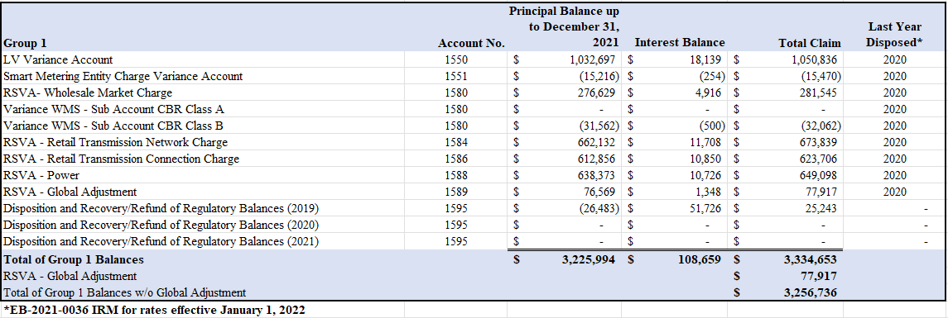
The threshold test resulting from the Group 1 balance is $0.0116. As this meets the threshold limit, IPC is requesting a one-year disposition (or 12 months) on the Group 1 deferral/variance accounts.

The resulting Deferral/Variance Account Rate Riders by rate class for the 2023 DVA is as follows, based on a 12- month disposal:

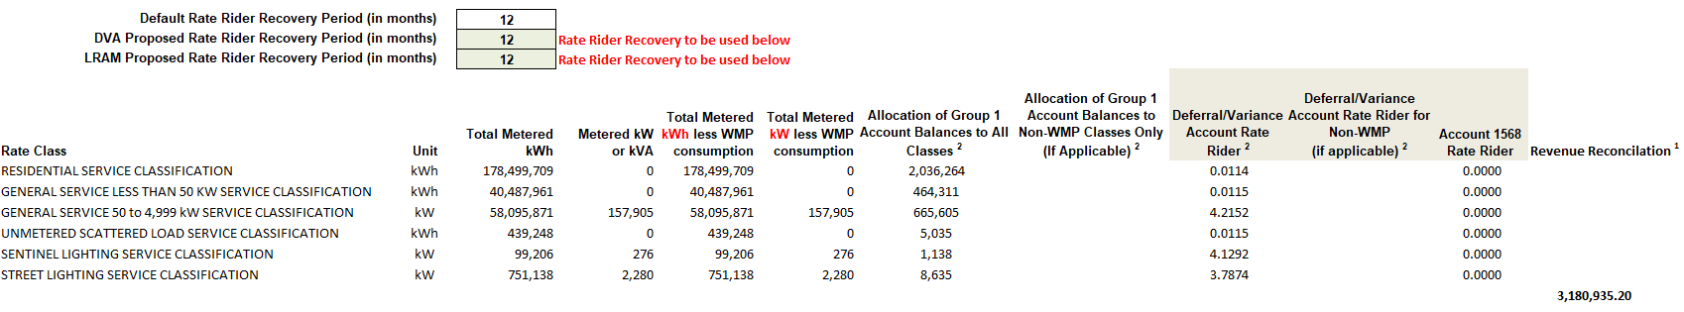

Adjustments of Deferral and Variance Accounts
The principal adjustments in the EB-2022-0043 submission include the current year CT 148 true-up of GA charges based on actual RPP volumes in the amount of ($46,437), as well as the CT 1142/142 true-up based on actuals in the amount of ($121,109). Please note, the prior year principal adjustments have not been included in the current year’s principal adjustment column (i.e. rate generator model), as they have been accounted for in the disposition amounts recorded during 2022. Including them as a reversal in the current year’s balance would duplicate the amounts.
Please note, there have no adjustments made to balances previously approved by the OEB on a final basis.
Please refer to the following file for detailed calculations of the variance:
- InnPower_2023_EB-2022-0043_Principal_Adjustments_20220803

2.5.1 1595 Analysis

IPC is seeking disposition of the 1595 (2019) account in the amount of $25,243 for the residual 2017 DVA account balance approved for disposition. Please note, IPC recorded a separate 1595 (2019) account in the amount of $124,287 for an over-refunded balance (see background below), which was approved for disposition in EB-2020-0033. As the rate riders for the 2017 DVA account balance expired in May 2020, it was not eligible for disposition in the EB-2020-033 application. Therefore, no request has been submitted to dispose of the balance in previous applications.

Background
In the Decision and Rate Order EB-2016-0085, the OEB found that IPC incorrectly continued to charge its rate riders after the approved expiry dates. In a letter dated January 9, 2018, the OEB indicated that it expected InnPower to end its rate riders effective December 31, 2017, which included the Rate Rider for Disposition of Capital Gains (see Appendix A). To address the issue, the OEB directed IPC to transfer the over-refunded balances with respect to capital gains to a sub account in Account 1595 for future disposition in a subsequent IRM application (see Appendix B: Section 3.13 of EB-2016-0085).
Instead, IPC’s assumption was to record the over-refunded balance to a Group 2 DVA account, to be disposed in a future Cost of Service application. IPC has since transferred the balance into a 1595 account and was granted disposition in the amount of $124,287 in EB-2020-0033.

2.5.2 Wholesale Market Participants

At the time of submission, IPC has no wholesale market participants.

2.5.3 Global Adjustment

Class A – Class B Customers
IPC did not have any customers transition between Class A and Class B during the period account 1589 GA or 1580 sub-account CBR B balance accumulated (i.e. from 2020 when the account balance was disposed to the end of 2021).

Global Adjustment
IPC has implemented robust processes and internal controls for the preparation, review, verification and oversight of account balances being proposed for disposition, that are in line with the OEB’s February 21, 2019 guidance.

As directed, IPC has undertaken and completed the GA Analysis Work form with this application for the year 2021, which include the above-mentioned principal adjustments. The resulting variance of Unresolved Difference as percentage of Expected GA payments to IESO for 2021 is 0.0%.

Please note the 1588 balance as a percentage of Account 4705 (Cost of Power) is 2.0%, which is higher than the 1% reasonability threshold. Analysis performed revealed an issue in the OEB approved loss factor. During InnPower’s last Cost of Service (EB-2016-0085), the OEB found it appropriate to revise the load forecast for billed energy by using the recent five-year average of 1.0604 for the total loss factor. The OEB found that losses based on a ten-year average overstates the recent trend in losses and understates the load forecast.

In reviewing the historical data submitted in EB-2016-0085, there were several factors inaccurately reported for the years 2012 to 2016, including the Supply Facilities Loss Factor and Wholesale Consumption. As such, the loss factor of 1.0604 for the period of 2017 to 2021 is understated. In 2021, InnPower has not appropriately collected funds to recover losses, resulting in an accumulation of costs not recovered in Account 1588.

The completed GA Workform model has been filed through portal.

Please refer to the following file for detailed calculations of the variances noted in the GA Analysis Work form:
- InnPower_2023_EB-2022-0043_Principal_Adjustments_20220803

2.5.4 CBR Class B

The resulting CBR Class B rate riders for all Class B customers who did not transition between Class A and Class B in the period since the Account 1580, sub-account CBR Class B balance accumulated is as follows:
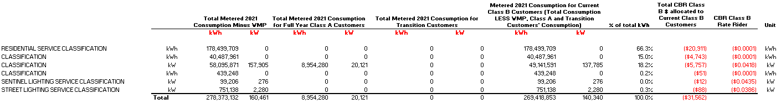

Group 2 Deferral and Variance Account Balances

In a letter dated December 10, 2021 (EB-2022-0043), IPC submitted a request to defer its cost-of-service application until January 1, 2024, while continuing on the Price Cap IR stream. In a letter dated February 10, 2022 (EB-2022-0043), the OEB approved the request to defer its 2023 cost of service application. Additionally, the OEB has requested InnPower seek disposition of a Group 2 account in the amount of ($67,453) in its 2023 rate application, which is normally disposed of during a rebasing application (see Appendix C).

Background
In the Decision and Order for IPC’s last cost-of-service proceeding (EB-2016-0085), the OEB stated it would undertake an audit of the affiliate transactions to ensure the allocation of costs and approach to costing and applicable revenue complies with the Affiliate Relationship Code (ARC). Additionally, two new variance accounts were created to account for the difference between the approved forecasted affiliate revenues/costs and actual revenues/fully allocated costs (as determined by the audit) (see Appendix D: Section 3.7 of EB-2016-0085).

In a letter dated April 9, 2019, the OEB finalized the audit and requested that InnPower record $162,871 in the variance account for affiliate revenues and $95,418 in the variance account for affiliate expenses, as of December 31, 2018. The net impact is a credit of $67,453 in additional revenue offsets, which IPC is requesting for disposition in the current application (see Appendix E). Additionally, IPC has incurred ($9,392.29) in interest for affiliate revenue and $5,656.32 in interest for affiliate expenses from January 1, 2018 to December 31, 2021. The projected interest from January 1, 2022 to December 31, 2022 is ($2,438.99) for affiliate revenue and $1,428.88 for affiliate expenses. The total net amount of interest is ($4,746.08), which IPC is also requesting for disposition in the current application.

LRAM Variance Account (LRAMVA)

IPC has no LRAMVA claims in this application.

Tax Changes

IPC has completed Tab 8.STS – Tax Change that has identified a Shared Tax amount of $0. The resulting amount did not produce a Rate Rider in all of IPC’s rate classes.
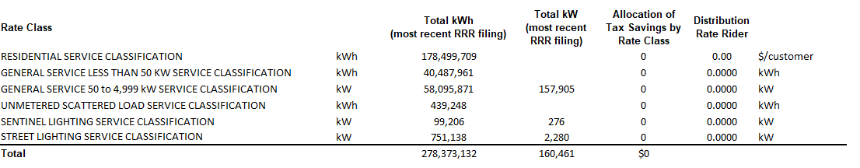

Z Factor Changes

IPC has no Z-Factor claims in this application.

3.0 Rate Change Summary and Bill Impacts

The following table presents a summary of the proposed rates and the associated bill impacts by Rate Class.
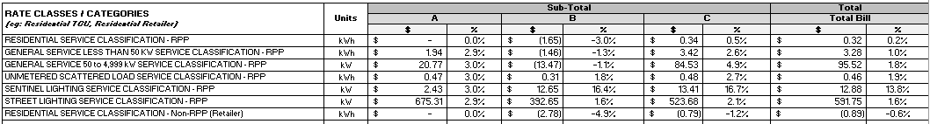
The calculated total bill impacts for this EB-2022-0043 IRM application reflect one rate class, sentinel lighting with an increase greater than 10% of the overall bill. The remaining total bill impacts show adjustments between -0.6% and 1.9%.

To mitigate the rate impact for sentinel light customers, IPC proposes a 24-month recovery period instead of a 12-month recovery period, specific to the sentinel light rate class.

The following bill impacts by rate class are presented.

Residential Rate Class

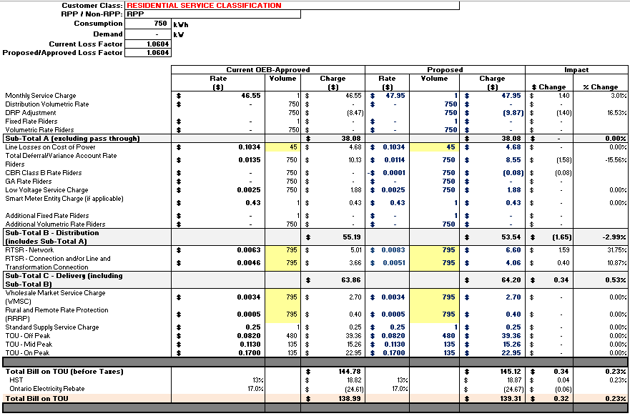

General Service Less than 50KW

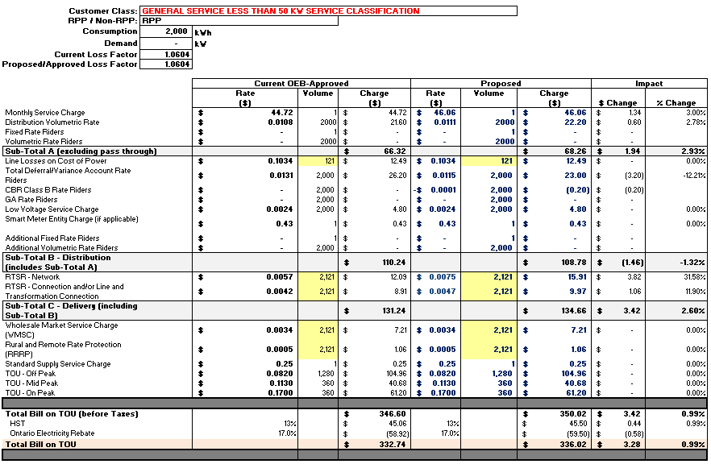

General Service 50 to 4,999 KW 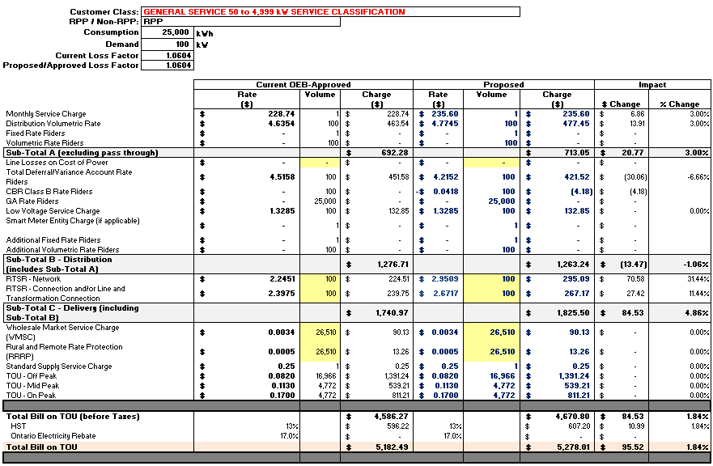

Unmetered Scattered Load
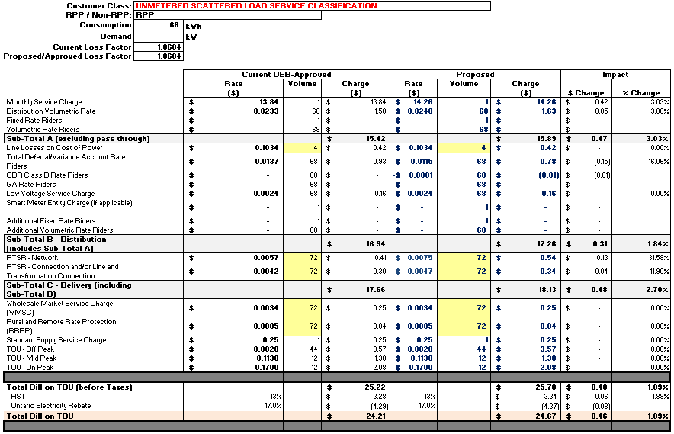

Sentinel Lighting
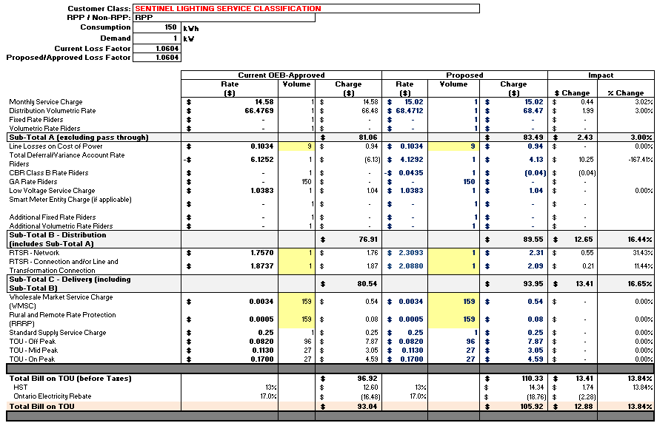

Street Lighting 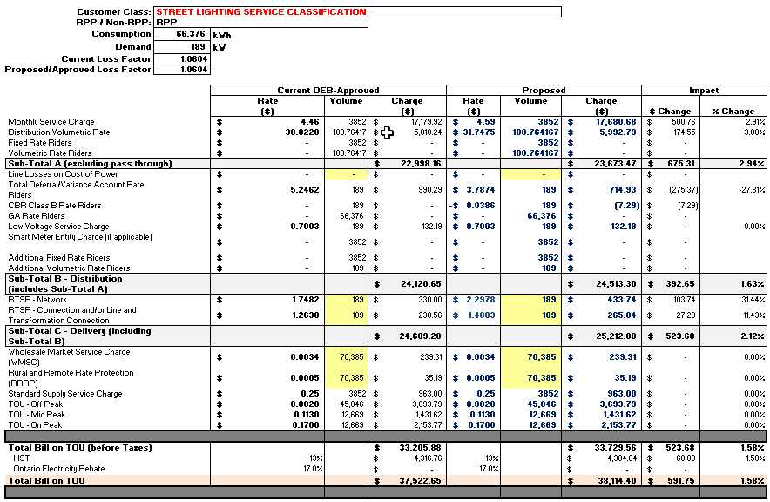

Residential Rate Class – Non-RPP
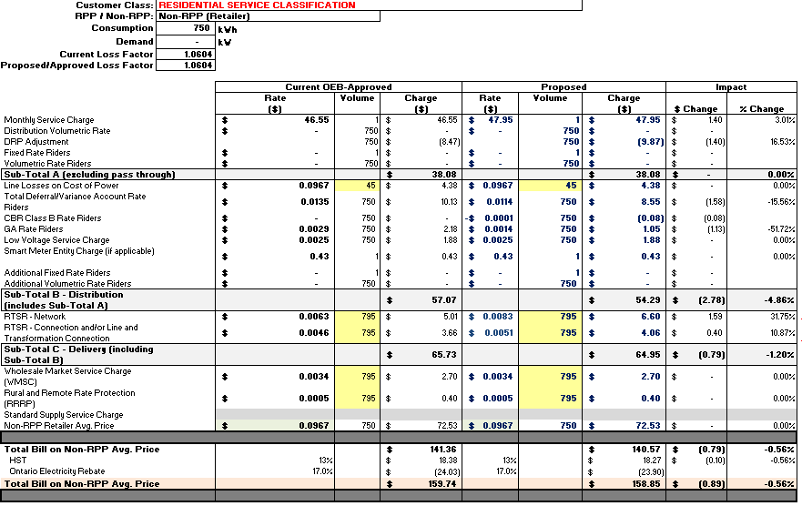

~Respectfully Submitted”

Appendices

A: OEB Letter Dated January 9, 2018, Re: InnPower Application for Rates Ontario Energy Board (OEB) File Number: EB-2016-0085

B: OEB Decision and Order, EB-2016-0085 Section 3.13 Rate Riders

C: OEB Letter Dated February 16, 2022, Re: Delay in Filing (OEB) File Number: EB-2022-0043

D: OEB Decision and Order, EB-2016-0085 Section 3.7 Revenues and Costs relating to Affiliate InnServices

E: OEB Letter Dated April 9, 2019, Re: Audit of Affiliate Transactions (OEB) File Number: EB-2016-0085

F: Current Tariff Sheet

G: IPC Certification

