Niagara Peninsula Energy Inc.

OEB Staff Questions

EB-2022-0051

**Niagara Peninsula Energy Inc.**

**EB-2022-0051**

Please note, Niagara Peninsula Energy Inc. (Niagara Peninsula Energy) is responsible for ensuring that all documents it files with the OEB, including responses to OEB staff questions and any other supporting documentation, do not include personal information (as that phrase is defined in the *Freedom of Information and Protection of Privacy Act*), unless filed in accordance with rule 9A of the OEB’s *Rules of Practice and Procedure*.

**Staff Question-1**

**Ref: IRM Rate Generator Model, Tab 8: STS - Tax Change**

OEB staff notes that a portion of the as-filed Sheet “8. STS – Tax Change” is not complete. The sheet is reproduced below:

Tax sharing form populated. Data extracted from revenue requirement work form filed in Niagara Peninsula Energy’s 2021 cost-of-service rate application (EB-2020-0040).

Question:

1. Please confirm that the IRM Rate Generator Model has been updated by OEB staff correctly.

**Staff Question - 2**

**Ref: IRM Rate Generator Model, Tabs 11-14**

OEB staff has updated the IRM Rate Generator Model in the following areas:

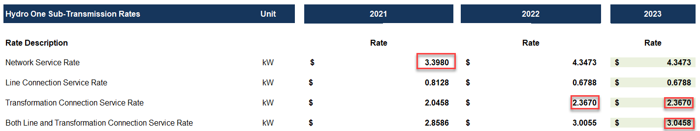

Tab 11: RTSR – UTRs & Sub-Tx, cells E35, I39, L39 and L41

The HONI Sub-transmission charges have been updated, as per EB-2020-0030 and EB-2021-0032 shown below:



Tab 13: RTSR – Current Wholesale

Tab 14: RTSR – Forecast Wholesale

The Transformation Connection Rate columns have been updated in Tabs 13 & 14.

Question:

1. Please confirm that the IRM Rate Generator Model has been updated by OEB staff correctly. (Please note there will be further updates before the final issuance of the Decision)

**Staff Question – 3**

**Ref: Lost Revenue Adjustment Mechanism Variance Account (LRAMVA)**

Please confirm that Niagara Peninsula Energy will not be seeking to dispose of any balance in the LRAMVA due to LRAM-eligible CDM activities funded by the IESO through the Conservation First Framework or Interim Framework in a future year’s application.

* 1. If not confirmed, please explain why a request for disposition was not submitted as part of this application.
  2. If confirmed, please also confirm that Niagara Peninsula Energy has verified that, relative to the LRAMVA threshold (if any) established in Niagara Peninsula Energy’s most recent rebasing application, the balance in the LRAMVA, and any prospective LRAM-eligible amounts until the next rebasing, are either zero or a debit (i.e., not a credit that would need to be refunded to customers).