Kitchener-Wilmot Hydro Inc. (KWHI)
2023 IRM Application
EB-2021-0045
Staff Questions

Staff-1
Ref: Rate Generator Model, Tab 4. Billing Det. For Def-Var, Cell J4
Preamble:

KHWI has not confirmed the accuracy of the data in cell J4:
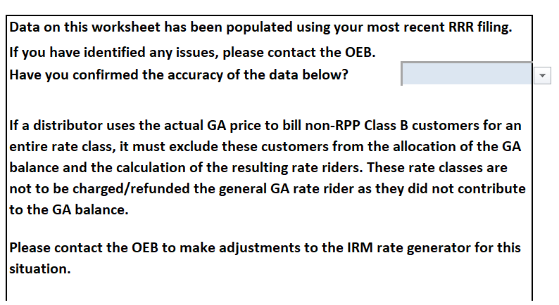
Question:
- Please update cell J4 in tab 4 to confirm the accuracy of the data.

Staff-2
Ref: Rate Generator Model, Tab 11. RTSR – UTRs & Sub-Tx, Cells G35 and J39

Preamble:
Staff noted that it appears that KWHI has utilized an older version of the Rate Generator Model, not the most up-to-date version (which is July 31, 2022). As a result, the Hydro One Sub-Transmission Rates – Network Service Rate for 2021 in cell G35 and Transformation Connection Service Rate in cell J39 were not updated.
Staff has updated the Network Service Rate from $3.3980 to $3.4778/kW and the Transformation Connection Service Rate from 2.3670 to $2.3267/kW.
Question:
- Please confirm that the model included in these staff questions reflects these updates.
Staff-3
Ref: Rate Generator Model, Tab 17. Regulatory Charges, Cell D33
Preamble:
On September 8, 2022, the Ontario Energy Board issued its Decision and Order in the above-noted proceeding which approved the smart metering charge (SMC) to be levied and collected by the Independent Electricity System Operator, in its capacity as the Smart Metering Entity, effective January 1, 2023. The new SMC is $0.42 per smart meter per month, a reduction from the previous interim SMC of $0.43 per smart meter per month.
Staff has updated the data in cell D33 to reflect the approved SMC of $0.42 shown below:
Question:
- Please confirm that the model included in these staff questions reflects this update.
Staff-4
Ref: Rate Generator Model, Tab 20, Table 2
Preamble:
Staff noted that the bill impacts in Table 2 were not populated and has updated the data in Table 2 with the bill impacts.
Question:
- Please confirm that the model included in these staff questions reflects this update.

Staff-5
Ref: (1) Rate Generator Model, Tab 3. Continuity Schedule
(2) Decision and Rate Order (EB-2018-0048), p.4 and p.9
Preamble:
According to the OEB’s Decision and Order (EB-2018-0048) in Ref (2), the OEB approved the disposition of ($2,210,291) as of December 31, 2017, including interest projected to December 31, 2018 for Group 1 accounts. The OEB also directed KWHI to record the OEB-approved tax sharing amount of $30,735 into Account 1595, sub-account 2019 – Principal by March 31, 2019 (Q1) for disposition at a later date. The total expected to be transferred to Account 1595 (2019) is ($2,179,556).
In the Rate Generator Model, tab 3 in Ref (1), the sum of the OEB-approved disposition for Account 1595 (2019) in cell AK34 and the OEB-approved interest for Account 1595 (2019) in cell AP34 is equal to $2,210,291 (which is expected to represent a credit amount in Account 1595 (2019) of ($2,210,291)).
Staff noted that the OEB-approved tax sharing amount of $30,735 is not included as part of the total disposition for Account 1595 (2019).
Question:
- Please confirm staff’s observation above and revise the evidence as needed.
Staff-6
Ref: Manager’s Summary
Preamble:
In the Manager’s Summary, KWHI stated that it is requesting disposition of its Group 1 Deferral and Variance account (DVAs) balances but has not stated whether it is requesting final or interim disposition of its Group 1 DVAs.
Question:
- Please clarify whether KWHI is seeking final or interim disposition of its Group 1 DVAs in the current proceeding. Please provide the reasons if KWHI is requesting the interim disposition of its Group 1 DVAs.

Staff-7
Ref: (1) Manager’s Summary, p.10
(2) GA Analysis Workform, Tab Principal Adjustments, Cells J54 and V54
(3) Rate Generator Model, Tab 3. Continuity Schedule, Cell BF29
Preamble:
In Ref (1), KWHI stated that Account 1589 includes the accrual for the GA true up for 2022 which is a debit of $38,192 and Account 1588 includes the accrual for the GA true up for 2022 which is a credit of ($38,192). However, in Ref (2), Account 1589 in cell J54 shows a credit principal adjustment of ($38,192) and Account 1588 in cell V54 shows a debit principal adjustment of $38,192. These two principal adjustments are also incorporated into the amounts shown in Ref (3).
Questions:
- Please confirm that KWHI is proposing to include an accrual for the GA true up of credit principal adjustment of ($38,192) for Account 1589 in 2022 (as opposed to a debit of $38,192) and a debit principal adjustment of $38,192 for Account 1588 in 2022 (as opposed to a credit of ($38,192)).
- If this is not the case, please explain why in Ref (2) KWHI has also shown equal and offsetting CT 148 true-ups of a credit to Account 1589 ($38,192) and a debit of $38,192 to Account 1588.
Staff-8
Ref: (1) Manager’s Summary, p.13
(2) GA Analysis Workform, tab GA 2021, Note 4

Preamble:
In Ref (1), KWHI stated that it does not calculate a volume variance using the table provided in the GA Analysis Workform in Ref (2) as it allocates actual GA dollars to the non-RPP customers based on a calculation of the Class B GA dollars less trued–up RPP kWh at actual rates. There are no amounts in account 1589 that have been allocated to the RPP customer.
For Account 1589, the GA costs (charge type 148) billed by the IESO are based on wholesale consumption. The portion of GA costs relating to non-RPP wholesale consumption is recorded in Account 1589. GA revenues based on retail consumption is also recorded in Account 1589. The difference between wholesale and retail consumption, represents the volume variance.

Question:
- Please further explain why a volume variance does not apply to KWHI in the context of the above. Please revise the evidence as needed.

Staff-9
Ref: (1) GA Analysis Workform, Tab Account 1588, Note 7
(2) Rate Generator Model, Tab 3. Continuity Schedule

Preamble:

Cell C20 in the GA Analysis Workform, Tab Account 1588, Note 7 shows the Transactions debit of $96,381:
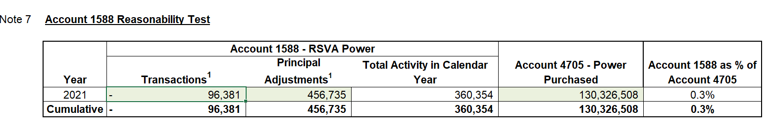

Cell BD 28 in tab 3 of the Rate Generator Model shows the transaction credit of 137,308:
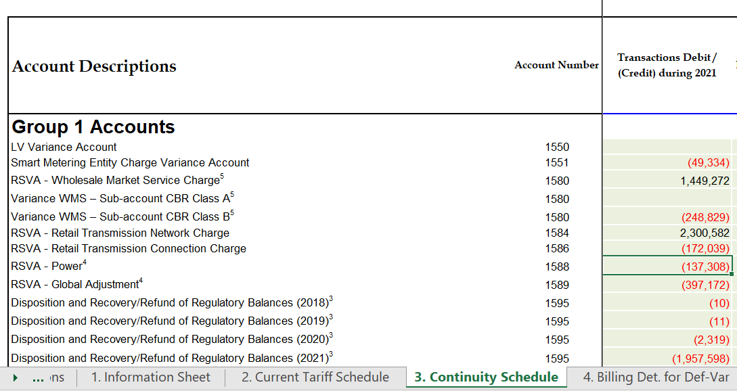
Staff noted that cell C20 in the GA Analysis Workform, tab Account 1588, Note 7 does not reconcile with cell BD 28 in the Rate Generator Model, tab 3.
Question:
- Please reconcile the difference between the two and revise the evidence as needed.

