EB-2022-0043
INNPOWER CORPORATION
Application for electricity distribution rates beginning
January 1, 2023
VECC Interrogatories September 29, 2022

VECC-1
Ref: Manager’s Summary p. 16-17
Please confirm that Innpower used the rates established by the OEB by month to calculate the Group 2 Account interest.
Yes, this is correct.
VECC-2
Ref: Manager’s Summary p. 8
Please provide the Rate Riders for Disposition of the Group 2 Account for rates effective January 1, 2023.
Please refer to the IPC_IRR_VECC_20221013.xml file. The “VECC 2a” and “VECC 2b” tabs show the rate rider calculations for the Group 2 accounts, including the following table:
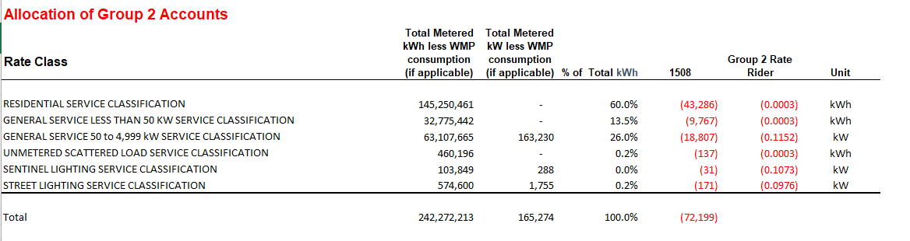

Additionally, Tab 18 of the OEB Rate Generator Model have been updated to reflect the Group 2 rate rider. Please refer to the file 2023-IRM-Rate-Generator-Model_20221013.

