BY EMAIL

September 28, 2022

Nancy Marconi Registrar
Ontario Energy Board
2300 Yonge Street, 27th Floor Toronto ON M4P 1E4

Dear Ms. Marconi:

Re: EB-2022-0043 Application for 2023 Rates

In accordance with Procedural Order #1, please find attached the Ontario Energy Board (OEB) staff interrogatories in the above proceeding. The applicant and intervenors have been copied on this filing.

InnPower Corporation’s responses to interrogatories are due by October 13, 2022.

Any questions relating to this letter should be directed to Kelli Benincasa at Kelli.Benincasa@oeb.ca or at 416-440-7624. The Board’s toll-free number is 1-888- 632-6273.

Yours truly,

Original Signed By

Kelli Benincasa
Incentive Rate Setting & Regulatory Accounting Encl.

2300 Yonge Street, 27th floor, P.O. Box 2319, Toronto, ON, M4P 1E4 2300, rue Yonge, 27e étage, C.P. 2319, Toronto (Ontario) M4P 1E4

T 416-481-1967 1-888-632-6273
F 416-440-7656 OEB.ca

OEB Staff Interrogatories InnPower Corporation EB-2022-0043

Please note, InnPower Corporation (InnPower) is responsible for ensuring that all documents it files with the OEB, including responses to OEB staff interrogatories and any other supporting documentation, do not include personal information (as that phrase is defined in the Freedom of Information and Protection of Privacy Act), unless filed in accordance with rule 9A of the OEB’s Rules of Practice and Procedure.

OEB Staff – 1

Group 1 DVA accounts
Ref. 1: Manager’s Summary, page 13
Ref 2: IRM Rate Generator, Tab.3 Continuity Schedule
In Reference 1, InnPower Corporation indicated the total balance of group 1 accounts is
$3,256,736 excluding Global adjustment. This amount does not match the balance of
$3,149,425 for the total group 1 balance excluding Global Adjustment in the continuity schedule of the IRM rate generator.

Question:

- Please confirm the balance of the group 1 accounts sought for disposition in the current application including and excluding the global adjustment balance.

The Group 1 account principal balances (in the report) included interest balances, which totaled $3,256,736.

Please see the updated table below. InnPower is seeking disposition of $3,149,425 for Group 1 accounts, excluding Global adjustment (as indicated in the continuity schedule).
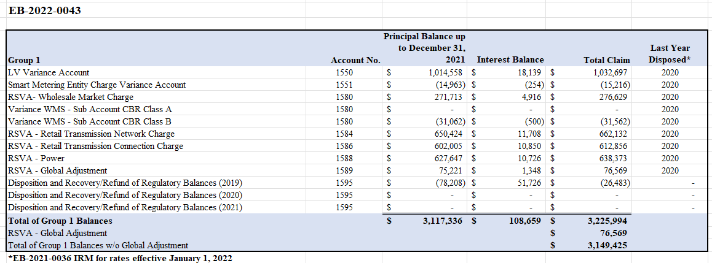
Please note, this does not impact the final rates, as the amount of $3,256,736 was only reflected in a reference table in the pdf report.

OEB Staff – 2 Account 1588
Ref. 1: InnPower_2023_GA_Analysis_Workform_1.0_20220527.xlsb, Tab Account 1588
Ref. 2: EB-2021-0036, InnPower’s Response to Staff question2
In reference 1, the total activity for account 1588 in the calendar year 2021 is about 2.0% when compared to the cost of power purchased. In response to Staff questions in EB-2021-0036 and as indicated in the account 1588 tab of the 2023 GA Analysis Workform, InnPower Corporation indicated there were several factors inaccurately reported for the years 2012 to 2016 in EB-2016-0085, including the supply facilities loss factor and wholesale consumption. InnPower Corporation concluded that as a result of the inaccuracies reported, the loss factor of 1.0604 for the period 2017-2021 was understated resulting in an accumulation of costs not recovered in account 1588.

Question:

- Please further explain the large activity in Account 1588 in 2021.

As stated above and calculated in b) and c) below, InnPower has not recovered the costs of electricity losses within the distribution system due to an inaccurate loss factor submitted in the 2017 Cost of Service application. As a result, the costs have not been recovered through billed revenue and have accumulated in account 1588.

- Please provide a correct calculation for the approved loss factor (i.e. reproduce Appendix 2-R in InnPower’s last rebasing application) and compare it to the original Appendix 2-R as approved in InnPower’s last rebasing application for the incorrect inputs used.

Please refer to the IPC_IRR_OEB_20221013.xml file. The original Appendix 2-R filed is located in the “OEB Staff 2a” tab and the amended Appendix 2-R is located in the “OEB Staff 2b” tab.
The original Appendix 2-R filed exhibits a loss factor of 1.0604 compared to the amended file loss factor of 1.0710. As previously stated, the wholesale and retail consumption, as well as the supply facilities loss factor has been updated to reflect actuals.

- Please provide quantify the impact of the incorrect approved loss factor on Account 1588.

Please refer to the “OEB Staff 2c” tab, for the impact of the incorrect approved loss factor. In 2021, InnPower did not recover costs for approximately 8.7 million kWh of electricity.

OEB Staff – 3

Accounts 1584 - RSVA-Retail Transmission Network Charge, and Account 1586- RSVA Retail Transmission Connection Charge
Ref. 1: InnPower_2023-IRM-Rate-Generator-Model_20220721_20220803.xlsb Ref. 2: dec_rate order_2022-IRM-Rate-Generator-Model_20211209.xlsb
In Reference 2, the transactions registered in 2020 for these two accounts were
$341,505 and $319,070 respectively. In Reference 1, the transactions recorded in 2021 increased to $650,424 and $602,005.

Question:

- Please explain the drivers behind this significant increase in the transactions recorded in these two accounts.

The drivers behind the significant increase in the transactions recorded include:
- A significant increase in units billed by Hydro One from 2020 to 2021.
  - InnPower is billed by Hydro One on peaks per transmission station versus actual system peaks. For instance, if there are two transmission stations, one that peaks at 30MW and another at 10MW a month (on average), InnPower would be billed 30MW and 10MW for the month. If at any point during the month load is switched between the transmission stations, the monthly billed amount from Hydro One will increase by the shifted load (i.e., if 30MW is shifted from one transmission station to the other, the billed amount will be 30MW average and 40MW (10MW average + 30MW shifted)). Please note, the increase in the billed amount from Hydro One will occur if load is only shifted on one hour, one day in the month.

OEB Staff – 4

Accounts 1588 and 1589
Ref. 1: InnPower_2022_GA_Analysis_Workform_1.0_20210722_20211105.xlsb
Ref. 2: InnPower_2023-IRM-Rate-Generator-Model_20220721_20220803.xlsb
Ref. 3: EB-2022-0043, page 14

As per the principal adjustment tab of InnPower’s 2022 GA Analysis Workform shown in the tables below, the principal adjustments were included in the 2020 account 1589 and 1588 balances for disposition as they were recorded in the GL in 2021 instead of 2020.
The 2021 transactions in the 2023 DVA continuity schedule should agree with the 2021 transactions recorded in InnPower’s GL, which would include the noted principal adjustments. Therefore, it appears that the adjustments would be double counted for disposition purposes if they are not reversed in the 2021 account 1589 and 1588 balances.
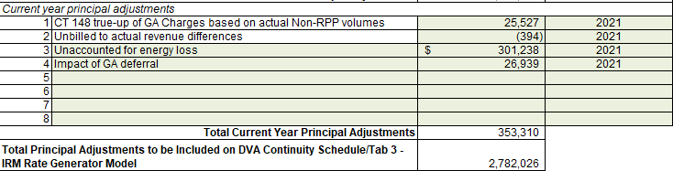
Account 1589 – RSVA Global Adjustment

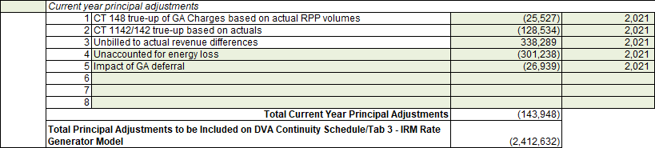
Account 1588 – RSVA Power
In reference 3, InnPower Corporation stated:

Please note, the prior year’s principal adjustments have not been included in the current year’s principal adjustment column (i.e. rate generator model), as they have been accounted for in the disposition amounts recorded during 2022.
Including them as a reversal in the current year’s balance would duplicate the amounts.

Question:

a) Please explain InnPower’s statement in consideration of the above and adjust the evidence if required.

Please refer to “OEB Staff 4” tab.

In the OEB Rate Generator Model, Tab 3. Continuity Schedule, Note 4. it states, “The amount in the “Transactions” column in this DVA Continuity Schedule are equal to the transactions in the General Ledger (excluding any amounts approved for disposition, which is shown separately in the “OEB Approved Disposition” columns)”.

As shown in the “OEB Staff 4” tab, InnPower has referenced the amount of the transactions recorded in General Ledger in 2021, less the disposition (which is shown in the “OEB Approved Disposition” column).

Within the transactions recorded in General Ledger are amounts that true-up balances from 2020.

An example is provided below:

Unbilled to Actual Revenue Differences:
- December 2020 consumption is recorded as revenue in January 2021.
- If revenue for December 2020 is $1,000,000, the full $1,000,000 is posted in January 2021.
- If the unbilled revenue estimate posted in December 2020 is $800,0000, there is a difference of $200,000.
- InnPower would then include $200,000 as a principal adjustment in the 2020 rate generator model to account for the difference. As a result, the revenue is adjusted from $800,000 to $1,000,000.
- InnPower completes the 1588 reconciliation for January, using the $1,000,000 and the unbilled revenue for February 2021 (January consumption). The difference in revenue and expenses now becomes part of the transactions recorded in the General Ledger.
- If InnPower was to include a reversal of the prior year principal adjustments, this would reduce the $1,000,000 back to $800,000, therefore, revenue would be understated by $200,000.

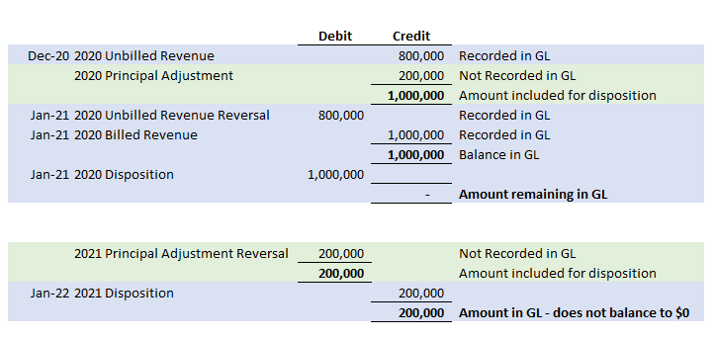

Based on the methodology above, it is of InnPower’s view that the principal adjustments should not be reversed in the following year. If required, the OEB should clarify that the prior year adjustments should be removed from the “Transactions” column and instead included in the “Principal Adjustment” column. In this case, the transactions amount will not match what was posted to the General Ledger for the corresponding year.

OEB Staff – 5

Ref: IRM Rate Generator Tab 17, 19 and 20 Smart Meter Entity (SME) Charge

OEB staff has updated the SME charge from $0.43 to $0.42.

Question:

- Please confirm this is correct.

Yes, this is correct.

OEB Staff – 6

Ref. 1: IRM Rate Generator Tab 18
Ref. 2: Managers Summary Pages 16 – 17

In the approval for InnPower to defer its Cost of Service (CoS), the OEB requested InnPower seek disposition of a Group 2 account in the amount of ($67,453) in its 2023 rate application, which is normally disposed of during a CoS application. In the Decision and Order for InnPower’s last CoS proceeding (EB-2016-0085), two new variance accounts were created Account 1508 – Other Regulatory Assets, Sub-account differences in Revenue from Affiliate Services Account 1508 – Other Regulatory Assets, Sub-account differences in Expenses from Affiliate Services.

Question:

- Please provide an Excel spreadsheet of the rate rider calculations for the Group two accounts.

Please refer to the “OEB Staff 6a” and “OEB Staff 6b” tabs. The following table shows the rate rider calculations for the Group 2 accounts.

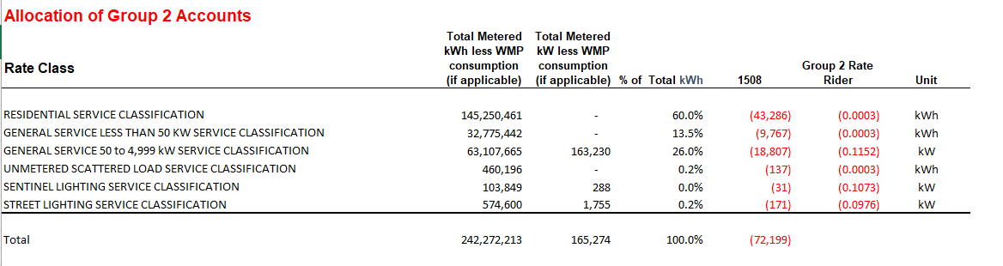

- Please update Tab 18 for the rate riders calculated.

Please refer to the 2023-IRM-Rate-Generator-Model_20221013 file for the updated rate generator model.

OEB Staff – 7

Ref. 1: Managers Summary Page 18
Ref. 2: IRM Rate Generator Tab 6.1 GA, Tab 7, Tab 19 and Tab 20

InnPower has requested a 24-month recovery for the Sentinel Rate class to mitigate rate impacts over 10%.

Question:

- Please confirm OEB staff has updated Tabs 6.1 GA, Tab 7, Tab 19 and Tab 20 for the Sentinel rate class correctly.

Yes, OEB staff has updated Tabs 6.1 GA, Tab 7, Tab 19 and Tab 20 correctly.

OEB Staff – 8

Ref. 1: Managers Summary Page 17

The 2021 CDM Guidelines (section 8) require distributors filing an application for 2023 rates to seek disposition of all outstanding LRAMVA balances related to previously established thresholds, including approval of LRAM-eligible amounts in future years (arising from persisting savings) until a distributor’s next rebasing application, unless a distributor does not have complete information on eligible savings.

Questions:

- Please confirm that the Niagara-on-the-Lake Hydro will not be seeking to dispose of any balance in the LRAMVA due to LRAM-eligible CDM activities funded by the IESO through the Conservation First Framework or Interim Framework in a
future year’s application.

  - If not confirmed, please explain why a request for disposition was not submitted as part of this application.

It is assumed this question is addressed to InnPower Corporation.

InnPower will not be seeking disposition of any balances in the LRAMVA in order to mitigate bill impacts for customers.

  - If confirmed, please also confirm that InnPower has verified that, relative to the LRAMVA threshold (if any) established in InnPower most recent rebasing application, the balance in the LRAMVA, and any prospective LRAM-eligible amounts until the next rebasing, are either zero or a debit (i.e., not a credit that would need to be refunded to customers).

