**Hydro Hawkesbury Inc.**

**Response to OEB Staff Questions**

**EB-2022-0039**

Please note, Hydro Hawkesbury Inc. (Hydro Hawkesbury) is responsible for ensuring that all documents it files with the OEB, including responses to OEB staff interrogatories and any other supporting documentation, do not include personal information (as that phrase is defined in the *Freedom of Information and Protection of Privacy Act*), unless filed in accordance with rule 9A of the OEB’s *Rules of Practice and Procedure*.

**OEB Staff – 1**

**Ref. 1: Managers Summary Page 14**

Reference 1 states that:

Hydro Hawkesbury is not seeking to dispose of any further balances in accounts 1588 and 19 1589 as part of this application process. Having said that, Hydro Hawkesbury and its external accounting firm continue to examine the balances in accounts 1588 and 1589. In the event that Hydro Hawkesbury is able to provide updated evidence with respect to 1588 and 1589 within the context of this rate application it will do so as soon as such evidence is available

1. Please confirm whether Hydro Hawkesbury will be able to provide updated evidence with respect to accounts 1588 and 1589 in this application.
2. If Hydro Hawkesbury is able to provide updated evidence and would like to seek the disposition of accounts 1588 and 1589, please provide the evidence as soon as possible.
3. If Hydro Hawkesbury is not able to provide the updated evidence, please confirm that HHI is not requesting the disposition of accounts 1588 and 1589.

**Response: HHI cannot at this time provide the necessary evidence to support disposal of the balances. Therefore, HHI is not requesting the disposition of accounts 1588 and 1589**

**OEB Staff – 2**

**Ref. 1: Managers Summary Page 20**

The 2021 CDM Guidelines (section 8) require distributors filing an application for 2023 rates to seek disposition of all outstanding LRAMVA balances related to previously established thresholds, including approval of LRAM-eligible amounts in future years (arising from persisting savings) until a distributor’s next rebasing application, unless a distributor does not have complete information on eligible savings.

**Questions:**

Please confirm that Hydro Hawkesbury will not be seeking to dispose of any balance in the LRAMVA due to LRAM-eligible CDM activities funded by the IESO through the Conservation First Framework or Interim Framework in a future year’s application.

1. If not confirmed, please explain why a request for disposition was not submitted as part of this application.
2. If confirmed, please also confirm that Hydro Hawkesbury has verified that, relative to the LRAMVA threshold (if any) established in Hydro Hawkesbury most recent rebasing application, the balance in the LRAMVA, and any prospective LRAM-eligible amounts until the next rebasing, are either zero or a debit (i.e., not a credit that would need to be refunded to customers).

**Response: HHI will not be seeking disposition of LRAMVA balances. The utility proposes to write off the residual balances of account 1568 in the amount of $4377 as reported in its 2021 RRR and which were related to an earlier entry that cannot be supported at this time.**

**OEB Staff – 3**

**Ref: IRM Rate Generator Tab 17, 19 and 20 Smart Meter Entity (SME) Charge**

OEB staff has updated the SME charge from $0.43 to $0.42.

**Question:**

1. Please confirm this is correct.

**Response : Confirmed**

**OEB Staff – 4**

**Ref: IRM Rate Generator Tab 20 and Managers Summary Page 22 Table 7**

**Question:**

1. Please confirm the bill impacts calculated on Tab 20 in the IRM Rate Generator model are correct and not the ones on Page 22 of the Managers Summary.

***Tab 20 Bill Impacts***



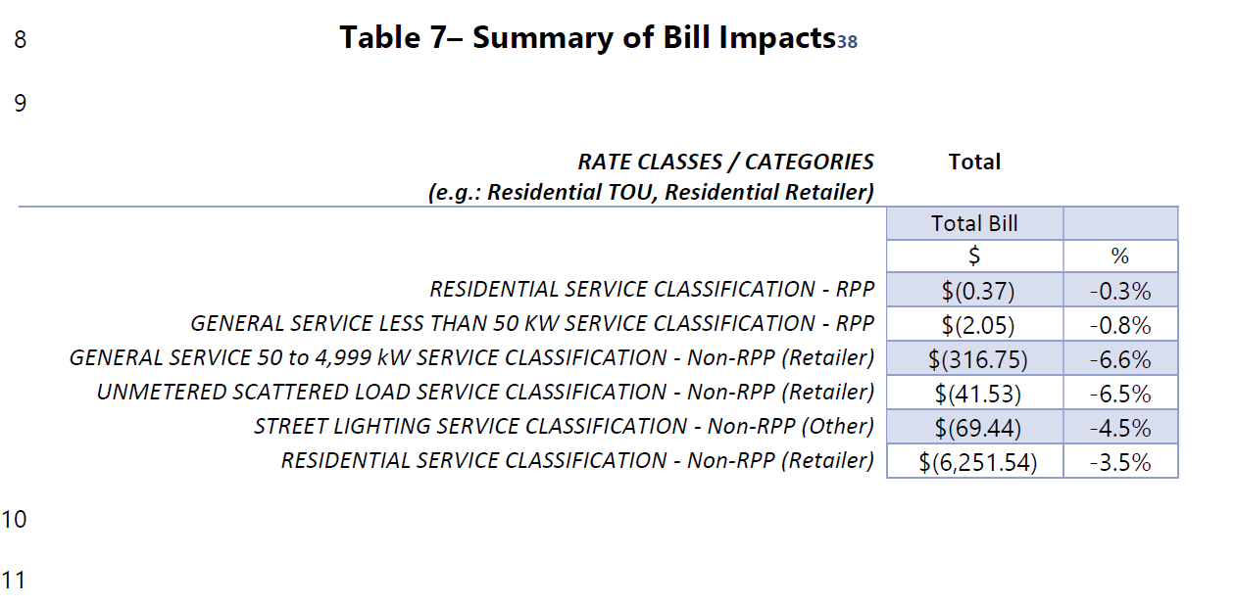

**Response ; the bill impacts at table 20 should have matched the impacts at table 7.**

**OEB Staff – 5**

**Ref: Managers Summary Page 20**

In Hydro Hawkesbury manager summary, it states:

Hydro Hawkesbury Inc. confirms that it disposed of its LRAM balances up to [Date] in its [Date] IRM application using the IESO’s final release of its verified results. Hydro Hawkesbury Inc. also confirms that it is not seeking any disposal of loss revenues related to conservation savings.

**Question:**

1. Please provide the date of when LRAM balances were last disposed up until.
2. Please provide the year of the IRM application of when LRAM balances were last disposed.

**Response ; HHI last disposed of its LRAMVA balances in its 2021 IRM application (EB-2020-0029). The disposition resulted in a marginal credit of $749 to the customer. This for the period up to December 2018 which was in line with the IESO verified reports. HHI never sought to recover any further balance beyond December 2018 and hasn’t since.**

**OEB Staff – 6**

**Ref: Managers Summary Page 17 and IRM Rate Generator Tab 3**

In Hydro Hawkesbury’s manager summary, it states that “Hydro Hawkesbury Inc. is not proposing to dispose of any 1595 balances as part of this application.”

1. Please confirm Hydro Hawkesbury wishes to dispose of balances in account 1595 (2018) and 1595 (2019), as indicated on Tab 3 of Rate Generator model.

**Response ; HHI confirms that the statement as quoted above is incorrect and that the utility is seeking to dispose of its residual balances as indicated in Tab 3 of the model and at Table 5 of the Manager Summary.**