InnPower Corporation
ED-2002-0520

InnPower Reply to OEB Staff Submission

Board File EB-2022-0043
For Rates Effective January 1, 2023

Group 1 Deferral and Variance Accounts

OEB Staff Submission
Account 1589 and Account 1588 Principal Adjustments
OEB staff has prepared the following reconciliation for the closing balances as of Dec 31, 2020, of Accounts 1588 and 1589 between the DVA continuity schedule filed in this application and the DVA continuity schedule filed in InnPower’s 2022 IRM application.
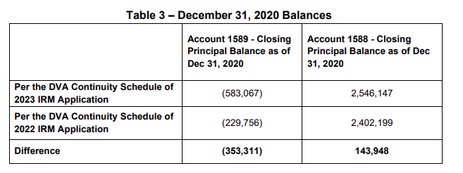
OEB staff notes that the above differences to the December 31, 2020, balances between the two DVA continuity Schedules appear to represent the reversal of the 2020 principal adjustments that were included in the 2020 final disposed amounts for Accounts 1588 and 1589. Rather than including the reversal of these principal adjustments and presenting them as part of the Principal Adjustments cells in the current DVA continuity schedule for Accounts 1588 and 1589, InnPower appears to have included them by changing the 2020 year-end closing balances (i.e., 2021 opening balances) for these two accounts. OEB staff notes that this practice is not in accordance with the general accounting practice because any adjustments or the reversal of the adjustments should be reflected as a principal adjustment rather than changing the closing/opening balance of an account. The closing/opening balance should not be revised so that the year-over year continuity of the balances is transparent.
In response to interrogatories, InnPower stated that the OEB should clarify that the prior year adjustments should be removed from the “Transactions” column and instead included in the “Principal Adjustment” column. OEB staff is of the view that the reversal of prior year principal adjustments was not included in InnPower’s “Transactions” column, nor included in the “Principal Adjustment” column for Accounts 1588 and 1589. As stated above, OEB staff is of the view that the reversal of prior year principal adjustments was included in the opening 2021 balances. OEB staff invites InnPower to confirm this observation in its reply submission. Nevertheless, where the principal adjustments are included in the current year’s DVA continuity schedule does not change the total claim amounts for Accounts 1588 and 1589. OEB staff further notes that InnPower has included the reversal of the prior-year principal adjustments in the GA reasonability test of Account 1589 on Tab “GA 2021” of the GA Analysis Workform in the current application and the results show that the 2021 Account 1589 balance after the adjustments are reasonable. In conclusion, OEB staff does not take issue with the final disposition of Accounts 1588 and 1589 balances in this application but submits that InnPower should make revisions to the DVA continuity schedule to include the reversal principal adjustments in the Principal Adjustment column instead of the opening 2021 balances. Going forward, InnPower should not change the closing balances for any DVA in the DVA continuity schedule.

InnPower Reply to OEB Staff Submission
InnPower agrees with the OEB Staff Submission regarding the prior year principal adjustments. InnPower has resubmitted the Rate Generator Model and the GA Analysis Workform to reflect the principal adjustments, as described above. As noted by OEB Staff, the 1588 and 1589 disposition amounts as of December 31, 2021, have remained the same.
Please note, OEB staff has updated the submitted rate generator model to reflect the 2023 inflation factor, as well as the RPP rates effective November 1, 2022.

Lost Revenue Adjustment Mechanism

OEB Staff Submission
OEB staff is of the view that InnPower is to confirm in its reply submission that the LRAMVA balance is either zero or a debit, not a credit that would need to be refunded to customers. If confirmed, OEB staff submits that no further entries to the LRAMVA be permitted at this time, but that the LRAMVA not be discontinued, in the event that InnPower requests the use of the LRAMVA for a CDM activity in a future application, which the OEB can consider on a case-by-case basis. OEB staff is recommending this approach for all distributors who have disposed of all outstanding LRAMVA balances as part of their 2023 rate applications.

InnPower Reply to OEB Staff Submission
InnPower confirms that the LRAMVA balance is not a credit that would be refunded to customers.

