Oakville Hydro Electricity Distribution Inc.
OEB Staff Questions
EB-2022-0055
Oakville Hydro Electricity Distribution Inc.
EB-2022-0055
Please note, Oakville Hydro Electricity Distribution Inc. is responsible for ensuring that all documents it files with the OEB, including responses to OEB staff questions and any other supporting documentation, do not include personal information (as that phrase is defined in the Freedom of Information and Protection of Privacy Act), unless filed in accordance with rule 9A of the OEB’s Rules of Practice and Procedure.
Staff Question-11
Ref:
1) LRAMVA Workform, Tab 5 – Prospective Disposition of Persisting CDM Savings
Question: To comply with OEB’s guidance on prospective disposition of LRAM-eligible amounts for future years until the next rebasing period, Oakville Hydro has applied for “approval of the 2023 to 2028 LRAM-eligible amounts” and has correctly kept this separate from the LRAMVA amounts through 2022, which are proposed for disposition. However, it appears that Oakville Hydro has not proposed disposition of the LRAM-eligible 2023 amount calculated at: (2023 LRAM-eligible amount shown in Table 1-C of LRAMVA workform) * (2023 OEB-approved inflation minus X- factor).
- Please confirm if Oakville Hydro is applying for disposition of the LRAM-eligible 2023 amount. If not, please provide the reasoning as to why Oakville Hydro is not seeking disposition of the LRAM-eligible 2023 amount.
Staff Question-12
Ref:
- Rate Generator Model
- 2023 GA Analysis Workform

Question:
GA Analysis Workform (GA 2021 tab) | Net Change in Principal Balance in the GL (i.e. Transactions in the Year) | -$5,189,526
DVA Continuity Schedule | Transactions Debit/Credit during 2021 | -$5,189,826
 | Difference | $ 300

Please reconcile the above noted difference in Transaction in cell BD29 at reference 1) Tab ‘3. DVA Continuity Schedule’ to the value at reference 2) Tab ‘GA 2021’, cell C75.

Staff Question-13
Ref:
- 2023 IRM Rate Generator Model, Tab 3
- 2022 IRM Rate Generator Model, Decision and Rate Order, Tab 3

Question:
- Please explain why the net transaction for Account 1580 RSVA – Wholesale Market Service Charge has changed significantly from a credit of ($770,624) in 2020 (cell BD23 in Reference 2) to a debit of $1,340,554 in 2021 (cell BD23 in Reference 1).
- Please explain why the net transaction for Account 1584 RSVA – Retail Transmission Network Charge has increased significantly from $111,022 in 2020 (cell BD26 in Reference 2) to $ 3,168,183 in 2021 (cell BD26 in Reference 1).

Staff Question-14
Ref:
- 2023 IRM Rate Generator Model, Tab 3
- Updated Managers Summary, Table 3
Question: Please reconcile the principal disposition for Account 1589 and 1588 in Table 3 (attached below) at reference 2 with the values in tab 3 at reference 1. Please explain the variance.
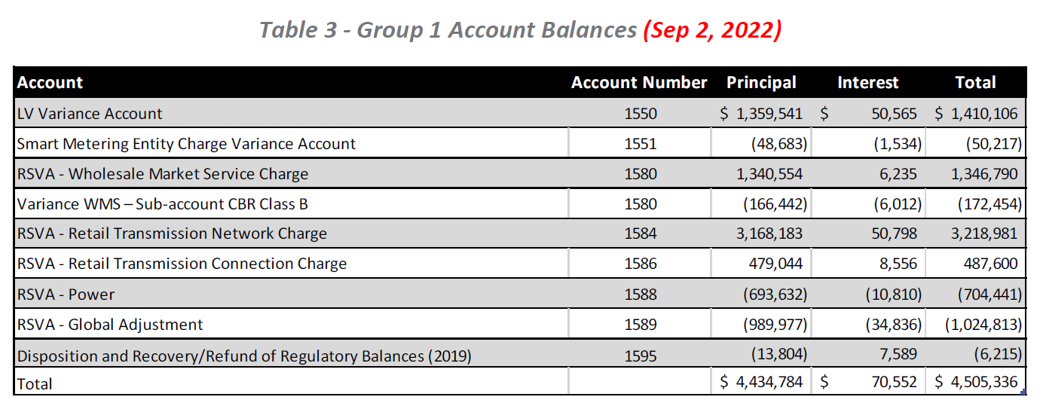
Staff Question-15
Ref:
- Staff Question 7
- Revised 2023 GA Analysis Workform
- EB-2021-0048, 2022 GA Analysis Workform

In response to Staff Question 7, for Account 1589, Oakville Hydro added a principal adjustment of ($82,023) relating to Class A GA balances in the Note 8 table Breakdown of principal adjustments included in last approved balance of the 2023 GA Analysis Workform, and then reversed it in the Note 9 table Principal adjustment reconciliation in current application under 2021. Per the 2022 GA Analysis Workform, the ($82,023) is the sum of the annual principal adjustments for 2016 to 2019.

- Please explain why these amounts need to be reversal principal adjustment in the 2021 Account 1589 balance requested for disposition.
- Please explain how each of the amounts were recorded in the general ledger, and in which year. Please also explain whether each of the amounts were reversed in the general ledger, and in which year.

Staff Question-16
Ref

- Staff Question 7
- Revised 2023 GA Analysis Workform
- EB-2021-0048, 2022 GA Analysis Workform

In response to Staff Question 7, for Account 1588, Oakville Hydro added a principal adjustment of $322,453 for “Adjustment - OEB Audit EG Adjustment” in the Note 8 table Breakdown of principal adjustments included in last approved balance of the 2023 GA Analysis Workform, and then reversed it in the Note 9 table Principal adjustment reconciliation in current application under 2021. Per the 2022 GA Analysis Workform, the $322,453 was in the reversal section of the 2019 table and was recorded in the general ledger in 2019.

- Please confirm that the $322,453 was a permanent adjusting entry, and not a timing journal entry that would be subsequently reversed.
- Please confirm that the $322,453 was recorded in the general ledger in 2019. If not confirmed, please explain when it was recorded.
- Please explain why these amounts need to be a reversal principal adjustment in the 2021 Account 1588 balance requested for disposition.

Staff Question-17
Ref:
- Staff Question 7
- Revised 2023 GA Analysis Workform

In response to Staff Question 7, for Account 1589, Oakville Hydro added in principal adjustments #5 to 7 for 2021 as shown below. These adjustments are not shown as reconciling items in the GA 2021 tab.
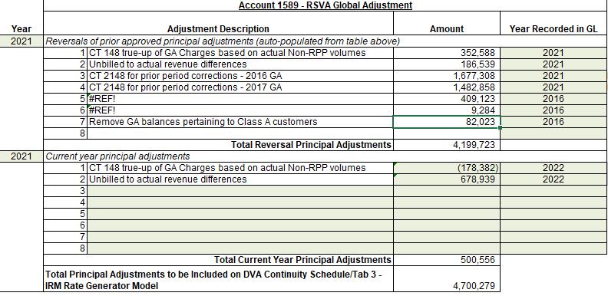

- Please explain why the principal adjustment #5 to 7 are not reconciling items in the GA 2021 tab.
- Please revise the GA 2021 tab as needed, and reassess the results unresolved difference as a % of expected GA payments to IESO.

