**Oakville Hydro Electricity Distribution Inc.**

**2023 Annual IR Application (EB-2022-0055)**

**Response to OEB Staff Interrogatories**

**Staff Question-11**

**Ref:**

1) LRAMVA Workform, Tab 5 – Prospective Disposition of Persisting CDM Savings

**Question:** To comply with OEB’s guidance on prospective disposition of LRAM-eligible amounts for future years until the next rebasing period, Oakville Hydro has applied for “approval of the 2023 to 2028 LRAM-eligible amounts” and has correctly kept this separate from the LRAMVA amounts through 2022, which are proposed for disposition. However, it appears that Oakville Hydro has not proposed disposition of the LRAM-eligible 2023 amount calculated at: (2023 LRAM-eligible amount shown in Table 1-C of LRAMVA workform) * (2023 OEB-approved inflation minus X- factor).

1. Please confirm if Oakville Hydro is applying for disposition of the LRAM-eligible 2023 amount. If not, please provide the reasoning as to why Oakville Hydro is not seeking disposition of the LRAM-eligible 2023 amount.

**Response:**

Oakville Hydro is not applying for disposition of the LRAM-eligible 2023 amount. OH has interpreted the description of Table 1-c of "LRAM-Eligible Amounts for Prospective Disposition" to mean disposal in future applications.

Oakville Hydro will be guided by the OEB in this matter.

**Staff Question-12**

**Ref:**

1. Rate Generator Model
2. 2023 GA Analysis Workform

**Question:**

|  |  |  |
| --- | --- | --- |
| GA Analysis Workform (GA 2021 tab) | Net Change in Principal Balance in the GL (i.e. Transactions in the Year) | -$5,189,526 |
| DVA Continuity Schedule | Transactions Debit/Credit during 2021 | -$5,189,826 |
|  | Difference | $ 300 |

Please reconcile the above noted difference in Transaction in cell BD29 at reference 1) Tab ‘3. DVA Continuity Schedule’ to the value at reference 2) Tab ‘GA 2021’, cell C75.

**Response:**

Oakville Hydro inadvertently populated -$5,189,526 in cell C75 in Tab “GA 2021” of the GA Analysis Workform, instead of -$5,189,826. Oakville Hydro has updated the GA Analysis Workform, filed as an attachment to this response.

**Staff Question-13**

**Ref:**

1. 2023 IRM Rate Generator Model, Tab 3
2. 2022 IRM Rate Generator Model, Decision and Rate Order, Tab 3

**Question:**

1. Please explain why the net transaction for Account 1580 RSVA – Wholesale Market Service Charge has changed significantly from a credit of ($770,624) in 2020 (cell BD23 in Reference 2) to a debit of $1,340,554 in 2021 (cell BD23 in Reference 1).

**Response:**

The net transaction for Account 1580 RSVA – Wholesale Market Service Charge has changed significantly from a credit of ($770,624) in 2020 to a debit of $1,340,554 in 2021 as the listed Wholesale Market Service Charges in the table below have increased $2.3 millions (109%) from 2020 to 2021. However, the Wholesale Market Service Rate, Oakville Hydro charges its customers, is unchanged ($0.0030/kWh) from 2020 to 2021.



1. Please explain why the net transaction for Account 1584 RSVA – Retail Transmission Network Charge has increased significantly from $111,022 in 2020 (cell BD26 in Reference 2) to $ 3,168,183 in 2021 (cell BD26 in Reference 1).

**Response:**

The net transaction for Account 1584 RSVA – Retail Transmission Network Charge has increased significantly from 2020 to 2021 due to the IESO Network Charge rate increasing by 22% compared to the Retail Transmission Rate - Network Service Rate Oakville Hydro charges its customers, which is generated based on $3.92 IESO Network Charge. Please refer to Cell E33 in tab “14. RTSR-Forecast Wholesale” of the 2021 Rate Generator (EB-2020-0045).



**Staff Question-14**

**Ref:**

1. 2023 IRM Rate Generator Model, Tab 3
2. Updated Managers Summary, Table 3

**Question:** Please reconcile the principal disposition for Account 1589 and 1588 in Table 3 (attached below) at reference 2 with the values in tab 3 at reference 1. Please explain the variance.

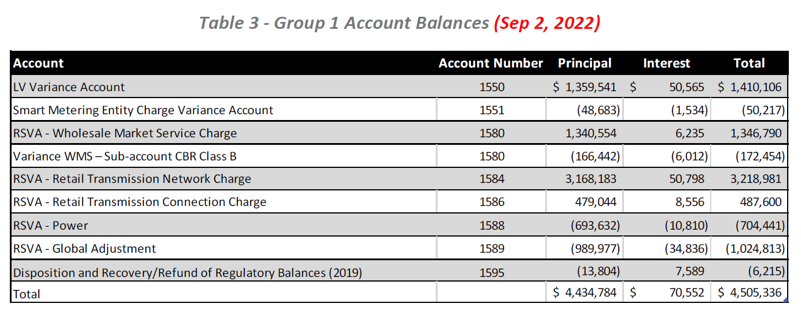

**Response:**

The difference between the principal disposition for Account 1589 and 1588 in Table 3 in the Managers Summary filed on September 2, 2022 and the total claim values in Column BT in the 2023 Rate Generator Model filed on September 28, 2022 is the difference of the 2021 principal adjustments filed on September 2, 2022 and the ones filed on September 28, 2022. Please see tables below for the reconciliations.





The tables below breakdown the principal adjustments variance.



**Staff Question-15**

**Ref:**

1. Staff Question 7
2. Revised 2023 GA Analysis Workform
3. EB-2021-0048, 2022 GA Analysis Workform

In response to Staff Question 7, for Account 1589, Oakville Hydro added a principal adjustment of ($82,023) relating to Class A GA balances in the Note 8 table *Breakdown of principal adjustments included in last approved balance* of the 2023 GA Analysis Workform, and then reversed it in the Note 9 table *Principal adjustment reconciliation in current application* under 2021. Per the 2022 GA Analysis Workform, the ($82,023) is the sum of the annual principal adjustments for 2016 to 2019.

1. Please explain why these amounts need to be reversal principal adjustment in the 2021 Account 1589 balance requested for disposition.

**Response:**

Class A customers are billed at actual GA rates, which equals the amounts charged to Oakville Hydro by the IESO. As such, there should be no balance in Account 1589 related to Class A customers.

From 2020 forward, no principal adjustments related to Class A GA were made, as per OEB guidelines.

The principal adjustments noted in the table below, totaling $82,023.89, should not have been made. These adjustments relate to differences between accrued revenue and actual billed revenue and should naturally reverse on a cumulative basis. For this reason, for the Continuity Schedule to balance with the GL, the cumulative impact of these adjustments needs to be reversed.



The table below illustrates how making the adjustment ensures the only difference between the 1589 balance to be claimed and the balance in the GL relates to annual reversing entries.



1. Please explain how each of the amounts were recorded in the general ledger, and in which year. Please also explain whether each of the amounts were reversed in the general ledger, and in which year.

**Response:**

The table below lists each of the amounts were recorded in the general ledger and in which year. The accrual amounts for unbilled revenue reverse in the general ledger.



**Staff Question-16**

**Ref**

1. Staff Question 7
2. Revised 2023 GA Analysis Workform
3. EB-2021-0048, 2022 GA Analysis Workform

In response to Staff Question 7, for Account 1588, Oakville Hydro added a principal adjustment of $322,453 for “Adjustment - OEB Audit EG Adjustment” in the Note 8 table *Breakdown of principal adjustments included in last approved balance* of the 2023 GA Analysis Workform, and then reversed it in the Note 9 table *Principal adjustment reconciliation in current application* under 2021. Per the 2022 GA Analysis Workform, the $322,453 was in the reversal section of the 2019 table and was recorded in the general ledger in 2019.

1. Please confirm that the $322,453 was a permanent adjusting entry, and not a timing journal entry that would be subsequently reversed.

**Response:**

Oakville Hydro confirm that $322,453 was a permanent adjusting entry, and not a timing journal entry that would be subsequently reversed.

Oakville Hydro undertook in the Assurance of Voluntary Compliance (EB-2019-0113), filed on April 30,2019, that within two weeks of receiving notice of the acceptance of this assurance by the OEB, Oakville Hydro would record the amount of $322,453 ( over-collected from its customers during the period of 2010 to 2015) in Account 1588.

1. Please confirm that the $322,453 was recorded in the general ledger in 2019. If not confirmed, please explain when it was recorded.

**Response:**

Oakville Hydro confirms that the credit amount of $322,453 was recorded in the general ledger in 2019.

1. Please explain why these amounts need to be a reversal principal adjustment in the 2021 Account 1588 balance requested for disposition.

**Response:**

In the Decision and Rate Order for the 2022 Rate Application, issued on December 9, 2021, Oakville Hydro was approved to dispose the credit amount of $322,453 in the Account 1588 balance in 2021. Oakville Hydro disposed the credit amount of $322,453 in the Account 1588 balance by debiting Account 1588. As the debit balance $322,453 sitting in Account 1588 is not relating to 2021 activities, the amount should be eliminated from the GA analysis Workform by recording a credit adjustment. Oakville Hydro has updated the GA Analysis Workform, filed as an attachment to this response.

**Staff Question-17**

**Ref:**

1. Staff Question 7
2. Revised 2023 GA Analysis Workform

In response to Staff Question 7, for Account 1589, Oakville Hydro added in principal adjustments #5 to 7 for 2021 as shown below. These adjustments are not shown as reconciling items in the GA 2021 tab.

1. Please explain why the principal adjustment #5 to 7 are not reconciling items in the GA 2021 tab.

**Response:**

The principal adjustment #5 to 7 are not reconciling items in the GA 2021 tab as they are not related to 2021 activities nor were recorded in 2021.

1. Please revise the GA 2021 tab as needed, and reassess the results unresolved difference as a % of expected GA payments to IESO.

**Response:**

The GA 2021 tab does not need to be revised as the principal adjustment #5 to 7 are not related to 2021 activities nor were recorded in 2021.