**Wellington North Power Inc.**

**OEB Staff Questions**

**EB-2022-0069**

Please note, Wellington North Power Inc. (Wellington North Power) is responsible for ensuring that all documents it files with the OEB, including responses to OEB staff interrogatories and any other supporting documentation, do not include personal information (as that phrase is defined in the *Freedom of Information and Protection of Privacy Act*), unless filed in accordance with rule 9A of the OEB’s *Rules of Practice and Procedure*.

**OEB Staff – 1**

**Ref: IRM Rate Generator Tab 16, 17, 19 and 20 – Annual Adjustment Mechanism Ref: OEB Letter, 2023 Inflation Parameters**

**Ref: EB-2022-0020, Decision and Order**

**Ref: EB-2022-0021, Decision and Order**

OEB staff has made the following updates to Wellington North Power’s Rate Generator:

* Updated the IPI Inflation Factor to 3.70%[1] in Tab 16 and Tab 17-Retail Service Charges
* Updated the Ontario Electricity Rebate in Tab 20 to 11.7% (as of November 1, 2022)
* Updated the Wireline Pole Attachment Charge to $36.05[2] in Tab 17
* Updated Retail Service Charges by the inflation factor of 3.7% in Tab 17

**Question:**

1. Please confirm the accuracy of these updates in the attached rate generator.

**OEB Staff – 2**

**Ref: IRM Rate Generator Tab 17, 19 and 20 Smart Meter Entity (SME) Charge**

OEB staff has updated the SME charge from $0.43 to $0.42.

**Question:**

1. Please confirm this is correct.

**OEB Staff – 3**

**Ref: IRM Rate Generator Tab 17 – Time of Use RPP Prices and Distribution Rate Protection Charge**

OEB staff has made the following updates to Tab 17 of the rate generator:

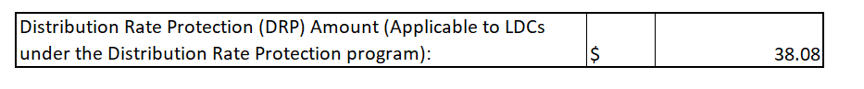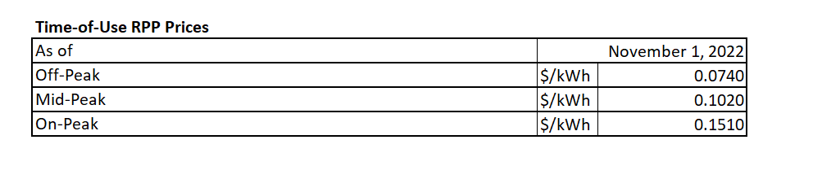

**Question:**

1. Please confirm the accuracy of the resulting changes in the rate generator.

**OEB Staff – 4**

**Ref: IRM Rate Generator Tab 3 – Continuity Schedule**

OEB staff has noted a principal adjustment in the amount of $332,338 in Account 1595 (2021) in column BF of tab 3.

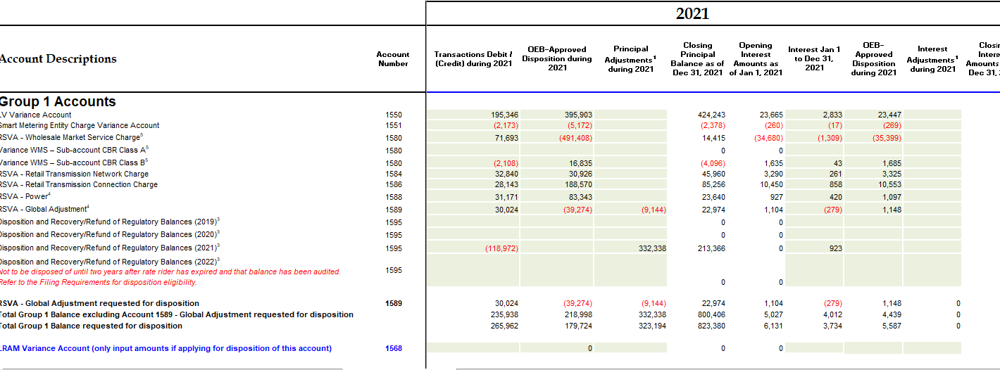

**Question:**

1. Please explain the nature of this principal adjustment in detail.

1. OEB Letter, 2023 Inflation parameters, issued October 20, 2022
2. EB-2022-0221, Decision and Order, issued November 3, 2022