2023 IRM Application
Interrogatory Responses
EB-2022-0031

Table of Contents
Table of Contents 2
Staff Question #1 3
Response 3
Staff Question #2 4
Response 4
Staff Question #3 4
Response 5
Staff Question #4 6
Response 6
Staff Question #5 7
Response 7
Staff Question #6 8
Response 8
Staff Question #7 8
Response 9

Staff Question #1
Ref: IRM Rate Generator Model, Tab 17 and Tab 19
OEB staff has updated Essex Power’s Rate Generator Model with the following changes:
Tabs 17 & 19: The Wireline Pole Attachment Charge in Tab 17 of the IRM model is inflated by 3.7% from the 2022 current charge of $34.76 to the new 2023 charge of $36.05.

Tab 17 & 19: Retail Service Charges is updated using the 2023 inflation factor (3.7%)
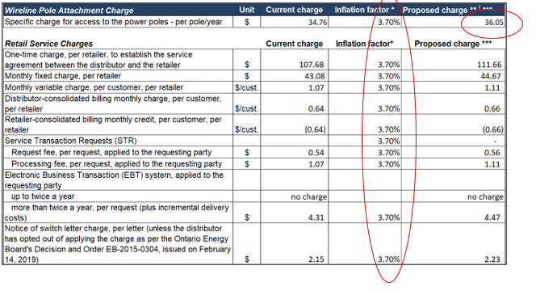
- Please confirm the accuracy of the updates.

Response
- Essex Powerlines confirms the accuracy of the updates.

Staff Question #2
Ref: Managers Summary page 8

The manager’s summary states that “Essex last disposed of claims for lost revenue during its 2020 IRM application (EB-2019-0034) for 2017 and related 2018 adjustments. As part of this application, Essex is not currently applying to dispose of any balances, but intends to bring forward any application for disposition of balances in its Cost of Service application”.

Preamble: The 2021 CDM Guidelines (section 8) require distributors filing an application for 2023 rates to seek disposition of all outstanding LRAMVA balances related to previously established thresholds, including approval of LRAM-eligible amounts in future years (arising from persisting savings) until a distributor’s next rebasing application, unless a distributor does not have complete information on eligible savings.

- Please explain why a request for the disposition of any LRAMVA balances was not submitted as part of this application.

Response
- A request for the disposition of any LRAMVA balances was not submitted as part of this application as Essex Powerlines is still working on gathering complete information on eligible savings.

Staff Question #3
Ref 1: Tab 8 of the IRM rate generator model, cells H18 and J18
Ref 2: EB-2017-0039, Test year Income Tax PILS workform_v1, dated April 13, 2018,
Tab 10 PILS Tax Provision, cell J10 and Tab T1 Taxable Income Test Year, cell F123

In Tab 8 of the IRM rate generator, Essex Powerlines filled in $58,033,511 for the cell for the OEB approved regulatory taxable income and the cell for the OEB approved rate base.
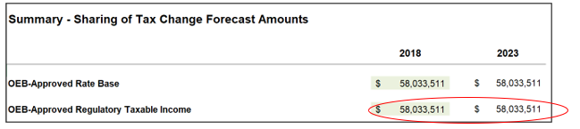
In Ref 2, the regulatory taxable income is shown as $614,858 below.
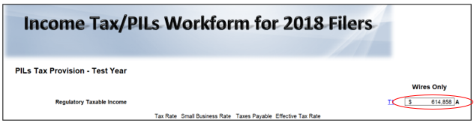
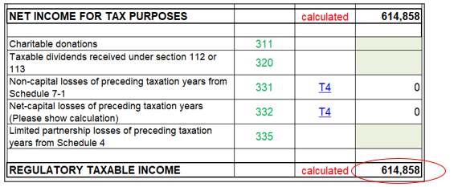
- Please update the IRM rate generator model by correcting the regulatory taxable income to $614,858.

Response
- The IRM rate generator model has been updated to reflect regulatory taxable income of $614,858.

Staff Question #4
Ref 1: Appendix C, Management Action Plan, section 1, finding #3, Future Action Items
Ref 2: Appendix C, Management Action Plan, section 2, finding #1, Future Action Items
Ref 3: EB-2022-0031, Essex Powerlines’ deferral request of its cost of service application,
Dated November 22, 2022

Preamble: In Ref 1, the management action plan states that KPMG is engaged to review the future action item (finalize any key regulatory Standard Operating Procedures and determine if any further key regulatory functions associated with quarterly/annual RRR filings still require Standard Operating Procedures) by April 2023 cost of service rate application.

In Ref 2, the management action plan states that KPMG is engaged to review the 1588 and 1589 accounts balances as directed by OEB, by April 2023 cost of service rate application filing.

In Ref 3, OEB staff notes that Essex Powerlines’ requested to defer filing its cost of service application from April 30, 2023 to April 30, 2024 for electricity distribution rates.

- Please provide an update on KPMG’s review as of now.

- Please provide Essex Powerlines’ plan in requesting the disposition of accounts 1588 and 1589.
Response
a) Essex Powerlines has provided KPMG with its key regulatory Standard Operating Procedures and is awaiting response and further follow-up. Essex Powerlines has provided KPMG with a comprehensive overview of its approach to reviewing the 1588 and 1589 balances. The actual review of these balances is ongoing by Essex Powerlines.

b) Essex Powerlines is planning to request disposition of accounts 1588 and 1589 as part of its 2024 IRM application if the request for deferral of its cost of service is approved. In the event that deferral is not granted, disposition of accounts 1588 and 1589 will be requested in the cost of service application to be filed by April 30, 2023.

Staff Question #5
Ref 1: Management Summary, page 7
Ref 2: IRM Rate Generator Model, Tab 7
Ref 3: EB-2022-0031, Essex Powerlines’ deferral request of filing its cost of service
Application, dated November 22, 2022

Preamble: Essex Powerlines states that it is requesting the disposition of group 1 balances excluding accounts 1588 and 1589, for 2021 in this application. The request for disposition is 8 months for DVA rate riders since the cost of service application was expected to be filed April 2023.

- Please confirm whether Essex Powerlines is requesting an interim or final disposition for Group 1 balances, excluding accounts 1588 and 1589, for 2021.

- If the OEB grants Essex Powerline’s request for an extension, will Essex Powerlines propose to change the disposition period to the default 12-month?

Response

- Essex Powerlines is requesting an interim disposition for Group 1 balances, excluding accounts 1588 and 1589, for 2021. Essex Powerlines will request final disposition of these balances in its next cost of service application.

- If the OEB grants Essex Powerlines’ request for an extension of its cost of service application deadline, Essex Powerlines will propose to change the disposition period to the default 12 months.

Staff Question #6
Ref 1: IRM Rate Generator Model, Tab 11, Tab 19 and Tab 20 – Retail Service Transmission
Rates (RTSRs)
Ref 2: Decision and Order, EB-2021-0110, page 512

OEB staff made the following updates to Tab 11 of the rate generator model:
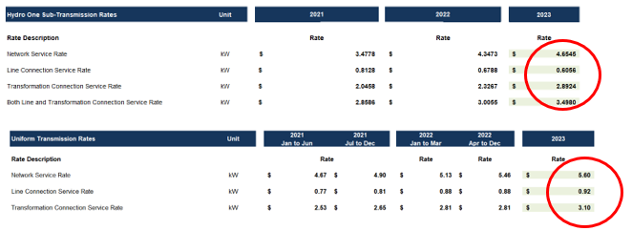
- Please confirm the accuracy of the updates.

Response
- Essex Powerlines confirms the accuracy of the updates.

Staff Question #7
Ref: IRM Rate Generator Model, Tab 6, Class A Customer 5 in 2020 year, cells I42 and H42

- In 2020, customer 5 consumed 6824 kWh from January to June 2020 and then 219,273 kWh from July to December 2020. Please explain why there is a large difference between these periods.

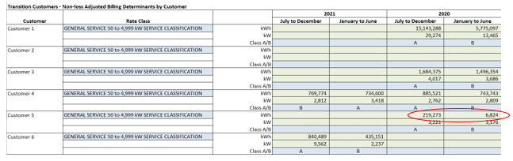

Response

- There is a large discrepancy between the consumption from January to June 2020 and from July to December 2020 for customer 5 because this customer undertook a major expansion in 2020 in the form of a new facility processing unit, as well as a 10MW combined heat and power generation facility.

