Newmarket-Tay Power Distribution Ltd.
OEB Staff Questions
EB-2022-0050

Please note, Newmarket-Tay Power Distribution Ltd (Newmarket-Tay Power) is responsible for ensuring that all documents it files with the OEB, including responses to OEB staff interrogatories and any other supporting documentation, do not include personal information (as that phrase is defined in the Freedom of Information and Protection of Privacy Act) unless filed in accordance with rule 9A of the OEB’s Rules of Practice and Procedure.
OEB Staff – 1
Ref 1: IRM Rate Generator Tab 16, 17, 19 and 20 – Annual Adjustment Mechanism Ref 2: OEB Letter, 2023 Inflation Parameters
Ref 3: EB-2022-0020, Decision and Order
Ref 4: EB-2022-0021, Decision and Order

OEB staff has made the following updates to Newmarket-Tay Power’s Main RZ as well as the former Midland RZ Rate Generators:
- Updated the IPI Inflation Factor to 3.70% in Tab 16 and Tab 17-Retail Service Charges
- Updated the Ontario Electricity Rebate in Tab 20 to 11.7% (as of November 1, 2022)
- Updated the Wireline Pole Attachment Charge to $36.05 in Tab 17
- Updated Retail Service Charges by the inflation factor of 3.7% in Tab 17

Question:
- Please confirm the accuracy of these updates in the attached rate generator.
OEB Staff – 2
Ref: IRM Rate Generator Tab 17 and Tab 20 – Regulatory Charges, Time of Use RPP Prices and Distribution Rate Protection Charge
OEB staff has made the following updates to Tab 17 of the rate generator:
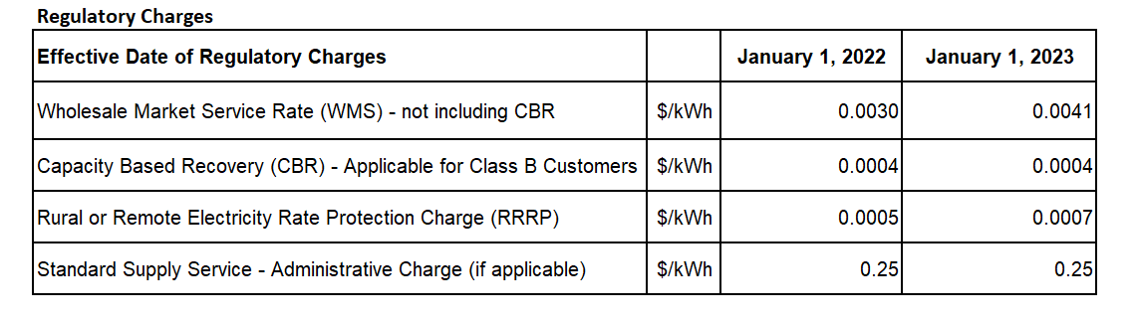
Question:
- Please confirm the accuracy of these updates in the rate generator.
OEB Staff – 3
Ref 1: IRM Rate Generator Tab 19 and Tab 20 – Retail Service Transmission Rates (RTSRs)
Ref 2: Decision and Order, EB-2021-0110

OEB staff made the following updates to Tab 11 of the rate generator model:
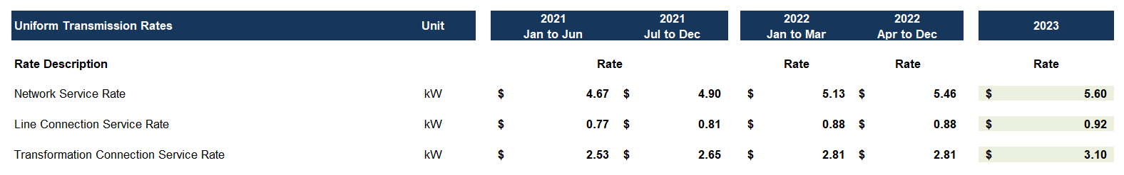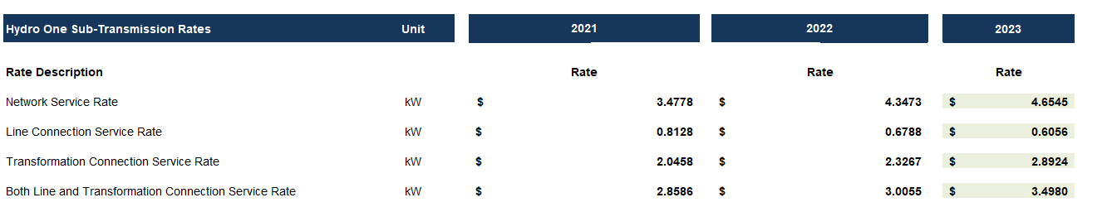
Question:
- Please confirm the accuracy of these updates in the rate generator.
Main RZ
OEB Staff – 4
Ref: NTRZ 2023 Rate Generator Model, Tab 3
OEB staff notes the following inputs for disposition in 2021 in Account 1595 (2016 and pre-2016), which cannot be reconciled with the Decision and Order EB-2020-0041.
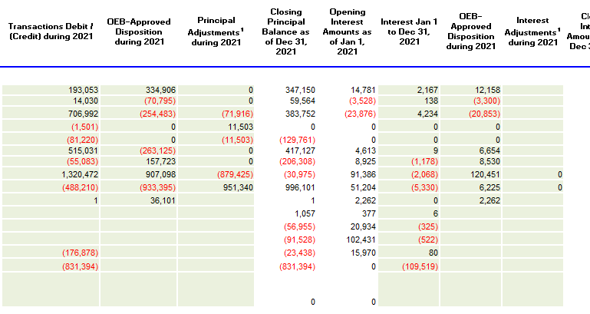
Question:
- Please explain the difference and update the rate generator if necessary.
- Please provide the amount that has been transferred to account 1595 (2021) and update the RG accordingly.
- Please complete the 1595 Workform for all applicable years.
OEB Staff - 5
Ref: NTRZ, GA Analysis WorkForm, Tab GA2021
OEB staff calculated the actual loss factor below based on information in the GA Analysis Workform.

NRTZ | 2021
Non-RPP retail kWh, including loss (A) | 187,795,660
Approved loss factor (B) | 1.0383
Non-RPP retail kWh excluding loss (C = A/B) | 180,868,400
Non-RPP wholesale kWh (D) | 191,420,826
Calculated actual loss factor (=D/C) | 1.0583

Question:
- Please comment on the reasonability of the calculated actual loss factor as compared to the actual losses that NT Power has experienced in NRTZ.

OEB Staff - 6
Ref 1: NT Power, 2023 Incentive ratemaking application, Page 6 of 22
Ref 2: NT Power, 2023 Incentive ratemaking application, Page 11 of 22
Ref 3: NTRZ & MRZ, 2023 Rate Generator Models, Tab3, Cell BT41

OEB staff has compiled the following table based on the information provided in Reference 1 & 2:

Group 1 Balance for Disposition | Reference 1 | Reference 2 | Variance
NTRZ | 2,165,814 | 2,155,433 | 10,381
MRZ | 984,086 | 944,951 | 39,135
NT Power | 3,149,900 | 3,100,385 | 49,515

OEB staff has also noted that the balances for both rate zones in Reference 2 match those in Reference 3.
Question
- Please reconcile the difference of both rate zones and the total Group 1 Balance for Dispositions in the above table, and revise the schedules as needed.
OEB Staff - 7
Ref 1: NTRZ, GA Analysis WorkForm, Tab GA2021 & Principal Adjustments Tab
Ref 2: NTPower, 2023 Incentive ratemaking application, Page 15 of 22
Ref 3: NTPower, 2023 Incentive ratemaking application, NTRZ, Page 12 of 22
Ref 4: NTPower, 2023 Incentive ratemaking application, MRZ, Page 13 of 22
Ref 5: OEB letter issued on October 31, 2019 – “Adjustments to Correct for Errors in Electricity Distributor “Pass-Through” Variance Accounts After Disposition”

In Reference 2, NT Power states that “NT Power reconciled the 2021 GA accounts for NTRZ and MRZ post the 2021 yearend due to staffing issues”.

NT Power provide a Table 8 for the reconciling items and provide the associated explanation as below.

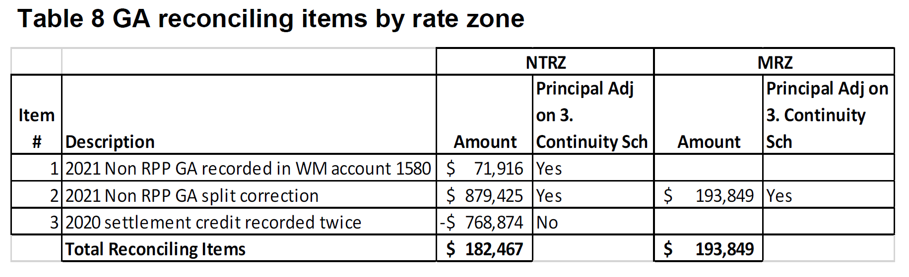
1. NTRZ coding error between GA account 1589 and 1580.
2. The incorrect GA RPP vs non RPP split percentage (%) used in January 2021 for calculating the non RPP GA.
3. NTRZ had submitted a post settlement class A adjustment in October 2020 for ($768,874) and accrued the adjustment in December 2020 by debiting AR IESO and crediting GA 1589.The adjustment was reversed in 2021 crediting AR IESO and debiting GA 1589.

Reference 3 states that “Identified the January 2021 adjustment for the RPP vs Non RPP GA was incorrect. An adjustment is provided in the continuity schedule in 2021 to reallocate $878,424 from Power 1588 account to GA 1589 account.”

Reference 4 states that “Identified the January 2021 adjustment for the RPP vs Non RPP GA was incorrect. An adjustment is provided in the continuity schedule in 2021 to reallocate $193,849 from Power 1588 account to GA 1589 account.”

Reference 5 states that “Where an accounting or other error is discovered after the balance in one of the above-listed variance accounts has been cleared by a final order of the OEB, the OEB will determine on a case-by-case basis whether to make a retroactive adjustment based on the particular circumstances of each case, including factors such as:
- whether the error was within the control of the distributor
- the frequency with which the distributor has made the same error
- failure to follow guidance provided by the OEB
- the degree to which other distributors are making similar errors

Questions:
- Please explain whether any of the adjustments identified in Table 8 impacts the final disposed balances for both rate zones.
- If so, please provide the details regarding the periods impacted and how it was impacted.
- If so, please provide NT Power’s consideration regarding the rates retroactivity issues raised in the OEB’s Oct 31, 2019 letter in Reference 5.
  - Please also comment on the four factors outlined in Reference 5.
- If not, please explain why not, especially related to the adjustment for 2020 settlement credit recorded twice,

- Please explain in detail what “a post settlement class A adjustment” in Reference 2 means.
- Please confirm that the adjustment of $(768,874) in Reference 2 was not included in the final disposed 2020 balance in 2022 IRM application. If so, please explain why.
- Please explain whether there is a corresponding adjustment to Account 1588 relating to the $(768,874) adjustment. Please why or why not.
- Please confirm the reconciling item #8 of $(768,874) in Reference 1 Tab GA2021 was recorded in the 2021 GL.
  - If confirmed, please also confirm the $(768,874) was not included in the “Net Change in Principal Balance in the GL” of $(488,210) on the Reference 1 Tab GA2021 Cell C75.
    - Please explain why the $(768,874) was a reconciling item. Please revise the evidence as needed.
  - If not confirmed, please explain why the $(768,874) is not shown as principal adjustment.
- The $878,424 in reference 3 does not match with the adjustment of $879,425 on NTRZ GA Analysis Workform in reference 1 Tab GA 2021 Cell. Please explain why.
- Please explain how NT Power identified the errors in Reference 3 & 4 and explain the nature of the adjustments in details.
- Please confirm that the two adjustments pertain to the year of 2021 but not impact any other prior years. If not, please provide the details regarding the periods that are impacts and the associated adjustments in the periods.
- Please elaborate on NT Power’s plan to address its global adjustment allocation practices moving forward.

OEB Staff - 8
Ref: MRZ 2023 Rate Generator model, Tab 3

Question:

- OEB staff noted that the Projected Interest on Dec 31, 2021 Balances for Account 1595 (2018) balances (Cell BQ33 & BR33) have not yet been completed. Please update the schedule and revise the evidence as needed.

Staff Question – 9
Ref: LRAMVA Workform, Tab 1 – LRAMVA Summary
Question:
- Please update Tab 1 – LRMVA Summary for both the MRZ and NTRZ LRAMVA workforms as it appears there was an error in the forms that were filed with NT Power’s application.

Staff Question -10

Ref 1: LRAMVA work form, Tab 5 – 2015-2027 LRAM
Ref 2: OEB 2021 CDM Guidelines (EB-2021-0106), December 20, 2021, p. 26
Guidance on Prospective Lost Revenue Adjustment Mechanism (LRAM) Amounts – 2023 Rates, June 3, 2022

The 2021 CDM Guidelines (section 8) require distributors filing an application for 2023 rates to seek disposition of all outstanding LRAMVA balances related to previously established thresholds, including approval of LRAM-eligible amounts in future years (arising from persisting savings) until a distributor’s next rebasing application, unless a distributor does not have complete information on eligible savings.

The additional guidance provided in June 2022 noted that the expectation is that distributors with prospective LRAMVA balances, beginning with 2023 amounts, will seek disposition at the time of the corresponding rate year. That means that for distributors with 2023 prospective LRAMVA balances, the expectation is that these amounts will be included in the 2023 rate generator model and addressed as part of this year’s rate applications.

Questions:

- Please confirm that NT Power will not be seeking to dispose of any balance in the LRAMVA due to LRAM-eligible CDM activities funded by the IESO through the Conservation First Framework or Interim Framework in a future year’s rate application, this includes LRAMVA amounts in 2022 and beyond.
- If not confirmed, please explain why a request for disposition was not submitted as part of this application.
- If not confirmed, please update the LRAMVA workform to include any persisting LRAMVA amounts into all years beyond 2021 until NT Power’s next rebasing application.
- If confirmed, please also confirm that NT Power has verified that, relative to the LRAMVA threshold established in Midland Hydro’s last rebasing application (EB-2013-0147), the balance in the LRAMVA, and any prospective LRAM-eligible amounts until the next rebasing, are either zero or a debit (i.e., not a credit that would need to be refunded to customers).

Staff Question -11

Ref: Manager’s Summary, p. 18
LRAMVA Workform, Tab 6

NT Power is seeking recovery of amounts to April 2023. NT Power indicated it has used the Q4 prescribed interest rate for the January-April 2023 carrying charges. The OEB has recently published its prescribed interest rate for deferral and variance account balances for Q1 2023.

Questions:
- Please update the carrying charges for Q1 2023 in Tab 6 of the LRAMVA Workform.
- Please update the IRM Model to reflect the updated total balance and carrying charges for the LRAMVA.

OEB Letter, 2023 Inflation parameters, issued October 20, 2022
EB-2022-0221, Decision and Order, issued November 3, 2022

