**Halton Hills Hydro Inc.**

**OEB Staff Questions**

**EB-2022-0036**

Please note, Halton Hills Hydro (Halton Hills Hydro) is responsible for ensuring that all documents it files with the OEB, including responses to OEB staff interrogatories and any other supporting documentation, do not include personal information (as that phrase is defined in the *Freedom of Information and Protection of Privacy Act*) unless filed in accordance with rule 9A of the OEB’s *Rules of Practice and Procedure*.

**OEB Staff – 1**

**Ref: IRM Rate Generator Tab 16, 17, 19 and 20 – Annual Adjustment Mechanism Ref: OEB Letter, 2023 Inflation Parameters**

**Ref: EB-2022-0020, Decision and Order**

**Ref: EB-2022-0021, Decision and Order**

OEB staff has made the following updates to Halton Hills Hydro’s Rate Generator:

* Updated the IPI Inflation Factor to 3.70%[1] in Tab 16 and Tab 17-Retail Service Charges
* Updated the Ontario Electricity Rebate in Tab 20 to 11.7% (as of November 1, 2022)
* Updated the Wireline Pole Attachment Charge to $36.05[2] in Tab 17
* Updated Retail Service Charges by the inflation factor of 3.7% in Tab 17

**Question:**

1. Please confirm the accuracy of these updates in the attached rate generator.

**OEB Staff – 2**

**Ref: IRM Rate Generator Tab 17, 19 and 20 Smart Meter Entity (SME) Charge**

OEB staff has updated the SME charge from $0.43 to $0.42.

**Question:**

1. Please confirm this is correct.

**OEB Staff – 3**

**Ref: IRM Rate Generator Tab 17 and Tab 20 – Regulatory Charges, Time of Use RPP Prices and Distribution Rate Protection Charge**

OEB staff has made the following updates to Tab 17 of the rate generator:

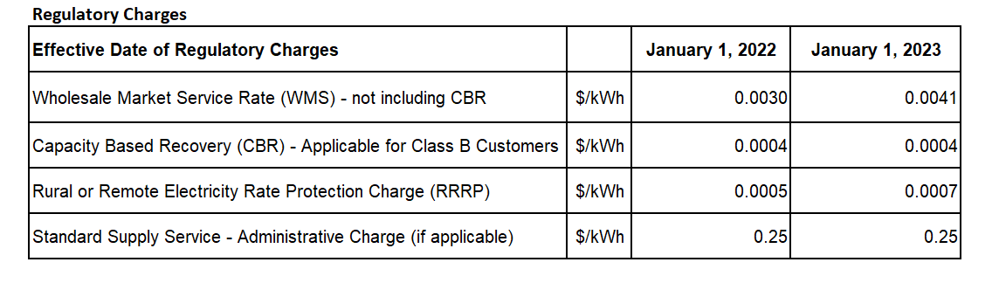

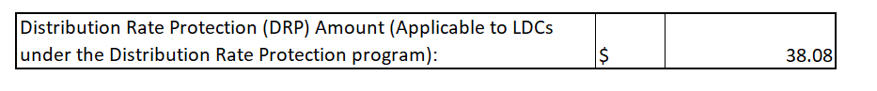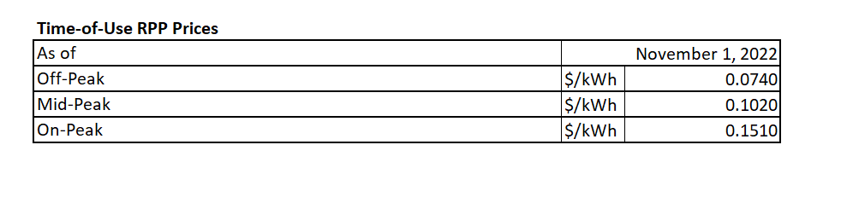**Question:**

1. Please confirm the accuracy of these updates in the rate generator.

**OEB Staff – 4**

**Ref: IRM Rate Generator Tab 19 and Tab 20 – Retail Service Transmission Rates (RTSRs)**

**Ref: Decision and Order, EB-2021-0110**

OEB staff made the following updates to Tab 11 of the rate generator model:

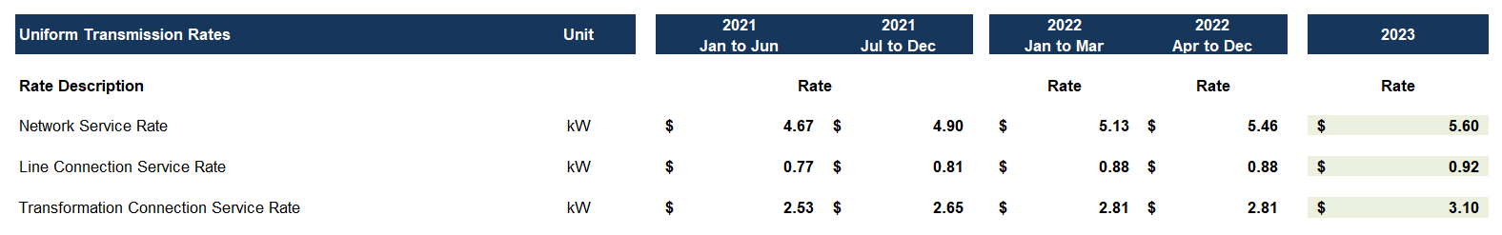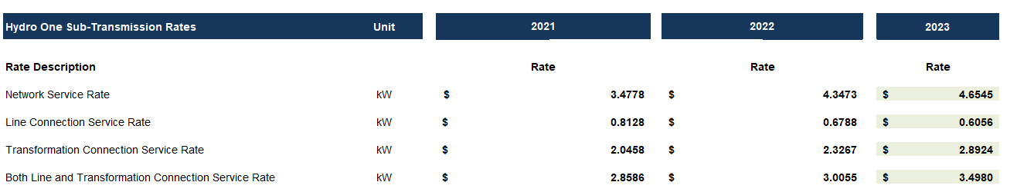

**Question:**

1. Please confirm the accuracy of these updates in the rate generator.

**OEB Staff – 5**

**Ref: 2023 Rate Generator Tab 3, Continuity Schedule -Account 1595**

Tab 3 of the rate generator shows an approved disposition principal amount of $971,346 and an interest amount of ($66,234) in Account 1595(2021).

**Question:**

1. Please provide a breakdown of the balances approved for disposition in 2021 and reconcile these balances.

**OEB Staff – 6**

**Ref: IRM Rate Generator Tab 3, November 11, 2022**

**Ref: Global Adjustment Analysis Workform, November 11, 2022**

OEB staff has prepared the following table which shows differences in Account 1588 2021 transactions between the 2023 IRM Rate Generator Model and the 2023 IRM GA Analysis Workform.

**Table 1 – Differences in Account 1588 2021 Transactions**

|  |  |  |  |
| --- | --- | --- | --- |
| **Account** | **2023 IRM Rate Generator Model** | **2023 GA Analysis Workform – Tab Account 1588 Reasonability** | **Difference** |
| **Transactions Debit / (Credit) during 2021** | **Transactions - 2021** |
| 1588 | 126,535 | 299,832 | (173,297) |

**Questions:**

1. Please confirm whether Halton Hills Hydro is in agreement with OEB staff’s calculations and values in the above-noted Table 1.
2. If this is not the case, please explain, and update Table 1.
3. Please update the relevant evidence to resolve this difference.
4. In the alternative, please explain why Halton Hills Hydro is of the view that no changes are required.

**OEB Staff – 7**

**Ref: IRM Rate Generator Tab 3, November 11, 2022**

**Ref: Global Adjustment Analysis Workform, November 11, 2022**

OEB staff has prepared the following table which shows differences in Account 1588 2021 principal amounts between the 2023 IRM Rate Generator Model and the 2023 IRM GA Analysis Workform.

**Table 2 – Differences in Account 1588 2021 Principal Amounts**

|  |  |  |  |
| --- | --- | --- | --- |
| **Account** | **2023 IRM Rate Generator Model** | **2023 GA Analysis Workform – Tab Account 1588 Reasonability and Tab Principal Adjustments** | **Difference** |
| **Principal Adjustments during 2021** | **Principal Adjustments - 2021** |
| 1588 | 193,128 | (153,466) | 346,594 |

**Questions:**

1. Please confirm whether Halton Hills Hydro is in agreement with OEB staff’s calculations and values in the above-noted Table 2.
2. If this is not the case, please explain, and update the Table 2.
3. Please update the relevant evidence to resolve this difference.
4. In the alternative, please explain why Halton Hills Hydro is of the view that no changes are required.

**OEB Staff – 8**

**Ref: IRM Rate Generator Tab 3, November 11, 2022**

**Ref: Global Adjustment Analysis Workform, November 11, 2022**

OEB staff has prepared the following table which shows differences in Account 1589 2021 transactions between the 2023 IRM Rate Generator Model and the 2023 IRM GA Analysis Workform.

**Table 3 – Differences in Account 1589 2021 Transactions**

|  |  |  |  |
| --- | --- | --- | --- |
| **Account** | **2023 IRM Rate Generator Model** | **2023 GA Analysis Workform – Tab GA 2021** | **Difference** |
| **Transactions Debit / (Credit) during 2021** | **Net Change in Principal Balance in the GL (i.e. Transactions in the Year) - 2021** |
| 1589 | (9,254) | (29,085) | 19,831 |

**Questions:**

1. Please confirm whether Halton Hills Hydro is in agreement with OEB staff’s calculations and values in the above-noted Table 3.
2. If this is not the case, please explain, and update Table 3.
3. Please update the relevant evidence to resolve this difference.
4. In the alternative, please explain why Halton Hills Hydro is of the view that no changes are required.

**OEB Staff – 9**

**Ref: DVA Continuity Schedule, 2021 Cost of Service, March 25, 2021**

**Ref: Global Adjustment Analysis Workform, 2021 Cost of Service, August 27, 2020**

**Ref: Global Adjustment Analysis Workform, November 11, 2022**

**Ref: Manager’s Summary, November 11, 2022, p. 6**

Halton Hills Hydro had 2019 principal adjustments of a credit of $1,210,325 in Account 1588 and a debit of $1,777,993 in Account 1589 that were approved by the OEB in its 2021 cost of service proceeding, as per the associated 2021 cost of service DVA continuity schedule and 2021 cost of service GA Analysis Workform.

However, in Note 8 of the GA Analysis Workform in the 2023 IRM proceeding, Halton Hills Hydro suggested that the 2019 principal adjustments were a credit of $921,789 in Account 1588 and a credit of $554,961 in Account 1589.

OEB staff has prepared the following table which shows these differences.

**Table 4 – Differences in Accounts 1588 and 1589 2019 Principal Adjustments**

|  |  |  |  |
| --- | --- | --- | --- |
| **Account** | **2023 IRM GA Analysis Workform - 2019 Principal Adjustments** | **2021 CoS GA Analysis Workform and 2021 CoS DVA Continuity Schedule - 2019 Principal Adjustments** | **Difference** |
| 1588 | (921,789) | (1,210,325) | 288,536 |
| 1589 | (554,961) | 1,777,993 | (2,332,954) |

Halton Hills Hydro also suggested that the CT 148 true-up of $554,961 (debit to Account 1588 and credit to Account 1589) was part of the 2019 principal adjustments that were approved by the OEB in the 2021 cost of service proceeding. However, Halton Hills Hydro stated that the actual re-allocation was not posted to the GL until 2022 and will be adjusted accordingly with 2022 year-end balance dispositions.

**Questions:**

1. Please confirm whether Halton Hills Hydro is in agreement with OEB staff’s calculations and values in the above-noted Table 4.
2. If this is not the case, please explain, and update Table 4.
3. Please update the relevant evidence to resolve this difference, including a reconciliation of the 2019 principal adjustments that were approved in the 2021 cost of service proceeding to those shown in Note 8 of the GA Analysis Workform in the 2023 IRM proceeding.
4. In the alternative, please explain why Halton Hills Hydro is of the view that no changes are required.
5. After this reconciliation has been conducted, please explain which amounts should be reversed as 2020 principal adjustments in Note 9 of the 2023 IRM GA Analysis Workform, depending on what amounts have been recorded in the 2020 GL.
6. Please confirm that the 2019 principal adjustment CT 148 true-up of $554,961 (debit to Account 1588 and credit to Account 1589) that was posted to the 2022 GL will be reversed as a 2022 principal adjustment in the 2024 IRM rate proceeding (as opposed to a 2020 principal adjustment in the current proceeding). If this is not the case, please explain.

**OEB Staff – 10**

**Ref: Global Adjustment Analysis Workform, November 11, 2022**

**Ref: IRM Rate Generator Tab 3, November 11, 2022**

Halton Hills Hydro has recorded 2021 “current year” principal adjustments in the Tab Principal Adjustments of the 2023 IRM GA Analysis Workform of a credit of $153,466 in Account 1588 and a credit of $19,831 in Account 1589. However, Halton Hills Hydro also indicated that these 2021 “current year” principal adjustments were recorded in the 2021 GL and not the 2022 GL.

OEB staff also notes that based on an above OEB staff question, the 2021 principal adjustment of a credit of $153,466 in Account 1588 may need to be revised, as well as from additional OEB staff questions below. OEB staff also notes that the 2021 principal adjustment of a credit of $19,831 in Account 1589 may need to be revised, as per additional OEB staff questions below.

OEB staff also notes that as part of the 2021 principal adjustment of a credit of $153,466 in Account 1588, Halton Hills Hydro has stated that it has recorded a credit of $173,297 that relates to a “Reversal of CT 1142/142 true-up based on actuals”. However, Halton Hills Hydro has not recorded a corresponding principal adjustment in 2020 that may need to be reversed in 2021.

**Questions:**

1. Please confirm whether Halton Hills Hydro meant to reference the 2021 “current year” principal adjustments in the Tab Principal Adjustments of the 2023 IRM GA Analysis Workform of a credit of $153,466 in Account 1588 (or any revised amount) and a credit of $19,831 in Account 1589 (or any revised amount) as being recorded in the 2022 GL, instead of the 2021 GL.
2. If these amounts (or any revised amounts) were recorded in the 2022 GL:
   1. Please update the labelling in the relevant cells of columns K and W of the Principal Adjustments tab of the 2023 IRM GA Analysis Workform.
   2. Please explain why these amounts are not part of the balance recorded in Column BW “Variance RRR vs. 2021 Balance (Principal + Interest)” in Tab 3 of the 2023 IRM Rate Generator Model.
3. If these amounts (or any revised amounts) were not recorded in the 2022 GL, please explain, particularly why there are 2021 principal adjustments recorded in the 2021 GL layered on top of the “Transactions Debit / (Credit) During 2021” amounts recorded in Tab 3 of the 2023 IRM Rate Generator Model that are also part of the 2021 GL.
4. Please explain why Halton Hills Hydro, as part of the 2021 principal adjustment of a credit of $153,466 in Account 1588, it has stated that it has recorded a credit of $173,297 that relates to a “Reversal of CT 1142/142 true-up based on actuals”, when it has not recorded a corresponding principal adjustment in 2020 that may need to be reversed in 2021.

**OEB Staff – 11**

**Ref: IRM Rate Generator Tab 3, November 11, 2022**

**Ref: 2022 IRM Rate Generator, Tab 3, March 24, 2022**

**Ref: Global Adjustment Analysis Workform, November 11, 2022**

**Ref: 2022 IRM Global Adjustment Analysis Workform, October 29, 2021**

OEB staff notes that there are differences between the 2020 transactions related to Accounts 1588 and 1589 between the current 2023 IRM proceeding and the 2022 IRM proceeding.

OEB staff has prepared the following table which shows these differences related to 2020 transactions.

**Table 5 – Differences in Accounts 1588 and 1589 2020 Transactions**

**between 2023 IRM and 2022 IRM**

|  |  |  |  |
| --- | --- | --- | --- |
| **Account** | **2023 IRM Rate Generator Model - Transactions Debit / (Credit) During 2020** | **2022 IRM Rate Generator Model - Transactions Debit / (Credit) During 2020** | **Difference** |
| 1588 | (2,649,128) | (2,999,106) | 349,978 |
| 1589 | 71,779 | 421,757 | (349,978) |

**Questions:**

1. Please confirm whether Halton Hills Hydro is in agreement with OEB staff’s calculations and values in the above-noted Table 5.
2. If this is not the case, please explain, and update Table 5.
3. Please update the relevant evidence to resolve this difference.
4. In the alternative, please explain why Halton Hills Hydro is of the view that no changes are required.

**OEB Staff – 12**

**Ref: IRM Rate Generator Tab 3, November 11, 2022**

**Ref: 2022 IRM Rate Generator, Tab 3, March 24, 2022**

**Ref: Global Adjustment Analysis Workform, November 11, 2022**

**Ref: 2022 IRM Global Adjustment Analysis Workform, October 29, 2021**

OEB staff notes that there are differences between the 2020 principal adjustments related to Accounts 1588 and 1589 between the current 2023 IRM proceeding and the 2022 IRM proceeding.

OEB staff has prepared the following table which shows these differences related to 2020 principal adjustments.

**Table 6 – Differences in Accounts 1588 and 1589 2020 Principal Amounts**

**between 2023 IRM and 2022 IRM**

|  |  |  |  |
| --- | --- | --- | --- |
| **Account** | **2023 IRM Rate Generator Model - Principal Adjustments During 2020** | **2022 IRM Rate Generator Model - Principal Adjustments During 2020** | **Difference** |
| 1588 | 1,476,750 | 1,271,767 | 204,983 |
| 1589 | 0 | 204,983 | (204,983) |

**Questions:**

1. Please confirm whether Halton Hills Hydro is in agreement with OEB staff’s calculations and values in the above-noted Table 6.
2. If this is not the case, please explain, and update Table 6.
3. Please update the relevant evidence to resolve this difference.
4. In the alternative, please explain why Halton Hills Hydro is of the view that no changes are required.

**OEB Staff – 13**

**Ref: IRM Rate Generator Tab 3, November 11, 2022**

**Ref: 2022 IRM Rate Generator, Tab 3, March 24, 2022**

**Ref: Global Adjustment Analysis Workform, November 11, 2022**

**Ref: 2022 IRM Global Adjustment Analysis Workform, October 29, 2021**

OEB staff notes that Halton Hills Hydro has included an Account 1589 2020 principal adjustment of a credit of $349,978 in Tab GA 2020 and Tab Principal Adjustments of the 2022 IRM GA Analysis Workform and the 2022 IRM Rate Generator Model However, this is labeled as a reconciling item (and not a principal adjustment) in Tab GA 2020 and missing from Tab Principal Adjustments of the 2023 IRM GA Analysis Workform and the 2023 IRM Rate Generator Model.

OEB staff also notes that Halton Hills Hydro has included an Account 1588 2020 principal adjustment of a debit of $349,978 in Tab Account 1588 Reasonability and Tab Principal Adjustments of the 2022 IRM GA Analysis Workform and the 2022 IRM Rate Generator Model. However, this is missing from Tab Account 1588 Reasonability and Tab Principal Adjustments of the 2023 IRM GA Analysis Workform and the 2023 IRM Rate Generator Model.

**Questions:**

1. Please explain why Halton Hills Hydro has included an Account 1589 2020 principal adjustment of a credit of $349,978 in Tab GA 2020 and Tab Principal Adjustments of the 2022 IRM GA Analysis Workform (and the 2022 IRM Rate Generator Model), but this is labeled as a reconciling item (and not a principal adjustment) in Tab GA 2020 and missing from Tab Principal Adjustments of the 2023 IRM GA Analysis Workform (and the 2023 IRM Rate Generator Model).
2. Please explain why this amount is not reversed as an Account 1589 2021. principal adjustment in the 2023 GA Analysis Workform (Tab GA 2021 and Tab Principal Adjustments) and the 2023 IRM Rate Generator Model (Tab 3).
3. Please explain why Halton Hills Hydro has included an Account 1588 2020 principal adjustment of a debit of $349,978 in Tab Account 1588 Reasonability and Tab Principal Adjustments of the 2022 IRM GA Analysis Workform (and the 2022 IRM Rate Generator Model), but this is missing from Tab Account 1588 Reasonability and Tab Principal Adjustments of the 2023 IRM GA Analysis Workform (and the 2023 IRM Rate Generator Model).
4. Please explain why this amount is not reversed as an Account 1588 2021 principal adjustment in the 2023 GA Analysis Workform (Tab Account 1588 Reasonability and Tab Principal Adjustments) and the 2023 IRM Rate Generator Model (Tab 3).

**OEB Staff – 14**

**Ref: Global Adjustment Analysis Workform, November 11, 2022**

**Ref: Manager’s Summary, p. 6, November 11, 2022**

Halton Hills Hydro provided an explanation of why the 2020 Account 1588 Reasonability Tab “Account 1588 as % of Account 4705”, cell G19, of -3.2% is greater than the threshold of +/- 1%. Halton Hills Hydro’s explanation resulted in a revised cell G19 of -0.01%, including the following adjustments to both the 2020 principal adjustments and the 2020 Account 4705:

* An addition of $1,491,431 related to 2017 true-ups (although Halton Hills Hydro stated a “reduction” in its explanation)
* An addition of $233,233 related to 2018 true-ups (although Halton Hills Hydro stated a “reduction” in its explanation)
* A reduction of $554,961 related to 2019 true-ups

OEB staff has prepared the following table which shows the calculations that support Halton Hills Hydro’s explanation at cell B66 of the Tab Account 1588 Reasonability of the 2023 IRM GA Analysis Workform, as well as the Manager’s Summary, including Halton Hills Hydro’s pro-forma adjustments included as part of its explanation.

**Table 7 – Pro-Forma Adjustments to the 2023 IRM GA Analysis Workform –**

**Tab Account 1588 Reasonability**

|  |  |  |  |  |  |  |
| --- | --- | --- | --- | --- | --- | --- |
|  | **Account** | **2020 Transactions** | **2020 Principal Adjustments** | **2020 Net Activity** | **2020 Account 4705** | **2020 Account 1588 as % of Account 4705** |
| 2023 IRM GA Analysis Workform - Tab Account 1588 Reasonability | 1588 | (2,649,128) | 1,476,750 | (1,172,378) | 36,876,214 | -3.18% |
| Add: 2017 true-ups | 1588 |  | 1,491,431 | 1,491,431 | 1,491,431 |  |
| Add: 2018 true-ups | 1588 |  | 233,233 | 233,233 | 233,233 |  |
| Sub-total | 1588 | (2,649,128) | 3,201,414 | 552,286 | 38,600,878 | 1.43% |
| Subtract: 2019 true-ups | 1588 |  | (554,961) | (554,961) | (554,961) |  |
| Total | 1588 | (2,649,128) | 2,646,453 | (2,675) | 38,045,917 | -0.01% |

OEB staff notes that there are other 2020 principal adjustments in the 2023 IRM GA Analysis Workform that have not been included by Halton Hills Hydro in its above pro-forma adjustments, such as a debit of $392,257 for 2019 true-ups, a credit of $720,098 for additional 2019 true-ups, and a debit of $79,927 for additional 2019 true-ups.

OEB staff also notes that other revisions to the 2020 transactions and principal adjustments may need to be included in Halton Hills Hydro’s explanation summary, based on the answers to the above OEB staff questions, such as:

* The 2020 principal adjustment debit of $349,978 to Account 1588
* Any further revisions to the 2020 transactions and principal adjustments once reconciled to the amounts that were presented in the 2022 IRM proceeding
* Any further revisions to the 2020 principal adjustments once reconciled to the amounts that should be reversed based on the OEB-approved 2019 principal adjustments in the 2021 cost of service proceeding

**Questions:**

1. Please confirm whether Halton Hills Hydro is in agreement with OEB staff’s calculations and values in the above-noted Table 7.
2. If this is not the case, please explain, and update Table 7.
3. Please update the relevant evidence to resolve this difference.
4. In the alternative, please explain why Halton Hills Hydro is of the view that no changes are required.
5. Please explain why Halton Hills Hydro has included the two above-noted references to a “reduction” in its explanation at cell B66 of the Tab Account 1588 Reasonability of the 2023 IRM GA Analysis Workform, as well as the Manager’s Summary, when Halton Hills Hydro has added these amounts and not subtracted them.
6. Please confirm that Halton Hills Hydro’s analysis should be revised to reflect reductions and not the additions that Halton Hills Hydro has included in its calculations. Please update the analysis. If this is not the case, please explain.
7. Please explain why Halton Hills Hydro in its above pro-forma adjustments in its explanation, has not included all 2020 transactions and principal adjustments such as the following and please update the analysis as required.
8. A debit of $392,257 for 2019 true-ups
9. A credit of $720,098 for additional 2019 true-ups
10. A debit of $79,927 for additional 2019 true-ups
11. Other revisions to the 2020 transactions and principal adjustments may need to be included in Halton Hills Hydro’s explanation summary, such as:
    * The 2020 principal adjustment debit of $349,978 to Account 1588
    * Any further revisions to the 2020 transactions and principal adjustments once reconciled to the amounts that were presented in the 2022 IRM proceeding
    * Any further revisions to the 2020 principal adjustments once reconciled to the amounts that should be reversed based on the OEB-approved 2019 principal adjustments in the 2021 cost of service proceeding
    * Other

**OEB Staff – 15**

OEB staff notes that based on the responses to OEB staff’s questions, 2020 and 2021 Accounts 1588 and 1589 balances may need to be changed, including the transactions and principal adjustments. This may impact the threshold calculations in the GA Analysis Workform.

**Questions:**

1. If changes are required to Account 1588 and the revised Account 1588 Reasonability Tab “Account 1588 as % of Account 4705”, cell G19 and cell G20, are greater than the threshold of +/- 1%, please explain.
2. If changes are required to Account 1589 and the revised Tab GA 2020 and Tab GA 2021 cells C93 (i.e., Unresolved Difference as % of Expected GA Payments to IESO) are greater than the threshold of +/- 1%, please explain.

**OEB Staff – 16**

**Ref: Manager’s Summary, page 13**

The 2021 CDM Guidelines (section 8) indicates that “Distributors filing an application for 2023 rates should seek disposition of all outstanding LRAMVA balances related to previously established thresholds. Distributors not rebasing for 2023 rates who have complete information on eligible savings (i.e., needing only to account for persistence of savings in future years) may seek a rate adjustment on a prospective basis to address amounts that would otherwise be recorded in the LRAMVA for all years until their next rebasing application.” Halton Hills Hydro states that it will not have prospective disposition amounts in future years.

**Questions:**

1. Please explain why Halton Hills Hydro will not have prospective disposition amounts in future years
2. Please confirm that if the disposition of the LRAMVA balance in this application is approved as filed, that the balance in the LRAMVA and any prospective LRAM-eligible amounts will be zero.

**OEB Staff – 17**

**Ref: Manager’s Summary, page 13**

Halton Hills notes in its Manager’s Summary that “The LRAMVA amounts, by class, excluding 2011 to 2014 programs, are provided in 3-VECC-15, part f). Persistence of programs from 2011 to 2014 are consistently excluded in Table IRR-45 (3-VECC-15) and persistence calculations in the LRAMVA workform.”

**Question:**

1. Please explain what is meant by the above-noted statements, and provide the referenced materials, if necessary.

**OEB Staff – 18**

**Ref: Manager’s Summary, page 12**

**Ref: LRAMVA Workform, Tab 5 and Tab 7**

Halton Hills Hydro states in its Manager Summary that the 2019 and 2020 retrofit savings were provided by Halton Hills Hydro’s consultant Aladaco. OEB staff is unable to confirm the source and calculation of the retrofit savings data in tab 5 of the LRAMVA workform.

**Question:**

1. Please clarify and provide the source of the retrofit savings for 2019 and 2020 in Tab 5 of the LRAMVA workform and as referenced in Tab 7 of the retrofit savings (e.g. the 2019 Aladaco Report and the 2020 Aladaco Report).

1. OEB Letter, 2023 Inflation parameters, issued October 20, 2022
2. EB-2022-0221, Decision and Order, issued November 3, 2022