Hydro 2000 Inc.
OEB Staff Questions
EB-2022-0038
Hydro 2000 Inc.
OEB Staff Questions

EB-2022-0038
Please note, Hydro 2000 Inc. (Hydro 2000) is responsible for ensuring that all documents it files with the OEB, including responses to OEB staff questions and any other supporting documentation, do not include personal information (as that phrase is defined in the Freedom of Information and Protection of Privacy Act), unless filed in accordance with rule 9A of the OEB’s Rules of Practice and Procedure.

Please also note, OEB staff has made the following generic updates in Hydro 2000’s Rate Generator Model and attached it to these OEB staff questions:
Staff Question- 1
Ref 1: Rate Generator Model, Tab 1
OEB staff notes that Tab 1, Cell 18 of the Rate Generator Model has not been completed.
- Please confirm that Hydro 2000 fills out application EB# in Tab 1, Cell 18.

Staff Question- 2
Ref 1: IRM Rate Generator Tab 17 and Tab 20 – Regulatory Charges
Ref 2: Decision and Order, EB-2022-0269
OEB staff has made the following updates to Tab 17 of the rate generator:
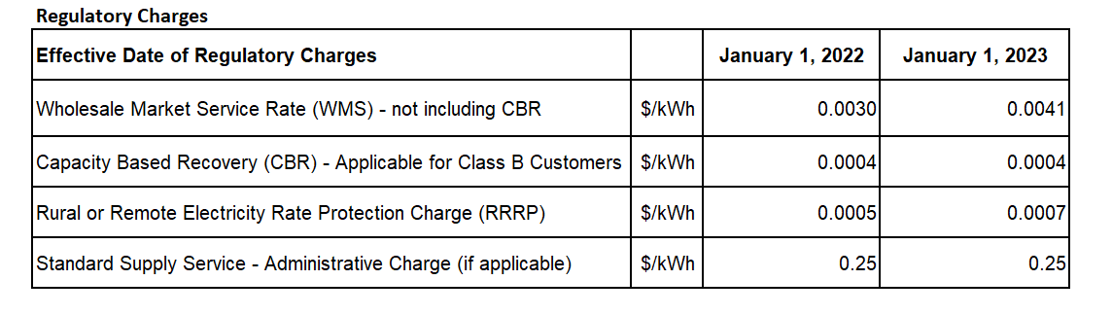
- Please confirm the accuracy of the updates.

Staff Question- 3
Ref 1: IRM Rate Generator Tab 11 – Retail Service Transmission Rates (RTSRs)
Ref 2: Decision and Order, EB-2021-0110

OEB staff made the following updates to Tab 11 of the rate generator model:
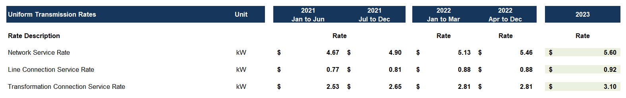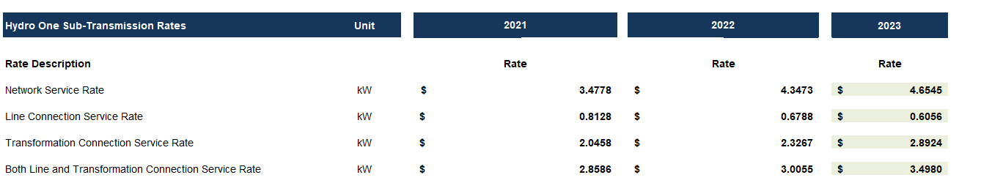
- Please confirm the accuracy of the updates.

Staff Question- 4
Ref 1: Manager Summary, p. 12
Hydro 2000 states the following in Reference 1 regarding the disposition threshold for the Group 1 deferral and variance accounts: “Since the threshold was met, Hydro 2000 is therefore not seeking disposal of its deferral and variance account in this proceeding.”
OEB staff notes this is a typo because the rest of the application indicates otherwise.
Question(s):
- Please confirm that Hydro 2000 is seeking the disposal of its Group 1 deferral and variance account on a final basis in this proceeding.

Staff Question- 5
Ref 1: Manager Summary, p. 14
Ref 2: 2023 IRM Rate Generator Model

Hydro 2000 states the following in Reference 1 regarding the disposition period for the Group 1 deferral and variance accounts: “The proposed rate riders sought for recovery or refund of balances proposed for disposition over the default period of two years.”

OEB staff finds this statement conflicts with the proposed and also default rate rider recovery period of 12 months indicated in Reference 2.

Question(s):

- Please confirm that the recovery period for the disposition of the Group 1 deferral and variance accounts is a default 12-month period.

Staff Question- 6
Ref 1: 2023 GA Analysis Workform
Ref 2: 2023 IRM Rate Generator Model

OEB staff finds the net change in principal balance in the GL stated in Reference 1 Tab GA 2021 cell C75 (a credit balance of $2,460) does not agree to the transactions during 2021 amount of $1,550 stated in the continuity schedule.

Question(s):

- Please explain the discrepancy noted above and update the relevant schedule/model as applicable.
Staff Question- 7
Ref 1: 2023 GA Analysis Workform

Per Tab GA 2021 in Reference 1, Hydro 2000 states a reconciling item of a credit amount of $6,071 due to variances from December consumption recorded in January.
OEB staff notes that Hydro 2000 did not indicate whether this adjustment is a principal adjustment on the DVA continuity schedule.

In addition, OEB staff notes there is no corresponding principal adjustment on DVA Continuity Schedule.
Question(s):
- Please confirm if there is a principal adjustment made in the GL for the unbilled December consumption.
- If so, please complete the Principal Adjustments tab in the GA Workform and update the relevant schedule/model as applicable.
- If not, please provide an explanation and update the relevant schedule/model as applicable.

Staff Question-8
Ref 1: 2023 IRM Rate Generator Model
Ref 2: Manager Summary, p. 12-13
Ref 3: Manager Summary, p. 16-17
Ref 3: EB-2021-0030, 2022 IRM Application Manager Summary, p.16

Hydro 2000 states in Reference 2, that variances between RRR and continuity schedule for Accounts 1588 and 1589 resulted from the utility using the OEB’s true-up template versus the previous method. The variances are provided in Reference 2 as shown below.

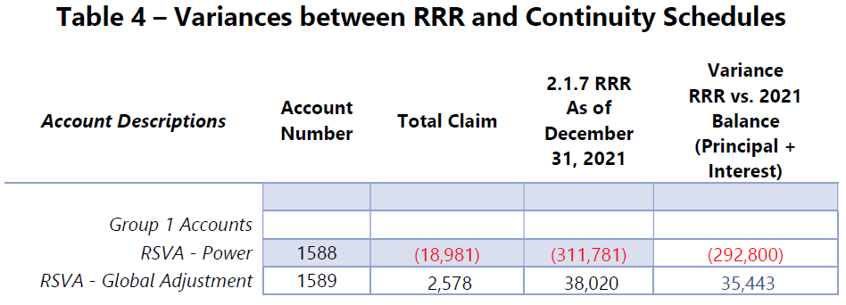

In Reference 2, Hydro 2000 also provided Table 5 Derivation of Variances to show the differences and derivation between the two methods.
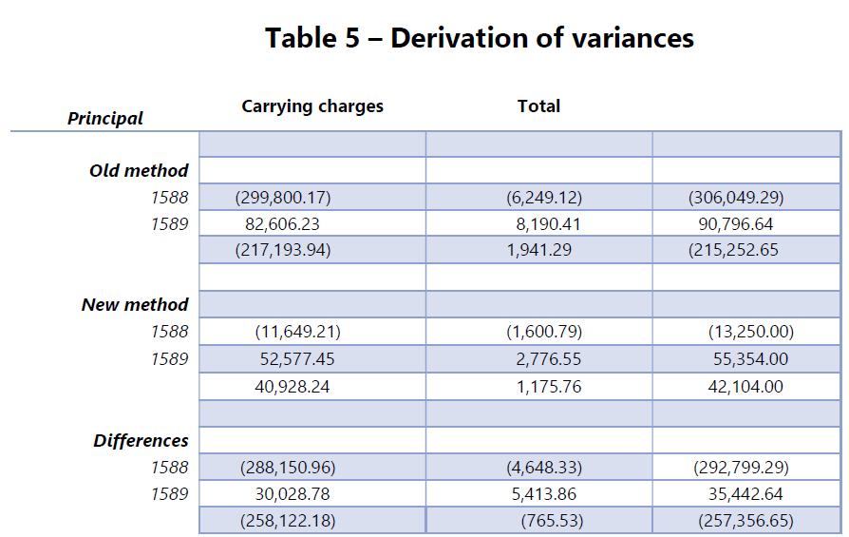

Hydro 2000 provided further explanation regarding the variances in Reference 3. OEB staff finds Hydro 2000 provided a similar explanation in the Manager Summary from the 2022 IRM application, in which Hydro 2000 stated the following,

Based on these facts, it was evident that an adjustment needed to be made to the variance accounts to bring them to their newly determined balances, with the other side of the entry impacting retained earnings in the form of a recast in the financial statements. This adjustment was completed while preparing the 2021 IRM.
Question(s):
- It appears that the balances for Accounts 1588 and 1589 under the old method provided in Table 5 are as of Dec 31, 2019. Please confirm and update the table to reflect the balances as of December 31, 2021, as applicable.

- OEB staff finds that the balances for Accounts 1588 (credit balance of $13,250) and 1589 ($55,354) provided in table 5 do not agree with the balances in the continuity schedules (1588 credit balance of $3,821, 1589 $1,787). Please explain and update the table to reflect the balances as of December 31, 2021, as applicable.

- Please confirm if the adjustment mentioned in Reference 4 has been made to the GL. If yes, please clarify in which year the adjustment was made. If not, why not?

