Welland Hydro Electric-Corporation

OEB Staff Questions

EB-2022-0068

**Welland Hydro Electric-Corporation**

**EB-2022-0068**

**Staff Question-1**

**Reference: IRM Rate Generator, Tab 3: Continuity Schedule**

**Preamble:**

There is a large increase in the total claims for Account 1580 RSVA Wholesale Market Service Charge and Account 1584 RSVA Retail Transmission Network Charge in the 2023 filed Rate Generator Model (Top table) as compared to the claim amounts in the 2022 final IRM Rate Generator Model (Bottom table).

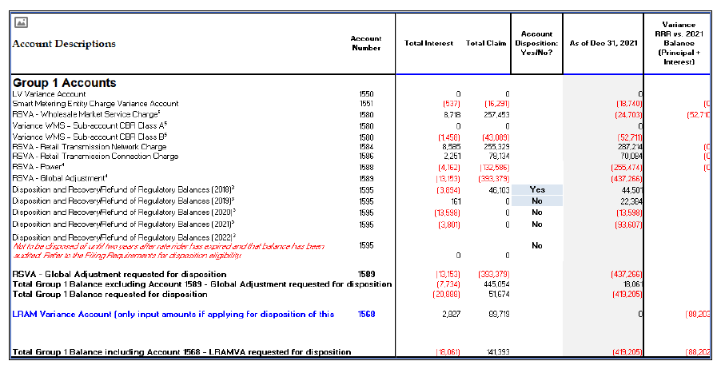

**Figure 1: 2023 filed Rate Generator Model**

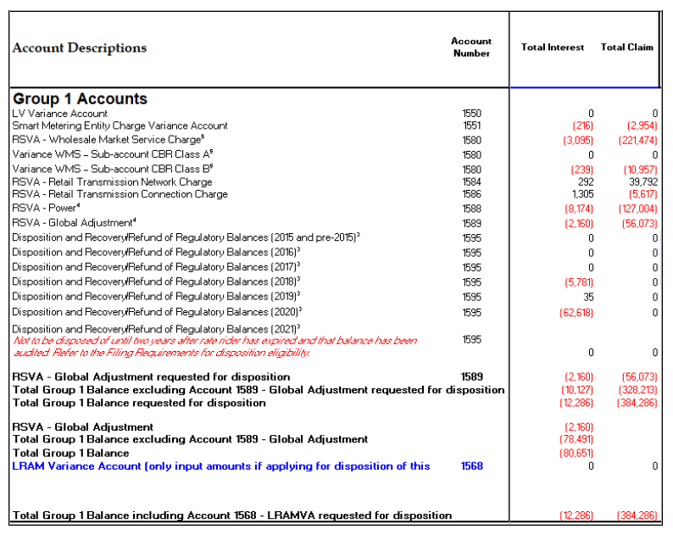

**Figure 2: 2022 final IRM Rate Generator Model**

**Questions:**

1. Please explain the reason in the significant change of the total claim for the Account 1580 RSVA Wholesale Market Service Charge from a credit of $221,474 in the 2022 application to a debit of $257,453 in the current application.

**Response:**

**Welland Hydro pays WMS charges to the IESO for services provided by the IESO to operate the electricity system and administer the wholesale market. Welland Hydro recovers these costs from their customers through the WMS rate, which is authorized by the OEB under section 78 of the OEB Act.**

**In the OEB’s Decision and Order (EB-2022-0269) related to regulatory charges effective January 1, 2023, it was identified that there was an under collection of revenue by distributors in 2021 and January to October 2022. Table 1 from the Decision and Order is shown below:**

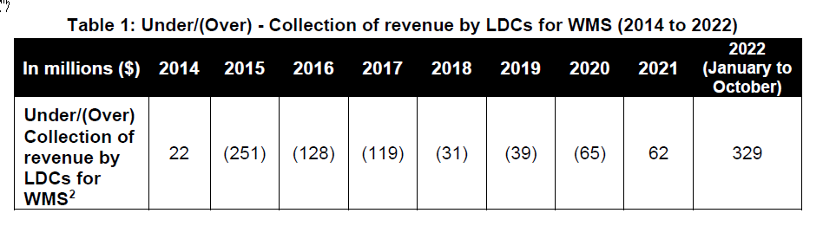

**Table 1 identifies an over collection of revenue by LDCs in 2020, followed by an under collection of revenues by LDCs in 2021. This is consistent with the change in Welland Hydro’s total claim for the Account 1580 RSVA Wholesale Market Charge from a credit of $221,474 in its 2022 application (based on 2020 year-end balances) to a debit of $257,453 in its current application (based on 2021 year-end balances). Welland Hydro has reviewed and confirmed that it’s 2020 and 2021 WMS related charges on it’s monthly IESO invoices have been recorded in the correct account. Welland Hydro has also reviewed and confirmed that the charges billed to customers in 2020 and 2021 related to the recovery of WMS charges was correct.**

1. Please explain the significant change in the total claim for the Account 1584 RSVA Retail Transmission Network Charge from a debit of $39,792 in the 2022 application to a debit of $255,329 in the current application.

**Response:**

**Welland Hydro is invoiced monthly by the IESO for actual transmission costs. Welland Hydro recovers transmission costs from their customers through Retail Transmission Service Rates (RTSRs), which are established for each rate class and approved by the OEB annually.**

**Welland Hydro has experienced a significant increase in the total claim for Account 1584 Retail Transmission Network Charge from a debit of $39,792 in its 2022 application (based on 2020 year-end balances) to a debit of $255,329 in its current application (based on 2021 year-end balances). The primary reason for the increase in the Account 1584 balance in the current application is due to timing, and the misalignment of the actual rate Welland Hydro is being charged by the IESO compared to the rate by which Welland Hydro is recovering these costs from its customers.**

**The RTSRs that Welland Hydro bills its customers to recovery transmission costs are approved in it’s annual Tariff of Rates and Charges. These rates are effective for the period of May 1 to April 30. Welland Hydro is billed transmission rates by the IESO for rates effective for the period of January 1 to December 31. As a result, from January to April, Welland Hydro is invoiced transmission charges at newly established rates, while it recovers these costs from customers through rates established using previous year’s UTRs.**

**For the 2020 calendar year, Welland Hydro was invoiced by the IESO for transmission costs at a UTR rate of $3.92/KW/month. From May to December 2020 Welland Hydro recovered transmission costs from customers based on the same rate of $3.92/KW/month. However, from January to April 2020, Welland Hydro’s recovery rate was based on the 2019 UTR rate of $3.61/KW/month. As a result, Welland Hydro under-recovered transmission costs from customers during the period of January to April 2020 in the amount of $0.31/KW/Month ($3.92-$3.61).**

**For the 2021 calendar year, Welland Hydro was invoiced by the IESO for transmission costs at a UTR rate of $4.67/KW/month for the months of January to June, and at a UTR rate of $4.90/KW/month for the months of July to December. From May to December 2021 Welland Hydro recovered transmission costs from customers based on the original approved rate of $4.67/KW/month. From January to April 2021, Welland Hydro’s recovery rate was based on the 2020 UTR rate of $3.92/KW/month. Although the rate charged to Welland Hydro by the IESO was increased from $4.67/KW/month to $4.90/KW/month effective July 1, 2021, there was no similar adjustment made to the RTSR rate billed to customers. As a result, Welland Hydro under-recovered transmission costs from customers during the period of January to April 2021 in the amount of $0.75/KW/Month ($4.67-$3.92), and from the period of July to December in the amount of $0.23/KW/month ($4.90-$4.67).**

**In summary, the reason for the large increase in the Account 1584 balance in the current IRM application is due to the larger rate differential from January to April 2021 compared to the same period of 2020. In addition, there was a subsequent rate differential during the period of July to December 2021 due to the increased costs to Welland Hydro that were not incorporated into the rates used to recover these costs from customers.**

**Staff Question-2**

**Reference: Manager’s Summary Pages 11-12**

**IRM Rate Generator Model, Tab 4: Billing Det. For Def-var**

**Preamble:**

The balance of Group 1 accounts in tab 4 of the rate generator model is a debit amount of $51, 674 which equates $0.0001 and does not pass the threshold test. Consistent with a letter from the OEB issued July 25, 2014 distributors may elect to dispose of Group 1 account balances below the threshold.

On page 11 of the Manager’s Summary, Welland Hydro requests to dispose of all Group 1 account balances totalling a debit of $51,674.

On page 15 of the Manager’s Summary, Welland Hydro requests to dispose of Group 1 account balances excluding Global Adjustment and CBR Class B, in the debit amount of $488,143.

The filing requirements state that distributors should assess the practicality of disposing of what may be small balances for one or more classes.

**Questions:**

1. Please clarify whether Welland Hydro’s disposition request for the Group 1 account balances includes the Global Adjustment and CBR Class B accounts.

**Response:**

**Welland Hydro confirms that it’s request for disposition of Group 1 account balances totalling a debit balance of $51,674, is inclusive of the Global Adjustment and CBR Class B accounts.**

**Welland Hydro is requesting to dispose of the Global Adjustment account balance related to Class A transition customers, in the credit amount of $32,319, through equal monthly payments as calculated on Tab 6.1a of the IRM Rate Generator Model. Welland Hydro is requesting to dispose of the Global Adjustment account balance related to non-RPP Class B non-transition customers, in the credit amount of $361,060, through rate riders as calculated on Tab 6.1 of the IRM Rate Generator Model. The total Global Adjustment being disposed of through equal monthly payments and the separate Global Adjustment rate riders is a credit of $393,379.**

**Welland Hydro is requesting to dispose of the CBR Class B account balance related to Class A transition customers, in the credit amount of $1,126, through equal monthly payments as calculated on Tab 6.2a of the IRM Rate Generator Model. Welland Hydro is requesting to dispose of the CBR Class B account balance related to Class B non-transition customers, in the credit amount of $41,963, through rate riders as calculated on Tab 6.2 of the IRM Rate Generator Model. The total CBR Class B balance being disposed of through equal monthly payments and the separate CBR Class B rate rider is a credit of $43,089.**

**Welland Hydro is requesting to dispose of the Group 1 account balances, excluding all Global Adjustment and CBR Class B account balances, in the amount of a $488,143 debit, through rate riders as calculated on Tab 7 of the IRM Rate Generator Model.**

**A summary of the requests for disposition can be seen in the table below:**



1. If the disposition request includes the Global Adjustment and CBR Class B account and thereby the debit amount is below the threshold, please explain the impact of the disposition of the Group 1 account balances on each rate class.

**Response:**

**Welland Hydro has calculated the impact of the disposition of the Group 1 account balances on each rate class in the Table below. A significant portion of the Global Adjustment credit account balance is related to the GS>50 customer class. As a result, although the overall debit balance in the amount of $51,674 is not significant, the impact between the GS>50 and the Residential customer classes is significant. If approved, the Residential customer class will be allocated a $201,836 debit balance, while the GS>50 customer class will be allocated a $177,773 credit. As a result, Welland Hydro is requesting that all Group 1 account balances be disposed of in this IRM Rate Application.**

**A summary of the impact by rate class can be seen in the table below:**



**Staff Question-3**

**Reference: Manager’s Summary Page 23**

**IRM Rate Generator, Tab 6: Class A Consumption Data**

**Preamble:**

Page 23 of the Manager’s Summary states that class A customers did not contribute to the CBR balance. However, ‘Yes’ was selected in cell c21 on tab 6 of the rate generator indicating that Class A customers contributed to the CBR balance.

**Question:**

1. Please clarify whether class A customers contributed to the CBR balance. Please update the evidence as appliable.

**Response:**

**On page 23, lines 5 to 7, of the Manager’s Summary, Welland Hydro states that “The Class A *non-transition* customers will not receive the CBR Class B rate rider that applies to all Class B customers as they were billed actual CBR Class A costs and therefore did not contribute to the CBR Class B variance balance”. Welland Hydro clarifies that the “Class A *non-transition* customers” represents those customers who were designated Class A during the entire period the CBR Class B balance accumulated.**

**Cell b21 on tab 6 of the rate generator states “Did you have any customers who transitioned between Class A and Class B (*transition customers*) during the period the Account 1580, sub-account CBR Class B balance accumulated? Welland Hydro did have 3 “transition” customers who transitioned between Class A and Class B and therefore the selection of “yes” in cell c21 on tab 6 remains the appropriate response.**

**Staff Question-4**

**Reference: IRM Rate Generator, Tab 8: STS Tax Change**

**Preamble:**

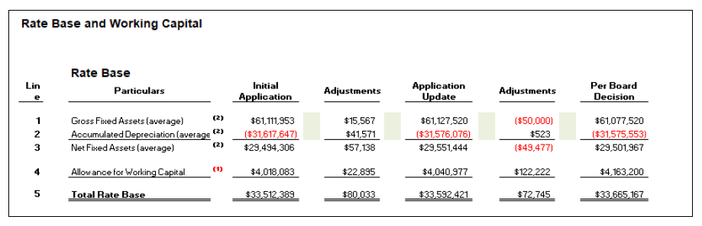

**Figure 3: EB-2016-0110, Revenue Requirement Workform**

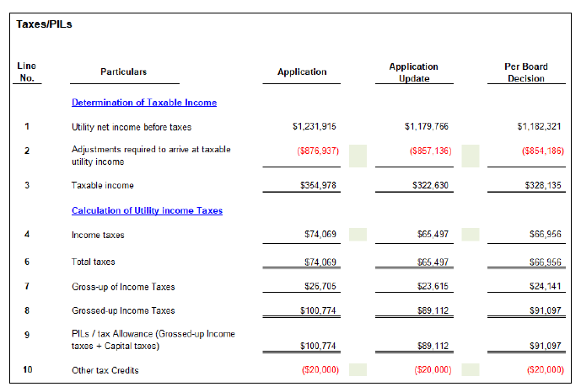

**Figure 4: EB-2016-0110, Revenue Requirement Workform**

The value entered in cell H16 of the Rate Generator does not match the “total Rate

Base” of $33,665,167 in the RRWF “Rate Base and Working Capital” section of the last

COS application.

The value entered in cell H18 of the Rate Generator does not match the “Taxable

Income” of $328,135 in the RRWF “Taxes/PILs” section of the last COS application.

The value entered in cell H40 of the Rate Generator does not match the “Other Tax

Credits” of ($20,000) in the RRWF “Taxes/PILs” section of the last COS application.

**Questions:**

1. Please review the value entered for the Total Rate Base amount in the Rate

Generator and update the value entered as applicable.

**Response:**

**Welland Hydro has updated the value entered for the Total Rate Base amount in the Rate Generator model to match the total Rate Base of $33,665,167 per the last COS application. Welland Hydro is not requesting any tax change rate riders in this application.**

1. Please review the value entered for the Taxable Income amount in the Rate

Generator and update the value entered as applicable.

**Response:**

**Welland Hydro has updated the value entered for the Taxable income amount in the Rate Generator model to match the Taxable Income of $328,135 per the last COS application. Welland Hydro is not requesting any tax change rate riders in this application.**

**Staff Question-5**

**Reference: (1) Description of LRAMVA Claim, November 1, 2022**

**Preamble:**

The 2021 CDM Guidelines (section 8) require distributors filing an application for 2023 rates to seek disposition of all outstanding LRAMVA balances related to previously established thresholds, including approval of LRAM-eligible amounts in future years (arising from persisting savings) until a distributor’s next rebasing application, unless a distributor does not have complete information on eligible savings.

**Questions:**

1. Please confirm if Welland Hydro is seeking disposition of all outstanding LRAMVA balances and whether the LRAMVA will have a zero balance if disposition is approved.

**Response:**

**Welland Hydro confirms that it is seeking disposition of all outstanding LRAMVA balances. If disposition is approved, Welland Hydro confirms that LRAMVA will have a zero balance.**

1. Please confirm that Welland Hydro will not be seeking to dispose of any balance in the LRAMVA due to LRAM-eligible CDM activities funded by the IESO through the Conservation First Framework or Interim Framework in a future year’s application.

**Response:**

**Welland Hydro confirms that it will not be seeking to dispose of any balance in the LRAMVA due to LRAM-eligible CDM activities funded by the IESO through the Conservation First Framework or Interim Framework in a future year’s application.**

**Staff Question-6**

**Reference: Excel LRAMVA Work Form, Tab 1a**

**Preamble:**

Tab 1a (Cell B 21) states the following:

Please document any changes in assumptions made to the generic inputs of the LRAMVA work form. This may include, but are not limited to, the use of different monthly multipliers to claim demand savings from energy efficiency programs; use of different rate allocations between current year savings and prior year savings adjustments; inclusion of additional adjustments affecting distribution rates; etc. All changes should be highlighted in the work form as well.

**Question:**

1. Please clarify if any changes have been made in the LRAMVA work form and not documented in Tab 1a.

**Response:**

**Welland Hydro confirms that it has not made any changes in the LRAMVA work form.**

**Staff Question-7**

**Reference: IRM Rate Generator Tab 17, 19 and 20**

OEB staff has updated the following in the rate generator:

* Inflation Factor 3.70%
* Tab 11: UTRs
* Tab 11: Host-RTSRs (HONI)
* Tab 17: TOU RPP Prices (Nov 1, 2022, rather than May 1, 2022)
* Tab 17: SME charge from $0.43 to $0.42.
* Tab 17: DRP $38.08
* Tab 17: WMS $0.0041/kwh
* Tab 17: RRRP $0.0007/kwh
* Tab 20: OER 11.7%

**Question:**

1. Please confirm these updates are correct.

**Response:**

**Welland Hydro confirms that the updated rates as listed above have been correctly reflected in the IRM Rate Generator Tab 17, 19 and 20.**