E.L.K. Energy Inc.
EB-2022-0023
OEB Staff 2nd Round Follow-up Questions
February 16, 2023

Please note, E.L.K. Energy Inc. (E.L.K.) is responsible for ensuring that all documents it files with the OEB, including responses to OEB staff questions and any other supporting documentation, do not include personal information (as that phrase is defined in the Freedom of Information and Protection of Privacy Act), unless filed in accordance with rule 9A of the OEB’s Rules of Practice and Procedure.

2nd Round Follow-up Question-1
Ref: Rate Generator Model – Tab 3 Continuity Schedule, Account 1595 (2018)
It’s noted that E.L.K. has the input in cell BU33 (Disposition Option) to “Yes” in the Continuity Schedule.
- Please confirm if E.L.K. is proposing to dispose of Account 1595 (2018) in the current application.
- There is a credit balance of $(97,323) in Account 1595 (2018) in Principal Transaction in the year of 2021 (cell BD33). Please provide explanation for this transaction amount in 2021.
- There is a non-zero variance of $(108,111) in Account 1595 (2018) between RRR and continuity schedule balances in cell BW33. Please provide explanation for this variance.
2nd Round Follow-up Question-2
Ref1: Rate Generator Model – Tab 3 Continuity Schedule, 2020 Year-end Balances in Accounts 1550, 1551, 1580 (including sub-accounts), 1584 and 1586
Ref2: EB-2021-0016, ELK_DVA_DVA Continuity Schedule_Settlement_20220610 (excel model), Tab 2a Continuity Schedule
- The 2020 year-end balances in Accounts 1550, 1551, 1580 (including Sub-Account CBR Class B), 1584 and 1586 entered in columns AW and BB do not match the 2020 year-end balances in Reference 2 evidence filed with the Settlement Proposal in E.L.K.’s 2022 Cost of Service proceeding. (Please see screenshot below.) Please make necessary updates for the 2020 year-end balances in the current Continuity Schedule. Otherwise, please provide explanations for the differences.
Ref 1:
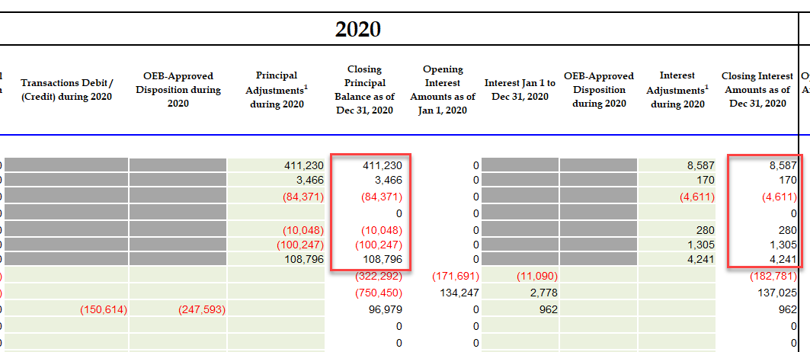
Ref 2:
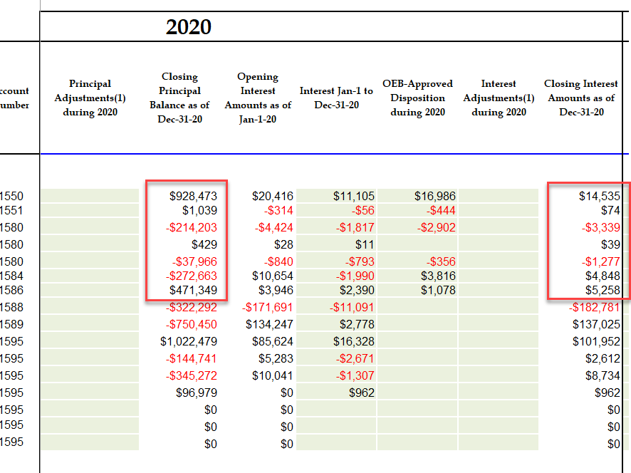
- After any updates are made in part a), if there are any non-zero variances in column BW in these accounts, please provide explanations.

