SYNERGY NORTH CORPORATION

2023 Electricity Distribution Rate application
Disposal of accounts 1588 & 1589
bifurcated from EB-2022-0063

ONTARIO ENERGY BOARD

IN THE MATTER OF the Ontario Energy Board Act, 1998, being Schedule B to the Energy Competition Act, 1998, S.O. 1998, c.15;

AND IN THE MATTER OF an Application by SYNERGY NORTH CORPORATION to the Ontario Energy Board for an Order or Orders approving or fixing just and reasonable rates and other service charges for the distribution of electricity as of May 1, 2023.

TITLE OF PROCEEDING: An Application by SYNERGY NORTH CORPORATION for an Order or Orders by Rate Zone approving or fixing just and reasonable distribution rates and other charges, effective May 1, 2023.

Application – Relief Sought

- SYNERGY NORTH CORPORATION (SYNERGY NORTH) is a distributor as defined in, and is licensed as such under, the Ontario Energy Board Act, 1998 (the “Act”). SYNERGY NORTH holds Electricity Distribution Licence ED-2018-0233.

- SYNERGY NORTH hereby applies to the Ontario Energy Board (the “Board”), pursuant to section 78 of the Act, for an Order or Orders approving or fixing just and reasonable rates for distribution service effective May 1, 2023. This Application is made in accordance with the Board’s update to Chapter 3 of the Filing Requirements for Electricity Distribution Rate Applications – 2022 Edition for 2023 Rate Applications, issued on May 24, 2022, and using the October 13, 2016, Handbook for Utility Rate Applications (the Handbook) IR methodology, including the following for each of SYNERGY NORTH’S Rate Zones:

  - Specifically, an election to dispose of Group 1 RSVA Accounts 1588 and 1589 balances, per Section 3.2.5 of Chapter 3 of the Filing Requirements for Electricity Distribution Rate Applications, issued on May 24, 2022, for both Zones.

- If the effective date does not coincide with the Board’s decided implementation date for 2023 distribution rates and charges, SYNERGY NORTH requests permission to recover the incremental disposal or recovery from the effective date to the implementation date.

- SYNERGY NORTH has used the Board’s Excel Model: 2023 IRM Rate Generator (“2023 Rate Model”) posted June 30, 2022, for this application.

- This Application is supported by the written evidence comprising of a Manager’s Summary and excel models. SYNERGY NORTH may amend or supplement this written evidence prior to or during the Board’s hearing of this Application.

3.1 Manager’s Summary

3.1 Introduction

SYNERGY NORTH is a corporation amalgamated under the laws of Ontario, with its head office in the City of Thunder Bay. SYNERGY NORTH carries on the business of distributing electricity within the City of Thunder Bay, Fort William First Nation Reserve, and the City of Kenora. SYNERGY NORTH CORPORATION is the name of the amalgamated corporation combining Thunder Bay Hydro Electricity Distribution Inc. and Kenora Hydro Electric Corporation Ltd. effective January 1, 2019. The amalgamation was approved by the Ontario Energy Board as documented in the MAAD Application (EB-2018-0124). The applicant has not yet rebased as an amalgamated company and maintains two sets of tariffs of rates and charges. For the proposed application the applicant will refer to them as the “Thunder Bay Rate Zone” and “Kenora Rate Zone”.

SYNERGY NORTH submits this stand-alone Bifurcated application, as a result of an OEB Staff Follow Up Question of January 25, 2023, 3(b), in EB-2022-0063. It was requested that, given the material impact of the proposed retroactive adjustments, Synergy North consider withdrawing the disposition of accounts 1588 and 1589 for both zones in the 2023 IRM application or request for the disposition of Group 1 DVAs at an interim basis. Synergy North filed a letter on February 15, 2023 stating that balances in Accounts 1588 and 1589 would be removed from the Group 1 RSVA disposal request in the 2023 IRM Application and disposal of these accounts would be requested in a stand-alone application.

SYNERGY NORTH submits herein an application (the “Application”) to bifurcate application EB-2022-0063, whereby “Phase 1” included distribution rates relating to the IRM adjustments, Group 1 Accounts (excluding 1588 & 1589) and the LRAMVA, for proposed distribution and transmission rates effective May 1, 2023, for both Thunder Bay and Kenora Rate Zones. SYNERGY NORTH is filing this “Phase 2” of the application to dispose of Group 1 RSVA 1588 & 1589 balances for both Thunder Bay Rate Zone and Kenora Rate Zone.

SYNERGY NORTH requests that this application be disposed of by way of a written hearing.

SYNERGY NORTH acknowledges that all customer rate classes will be impacted in both Zones by this application.

3.1.2 Components of the Application Filing

SYNERGY NORTH has included in this application the following for both the Thunder Bay and Kenora Rate Zones:
- Managers Summary.
- Contact Information.
- Rate Generation Model & Supplemental Global Adjustment Workform for each Rate Zone.
- Supporting documentation, validated reporting record keeping requirements, and other data referred to in the application for each Rate Zone.
- A statement of who will be affected by the application and particular bill impacts for both Rate Zones.
- Confirmation of the Applicants internet address.
- Statement of confirmation related to accuracy of the billing determinants for each Rate Zone.
- Text searchable Adobe PDF format for all documents.
- Certification of accuracy, consistency and completeness by a senior officer.

3.1.2.1 Contact Information

The following is the contact information for SYNERGY NORTH in this proceeding:

Applicant’s Address for Service: 34 Cumberland St. N.
Thunder Bay, Ontario
P7A 4L4

Primary Contact for Electricity Distribution Licence:

Aaron Blazina, CPA, CA Phone: 807-343-1118
Vice President, Finance Fax: 807-343-1009
Email: ablazina@synergynorth.ca

Primary Contacts for the Application:

Janice Robertson, CPA, CA Phone: 807-467-8014
Manager, Regulatory & Financial Fax: 807-343-1009
Assurance, Kenora Email: jrobertson@synergynorth.ca

3.1.2.2 / 3.1.2.3 List of Attachments

The final page of this document lists the electronic files which have been uploaded along with this application.

3.1.2.4 Supporting Documentation

SYNERGY NORTH confirms that it has provided supporting documentation where appropriate as support to the models mentioned in the 3.1.2.3 List of Attachments for both Rate Zones. SYNERGY NORTH has also confirmed it has validated any references to the 2021 year-end RRR reporting record keeping requirements and other data referred to in the application for both Rate Zones.

3.1.2.5 Notice of Application

SYNERGY NORTH recognizes that all of its customer classes will be affected by the outcome of this “Phase 2” of the rate application.

3.1.2.6 Confirmation of Application

SYNERGY NORTH will provide its customers a link to the website where this application will be posted. If a customer requires a physical copy to accommodate special needs or by specific request SYNERGY NORTH will provide one at its customer service desk, as well as publish any updates directly to its public website for purposes of viewing the application, previous applications and related documents.

SYNERGY NORTH’s Public Website Address: https://synergynorth.ca/

3.1.2.7 Certification of Evidence
SYNERGY NORTH’s Vice President of Finance certifies that the evidence filed in this bifurcation of the 2023 IRM Rate Application, is accurate to the best of his knowledge for both Thunder Bay and Kenora Rate Zones.

3.1.3 Applications and Electronic Models

SYNERGY NORTH has used the Board’s 2023 IRM Rate Generator as updated by the Board June 30, 2022. SYNERGY NORTH has completed the 2023 Rate Models in accordance with the Board staff instructions. SYNERGY NORTH does not have any unique rate classes for either Rate Zone.

SYNERGY NORTH confirms the accuracy of the pre-populated billing determinates, customer counts for Residential and GS<50 Classes and customer volume, as included in Tab 4. ‘Billing Det. For Def Var’ of the models for both Rate Zones. Additionally, SYNERGY NORTH has completed Tab 3. ‘Continuity Schedule’ and confirms the entries in column “BV”, representing Group 1 1588 & 1589 Deferral and Variance Account balances, as of December 31, 2021 are accurate for both Thunder Bay and Kenora Rate Zones.

SYNERGY NORTH confirms that it has not diverged from the Board’s model concept or modified the 2023 Rate Models to be different than the OEB published models.

3.2.5 Review and Disposition of Group 1 1588 & 1589 Variance Account Balances

SYNERGY NORTH is applying to dispose of the Group 1 1588 & 1589 balances Deferral and Variance Accounts, as of December 31, 2021, for both Thunder Bay and Kenora Rate Zones. Carrying charges in 2021 were calculated using the Board’s monthly prescribed interest rates. Estimated carrying charges from January 1, 2022 to Dec 31, 2022 are calculated using an average of the Board’s 2022 rates, 1.9%. Projected carrying charges from January 1, 2023 to April 30, 2023 are calculated using the Board’s most recent first quarter 2023 rate of 4.73%.

Retroactive Adjustment to Account 1588

In preparing responses to OEB Staff Questions of December 13, 2022 on Application EB-2022-0063, SYNERGY NORTH discovered an error in billing codes, which had resulted in an underpayment to the IESO and excess credits accumulating in Account 1588 for both Zones.

SYNERGY NORTH customers in the Price Protected General Service Over 50 kW customer class transitioned from non-interval meters to interval (real time) meters. Billing components within customer accounts differ between non-interval and real time meters. Additional components for real time metering were added to accounts during the transition to real time meters, which included the additions of “RTP” (real time pricing) and “RTN” (real time pricing offset) components. The original “NSLS” (HOEP) and “NSOS” (HOEP offset) on the non-interval meter components were not removed when the real time meters were implemented.

Prior to the addition of the real time components, when an account billed with a non-interval meter, the accounts had the correct components. The price protected accounts with real time meters consequently had two (one from RTN and one from NSOS) debits being recorded to the IESO settlement general ledger account. Customer bills were correctly calculated. This duplication of components did not impact the total amounts charged on any bill to any customer class.

This difference has resulted in underpayments to the IESO, and an overstated credit in Account 1588.
The error has the following annual impacts, with settlements to the IESO being underpaid, and Account 1588 having an excess credit of:
Table 1: Account 1588 Error by Year:
YEAR | KENORA | THUNDER BAY
2021 | $ 136,784 | $ 864,240
2020 | $ 31,084 | $ 442,963
2019 | $ 0 | $ 236,071
2018 | $ 0 | $ 70,446
2017 | $ 0 | $ 33,575
2016 | $ 0 | $ 25,710
Prior to 2020, the Kenora zone did not have Price Protected Over 50 kW class customers with real time metering.
Thunder Bay Hydro Electricity Distribution filed a Cost-of-Service Application EB-2016-0105 for rates in 2017, disposing Account 1588 balance on a final basis as of December 31, 2015. In this response, errors from 2016 to December 31, 2021 have been presented.
In application EB-2021-0058, both Thunder Bay and Kenora rate zones had their respective December 31, 2020 balances in Account 1588 disposed of on a final basis.

This error has previously been undetected due to its immaterial impact on Account 1588, however as more of the Over 50 kW accounts have been transitioned to Real Time meters, the impact on Account 1588 has been increasing.

The Board’s October 31, 2019 letter “Re: Adjustments to Correct for Errors in Electricity Distributor “Pass-Through” Variance Accounts After Disposition” (“OEB Letter”) permits retroactive adjustments on a case-by-case basis to correct for errors in electricity distributor “Pass-Through” variance accounts after final disposition, including account 1588.

For the reasons that follow, SYNERGY NORTH requests that the OEB correct the balances in Account 1588 for the years that have been disposed on both a final and interim basis in accordance with the proposal below. While the adjustments are in favour of the IESO, the proposed adjustments are aligned with the intent of the OEB Letter and serve the public interest.

With respect to amounts that have been disposed on a final basis, the OEB has listed four factors that will be considered in making such a determination on a case-by-case basis:
- Whether the error was within the control of the distributor.
- The frequency with which the distributor has made the same error.
- Failure to follow guidance provided by the OEB.
- The degree to which other distributors are making similar errors.

In response to each of these factors, SYNERGY NORTH submits as follows:
- SYNERGY NORTH acknowledges that the error was within its control. However, the error was not intentional and not easily identifiable given the small variance.
- This is the first time SYNERGY NORTH has requested retroactive adjustment due to an error in Account 1588. SYNERGY NORTH will not be profiting from this error. Rather it is a correction to ensure proper payment is remitted to the IESO. No benefit will accrue to SYNERGY NORTH if the balances are corrected.
- SYNERGY NORTH is not aware of any guidance from the OEB issued in relation to this issue.
- As noted by the OEB in Decision EB-2022-0067 (pages 10-11), the OEB acknowledges that other distributors make similar errors in 1588 given the accounting complexities to calculate the accounting entries.

THUNDER BAY RATE ZONE

Proposed Dispositions

The total of Group 1 Accounts 1588 & 1589 to be disposed of for the Thunder Bay Rate Zone is $(414,668).

Table 2: Thunder Bay Rate Zone Proposed Disposition by Principal and Interest
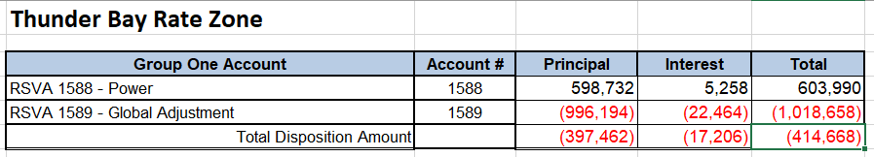

Account 1588 Proposed Disposition

Retroactive Adjustment to Account 1588 for the Thunder Bay Rate Zone

A current year principal adjustment to Account 1588 in the Thunder Bay Zone of $864,240 (2021 year), plus two retroactive adjustments of $442,963 (2020 year) and $236,071 (2019 year) have been made in the “Principal Adjustments” Tab of the GA Workform, correcting the RTN NSOS error as indicated in Table 1, for 2021, 2020 and 2019. Errors occurring prior to 2019 are not considered material and have not been included in this request for retroactive corrections to customers or correction with the IESO.

The balance of Account 1588 including the retroactive adjustments is $603,990. The following Table, taken from the IRM calculates the allocation by class and the resulting rate rider over a one year disposal period.

Table 3: Thunder Bay Rate Zone Group One 1588 Disposition and Riders

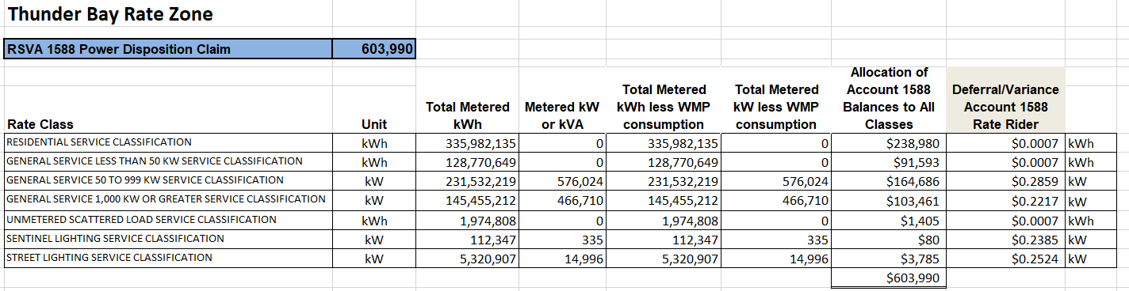

Account 1589 Proposed Disposition

The RSVA Global Adjustment balance for disposal in account 1589 is $(1,018,658) to be returned in a rate rider from Non-RPP customers (excluding Class A customers). There was one transition customer from Class B to Class A during 2021 (see Table 3), reducing the total to $(1,001,267) which will be disposed of to Class B Non-RPP customers.

Table 4: Thunder Bay Account 1589 Disposition and Riders
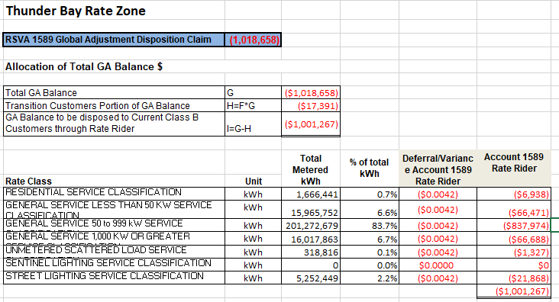
GA rate riders for all classes have been calculated on an energy basis (kWh) as per 2023 Filing Requirements section 3.2.5.2 and can be found on Tab 6.1 ‘GA’ in the 2023 Thunder Bay Rate Zone IRM Rate Generator Model.

A one-year disposition period is requested for the Group 1 1588 & 1589 RSVA Accounts, with rate riders effective May 1, 2023, until April 30, 2024.

Thunder Bay Rate Zone Bill Impacts

Table 5 is a summary of the bill impact for each rate class, based on Tab 20 of the 2023 IRM Rate Generator Model for the Account 1588 & 1589 Riders. Column “F” in Tab 20 of the IRM has been input as the Rates submitted in “Phase 1” of EB-2022-0063 to calculate the impact of the riders in this Bifurcated application.

Table 5 : Thunder Bay Rate Zone 2023 Bill Impact Summary
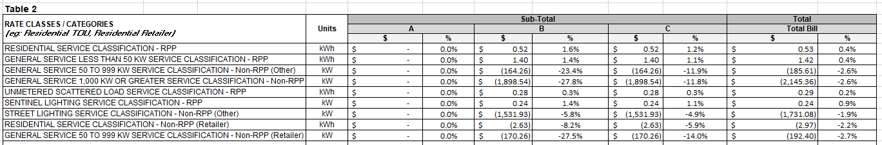
KENORA RATE ZONE

Proposed Dispositions

The total of Group 1 1588 & 1589 Accounts to be disposed of for the Kenora Rate Zone is $(40,762).

Table 6: Kenora Rate Zone Proposed Disposition by Principal and Interest
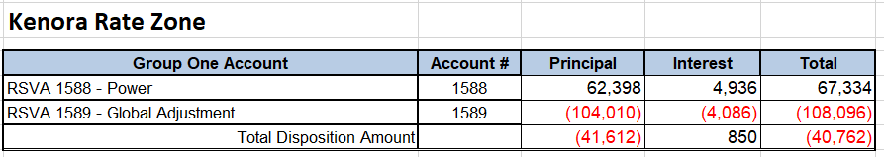

Account 1588 Proposed Disposition

Retroactive Adjustment to Account 1588 for the Kenora Rate Zone

A current year principal adjustment to Account 1588 in the Kenora Zone of $136,784 has been made in the “Principal Adjustments” Tab of the GA Workform, correcting the RTN NSOS error for 2021 as noted in Table 1. Errors occurring prior to 2021 are not considered material and have not been included as retroactive corrections to customers or corrections with the IESO.

The balance of Account 1588 including the 2021 adjustment is $67,334. The following Table taken from the IRM calculates the allocation by class and the resulting rate rider over a one year disposal period.

Table 7: Kenora Rate Zone Group One 1588 Disposition and Riders

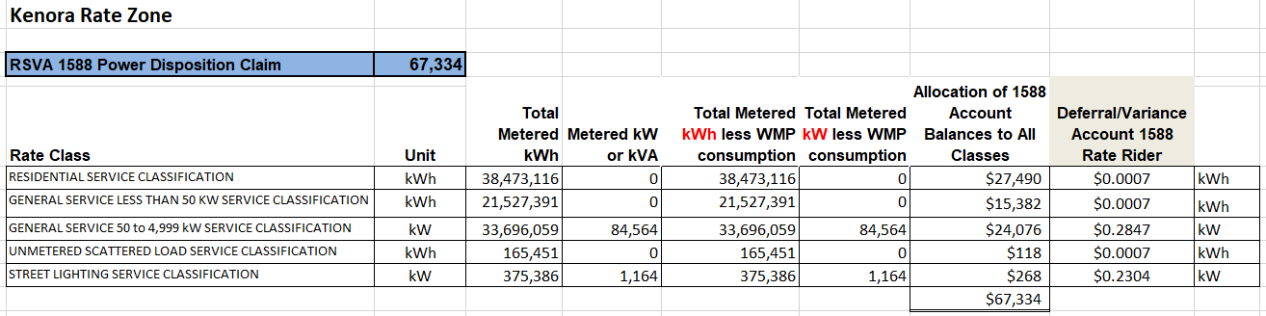
Account 1589 Proposed Disposition

The RSVA Global Adjustment balance for disposal in Account 1589 is $(108,096) to be returned in a rate rider from Non-RPP customers Class B customers. There were no Class A customers during 2021.

Table 8: Kenora Rate Zone Account 1589 Disposition and Riders
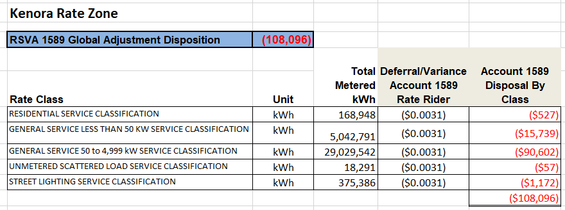

GA rate riders for all classes have been calculated on an energy basis (kWh) as per 2023 Filing Requirements section 3.2.5.2 and can be found on Tab 6.1 ‘GA’ in the 2023 Thunder Bay Rate Zone IRM Rate Generator Model.

A one-year disposition period is requested for the Group 1 Deferral and Variance Accounts, with rate riders effective May 1, 2023, until April 30, 2024.

Kenora Rate Zone Bill Impacts

Table 9 is a summary of the bill impact for each rate class, based on Tab 20 of the 2023 IRM Rate Generator Model for Account 1588 & 1589 Riders. Column “F” in Tab 20 of the IRM has been input as the Rates submitted in “Phase 1” of EB-2022-0063 to calculate the impact of the riders in this Bifurcated application.

Table 9: Kenora Rate Zone 2023 Bill Impact Summary
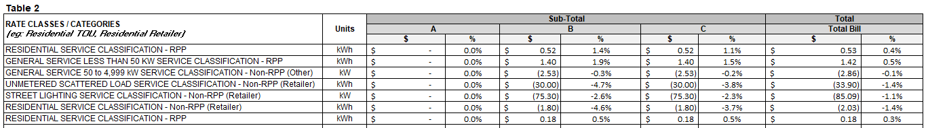

3.2.5.3 Global Adjustment

The majority of SYNERGY NORTH customers are Class B customers for both Thunder Bay and Kenora Rate Zones. There were 10 Class A customers from January to June, and 11 Class A customers from July to December in Thunder Bay Rate Zone during the 2021 year. There were no Class A customers in the Kenora Rate Zone during 2021. Class B customers pay the global adjustment (“GA”) charge based on the amount of electricity they consume in a month (kWh). Within the Class B group, there are two categories of customers: RPP customers who pay an RPP rate which has a built in GA adjustment component and the remaining Non-RPP customers who pay the Hourly Ontario Electricity Price, and a monthly GA price separately on their bills.

For Class B customers, RSVA 1589 GA captures the difference between the amounts billed (or estimated to be billed) to Non-RPP customers and the actual amount paid by the distributor to the IESO for those customers. This is the variance between the final rate for the GA and what is billed to the customers using the first estimate price as is loaded into the billing system. For Non-RPP customers, this variance is recorded in the USoA account 1589 RSVA GA. For RPP customers, this variance is built into the RPP rate for the following RPP term.

Customers that participate in the Industrial Conservation Initiative (“ICI”) are referred to as Class A customers and pay GA based on their percentage contribution to the top five peak Ontario demand hours (i.e. peak demand factor) over a year-long period. SYNERGY NORTH Thunder Bay Rate Zone settles GA costs with Class A customers on the basis of actual cost, so Class A customers have not contributed to the balance in 1589 RSVA GA for the period they were Class A customers.

Only Non-RPP, Non-Class A customers have contributed to the balance in the RSVA 1589 GA variance account. The balance in this account has been allocated based on Non-RPP, Non-Class A consumption in 2021.

3.2.5.4 Class A Global Adjustment

The Board has included a requirement for 2022 Applications in its 2023 Filing Requirements for distributors to provide information regarding its Class A customers. This only applies to Thunder Bay Rate Zone.

SYNERGY NORTH Thunder Bay Rate Zone has indicated in the IRM Rate Generator Tab 1. ‘Information Sheet’ that it had Class A customers during the period that the Account 1589 GA balances was accumulated (i.e. from the year the balance was last disposed). This is also true for the Account 1580 WMS CBR Balance.

Section 3.2.5.2 of the 2023 Filing Guidelines requires that distributors propose an approximate allocation for the recovery of the GA variance. Selecting this Class A option to account for Class A customers in Tab 1. ‘Information Sheet’ Schedule results in Tab 6. ‘Class A Consumption Data’ requirement to input the Billing Determinants by Customer Rate Classification for Class A kWh and kW. These Class A reported kWh and kW volumes are then stripped from the disposition of 1589 Global Adjustment Disposition, and 1580 WMS – CBR Class B Disposition by rate class, to appropriately allocate the balance of 1589 to Class B customers who contributed to the variance account in Tab 6.1 ‘GA’.

From July 2020 to June 2021, Thunder Bay Rate Zone had 10 Class A customers with a peak demand factor of 0.00069561. On July 1, 2021, Thunder Bay Rate Zone had one customer “opt into” the Class A program. Class A customer counts remained at 11 customers until December 31, 2021, with a peak demand factor of 0.00077963. There was one transition customers to account for partial allocations of the 1589 Global Adjustment Disposition, and 1580 WMS – CBR Class B Disposition.

As mentioned previously, Thunder Bay Rate Zone settles GA with Class A customers on a monthly basis and on the basis of actual cost. As a result, the customers in the Class A program did not contribute to the balance in RSVA 1589 GA for the period they were Class A customers. Therefore, the entire Class A consumption (full year Class A) is stripped from the Total Metered Non-RPP 2021 consumption used to develop a GA Rate Rider in Tab 6.1 ‘GA’.

3.2.5.4.1 Global Adjustment Analysis Workforms

As directed by the Board for the 2023 Rate Applications, distributors are required to complete the Global Adjustment (GA) Analysis Workform. This workform compares the general ledger principal balance to an expected principal balance based on monthly GA volumes, revenues and costs.

SYNERGY NORTH has completed the GA Analysis Workform for both Thunder Bay and Kenora Rate Zone. The GA Analysis helps the OEB assess if the balance being requested for disposition in Account 1589 is reasonable and helps confirm the accuracy of both accounts 1588 and 1589. SYNERGY NORTH confirms that the Consumption Data from Note 2 reflects the RRR data which was filed April 30, 2022, for 2021 volumes, non-loss adjusted.

No retroactive adjustments are required for Account 1589 balances that were previously approved, for either Zone.

SYNERGY NORTH confirms that it uses the first estimate of global adjustment to bill its customers for both of its Rate Zones. This treatment is applicable for all customer classes and is trued-up to the final rate posted by the IESO.

SYNERGY NORTH also confirms that the same GA rate is used to bill all customer classes and that GA Rate for Unbilled Revenue is the same as the one used for billed revenue in any particular month.

OEB has indicated that distributors who have a more precise monthly kWh volume data available based on allocation of billing data by calendar/load month may propose to use this data in the GA Analysis to calculate the expected GA balance. SYNERGY NORTH has chosen to populate the GA Analysis Workform with its Non-RPP Class B consumption with losses for both Rate Zones. A billing system query produces a report of the monthly “consumed” kWh for each Non-RPP customer. The system pulls the consumption billed between meter read dates, and based on consumption by day, provides a calendar month “consumed” amount. SYNERGY NORTH uses the results of this report to true up its estimates once all billing cycles for the quarter have fully billed out volumes for the period.

Unresolved differences as a percent of expected GA payments to the IESO fall below the OEB’s instructed 1% threshold: (0.9)% variance for the Thunder Bay Rate Zone principal balance, and 1.0% variance to the Kenora Rate Zone principal balance.

Supporting Electronic Documents / Appendices

Please see the listing below for electronic files uploaded to the website which support the application.

KN_Bifurcated_IRM-Rate-Generator-Model_20230313: 2023 Kenora Rate Zone Rate Generator Model

KN_Bifurcated_GA_Analysis_Workform_20230313: Kenora Rate Zone Global Adjustment Analysis Workform

TB_Bifurcated_Rate-Generator-Model_20230313: 2023 Thunder Bay Zone Rate Generator Model

TB_Bifurcated_GA_Analysis_Workform_20230313: Thunder Bay Rate Zone Global Adjustment Analysis Workform

