March 20, 2023

The Registrar
Ontario Energy Board
P.O. Box 2319
27th Floor – 2300 Yonge Street
Toronto, ON M4P 1E4

Dear Board Registrar:

Re: SYNERGY NORTH CORPORATION - 2023 Electricity Distribution Rate Application EB-2023-0106

Synergy North Corporation (SYNERGY NORTH) confirms that the above noted application does not contain any personal information.

If you require any further information, please contact the undersigned at (807) 467-8014.

Sincerely,
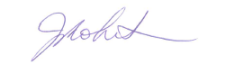
Janice Robertson
Finance & Regulatory Assurance Manager
SYNERGY NORTH CORPORATION
34 Cumberland Street North
Thunder Bay, Ontario
P7A 4L4

Phone: (807) 467-8014
Email: jrobertson@synergynorth.ca

