Grimsby Power Inc. (GPI)
Staff Questions
October 5th, 2023
Please note, that Grimsby Power Inc. is responsible for ensuring that all documents it files with the OEB, including responses to OEB staff interrogatories and any other supporting documentation, do not include personal information (as that phrase is defined in the Freedom of Information and Protection of Privacy Act), unless filed in accordance with rule 9A of the OEB’s Rules of Practice and Procedure.

OEB Staff Question 1
Ref: 2024 IRM Rate Generator, Tab 1 and Manager’s Summary, p. 6
GPI indicated that they are NOT requesting to update low voltage service rates in Manager’s summary, however selected “Yes” to update low voltage service rate on Tab 1 Cell 58 in the IRM Rate Generator.
Question:
- Please review the updated Rate Generator and confirm the accuracy of the answer on Tab 1 Cell 58.
- Please update the Rate Generator, if necessary.

OEB Staff Question 2
Ref: Rate Generator Model, Tab 3, Continuity Schedule

On September 12, 2023, the OEB published the 2023 Quarter 4 prescribed accounting interest rates applicable to the carrying charges of deferral, variance and construction work in progress (CWIP) accounts of natural gas utilities, electricity distributors and other rate-regulated entities.

Question:

- Please update Tab 3 (Continuity Schedule) as necessary to reflect the Q4 2023 OEB-prescribed interest rate of 5.49%.

OEB Staff Question 3
Ref: 2024 IRM Rate Generator, Tab 11, 15 and 20
On September 28th, 2023 the OEB issued a letter regarding 2024 Preliminary Uniform Transmission Rates (UTRs) and Hydro One Sub-Transmission Rates. The OEB determined to use of preliminary UTRs to calculate 2024 Retail Service Transmission rates to improve regulatory efficiency, allowing for this data to feed into the rate applications including annual updates for electricity distributors on a timelier basis. The OEB also directed distributors to update their 2024 application with Hydro One Network Inc.’s proposed host RTSRs.
OEB staff has updated LDC’s rate generator with the preliminary UTRs/and proposed host RTSR by HONI as follows:
UTRs
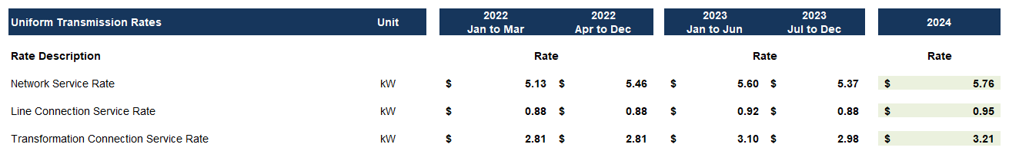
Hydro One Sub-Transmission Rates
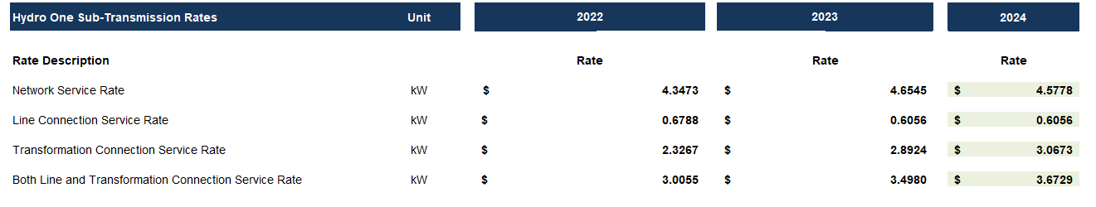
Question: Please confirm the accuracy of the Rate Generator update, as well as the accuracy of the resulting Retail Transmission Service Rates following these updates.

Ref 1: 2024 IRM Rate Generator Model, Continuity Schedule, Tab 3
Ref 2: IRM Rate Generator – DVA Tabs Instructions ‐ 2024 Rates
Ref 3: OEB Guidance for Electricity Distributors with Forgone Revenues Due to Postponed Rate Implementation from COVID-19, August 6, 2020, page 5
On July 18, 2023, the OEB issued the DVA Tabs Instructions for the 2024 IRM Rate Generator Model. Pages 1 and 3 noted that Account 1509 - Impacts Arising from the COVID-19 Emergency, Subaccount Forgone Revenues from Postponing Rate Implementation was added to the model. A separate rider is calculated for this account in Tab 7, if the disposition is approved.
Regarding Account 1509, Impacts Arising from the COVID-19 Emergency Account, Sub-account Forgone Revenues from Postponing Rate Implementation, the following steps are noted in the August 6, 2020 guidance:
- Upon implementation of the forgone revenue rate rider that is calculated from the Forgone Revenue Model, the rate rider transactions will be recorded in the same Forgone Revenues Sub-account. This will draw down the accumulated balance of actual forgone revenues/amounts.
- Any residual balance after the expiry of the rate riders should be requested for final disposition in a future rate application (cost of service or IRM), once the balance has been audited in accordance with normal deferral and variance account disposition practices.
- If disposition is approved, the residual balance in the Forgone Revenues Sub-account should be disposed proportionately by customer class and the residual balance will be transferred to Account 1595.
Question(s):
- Please update Tab 3 (Continuity Schedule) as necessary to reflect a balance in Account 1509 – Impacts Arising from the COVID-19 Emergency, Subaccount Forgone Revenues from Postponing Rate Implementation. Please complete the above-noted steps #1, #2, #3.
- If this balance is not applicable, please explain.

OEB Letter, EB-2023-0222, 2024 Preliminary Uniform Transmission Rates and Hydro One Sub-Transmission Rates, issued September 28th, 2023

