**OEB Staff Interrogatories**

**Enova Power Corp.**

**EB-2023-0015**

Please note, Enova Power Corp. is responsible for ensuring that all documents it files with the OEB, including responses to OEB staff interrogatories and any other supporting documentation, do not include personal information (as that phrase is defined in the Freedom of Information and Protection of Privacy Act), unless filed in accordance with rule 9A of the OEB’s Rules of Practice and Procedure.

OEB staff is aware that Waterloo North Hydro Inc. and Kitchener-Wilmot Hydro have amalgamated and incorporated under the name Enova Power Corp. For the purposes of interrogatories, former Waterloo North Hydro Inc. is referred to as Enova-WNH and former Kitchener-Wilmot Hydro is referred to as Enova- Kitchener-Wilmot.

**Staff Question-1**

**Ref:** **Rate Generator Model, Tab 3, Continuity Schedule**

On September 12, 2023, the OEB published the 2023 Quarter 4 prescribed accounting interest rates applicable to the carrying charges of deferral, variance and construction work in progress (CWIP) accounts of natural gas utilities, electricity distributors and other rate-regulated entities.

Question:

1. Please update Tab 3 (Continuity Schedule) as necessary to reflect the Q4 2023 OEB-prescribed interest rate of 5.49%.

**Staff Question-2**

**Ref: 2024 IRM Rate Generator, Tab 11, 15 and 2**

On September 28, the OEB issued a letter regarding 2024 Preliminary Uniform Transmission Rates (UTRs) and Hydro One Sub-Transmission Rates.[1] The OEB determined to use of preliminary UTRs to calculate 2024 Retail Service Transmission rates (RTSR) to improve regulatory efficiency, allowing for this data to feed into the rate applications including annual updates for electricity distributors on a timelier basis. The OEB also directed distributors to update their 2024 application with Hydro One Network Inc.’s proposed host RTSRs.

OEB staff has updated Enova’s rate generator for each rate zone with the preliminary UTRs/and proposed host RTSR by HONI as follows:

**UTRs**

**Hydro One Sub-Transmission Rates**

Question:

1. Please confirm the accuracy of the Rate Generator update, as well as the accuracy of the resulting Retail Transmission Service Rates following these updates.

**Staff Questions-3**

**Ref 1: Manager’s Summary, pages 19 & 20, August 18, 2023**

**Ref 2: EB-2022-0006, Kitchener-Wilmot Hydro Inc., Waterloo North Hydro Inc., Decision and Order, June 28, 2022, p. 32**

Enova Power stated that as per the EB-2022-0006 decision relating to the merger of KWHI and WNHI, the effective date of Account 1508 – Other Regulatory Assets, Sub-Account Impact of Post-Merger Accounting Policy Changes is January 1, 2023.

Enova Power has provided Table 11 in its application which demonstrates the value of the assets beginning in September 2022. Table 11 also shows the forecasted balance of a credit of $423,824 as at December 31, 2023 in Account 1508 – Other Regulatory Assets, Sub-Account Impact of Post-Merger Accounting Policy Changes.

**Question(s):**

1. Please explain why Enova Power has calculated the forecasted balance Account 1508 – Other Regulatory Assets, Sub-Account Impact of Post-Merger Accounting Policy Changes with a September 1, 2022 start date, as opposed to a January 1, 2023 start date, given the OEB EB-2022-0006 decision.
2. Please explain why there are no capital additions forecasted for the 2023 calendar year (i.e., to December 31, 2023) which should show cumulative differences between the WNHI net property, plant and equipment (PP&E) under the pre-merger capitalization policy and its net PP&E under the post-merger capitalization policy.
3. Please confirm that the 2023 depreciation should also show cumulative differences between the WNHI net PP&E under the pre-merger depreciation policy and its net PP&E under the post-merger depreciation policy.
4. Please confirm that deprecation has been forecasted to December 31, 2023.
5. Please explain why the 2022 depreciation amounts in Table 11 are different (as opposed to the same values), given that the start date of the DVA is January 1, 2023, as per the OEB EB-2022-0006 decision.
6. Please update Table 11 as applicable to reflect all of the above questions, including showing a revised December 31, 2023 forecasted balance in Account 1508 – Other Regulatory Assets, Sub-Account Impact of Post-Merger Accounting Policy Changes.

**Staff Questions-4**

**Ref 1: EB-2022-0006, Kitchener-Wilmot Hydro Inc., Waterloo North Hydro Inc., Accounting Order, July 28, 2022**

**Ref 2: EB-2022-0006, Kitchener-Wilmot Hydro Inc., Waterloo North Hydro Inc., Decision and Order, June 28, 2022, p. 32**

**Ref 3: Manager’s Summary, pages 19 & 20, August 18, 2023**

The OEB’s EB-2022-0006 Accounting Order required Enova Power to establish and use Account 1508 Other Regulatory Assets, sub account Impact of Post-Merger Accounting Policy Changes to record the cumulative difference between WNHI net PP&E under the pre-merger capitalization policy and pre-merger depreciation policy and its net PP&E under the post-merger capitalization policy and post-merger depreciation policy.

In its EB-2022-0006 decision and order, the OEB determined that the account will only reflect changes of WNHI adopting KWHI’s accounting policies (including depreciation estimates) and not capture impacts from both legacy distributors.

Enova Power noted that all new assets are adopting Enova Power’s capitalization policy which is the same as the legacy utilities.

**Question(s):**

1. Please confirm that the PP&E amounts recorded in Account 1508 – Other Regulatory Assets, Sub-Account Impact of Post-Merger Accounting Policy Changes relate to PP&E of the former WNHI and not both WNHI and KWHI.
2. Please explain at a high level the drivers and the nature of significant amounts recorded in Account 1508 – Other Regulatory Assets, Sub-Account Impact of Post-Merger Accounting Policy Changes.
3. Please update Table 11 as applicable to reflect all of the above questions, including showing a revised December 31, 2023 forecasted balance in Account 1508 – Other Regulatory Assets, Sub-Account Impact of Post-Merger Accounting Policy Changes.

**Staff Question-5**

**Ref 1: 2024 WNRZ IRM Rate Generator, Tab 1, Information Sheet**

**Ref 2: 2024 WNRZ IRM Rate Generator, Tab 16.1, 16.2**

**Ref 3: 2024 WNRZ IRM Rate Generator, Tab 11, Row 44& 59**

**Ref 4: 2024 ENOVA Application, Low Voltage Service Rates, Page 16**

In WNRZ Rate Generator’s information sheet, Waterloo North Rate Zone is selected as “Transmission Connected”.

Tab 16.1- LV Expense shows that WNRZ is connected to different service points with different low voltage rates.

Question:

1. Please explain the reason why WNRZ selected Transmission Connected while charged by Low Voltage Rates.
2. Please provide a description of ENOVA’s system, explaining how WNRZ and KWRZ are embedded within each other as well as different host distributors.
3. Please confirm if the host distributor for 3567 Nafziger Rd, Fountain St N, Elmira, and Pentland respectively belongs to the former Kitchener Hydro, Energy+, Hydro One legacy rate zones and Hydro One.
4. ENOVA states in the application that the IRM rate generator for WNRZ did not correctly calculate the Low Voltage Service rate for the GS>50 rate class. OEB staff has updated the rate generator. Please confirm the updated LV rates are correct in the attached WNRZ model.

**Staff Question-6**

**Ref 1: 2024 WNRZ IRM Rate Generator, Tab 3, Continuity Schedule**

**Ref 2: 2024 KWRZ IRM Rate Generator, Tab 3, Continuity Schedule**

OEB staff has compiled tables below comparing WNRZ and KWRZ’s continuity balances from the 2023 rate application and the 2024 rate application.

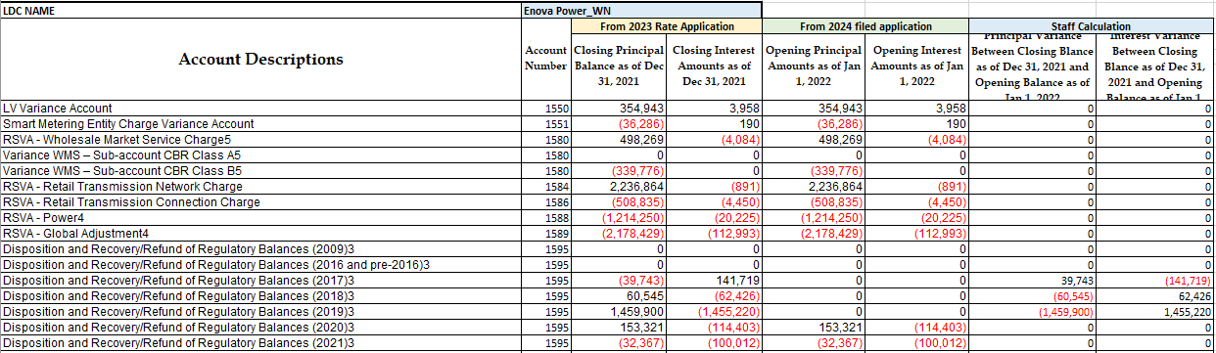

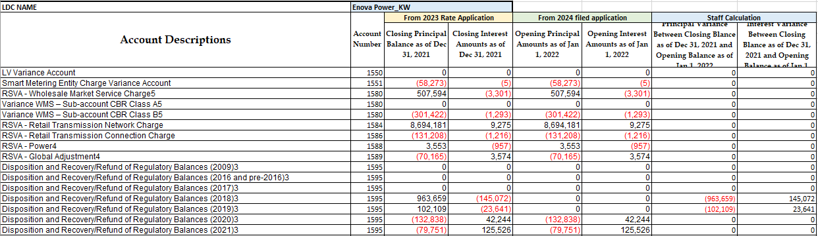

Questions:

1. Please explain the difference in WNRZ’s Account 1595 (2017), Account 1595 (2018), and Account 1595 (2019) between the two IRM applications.
2. Please explain the difference in WNRZ’s Account 1595 (2018), and Account 1595 (2019) between the two IRM applications.

1. OEB Letter, EB-2023-0222, 2024 Preliminary Uniform Transmission Rates and Hydro One Sub-Transmission Rates, issued September 28, 2023