Centre Wellington Hydro Ltd. EB-2023-0010
October 4, 2023
Please note, Centre wellington Hydro Ltd. (Centre Wellington) is responsible for ensuring that all documents it files with the OEB, including responses to OEB staff questions and any other supporting documentation, do not include personal information as that phrase is defined in the Freedom of Information and Protection of Privacy Act, unless filed in accordance with rule 9A of the OEB’s Rules of Practice and Procedure.
Staff Question-1
Ref: Information Sheet of IRM Rate Generator Model F18
As per the OEB letter, issued August 21, 2023, the OEB assigned EB-2023-0010 to Centre Wellington’s 2024 IRM application. OEB staff notes that Cell F18 shows a EB-2023-0090
- Please confirm that EB-2023-0010 is the correct number and update the rate generator accordingly.
Staff Question-2
Ref: Information Sheet of IRM Rate Generator Model F49 and F51 and Manager’s Summary, p. 16
OEB staff notes that Centre Wellington selected “No” in response to question 5 and 6 on Tab 1 of the rate generator, indicating that it did not have Class A customer since 2021. On page 18 of the Manager’s Summary, Centre Wellington stated that as at December 31, 2022 it has three active Class A customers, which have been part of Class A for the full duration of the accumulation of the Group 1 variance balances.
- Can you please confirm that Centre Wellington had Class A during the time the balances in Account 1589 and Account 1580, Sub-account CBR Class B accumulated.
- If yes, please update Tab 1 of the rate generator as well as any subsequent applicable tabs.
- Please confirm that Centre Wellington did not have customers that transitioned from Class A to Class B or vice versa during that time.
Staff Question-3
Ref: IRM Rate Generator Model, Tab 3, Continuity Schedule and GA Workform, Principle Adjustments
On the Principle Adjustment Tab fo the GA workform, Centre Wellington listed a principal adjustment of ($547). OEB staff notes that this adjustment has not been transferred to Tab 3 of the rate generator.
- Please explain and update the rate generator, if necessary
Staff Question-4
Ref: IRM Rate Generator Model, Tab 3, Continuity Schedule
In Tab 3, column BE, OEB staff notes that Centre Wellington transferred a total principal amount of ($242,331) and a total interest amount of ($4,827) into Account 1595(2022). In 2022 the OEB approved a a total principal amount of $250,947 and a total interest amount of $4,965.
- Please explain the difference and update the rate generator, if necessary.
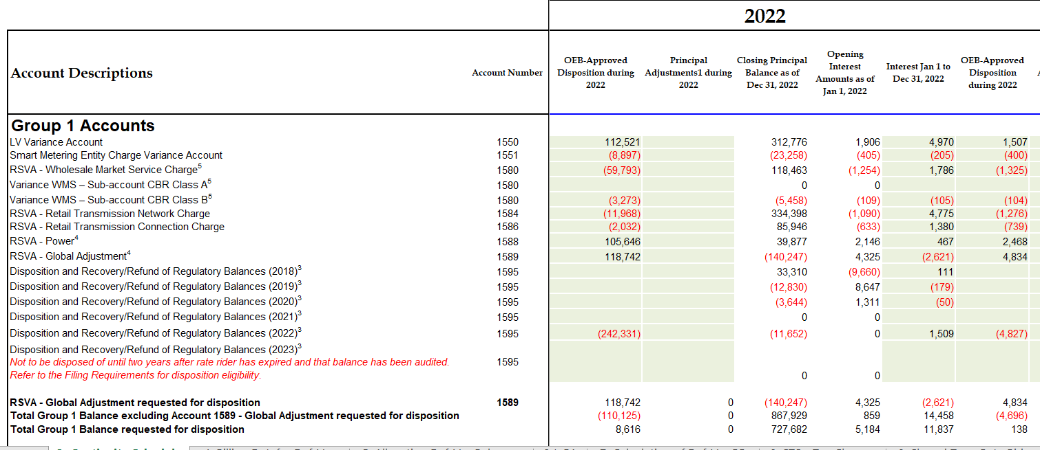
Staff Question-5

Ref: Rate Generator Model, Tab 3, Continuity Schedule

On September 12, 2023, the OEB published the 2023 Quarter 4 prescribed accounting interest rates applicable to the carrying charges of deferral, variance and construction work in progress (CWIP) accounts of natural gas utilities, electricity distributors and other rate-regulated entities.

- Please update Tab 3 (Continuity Schedule) as necessary to reflect the Q4 2023 OEB-prescribed interest rate of 5.49%.

Staff Question-6
Ref: 2024 IRM Rate Generator, Tab 11, 15 and 20
On September 28, 2023 the OEB issued a letter regarding 2024 Preliminary Uniform Transmission Rates (UTRs) and Hydro One Sub-Transmission Rates. The OEB determined to use of preliminary UTRs to calculate 2024 Retail Service Transmission rates (RTSR) to improve regulatory efficiency, allowing for this data to feed into the rate applications including annual updates for electricity distributors on a timelier basis. The OEB also directed distributors to update their 2024 application with Hydro One Network Inc.’s proposed host RTSRs. Any further updates to Hydro One’s proposed host RTSR will be reflected in the final rate generator.
OEB staff has updated LDC’s rate generator with the preliminary UTRs/and proposed host RTSR by HONI as follows:
UTRs
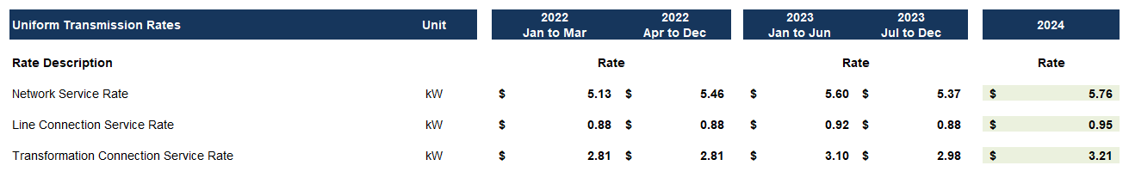
Hydro One Sub-Transmission Rates
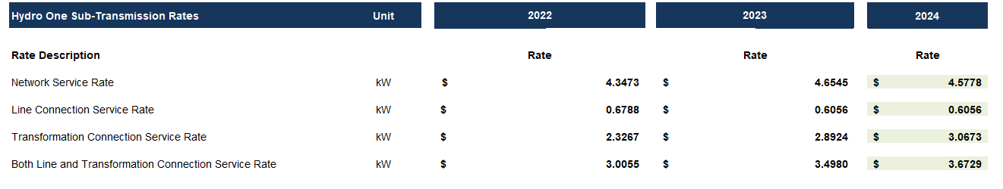
- Please confirm the accuracy of the Rate Generator update, as well as the accuracy of the resulting Retail Transmission Service Rates following these updates.

OEB Letter, EB-2023-0222, 2024 Preliminary Uniform Transmission Rates and Hydro One Sub-Transmission Rates, issued September 28, 2023
EB-2023-0030, Hydro One’s 2024 Custom IR Annual Update Application

