Milton Hydro Inc.
EB-2023-0038
October 2, 2023
Please note, Milton Hydro Inc. is responsible for ensuring that all documents it files with the OEB, including responses to OEB staff questions and any other supporting documentation, do not include personal information as that phrase is defined in the Freedom of Information and Protection of Privacy Act, unless filed in accordance with rule 9A of the OEB’s Rules of Practice and Procedure.

Staff Question-1
Reference:
(i) Rate Generator Model, Tab 3, Continuity Schedule

On September 12, 2023, the OEB published the 2023 Quarter 4 prescribed accounting interest rates applicable to the carrying charges of deferral, variance and construction work in progress (CWIP) accounts of natural gas utilities, electricity distributors and other rate-regulated entities.

Question(s):
- Please update Tab 3 (Continuity Schedule) as necessary to reflect the Q4 2023 OEB-prescribed interest rate of 5.49%.

Response:
- Milton Hydro has updated Tab 3 (Continuity Schedule) in the 2024 Rate Generator Model to reflect the Q4 2023 OEB-prescribed interest rate of 5.49%.

Staff Question-2
Reference:
- 2024 IRM Rate Generator Model, Continuity Schedule, Tab 3
- IRM Rate Generator – DVA Tabs Instructions ‐ 2024 Rates
- OEB Guidance for Electricity Distributors with Forgone Revenues Due to Postponed Rate Implementation from COVID-19, August 6, 2020, page 5

On July 18, 2023, the OEB issued the DVA Tabs Instructions for the 2024 IRM Rate Generator Model. Pages 1 and 3 noted that Account 1509 - Impacts Arising from the COVID-19 Emergency, Subaccount Forgone Revenues from Postponing Rate Implementation was added to the model. A separate rider is calculated for this account in Tab 7, if the disposition is approved.

Regarding Account 1509, Impacts Arising from the COVID-19 Emergency Account, Sub-account Forgone Revenues from Postponing Rate Implementation, the following steps are noted in the August 6, 2020 guidance:

- Upon implementation of the forgone revenue rate rider that is calculated from the Forgone Revenue Model, the rate rider transactions will be recorded in the same Forgone Revenues Sub-account. This will draw down the accumulated balance of actual forgone revenues/amounts.

- Any residual balance after the expiry of the rate riders should be requested for final disposition in a future rate application (cost of service or IRM), once the balance has been audited in accordance with normal deferral and variance account disposition practices.

- If disposition is approved, the residual balance in the Forgone Revenues Sub-account should be disposed proportionately by customer class and the residual balance will be transferred to Account 1595.

Question(s):
- Please update Tab 3 (Continuity Schedule) as necessary to reflect a balance in Account 1509 – Impacts Arising from the COVID-19 Emergency, Subaccount Forgone Revenues from Postponing Rate Implementation. Please complete the above-noted steps #1, #2, #3.
- If this balance is not applicable, please explain.

Response:
- Updates are not necessary as Milton Hydro did not apply to defer the implementation of any previous IRM rate increases.
- Milton Hydro has no balance in Account 1509 - Impacts Arising from the COVID-19 Emergency, Subaccount Forgone Revenues from Postponing Rate Implementation, and there is no balance to recover for this account in this rate application.

Staff Question-3
Reference:
- 2024 IRM Rate Generator, Tab 11, 15 and 20

On September 28, 2023, the OEB issued a letter regarding 2024 Preliminary Uniform Transmission Rates (UTRs) and Hydro One Sub-Transmission Rates. The OEB determined to use of preliminary UTRs to calculate 2024 Retail Service Transmission rates (RTSR) to improve regulatory efficiency, allowing for this data to feed into the rate applications including annual updates for electricity distributors on a timelier basis. The OEB also directed distributors to update their 2024 application with Hydro One Network Inc.’s proposed host RTSRs.
OEB staff has updated LDC’s rate generator with the preliminary UTRs/and proposed host RTSR by HONI as follows:
UTRs
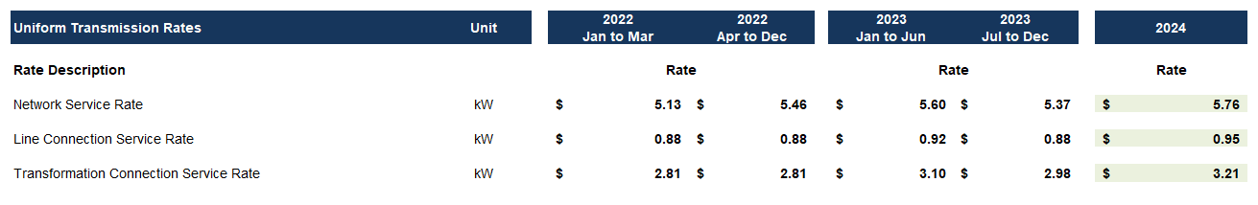
Hydro One Sub-Transmission Rates
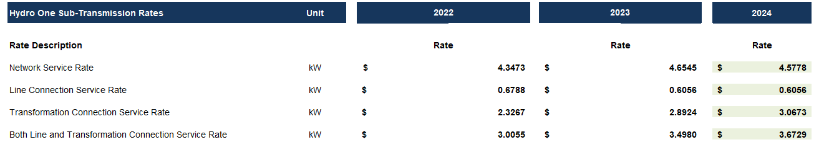
Question(s):
- Please confirm the accuracy of the Rate Generator update, as well as the accuracy of the resulting Retail Transmission Service Rates following these updates.

Response:
- Milton Hydro confirms that the 2024 UTRs and Hydro One Sub-Transmission Rates in the 2024 Rate Generator Model have been updated correctly.

Staff Question-4
Reference:
- IRM Rate Generator Model, Tab 3, Continuity Schedule
- Decision Order dated December 9, 2021 (Application: EB-2021-0042)

In the decision order dated December 9, 2021, OEB had approved disposition of Group 1 accounts that summed up to a credit balance of $745,754. However, OEB staff noticed that the total disposition claimed for 2022 is a credit balance of $780,905.

Question(s):
- Please confirm reason for not disposing $88,744 of principal and $35,148 of interest debit balances approved for 1595 sub-accounts.
Response:
- As noted, Milton Hydro obtained OEB approval for the disposal of a debit balance of $88,744 of principal and a credit balance of $53,597 of interest for 1595 sub-accounts (Vintage year of 2016 and 2017) see Table 1 below. Milton Hydro did not record the disposition of the balances in the 2024 IRM Rate Generator Model as there are no rows to record the Disposition and Recovery/Refund of Regulatory Balances for 1595 (2016) or 1595 (2017) in the current Rate Generator Model for these two sub-accounts, see table 2 below.

Table 1: Details of principal and interest for 595 (2016) and 1595 (2017) 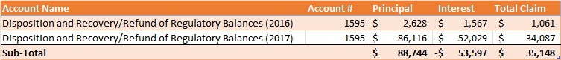

Table 2: Excerpt from Tab 3 Continuity Schedule of 2024 Rate Generator Model
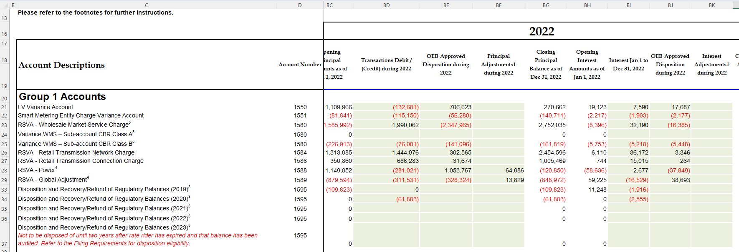

Staff Question-5
Reference:
- IRM Rate Generator Model, Tab 3, Continuity Schedule
- Chapter 3 of OEB filing requirements, Section 3.2.6.5

According to Chapter 3 of OEB filing requirements, when the OEB approves disposition of DVA balances, the approved amounts of the principal and carrying charges are transferred to Account 1595 for the rate year. Distributors are expected to request disposition of the residual balances in Account 1595 sub-accounts for each vintage year on a final basis.
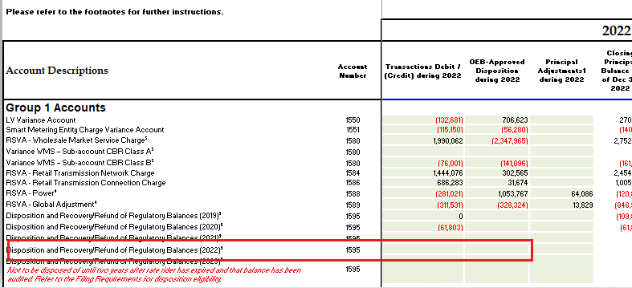
OEB staff noticed that the ‘transactions’ and ‘OEB approved disposition’ fields for the sub-account 1595 (2022) are empty.

Question(s):
- Please confirm whether sub-account 1595 (2022) was used for disposition of Group 1 account balances.

- If so, please make the necessary adjustments. If not, please explain why and discuss any variances.
Response:
- Milton Hydro confirms that sub-account 1595 (2022) was used for disposition of Group 1 account balances.

- Milton Hydro inadvertently populated the sub-account 1595 (2022) in the sub-account (2020) in both Tab 3 (Continuity Schedule) in the Rate Generator Model and the 2022 2.1.7 RRR fillings. Milton Hydro updates the sub-account 1595 (2019/2020/2022) in Tab 3 (Continuity Schedule) in the 2024 Rate Generator Model filed the OEB staff question responses. In addition, Milton Hydro will file a change request for 2022 2.1.7 RRR filings to update the sub-accounts of account 1595 (2019/2020/2022). See Table 3 below which summarizes the updates to the 1595 subaccounts in the 2024 Rate Generator Model and the 2022 RRR 2.1.7 Regulatory Trial Balance.

Table 3: Summary of 1595 (2019, 2020,2022) Updates to Principal & Interest
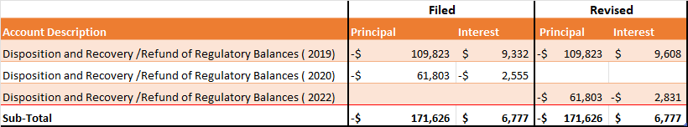

Staff Question-6
Reference:
- IRM Rate Generator Model, Tab 3, Continuity Schedule
- Ontario Energy Board Accounting Procedures Handbook Guidance, March 2015, Section 11, Pg. 13
- Decision and Order, EB-2022-0049, Application for electricity distribution rate beginning January 1, 2023, Pg. 5
As per the Ontario Energy Board Accounting Procedures Handbook Guidance the accounting entry for the approved recoveries for the LRAMVA is the same as for other deferral and variance accounts. When an LRAMVA amount is approved for recovery, the amount is transferred from Account 1568 to Account 1595 Disposition and Recovery / Refund of Regulatory Balances, Sub-account approved in 2022.

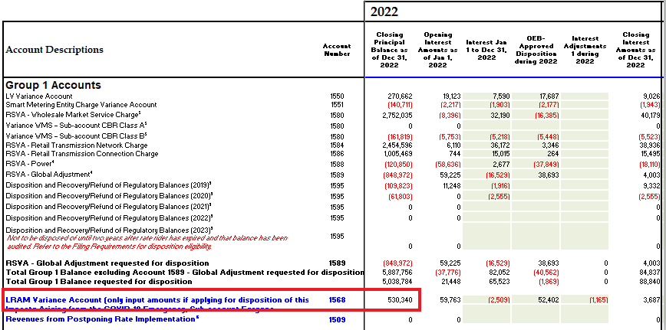
In its decision order for 2023 rates application the OEB approved LRAMVA debit balance of $537,792 over a 24-month period.

Question(s):
- Please confirm that the OEB approved disposition of LRAMVA account balance of $537,792 was transferred to Account 1595 (2022).
- If not, please provide a reason for not transferring the amount to Account 1595 and explain any variances.
- Please also explain the 2022 closing balance of $530,340 in Account 1568 presented on the DVA continuity schedule in the 2024 IRM rate generator model.
Response:
- A balance in account 1568 LRAMVA of $537,702 was approved by the OEB in Milton Hydro’s 2023 Cost of Service Rate application and was transferred to account 1595 (2023) on January 1, 2023. See excerpt from 2024 Rate Generator Model below for Account 1568.

Table 4: Excerpt from Tab 3: Continuity Schedule 2024 Rate Generator Model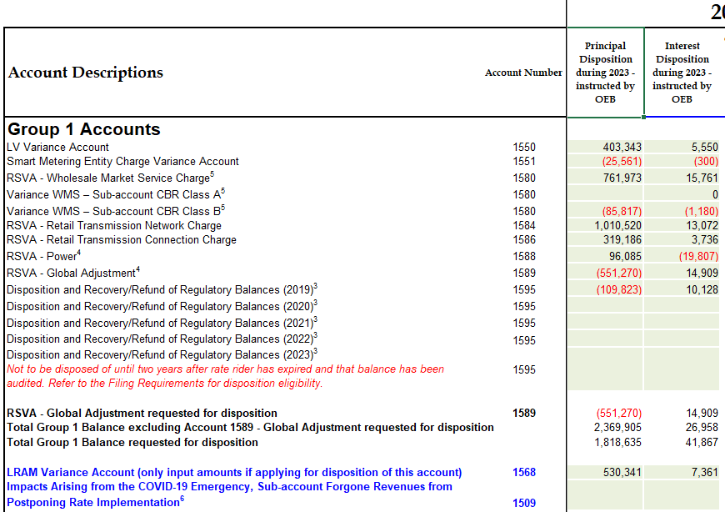

- Confirmed that the balance of $537,702 in Account 1568 was transferred to 1595 (2023).
- As provided in response to (i) above, the amount of $530,341 principal and $7,361 carrying charges totalling $537,702 for Account 1568 – LRAMVA as depicted in Table 4 above is shown as approved by the OEB during 2023. Milton Hydro had LRAMVA amounts approved in both of its 2022 IRM and 2023 COS proceedings. Milton Hydro transferred all amounts approved to the applicable 1595 sub accounts as required. The balance filed in Milton Hydro’s RRR for December 31, 2022 was transferred to Account 1595 (2023) on January 1, 2023 as required in the OEB accounting guidance related to sub-accounts of account 1595.

Staff Question-7
Reference:
- IRM Rate Generator Model, Tab 3, Continuity Schedule
- GA Analysis Work form, Tab 4, Principal Adjustments

In GA analysis work form the principal adjustments are shown under the current year (i.e., 2023). However, the continuity schedule shows the net of those transactions under 2022.
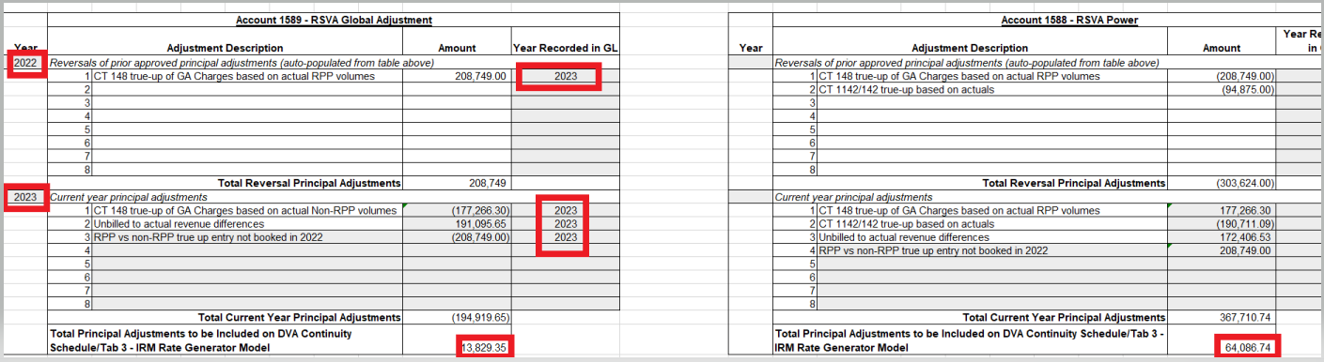
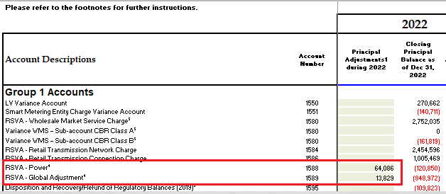
Question(s):
- Please confirm if this is only a labelling error in the GA work form.
- If yes, please update the GA work form with the correct year, i.e., 2022 in both “Year” and “Year Recorded in GL” Columns.

Response:

- Milton Hydro confirms that this is a labelling error in the GA Analysis Work Form. The years under column A and M should be 2022, as the principal adjustments are related to 2022 activities. The years under column K and W are all correct. They indicate the years in which the activities were booked in Milton Hydro’s General Ledger. Table 5 provides an except from the corrected GA Analysis Work Form and Milton Hydro files an updated GA Analysis Work form for 2022.

Table 5: Excerpt from GA Analysis Work Form
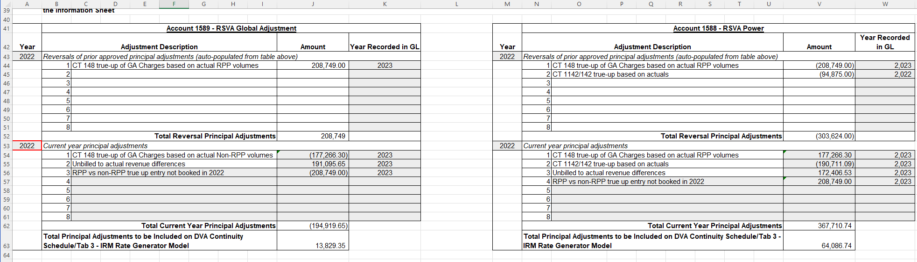

- Response:
Milton Hydro updates the years under column A and M in Tab 4 Principal Adjustments in the GA Analysis Work Form.

Staff Question-8
Reference:
- GA Analysis Work form, Tab 4, Principal Adjustments

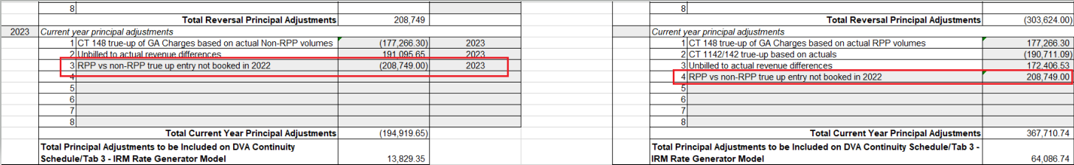
Principal Adjustments tab in the GA work form shows transactions with description “RPP vs non-RPP true up entry not booked in 2022” under Accounts 1589 and 1588.

Question(s):
- Please explain and elaborate on the nature of these transactions.

Response:
a) The credit adjustment of $208,749 to account 1589 and the offsetting debit adjustment of $208,749 to account 1588 relate to an RPP vs Non-RPP True up of Global Adjustment that was recorded as Principal Adjustments in 2021 in the DVA Continuity Schedule submitted with the 2023 Cost of Service rate application and was to have been recorded in the General Ledger in 2022. As the journal entry was inadvertently not recorded in the General Ledger in 2022, Milton Hydro recorded the journal entry in the General Ledger in 2023. The amount relates to 2021, and was correctly reflected in the 2021 balances that were approved by the OEB for disposition in Milton Hydro’s 2023 Cost of Service Rate Application.

The amount was to have been journalized in 2022, and since it wasn’t, Milton Hydro made a principal adjustment for the same amounts once again in 2022 and recorded the true-up adjustment journal entry in its General Ledger in 2023. By making the principal adjustment to 2022 Milton Hydro correctly reflects the year end balances of accounts 1588 and 1589 in 2022. In its 2025 IRM it will reverse the principal adjustments recorded to 2023 in the DVA Continuity Schedule, which will offset the General Ledger entries in 2023 to reflect the correct balances at the end of 2023.

Staff Question-9
Kindly describe your experience and provide any feedback related to the IRM online platform as well as the over-all process.

Response:
Milton Hydro’s experience with the IRM Online Platform was quite positive. Although there were a few minor matters in the IRM Online Platform that were different from the IRM Rate Generator excel Model, once those items are resolved, and the Online Platform fully reconciles to the IRM Rate Generator excel Model, then the Online Platform could be solely relied upon for filing rate application calculations. One observation Milton Hydro had with the over-all process was that it was input intensive, taking a fairly significant amount of time to populate the various tabs manually, and then to check the inputs manually. Milton Hydro made a suggestion to OEB Staff to make the Online Platform more efficient by enabling the uploading of excel format data files thereby reducing the amount of inputting into the Online Platform. If the OEB enables the upload of data into the Online Platform to reduce the amount of manual inputting and manual checking of inputs, the Online Platform would be much more useable and more efficient from the current Online Platform processes, and depending on how the uploads are set up, the process could be more efficient from the current Rate Generator excel Model.

OEB Letter, EB-2023-0222, 2024 Preliminary Uniform Transmission Rates and Hydro One Sub-Transmission Rates, issued September 28, 2023
EB-2022-0049 Decision and Order, Application for electricity distribution rates beginning January 1, 2023. Page 39 of 45 Settlement Proposal Table 4.2A Proposed Disposal of Deferral and Variance Accounts.

