**Oakville Hydro Electricity Distribution Inc.**

**EB-2023-0044**

**Response to OEB Staff Questions**

**Staff Question-1**

**Ref: Rate Generator Model, Tab 3, Continuity Schedule**

On September 12, 2023, the OEB published the 2023 Quarter 4 prescribed accounting interest rates applicable to the carrying charges of deferral, variance and construction work in progress (CWIP) accounts of natural gas utilities, electricity distributors and other rate-regulated entities.

**Question:** Please update Tab 3 (Continuity Schedule) as necessary to reflect the Q4 2023 OEB-prescribed interest rate of 5.49%.

**Response:**

Tab 3 (Continuity Schedule) has been updated with the Q4 2023 OEB-prescribed interest rate of 5.49%. A revised table of Group 1 balances, including a summary of the change compared with the original submission, is presented below.

**Group 1 Account Balances**



These updates, along with incorporating the preliminary UTRs and proposed host RTSR by HONI in Staff Question-2, result in the following updated bill impacts:

* a typical residential customer using 750 kWh per month will see an increase of $3.93 or 3.05% ($3.06 or 2.38% in original filing) in their total monthly bill, and
* a customer in the General Service < 50 kW class using 2,000 kWh per month will see an increase of $4.09 or 1.21% ($1.36 or 0.4% in original filing) in their total monthly bill.

**Staff Question-2**

**Ref: 2024 IRM Rate Generator, Tab 11, 15 and 20**

On September 28, 2023, the OEB issued a letter regarding 2024 Preliminary Uniform Transmission Rates (UTRs) and Hydro One Sub-Transmission Rates.[1] The OEB determined to use of preliminary UTRs to calculate 2024 Retail Service Transmission rates (RTSR) to improve regulatory efficiency, allowing for this data to feed into the rate applications including annual updates for electricity distributors on a timelier basis. The OEB also directed distributors to update their 2024 application with Hydro One Network Inc.’s proposed host RTSRs.

OEB staff has updated LDC’s rate generator with the preliminary UTRs and proposed host RTSR by HONI as follows:

**UTRs**

**Hydro One Sub-Transmission Rates**

**Question:** Please confirm the accuracy of the Rate Generator update, as well as the accuracy of the resulting Retail Transmission Service Rates following these updates.

**Response:**

Oakville Hydro confirms the accuracy of the Rate Generator update, as well as the accuracy of the resulting Retail Transmission Service Rates following these updates.

**Staff Question-3**

**Ref 1: 2024 IRM Rate Generator Model, Continuity Schedule, Tab 3**

**Ref 2: IRM Rate Generator – DVA Tabs Instructions ‐ 2024 Rates**

**Ref 3: OEB Guidance for Electricity Distributors with Forgone Revenues Due to Postponed Rate Implementation from COVID-19, August 6, 2020, page 5**

On July 18, 2023, the OEB issued the DVA Tabs Instructions for the 2024 IRM Rate Generator Model. Pages 1 and 3 noted that Account 1509 - Impacts Arising from the COVID-19 Emergency, Subaccount Forgone Revenues from Postponing Rate Implementation was added to the model. A separate rider is calculated for this account in Tab 7, if the disposition is approved.

Regarding Account 1509, Impacts Arising from the COVID-19 Emergency Account, Sub-account Forgone Revenues from Postponing Rate Implementation, the following steps are noted in the August 6, 2020 guidance:

1. Upon implementation of the forgone revenue rate rider that is calculated from the Forgone Revenue Model, the rate rider transactions will be recorded in the same Forgone Revenues Sub-account. This will draw down the accumulated balance of actual forgone revenues/amounts.
2. Any residual balance after the expiry of the rate riders should be requested for final disposition in a future rate application (cost of service or IRM), once the balance has been audited in accordance with normal deferral and variance account disposition practices.
3. If disposition is approved, the residual balance in the Forgone Revenues Sub-account should be disposed proportionately by customer class and the residual balance will be transferred to Account 1595.

**Questions:**

1. Please update Tab 3 (Continuity Schedule) as necessary to reflect a balance in Account 1509 – Impacts Arising from the COVID-19 Emergency, Subaccount Forgone Revenues from Postponing Rate Implementation. Please complete the above-noted steps #1, #2, #3.
2. If this balance is not applicable, please explain.

**Response:**

Account 1509, Impacts Arising from the COVID-19 Emergency Account, Sub-account Forgone Revenues from Postponing Rate Implementation is not applicable to Oakville Hydro. Oakville Hydro implemented its annual rate increase on January 1st, 2020.

**Staff Question-4**

**Ref 1: 2024 IRM Rate Generator Model, Continuity Schedule, Tab 3**

**Ref 2: 2023 IRM Rate Generator Model, Continuity Schedule, Tab 3**

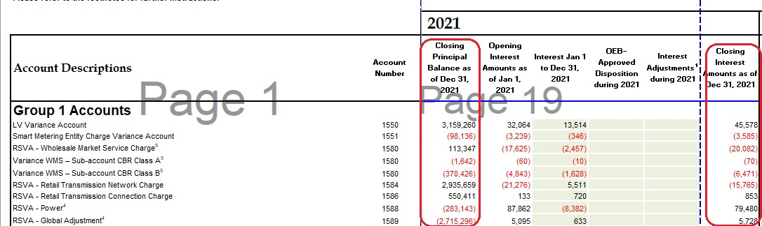

**Questions:**

1. Please update the Opening Principal/Interest Amounts as of Jan1, 2022 in Ref 1, which should agree to the Closing Principal/Interest Amounts as of Dec 31, 2021 in Ref 2
2. Please fill out OEB-Approved Disposition during 2022 for both principal and interest based on Decision and Rate Order (EB-2021-0048).

**Response:**

1. Oakville Hydro has made the necessary corrections to Tab 3. The closing balances remain unchanged.
2. Oakville Hydro has made the necessary corrections to Tab 3. The closing balances remain unchanged.

**Staff Question-5**

**Ref 1: 2024 IRM Rate Generator Model, RTSR Current Rates, Tab 10**

**Question**: Please confirm whether there was no consumption in General Service 50 To 999KW Service Classification – Retail Transmission Rate – Network Service Rate and Line and Transmission Connection Service Rate in Ref 1, as we are seeing loads for the same rate class in 2023 Rate Generator.

**Response:**

There was consumption in the General Service 50 To 999KW Service Classification – Retail Transmission Rate – Network Service Rate and Line and Transmission Connection Service Rate.

However, all customers in this class have been transitioned to interval meters and a separate rate for manually read customers is no longer required.

1. OEB Letter, EB-2023-0222, 2024 Preliminary Uniform Transmission Rates and Hydro One Sub-Transmission Rates, issued September 28, 2023