Orangeville Hydro Limited
EB-2023-0045
Error Checking Review

- Ref 1: Exhibit 1, p. 9, line 7
Ref 2: 2024_Rev_Reqt_Workform, tab 3. Data_Input_sheet, cell E20
Ref 3: 2014 Decision and Order:
Appendix C_OHL_2014_Rev_Reqt_Work_form_V6_per decision_20140403, tab 3. Data_Input_Sheet, cell U20
In Ref 1, Exhibit 1 states that cost of power has increased by over $2.5M since 2014.

In Ref 2, the 2024 revenue requirement workform shows the cost of power of $29.3M.

In Ref 3, the 2014 revenue requirement workform (from the 2014 Decision) shows the cost of power of $27.7M. The difference between the cost of power in Ref 2 and Ref 3 is $1.5M ($29.3 M - $27.7M).

Please explain the difference between OEB staff’s calculation of $1.5M and Orangeville Hydro’s calculation in Ref 1. Please update Exhibit 1 as needed.

- Ref 1: Exhibit 1, p. 13, Table 1-7
Ref 2: 2014 Decision and Order:
Appendix C_OHL_2014_Rev_Reqt_Work_form_V6_per decision_20140403, Tab 3. Data Input Sheet, cells U19-U20 and Tab 4. Rate_Base, cells W24-W26

Ref 1 shows the following components for Working Capital Allowance for 2024 and 2014:

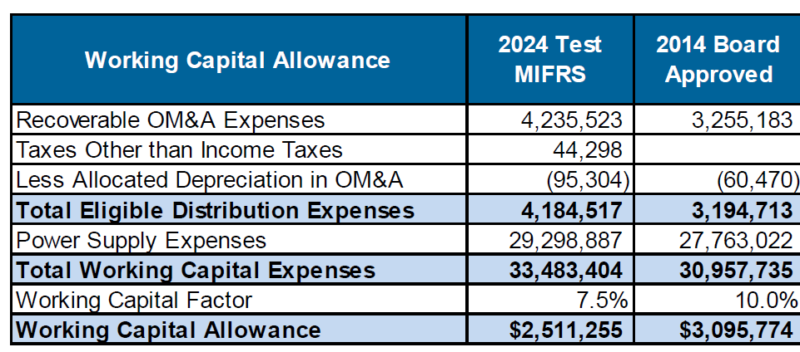

For 2014, Ref 2 shows the following components of the total working capital base:
Controllable Expenses | $3,255,183
Cost of Power | $27,702,552
Working Capital Base | $30,957,735

Although the total working capital expense in 2014 in Ref 1 reconciles with the working capital base in Ref 2 ($30,957,735), its components do not match. Please explain the difference and update the evidence as needed.

- Ref 1: Exhibit 1, p. 22, Table 1-14
Ref 2: Exhibit 8, p. 19, Table 8-19
Ref 3: Tariff_Schedule_and_Bill_Impact_Model 20230929, tab 6. Bill Impacts

The total bill impact columns ($ and %) in Ref 1, the bill impact columns ($ and %) for sub-total A (for certain rate classes), sub-total B, sub-total C ($ and %), and total bill impact columns ($ and %) in Ref 2 do not reconcile with Ref 3. Please explain and update the evidence as needed.

- Ref 1: Exhibit 1, p. 52, table 1-28
Ref 2: Exhibit 1, p. 55, table 1-37

In Ref 1, the five-year average for Station CAPEX shows $2,503.15. It appears that the average has been calculated over five years based on two zero values in 2020 and 2021, resulting in a lower value of Station CAPEX.

In Ref 2, with no unit cost in 2020 and 2021, OEB staff calculated the three-year average for 2017 – 2019 as (5,479+2,968+4,069)/3 = $4,172.

Please explain why Station CAPEX values are zero in 2020 and 2021 and update the evidence as need.

- Ref: Exhibit 4, p. 23, lines 2-3

The sentence states Table 4-14 instead of 4.15. Please correct the table number.

- Ref: Exhibit 5, p. 13, line 10
Please correct the Section number to 5.2.5

- Ref 1: A Chapter2_Appendix 2-L_OM&A_per_Cust_FTE
Ref 2: Exhibit 4, Section 4.2.4, p. 38
Ref 3: Chapter2_Appendix 2-JA_OM&A_Summary_Analys

Admin Expenses in Line 17 in Ref 1 and in Table 4-17 in Ref 2 does not reconcile with line 22 in Ref 3 (line 22 = sum of lines 19, 20 and 21 which are Billing and Collecting + Community Relations + Administrative and General). It appears that the Admin Expenses in Ref 1 excludes Billing and Collecting and Community Relation. For example, the Admin Expenses in 2024 in Ref 1 is equal to $1,623,330 which is the same value as Administrative and General OM&A in Ref 3.

Please correct the Admin Expenses line in Ref 1 and Ref 2 which should be equal to Billing and Collecting + Community Relations + Administrative and General. Please update all the affected cells and the evidence as needed.

- Ref 1: A Chapter2_Appendix 2-JC_OM&A Programs
Ref 2: Exhibit 4, Section 4.2.3, Table 4-16, p. 24 and Table 4-18, p. 40

In Ref 1, Cell N46 and Cell O46 do not have LEAP variance calculations as shown in Ref 2. Please update Ref 1 to include these variances.

In Ref 1, the reporting basis in cell B14 shows MIFRS compared to CGAAP in Ref 2. Please correct the reporting basis.

- Ref 1: Exhibit 4, Table 4-37, p. 53
Ref 2: Exhibit 4, p. 61
Ref 3: Chapter 2 Appendix 2-K Employee Costs
In Ref 1, several numbers in the 2023 Bridge Year and 2024 Test Year columns do not match with the numbers in Ref 3. Please reconcile and update the evidence as needed.
Please also reconcile the change in wages for 2024 Test to 2023 Bridge in Ref 2 and update the evidence as needed.
- Ref: Exhibit 4, pp. 15, 23, 63, 74, 76, and 79
OEB staff notes incorrect table numbers stated throughout Exhibit 4. For example, page 15, line 2, Table 4-2 should read Table 4-3. Please update the evidence to reflect correct table numbers.
- Ref 1: Exhibit 5, Table 5-2, p. 4
Ref 2: Chapter 2 Appendix 2-OA

The Capitalization Ratio ($) column and Return (4) column in Ref 1 and Ref 2 do not match.

Please explain why. Please reconcile and update the evidence as needed.

- Ref 1: Exhibit 5, Table 5-19, p. 12
Ref 2: Chapter 2 Appendix 2-OA
In Ref 1, the rate base calculations for 2024 do not reconcile with Ref 2. For example, the regulated return on capital in Ref 1 is 1,732,795 and in Ref 2 is $1,733,078.
Please explain why. Please reconcile and update the evidence as needed.
- Ref 1: Exhibit 5, pp. 12-13
Ref 2: Chapter 2 Appendix 2-OB

In Ref 1, Orangeville Hydro states that it is planning on taking $1.5M of new third-party debt in the 2024 Test Year at a rate of 5.3% on May 31, 2024, for a term of 5 years.

In Ref 2, the debt instrument for 2024 shows budgeted term loan (Row 9) with the start date May 31, 2024 and a principal of $743,954 at 5.3%.

Please explain the difference between $1.5M in Ref 1 and $743,954 in Ref 2. Please update the evidence as needed.

- Ref 1: Exhibit 6, p. 12, line 22
Ref 2: Exhibit 6, Table 6-8, p. 10

The revenue deficiency in Ref 1 is $829,782. Ref 2 shows the revenue deficiency of $829,921 (line no. 26).

Please explain why they do not match. Please reconcile and update the evidence as needed.

- Ref 1: Exhibit 6, Table 6-8, page 12
Ref 2: 2014 Decision and Order:
Appendix C_OHL_2014_Rev_Reqt_Work_form_V6_per decision_20140403, Tab 4. Rate_Base, cells W24-W26

The Working Capital for the Board-approved 2014 in Ref 1 matches with Ref 2. However, the Cost of Power and Operating Expenses in Ref 1 and Ref 2 do not match.

Please explain the differences in these components and update the evidence as needed.

- Ref 1: Exhibit 2, p. 48, Table 2-40
Ref 2: Chapter 2 Appendices, tab 2-AB

2018 General Plant in Ref 1 is $443,852 and Ref 2 is $451k. Contributions are -$198,868 vs $206k. The Net Capital Expenditures matches but the line items do not.

OEB staff notes that this is below materiality, however, if Orangeville Hydro is making corrections to other items, please include this update as well. This is in all pdf replications of the table, in Exhibit 2 and the DSP.

- Ref 1: Chapter 2 Appendix 2-BA, Account 2440 – Deferred Revenues Depreciation Additions (column K)
Ref 2: Chapter 2 Appendix H, Account 4245 - Government and Other Assistance Directly Credited to income

Depreciation in Account 2440 in 2-BA does not match the amortization in Account 4245 for 2015, 2019, and 2022.

Please update the evidence as needed.

- Ref 1: Chapter 2 Appendix 2-AB
Ref 2: DSP, p. 83 (or p. 175 of PDF), Figure 5.4-3

In Ref 2, the Figure 5.4.3 is titled “Overall Gross Capital Expenditures” and the figure itself has a title “Overall Net Expenditures ($000). The values shown in the table do not match the values, net or gross in Ref 1.

Please explain why and update the evidence as needed.

- Ref 1: Exhibit 9, p. 29 – Account 1518
Ref 2: DVA Continuity Schedule, Tab 2b – Account 1518 claim amount

Ref 1 indicates Account 1518 requested for disposition is $263,016.60. Ref 2 indicates claim amount is $262,279.08.

Please reconcile and update the evidence as needed.

- Ref 1: Exhibit 9, p.36-37, Tables 9-23 to 9-28
Ref 2: DVA Continuity Schedule, Tab 7

Each of the rate rider tables do not completely agree between Exhibit 9 and DVA Continuity Schedule for certain rate classes.

Please explain why and update the evidence as needed.

- Ref 1: DVA Continuity Schedule
Ref 2: Per Exhibit 9, p.15

In Ref 2, Accounts 1588 and 1589 were last disposed on a final basis in 2016. The DVA Continuity Schedule should start from 2017. OEB staff has modified the DVA Continuity Schedule to open up all cells for 2017. The modified DVA Continuity Schedule has been attached to this Error Checking Review.

Please input all appropriate amounts in 2017 for Accounts 1588 and 1589.

- Ref 1: Cost Allocation Model Sheet I7.2 Customer Data
Ref 2: Cost Allocation Model Sheet I7.1 Meter Capital

The Meter Data reflects fewer meters than customers in the Residential and GS < 50 rate classes. There should be at least one meter per customer. Please explain why and revise the spreadsheets as needed.

- Ref 1: Exhibit 8, Table 8-6
Ref 2: Exhibit 8, Table 8-7
Ref 3: 2024_Rev_Reqt_Workform, tab 13 Rate Design

The variable charge for GS > 50 kW in Ref 1 does not match the values from Ref 2 and Ref 3. Please reconcile and update the evidence as needed.

