Bluewater Power Distribution Corporation
EB-2023-007
January 12th, 2024
Please note, Bluewater Power Distribution Corporation is responsible for ensuring that all documents it files with the OEB, including responses to OEB staff questions and any other supporting documentation, do not include personal information as that phrase is defined in the Freedom of Information and Protection of Privacy Act, unless filed in accordance with rule 9A of the OEB’s Rules of Practice and Procedure.
Staff Question-1
Ref: Rate Generator Model, Tab 3, Continuity Schedule
On September 12, 2023, the OEB published the 2023 Quarter 4 prescribed accounting interest rates applicable to the carrying charges of deferral, variance and construction work in progress (CWIP) accounts of natural gas utilities, electricity distributors and other rate-regulated entities.

Question(s):
- Please update Tab 3 (Continuity Schedule) as necessary to reflect the Q4 2023 OEB-prescribed interest rate of 5.49%.

Staff Question-2
Ref 1: IRM Rate Generator Model, Tab 3, Continuity Schedule
Ref 2: IRM Rate Generator – DVA Tabs Instructions
Ref 3: OEB Guidance for Electricity Distributors with Forgone
Revenues Due to Postponed Rate Implementation from COVID-19, August
6, 2020, page 5

On July 18, 2023, the OEB issued the DVA Tabs Instructions for the 2024 IRM Rate Generator Model. Pages 1 and 3 noted that Account 1509 - Impacts Arising from the COVID-19 Emergency, Subaccount Forgone Revenues from Postponing Rate Implementation was added to the model. A separate rider is calculated for this account in Tab 7, if the disposition is approved.

Regarding Account 1509, Impacts Arising from the COVID-19 Emergency Account, Subaccount Forgone Revenues from Postponing Rate Implementation, the following steps are noted in the August 6, 2020 guidance:

- Upon implementation of the forgone revenue rate rider that is calculated from the Forgone Revenue Model, the rate rider transactions will be recorded in the same Forgone Revenues Subaccount. This will draw down the accumulated balance of actual forgone revenues/amounts.

- Any residual balance after the expiry of the rate riders should be requested for final disposition in a future rate application (cost of service or IRM), once the balance has been audited in accordance with normal deferral and variance account disposition practices.

- If disposition is approved, the residual balance in the Forgone Revenues Subaccount should be disposed proportionately by customer class and the residual balance will be transferred to Account 1595.

Question(s):
- Please update Tab 3 (Continuity Schedule) as necessary to reflect a balance in Account 1509 – Impacts Arising from the COVID-19 Emergency, Subaccount Forgone Revenues from Postponing Rate Implementation. Please complete the above-noted steps #1, #2, #3.
- If this balance is not applicable, please explain.

Staff Question-2
Ref 1: 2024 IRM Rate Generator Model, Tabs 11, 15 and 20
Ref 2: OEB Letter, EB-2023-0222, 2024 Preliminary Uniform Transmission Rates and Hydro One Sub-Transmission Rates, September 28, 2023

On September 28, 2023 the OEB issued a letter regarding 2024 Preliminary Uniform Transmission Rates (UTRs) and Hydro One Sub-Transmission Rates. The OEB determined the use of preliminary UTRs to calculate 2024 Retail Service Transmission Rates (RTSRs) to improve regulatory efficiency, allowing for this data to feed into the rate applications including annual updates for electricity distributors on a timelier basis. The OEB also directed distributors to update their 2024 application with Hydro One Network Inc.’s proposed host RTSRs.
OEB staff has updated Bluewater’s Rate Generators with the preliminary UTRs and proposed host RTSR by HONI as follows:
UTRs:
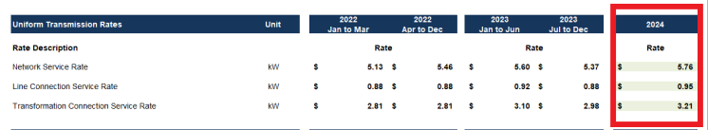
Hydro One Sub-Transmission Rates:
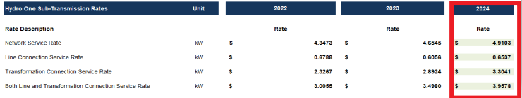
Question(s):

- Please confirm the accuracy of the Rate Generator update, as well as the accuracy of the resulting Retail Transmission Service Rates following these updates.

Staff Question-3
Ref 1: 2024 IRM Rate Generator Model, Tab 18
Ref 2: EB-2023-0268, Decision and Order, December 7, 2023
Ref 3: EB-2023-0222, OEB Letter “2024 Preliminary Uniform Transmission
Rates, issued September 28, 2023

Question(s):
- The Rate Generator Model was updated to reflect the outcome of the references above. Please confirm the accuracy of the Rate Generator update, as well as the accuracy of the results from these updates, as outlined below.

- Tab 18 Regulatory Charges, RRRP Charges
RRRP charge = $0.0014/kWh

- Tab 18 Time of Use RRP Prices and Percentages
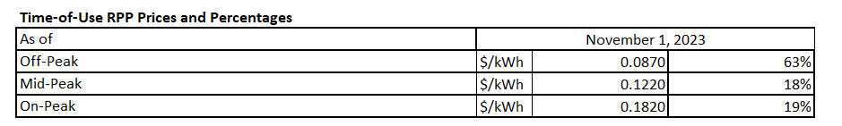
- Tab 21 Bill Impacts to a 19.3% Ontario Electricity Rebate

Staff Question-4
Ref 1: 2024 IRM Rate Generator Model, Tab 8
Ref 2: EB-2022-0016, 2023 IRM Rate Generator Model

Question(s):
Please explain how did you come to the tax numbers in Tab 8 Cell H18, H36? In your response, please explain any deviations from the value approved in the Bluewater Power Distribution Powerlines EB-2022-0016, 2023 Cost of Service application.

Staff Question-5
Ref 1: 2024 GA Analysis Work Form, Tab “GA 2022”
Ref 2: 2024 IRM Rate Generator Model, Tab 3

In Reference 1, Bluewater Power Distribution reports a debit balance of $81,230 in Net Change in Principal Balance in the GL (i.e. Transactions in the Year) in Cell B75. However, in Reference 2, Bluewater reported transaction during 2022 of debit balance of $79,828 in Cell BD 29.

Question(s):
- Please explain variance and update accordingly.

Staff Question-6
Ref 1: 2024 GA Analysis Work Form, Tab “Account 1588”
Ref 2: 2024 IRM Rate Generator Model, Tab 3

In Reference 1, Bluewater Power Distribution reports a credit balance of $283,907 in Account 1588 - RSVA Power in the GL (i.e. Transactions in the Year) in Cell C20. However, in Reference 2, Bluewater reported transaction during 2022 of debit balance of $283,907 in Cell BO 28.

Question(s):
- Please explain variance and update accordingly.

