**Atikokan Hydro Inc. (Atikokan Hydro)**

**Staff Questions**

**January 4, 2024**

Please note, that Atikokan Hydro is responsible for ensuring that all documents it files with the OEB, including responses to OEB staff interrogatories and any other supporting documentation, do not include personal information (as that phrase is defined in the Freedom of Information and Protection of Privacy Act), unless filed in accordance with rule 9A of the OEB’s Rules of Practice and Procedure.

**OEB Staff Question 1**

**Ref: 2024 IRM Rate Generator, Tabs 18 and 20**

On December 7th, 2023, the OEB issued a decision and order regarding the 2024 Wholesale Market Services rate (WMS) and the Rural or Remote Electricity Rate Protection charge (RRRP).[1]

OEB staff has updated Tab 18 of Atikokan Hydro’s Rate Generator with the revised RRRP charge of $0.0014 per kWh as follows:

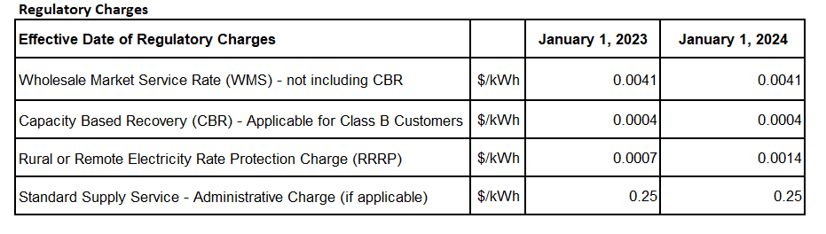

1. Please confirm the accuracy of the Rate Generator update, as well as the accuracy of the resulting Regulatory Charges following these updates.

**Response:**

Atikokan confirms the accuracy of the Rate Generator with the revised RRRP charge and the resulting Regulatory charges.

**Staff Question 2**

**Ref: 2024 IRM Rate Generator Model, Tabs 11, 15, and 20**

On September 28th, 2023, the OEB issued a letter regarding 2024 preliminary Uniform Transmission Rates (UTRs) and Hydro One Sub-Transmission Rates (RTSR).[2] The OEB determined the use of preliminary UTRs to calculate 2024 Retail Service Transmission Rates (RTSRs) to improve regulatory efficiency, allowing for this data to feed into the rate applications including annual updates for electricity distributors on a timelier basis. On December 14th, 2023, the OEB approved Hydro One Network Inc’s final host RTSRs.[3]

OEB staff has updated Atikokan Hydro’s Rate Generator with the preliminary UTRs and updated host RTSRs by HONI as follows:

**UTRs**

**Hydro One Sub-Transmission Rates**

1. Please confirm the accuracy of the Rate Generator updates, as well as the accuracy of the resulting Retail Transmission Service Rates.

**Response:**

Atikokan confirms the accuracy of the Rate Generator updates as well as the resulting Transmission Service Rates.

**Staff Question 3**

**Ref (1): 2024 IRM Rate Generator Model, Tab 3**

**Ref (2): EB-2021-0007: 2022 IRM Decision Order, Section 6**

On the continuity schedule of the 2024 Rate Generator, Atikokan reported $780 in Cell BE36, and $10 in Cell BJ36 as the amount of OEB approved for Account 1595 (2022) disposition during 2022.

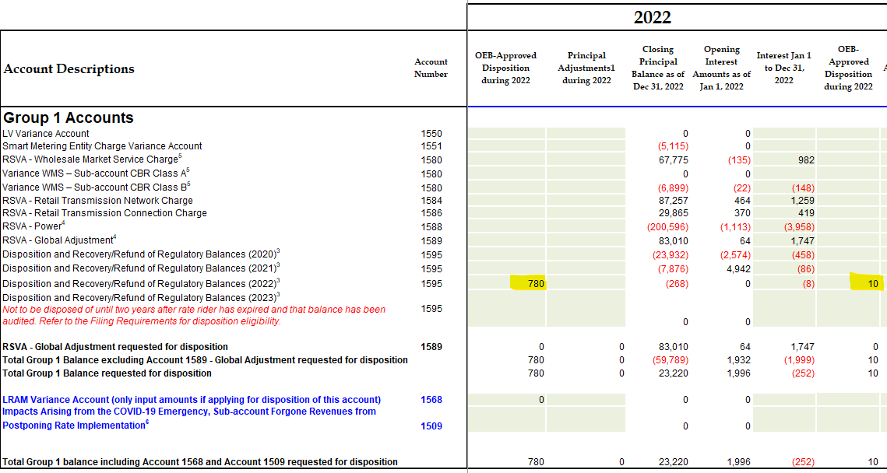

However, in Atikokan’s 2022 Decision and Rate Order, the OEB specified there was no Group 1 DVA Accounts disposition required, as the disposition threshold has not been exceeded.

1. Please provide an explanation for the above discrepancy.

**Response:**

Atikokan confirms there was no disposition of group 1 as the threshold was not exceeded; however, Atikokan applied and was approved to dispose of its LRAMVA credit balance of $780. The amounts recorded in cells BE36 and BJ10 represent the LRAMVA disposition, principal and interest amounts.

**Staff Question 4**

**Ref (1): 2024 IRM GA Analysis Workform**

The two tables in Note 8-Breakdown of principal adjustments included in last approved balance of Tab “Principle Adjustment” are not completed.

1. Please update these two tables in GA Workform.

**Response:**

Atikokan did not complete the Tab “Principal Adjustments” because it had no principal adjustments to complete.

**Staff Question 5**

**Ref: 2024 IRM rate Generator Model, Tab 3, Cells C58, BW23, BW25 & BV25**

References Cell C58 states that “RRR balance for Account 1580 RSVA - Wholesale Market Service Charge should equal to the control account as reported in the RRR. This would include the balance for Account 1580,Variance WMS – Sub-account CBR Class B.”

OEB staff notes that the control account 1580 in the continuity schedule excludes balances in CBR Class A and CBR Class B. The control account in RRR includes the balances of the two sub-accounts. Therefore, in the variance column, it is expected to see a variance in cell BW23 equaling the RRR balance of 1580 Sub-account CBR Class B in cell BV25.

Question(s)

1. Please explain why there is a variance in Cell BW25, and why the variance in Cell BW23 is not equal to the RRR balance in Cell BV25.
   1. Please revise the schedules or the RRR filing (2.1.7) as needed. If not, please explain.

**Response:**

Atikokan concludes it has made a clerical error in the RRR filing 2.1.7and requests OEB staff assistance in opening the 2.1.7 filing for year ending 2022. In making the filing correction and with a Rate Generator Model update cell BV25 should equal the variance in BW23. The variance in cell BW25 is because of the clerical error Atikokan made in its 2.1.7 filing.

**Staff Question 6**

**Ref (1): 2024 IRM Rate Application, p. 20**

**Ref (2): 2024 IRM GA Analysis Workform, Tab Account 1588, Cell B74**

**Ref (3): 2024 IRM GA Analysis Workform, Tab GA 2022, Cell K61**

**Ref (4): EB-2022-0015, 2023 IRM GA Analysis Workform V2 20230123, Tabs GA 2020 & GA 2021, Cell K61**

Reference 1 states that “For the year 2022, the 1588 variance was 2.6% of account 4705, cost of power. This is a result of line losses. Atikokan notes the calculated actual annual line loss has been less than the line loss charged to customers as per the Board Approved line loss factor of 1.0945.”

Reference 2 states that “Large balances are not expected for Account 1588; should only hold variance between commodity costs based on actual line losses and commodity revenues calculated by approved line losses. Atikokan has noted its actual line losses are less than the approved loss factor of 1.0945. “

OEB staff has compiled the following table based on the information provided in Reference 3 & 4:

|  |  |  |  |
| --- | --- | --- | --- |
|  | 2020 (Ref 4) | 2021 (Ref 4) | 2022 (Ref 3) |
| Calculated Loss Factor | 9.45% | 9.46% | 9.44% |
| Approved Loss Factor | 9.45% | 9.45% | 9.45% |
| Variance | 0% | 0.01% | (0.01)% |

Question(s):

1. Please explain why Atikokan Hydro's Account 1588 variance of 2.6% is much greater than the 1% threshold, despite the fact that the three-year average calculated loss factor, as noted in the above table, remains indifferent to the OEB-approved loss factor.
2. Please confirm the split of the IESO Charge Type CT148 between the Account 1588 and 1589 balances is correct. If not confirmed, please revise the schedules as needed.
3. Please also confirm the RPP portion of CT 148 is correctly captured in Account 4705. If not confirmed, please revise the schedules as needed.

**Response:**

* 1. Reference 1 stated: “For the year 2022, the 1588 variance was 2.6% of account 4705, cost of power. This is a result of line losses. Atikokan notes the calculated actual annual line loss has been less than the line loss charged to customers as per the Board Approved line loss factor of 1.0945.” This means that the approved loss factor allowed for an over-recovery of the 2022 energy purchases. The actual line losses were less than the OEB approved contributing to the credit of 1588 balance. Atikokan is scheduled to file its 2025 Cost of Service; loss factor changes is part of the filing requirements expected to be addressed if applicable. As applicable, Atikokan will request Loss Factor changes as part of its application.
  2. Atikokan believes the split of the CT148 between 1588 and 1589 are correct.
  3. The RPP portion of CT148 is correctly captured in Account 4705.

1. EB-2023-0268, Decision and Order, page 1
2. EB-2023-0222, OEB Letter, 2024 Preliminary Uniform Transmission Rates and Hydro One Sub-Transmission Rates, issued September 28, 2023
3. EB-2023-0030, Partial Decision and Rate Order, page 12