Welland Hydro-Electric Corporation
EB-2023-0056
January 19, 2024

Please note that Welland Hydro-Electric Corporation is responsible for ensuring that all documents it files with the Ontario Energy Board (OEB), including responses to OEB staff questions and any other supporting documentation, do not include personal information (as that phrase is defined in the Freedom of Information and Protection of Privacy Act), unless filed in accordance with rule 9A of the OEB’s Rules of Practice and Procedure.

OEB Staff Question - 1
Ref: 2024 IRM Rate Generator, Tab 11, 15 and 20

On January 18, 2024, the OEB issued a Decision and Rate Order which sets out the 2024 transmission revenue requirements by rate pool, and the Uniform Transmission Rates (UTRs), effective January 1, 2024.
On December 14, 2023, the OEB issued a partial decision and rate order (EB-2023-0030) containing Hydro One Sub-Transmission Rates.
OEB staff have updated Welland Hydro’s rate generator with Hydro One’s final host RTSR as follows:
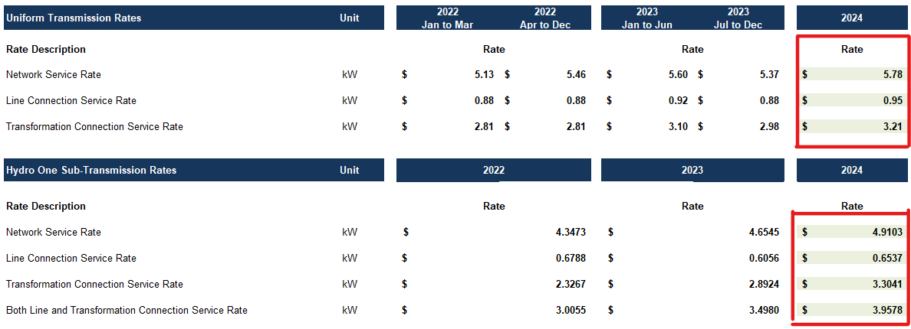
Question:
Please confirm the accuracy of the Rate Generator update, as well as the accuracy of the resulting Retail Transmission Service Rates following these updates.

Response:
Welland Hydro has reviewed the updates made to the Retail Service Rates on Tabs 11, 15 and 20 of the IRM Rate Generator. Welland Hydro confirms that the updates and forecasted rates as calculated on Tabs 11 and 15 are accurate. However, the updates are not reflecting correctly on the proposed Tariffs on Tab 20 for all but the Residential customer class. The rates that appear on the Tariff reflect those as previously filed, and have not been updated for the revisions. Also, the updates rates are not being reflected on Tab 21 Bill impacts.

OEB Staff Question-2
Ref: (i) Rate Generator Model, Tab 18, Regulatory Charges
(ii) Rate Generator Model, Tab 20, 21, Ontario Energy Rebate (OER)

The OEB announced on October 19, 2023, that electricity prices under the Regulated Price Plan (RPP) for households, small business and farms will increase as of November 1, 2023. Also effective November 1, 2023, the Ontario government’s Ontario Electricity Rebate (OER) will increase to 19.3%.

Question:
OEB staff have updated the 2024 RRRP data in Tab 18 of the 2024 rate generator model as well as the OER. Please confirm the accuracy of the resulting changes in the subsequent Tariff Sheet.

Response:
Welland Hydro has reviewed the updated 2024 RRRP data in Tab 18 of the 2024 rate generator model as well as the OER. Welland Hydro confirms the accuracy of the resulting changes in the subsequent Tariff Sheet.

OEB Staff Question-3
Ref: Manager’s Summary, pg 22.

Welland Hydro has indicated that it is seeking rate riders to recover LRAM-eligible amounts for 2024 previously approved in Decision and Rate Order EB-2022-0068.

Question:
- Please confirm that Welland Hydro is not requesting disposition of an LRAMVA balance.

Response:
Welland Hydro confirms that it is not requesting disposition of an LRAMVA balance.

