**Atikokan Hydro Inc. (Atikokan Hydro)**

**Staff Questions**

**January 22, 2024**

Please note, Atikokan Hydro Inc. is responsible for ensuring that all documents it files with the OEB, including responses to OEB staff questions and any other supporting documentation, do not include personal information (as that phrase is defined in the *Freedom of Information and Protection of Privacy Act*), unless filed in accordance with rule 9A of the OEB’s *Rules of Practice and Procedure*.

**Staff Question 7**

**Ref: 2024 IRM rate Generator Model, Tab 18**

**Ref: 2024 IRM rate Generator Model, Tab 20**

On October 19, 2023, the OEB announced that electricity prices under the Regulated Price Plan (RPP) for households, small business and farms will increase as of November 1, 2023. The current Time-of-Use (TOU) hours and the change in the threshold for residential customers on tiered pricing took effect November 1, 2023. Also, effective November 1, 2023, the Ontario government’s Ontario Electricity Rebate (OER) increased to 19.3%.

OEB staff has updated Atikokan Hydro’s Rate Generator, Tab 18 with the updated TOU pricing and Tab 20 with the OER as follows:

**TOU:**

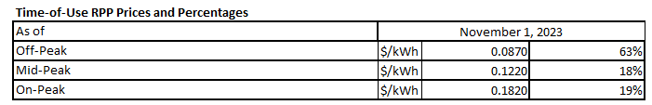

**OER:**

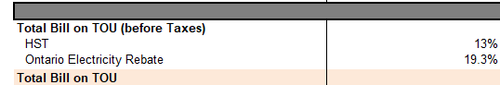

* 1. Please confirm the accuracy of the Rate Generator updates, as well as the accuracy of bill impacts.

**Response:**

Atikokan confirms the accuracy of both the updated TOU pricing and the OER Rate Generator updates.

Atikokan also confirms the accuracy of the Rate Generator Model with the corrected RRR data.

**Staff Question 8**

**Ref: 2024 IRM Rate Generator Model, Tabs 11, 20**

On January 18th, 2024, the OEB issued the final 2024 Uniform Transmission Rates. [1] There is a $0.02 difference in the Net Service Rate.

OEB staff has updated Atikokan Hydro’s Rate Generator with the final UTRs as follows:

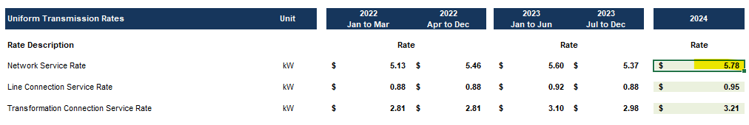

1. Please confirm the accuracy of the Rate Generator updates, as well as the accuracy of the resulting Retail Transmission Service Rates.

**Response:**

Atikokan confirms the accuracy of the Rate Generator updates as well as the accuracy of the resulting Retail Transmission Service Rates.

1. EB-2023-0222, Decision and Order, 2024 Uniform Transmission Rates, issued January 18, 2024