**Hearst Power Distribution Co. Ltd. (Hearst Power)**

**Follow-up Staff Questions**

**January 29, 2024**

Please note, that Hearst Power is responsible for ensuring that all documents it files with the OEB, including responses to OEB staff interrogatories and any other supporting documentation, do not include personal information (as that phrase is defined in the Freedom of Information and Protection of Privacy Act), unless filed in accordance with rule 9A of the OEB’s Rules of Practice and Procedure.

**Staff Question 9**

**Ref 1: 2024 IRM GA Analysis Workform, Tab Account 1588, Cells G20 & H20  
Ref 2:** [**Chapter 3 Filing Requirements for Electricity Distributors (oeb.ca)**](https://www.oeb.ca/sites/default/files/OEB-Filing-Reqs-Chapter-3-2024-20230615.pdf)**, p13**

Reference 2 Cell H20 states that “The annual Account 1588 balance relative to cost of power is expected to be small. If it is greater than +/-1%, provide an explanation in the text box below.”

Reference 3 states that “To further support a conclusion that GA charges have been appropriately allocated between customer classes, distributors must also perform a reasonability test for Account 1588. “

Question(s):

1. Please explain why Hearst Power's Account 1588 variance of 2.1% is much greater than the 1% threshold.
2. Please confirm the split of the IESO Charge Type CT148 between the Account 1588 and 1589 balances is correct. If not confirmed, please revise the schedules as needed.
3. Please also confirm the RPP portion of CT 148 is correctly captured in Account 4705. If not confirmed, please revise the schedules as needed.
4. OEB staff noted that large balances are not expected for Account 1588, as it should only hold the variance between commodity costs based on actual line losses and commodity revenues calculated based on approved line losses. Please confirm that the actual line loss is the same as the approved line loss of 1.0598. If not confirmed, please explain whether Hearst Power is going to address its loss factor changes in the next Cost of Services application.

**Staff Question 10**

**Ref: 2024 IRM Rate Generator Model, Tabs 11, 20**

On January 18th, 2024, the OEB issued the final 2024 Uniform Transmission Rates.[1] There is a $0.02 difference in the Network Service Rate.

OEB staff has updated Atikokan Hydro’s Rate Generator with the final UTRs as follows:

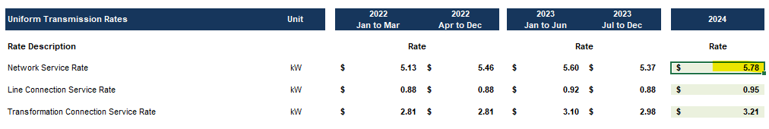

1. Please confirm the accuracy of the Rate Generator updates, as well as the accuracy of the resulting Retail Transmission Service Rates.

**Staff Question 11**

**Ref: 2024 IRM Rate Generator Model, Tab 3**

OEB staff has updated the Rate Generator with the corrected RRR data, regarding Hearst Power’s response to Staff Question 6.

1. Please confirm the accuracy of the Rate Generator updates, as well as the accuracy of bill impacts.

1. EB-2023-0222, Decision and Order, 2024 Uniform Transmission Rates, issued January 18, 2024