March 22, 2024

VIA RESS

Ms. Nancy Marconi
Registrar
Ontario Energy Board
2300 Yonge Street, Suite 2700
Toronto, ON M4P 1E4Ale

Dear Ms. Marconi:

Re: Generic Proceeding - Cost of Capital and Other Matters; OEB File: EB-2024-0063 – Alectra Utilities Corporation Participation Request

On March 6, 2024, the Ontario Energy Board gave notice that it has commenced a hearing to consider the methodology for determining the values of the cost of capital parameters and deemed capital structure to be used to set rates for electricity transmitters, electricity distributors, natural gas utilities, and Ontario Power Generation Inc. The hearing will also consider prescribed interest rates and other matters related to the OEB’s Cloud Computing Deferral Account.

By way of this letter, Alectra Utilities confirms its intention to participate in this generic proceeding.

All related correspondence and materials can be sent to Michael.Lister@alectrautilities.com.

Yours truly,

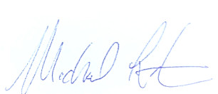

Michael Lister
Director, Policy & Strategy
Alectra Utilities Corporation

