Elizabeth Carswell

elizabeth@cyoo.ca

Independent Participant Submission

Sandford Community Expansion Project

EB-2023-0200

April 2, 2024

INTRODUCTION …………………………………………………………………… Page 2

PROJECT NEED (Enbridge B) …………………………………………………. Page 3

PROJECT COST AND ECONOMICS (Enbridge D) ……………………. Page 5

ENVIRONMENTAL (Enbridge E) ……………………………………………. Page 7

CONSULTATION (Enbridge G) ……………………………………………….. Page 7

CONCLUSION ………………………………………………………………………. Page 8

ATTACHMENTS …………………………………………………………………….. Page 8

**INTRODUCTION**

Enbridge Gas Inc. [Enbridge] is hoping to sell gas to my neighbours in Sandford. Some of the homes are older and have oil furnaces or wood heating. Some are in the newer hamlet built between 1995 – 1997 and most of these have propane. A few wood heat, have heat pumps, use geothermal or a combination. All of my neighbours also have their own source of water and water treatment. These are rural properties with independent solutions for utilities.

They all have heating that meets building code.

They do not ***need*** gas.

I have six concerns with the Enbridge expansion plan application for Sandford. I have not included concern about climate change or my very big concern that my neighbours will miss the chance of heat pump savings, for the life of a gas furnace, if they are swayed by the Enbridge advertising and do not have time to research other options.

Project Need – Community Support

1. Municipal Support Issues: Enbridge relies on support from the Municipality in the Introduction paragraph 6 and Project Need paragraph 7 & 8 and in Community Support Paragraph 11 and Paragraph 16 and 17. The communication with Uxbridge Council demonstrates that a good relationship has been established between Enbridge and Uxbridge Council. My opinion is that this support results from the relationship established and does not represent resident requests for gas as is implied.

Project Cost and Economics

1. Survey Flaws: Enbridge relies on a survey of customer support in the Introduction paragraph 6 and Project Need paragraphs 7 and 8 and in Community Support Paragraphs 16 and 17 and Growth forecast Paragraph 19. My opinion is that the survey results overstate the number of residents who will connect and that better survey information would show that the project does not meet the Economic threshold.
2. Residents are learning about Heat Pumps: Enbridge information for residents is misleading about the amount of savings available with a switch to gas from other fuels. Residents are learning about heat pump savings and as they understand the true value they will not choose gas.
3. Revenue Risk: The Project Cost and Economics section Paragraph 22 and 23 include financial assumptions that residents will continue to use gas and pay the SES for 40 years. This seems very unlikely to me. I am concerned about the financial risk for my neighbours and also other gas customers and even Ontario tax payers as residents disconnect earlier. These paragraphs also rely on the flawed survey results overstating the number of customers who will connect.

Environmental

1. Operational Environmental Impacts: The Environmental assessment considered only the risks during construction and did not consider that additional fossil fuels will be used as a result of this expansion and will increase greenhouse gas emissions during operation. This type of report has been accepted before but my opinion is that it is inadequate without also finding ways to limit impacts during operation. The Environmental Section Paragraph 26 mentions that operation was considered in the Environmental report but I did not see this.

Consultation

1. Consultations Exaggerate: The letters of consultation mention that gas is needed to meet the demand for affordable energy but the affordability message has been challenged with the Competition Bureau.

I ask that the Ontario Energy Board [OEB] decline to approve wasteful construction in Sandford and protect my neighbours from making an unnecessary investment in new equipment or equipment modifications. Enbridge has been careful in the three recent full back page advertisements in our local paper, The Cosmos. They have not said it is the cheapest way. They have said “Safe”, “join your neighbours” and “75% of Ontarians choose natural gas”. My neighbours may not have time to spend reading the Canadian Association of Physicians for the Environment material that says gas is not safe inside a home. They may not have time to research how subdivisions are built and realize that developers, not their neighbours, are the ones choosing the gas. No one is paying for advertisements in our paper showing any other options. Enbridge says “Natural gas is coming to Sandford” and it sounds as if it is progress. I ask that you decline this application and protect my neighbours from a choice that sounds money saving today but will need to have a much more expensive future as we pay the price to meet our commitments to greenhouse gas reduction.

**PROJECT NEED – COMMUNITY SUPPORT**

1. Municipal Support Issues

Enbridge, Municipal Stakeholder & Community Engagement representative, Cindy Mills, wrote an email to Mayor Barton mentioning the “safe, reliable and affordable energy” to be delivered via the expansion and appreciating Mayor Barton’s support. On July 24th, 2023, Kendra Black wrote an email to Mayor Barton including a template of a letter of support she requested. On July 24th, 2020 (perhaps a miss-type) the Township of Uxbridge sent in a letter of support following the template. On August 29, 2023, Enbridge emailed Mayor Barton mentioning “it was great to have the opportunity to meet you at the Enbridge reception” and following up on their discussion. They asked for support to increase the OEB oversight threshold and included wording. Mayor Barton put the suggestion on the agenda for the meeting and on September 25th Council passed the resolution.

Also on September 25th Enbridge wrote an email mentioning a social media post they would prepare and would like Mayor Barton to reshare. They did and he did.

On November 8th while preparing the answers to the interrogatories Enbridge again wrote to Mayor Barton to request an additional letter of support. Now they describe gas as accessible rather than affordable. They also mentioned my presentation to Council on October 16th. On November 17th Enbridge emailed again for support and that same day Mayor Barton replied with a letter following the template.

This communication pattern demonstrates that Uxbridge Council responds when Enbridge asks for support. The Municipal communication does not mention requests from residents. I have watched numerous Uxbridge Council meetings and I have followed the agendas closely and I have not seen residents in the community asking for gas. It is very possible that residents complain about the cost of propane or gasoline or groceries but bringing gas to the community is not the only way to reduce heating costs.

Recently a nearby farmer wrote a letter to Uxbridge Council asking for gas and Mayor Barton mentioned that he is expecting more letters. This letter and the meeting video is available online for the Feb 26th meeting <https://www.uxbridge.ca/en/your-local-government/council-meeting-calendar.aspx> On July 29th I emailed Mayor Barton myself asking the opposite. He replied very quickly as a “representative(s) of our Farmers” with 6 reasons why farmers need gas. I replied with counter arguments and did not get a response. The emails are attached as #1-4. I also sent Mayor Barton a link to the competition bureau complaint about Enbridge asking for it to be shared so residents in Sandford would have additional information. Unlike a similar request from Enbridge my suggested link was not shared.

I understand Mayor Barton’s concern about the cost of crop drying and using a heat pump for this purpose requires further development investment. A farm near me has a large crop drying operation and wanted to bring gas a little further so that they could attach. I asked about the cost for farms a little beyond the map in my interrogatories. The answer from Enbridge is that anything outside the map is out of scope but a Farm that is interested could apply for connection and pay the full cost either via SES or CIAC. This seems quite unfair as other more densely populated sections, chosen by Enbridge, are able to benefit from the NGEP funding. The farmers that have some activities not yet solved by heat pumps are being left out.

I am aware of Federal benefits for farmers intended to offset the carbon taxes and energy costs and I have not researched these. If there is any shortfall in benefits between farms with and without gas I suggest that this be solved by specific subsidy and not by increasing the distribution of gas.

I know that there are people in my community that are concerned about high heating costs although I have not seen anyone suggest that Council ask for gas. I have asked our Environmental Advisory Committee to ask Council to request that the NGEP funding be repurposed to provide heat pump funding. We have seen community support for the Federal program supporting heat pumps.

**PROJECT COST AND ECONOMICS**

1. Survey Flaws:

The survey of resident interest in gas is not reliable for a number of reasons. According to an article in the Toronto Star, January 29th ONO News page 7 that references another survey “opt-in polls cannot be assigned a margin of error”. A report in the Indian J Psychol Med published online says in the Abstract “Online surveys commonly suffer from two serious methodological limitations: the population to which they are distributed cannot be described, and respondents with biases may select themselves into the sample. Research is of value only when the findings from a sample can be generalized to a meaningful population.” <https://www.ncbi.nlm.nih.gov/pmc/articles/PMC7735245/>

These quotes explain one of my concerns about the Enbridge survey. Residents were told “Enbridge Gas has asked Forum Research to conduct a survey to help evaluate the feasibility of

extending the natural gas system to homes and businesses similar to yours. This online **survey will run** from August 15th – September 12th, 2022 with the intention of **gauging your interest in connecting to natural gas, should it become available in your community.”** Residents of Sandford that already know they do not want gas would not have taken their time to answer a survey with this topic. Residents that already know they do not want gas are completely missing and need to be added to the Forum research totals. This would significantly alter the totals that are relied on in the financial projections. I remember that Enbridge suggested that the OEB has always accepted this survey but Enbridge themselves mentioned that customers that want gas would not reply to an Environmental Defense survey which is the exact argument that I am making. Enbridge said “Consumers having any desire to obtain natural gas service may be understandably reluctant to participate in such a survey, which would in turn make the survey results unreliable for the purpose of assessing consumer interest in connecting to the natural gas system.” It seems Enbridge agrees that if you are not interested in the survey topic you will not respond. The experts I have quoted above agree that online survey results are not reliable. This represents a risk to the financial forecast and suggests a much lower PI.

When I conducted my informal survey I mentioned Gas first and took note of those who immediately were not interested. 8 of the 50 people I talked to were definite that they would not connect to gas. Based on our conversations there are two additional that are very unlikely to connect. One has oil now but really wood heats and said that he will carefully consider a heat pump when he stops being able to handle wood heating. The other has a new heat pump with propane backup that comes on when the outside temperature is -13 or below. In nearby Udora the climate station recorded only 13 days in the last year with a minimum temperature below -13. He will use very little propane. In addition to these 20% there were a couple others that were skeptical in general. I remember a man who said “What next? Will they make me take water and sewer?” There were also many that were interested in heat pumps and said they would research further before connecting. In total 55% were not interested in gas or were interested in heat pumps when I spoke to them at the door.

The OEB has previously noted “the decision of individual consumers to opt for natural gas service is based on ‘all relevant factors including financial and non-financial considerations relevant to their geographic location, heating need, housing and electrical standard.” Financial considerations depend on the circumstances at the time. I mentioned in a letter of comment a survey of these exact same residents about signing up for a less expensive and faster internet connection. The survey did not require any financial outlay and similar to the Enbridge survey it anticipated cost savings after connection. The resulting connections to the internet were much lower than the survey result anticipated. An explanation could be that the financial circumstances had changed and the respondents who said they would connect now found it difficult to come up with the small initial connection cost for the hardware. These are the same residents in Sandford that were offered the less expensive and faster internet service and found it difficult to connect as planned. I expect that they will also find it difficult to pay the up front conversion cost for gas. Today, residents who use oil, could have immediate savings by converting to propane and yet they did not. Likely it is the up front cost that stops them and there will be the same up front cost stopping them from connecting to gas. In addition to the conversion costs mentioned in the survey many will be faced with large up front extra length costs because of the long rural driveways.

1. Residents are learning about Heat Pumps:

The survey that Enbridge relies on for the project economics was conducted a long time ago now. Since that time there has been a lot of new information made available on savings related to heat pumps. I provided information to 100 residents in Sandford during two weekends in October 2023. I either handed out in person and discussed the Ontario Clean Air Alliance pamphlet or I left it on the doorstep. I know that even on the doorstep this pamphlet is compelling because I received a phone call follow up from a homeowner on the 4th Concession that was very interested and wanted to buy one. My in person discussions were also well received. One homeowner went to get her husband away from installing a microwave so that he could participate in the discussion. They were very interested and said they would follow up further.

In addition, I made two presentations to Uxbridge Council which is attended in person as well as by zoom and is then also available online in several formats. My October 16th presentation included the Enbridge gas saving calculations with an additional graphic showing the extra savings from heat pumps beside in the same format. This presentation was covered in our local newspaper, The Cosmos, Oct 19th, which is the same one that Enbridge uses to make announcements.

I have also had three letters To the Editor published in The Cosmos which is delivered by mail to all the Residents of Sandford. Residents are gaining information about heat pumps which will displace their earlier interest in gas. Widespread coverage of the ending of the Heat Pump grant also mentioned that heat pump interest was growing much faster than expected.

There was an article in The Toronto Star, ONO A12 on September 9th about this project and the competition bureau complaint.

The letter of comment from outside the area also deserves consideration. That is one more motivated person in Ontario who is likely speaking to many others and continuing to spread concern about gas and greenhouse gases. There is more and more information to change minds in Sandford.

1. Revenue Risk:

In addition to the revenue risk from fewer connections than identified in the flawed survey there is also the risk of the revenue horizon. Revenue horizon is suddenly big news with the recent introduction of Bill 165 which has been covered by The Narwhal and others <https://thenarwhal.ca/ontario-overrules-energy-board-enbridge/> . Many more people in Ontario and in Sandford are suddenly hearing the news that gas customers are expected to subsidize connections over the next 40 years. A number of groups and reports and including Mr. Mike Schreiner, during the 2nd reading debate, mention that this is unlikely and even impossible as we must meet our commitments to reduce greenhouse gas emissions by 2050. 2040 is much closer than 40 years after construction of the Sandford project. The answer to my interrogatory about the 40 years did not provide any certainty for gas customers.

**ENVIRONMENTAL**

1. Operational Environmental Impacts

Did I understand correctly that the distribution in Sandford will release 4,390,200 cubic meters of greenhouse gas over the first 10 years? How is that not considered in the Environmental impact assessment? Enbridge has assumed that customers not using fossil fuel today will also connect. Enbridge has assumed that electric water heaters will also be converted to gas. Enbridge is planning to increase greenhouse gas emissions beyond the fossil fuel uses today in order to meet the project financial plan. This project greenhouse gas emissions will be far more than the heat pump alternatives that are available today. Enbridge also plans to share advertising about other uses of gas. This is from the website, April 1st, 2024, “Ways to Save”, “On the patio”, “Natural gas lamps are a more efficient alternative to electric lights – without the cost and hassle of changing burnt-out bulbs.” Lack of outdoor lighting on your patio would be the less expensive and more environmentally friendly alternative. The same page also says “Ways to save”, “In the laundry room” “Natural gas dryers are better for your wallet and the environment, compared to electric units.” The less expensive and environmentally friendly alternative is a clothesline.

**CONSULTATION**

1. Consultations exaggerate

The letters of consultation sent out by WSP and Enbridge all start with the words “upcoming pipeline project to meet the increased demand for affordable energy”. This letter is part of an environmental study and therefore I find it reasonable to assume that a letter mentioning affordable energy could be assumed to mean that there are no other affordable alternatives that are more environmentally friendly. Not so!

And Enbridge knows about heat pumps. Enbridge is involved in the projects in Ontario where heat pumps are added to gas furnaces. Enbridge has information about heat pumps from the assessment they paid for from Guidehouse Inc.

Enbridge also exaggerates, by 5%, the savings expected by propane users. Enbridge suggests that 5% is not material but I just recently chose a different store for a purchase of garden edging for a 5% savings. My neighbours would likely agree that 5% of the savings expected are important to them.

**CONCLUSION**

I ask that the OEB decline this application to expand gas distribution to Sandford. Declining expansion would protect the residents from making an investment that cannot produce the savings they have been promised, and simultaneously, meet our greenhouse gas reduction commitments. Declining the expansion would also protect existing gas customers from the risk that their rates will subsidize this construction because the customer attachment forecast was too high.

If the OEB decides to allow this expansion, I suggest as a condition prior to construction, Enbridge be required to collect an amount equal to the expected conversion costs, from the anticipated number of residential customers. Enbridge could pay interest to the residents and then refund the upfront amounts when the connection is made. Interest is already included in the project budget so this would be no additional project cost. This condition would protect gas customers from the probability that the forecast number of attachments are higher than the actual number who sign up to buy gas.

**ATTACHMENTS**

#1 email to mayor

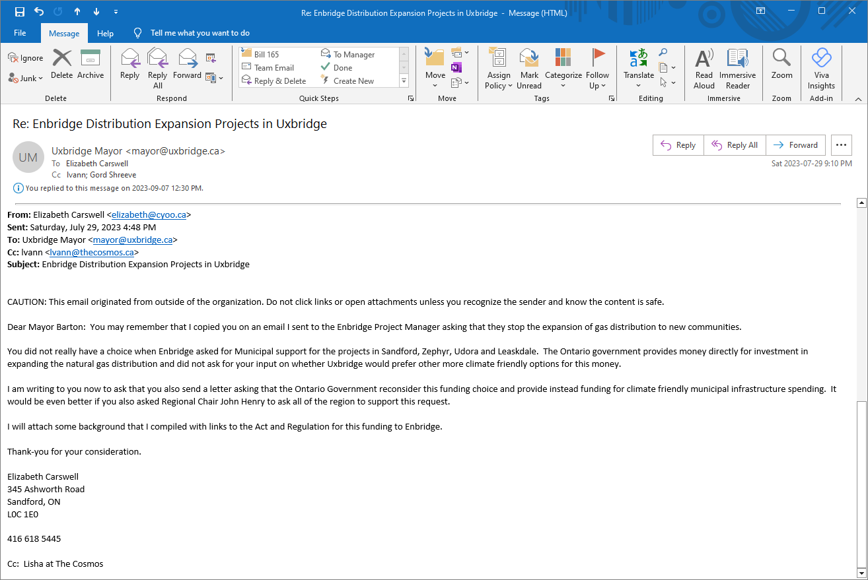

#2 Reply from Mayor

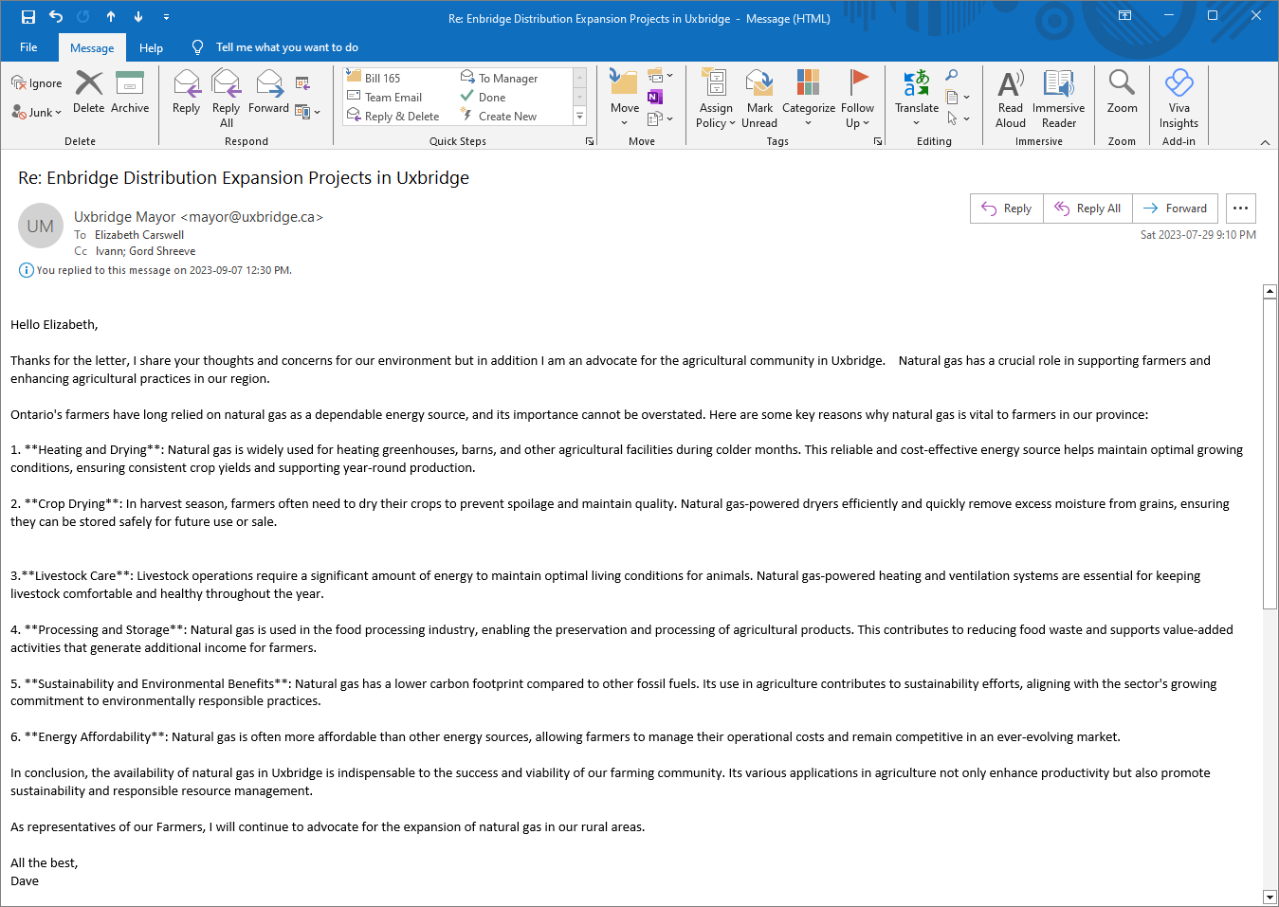

#3 My reply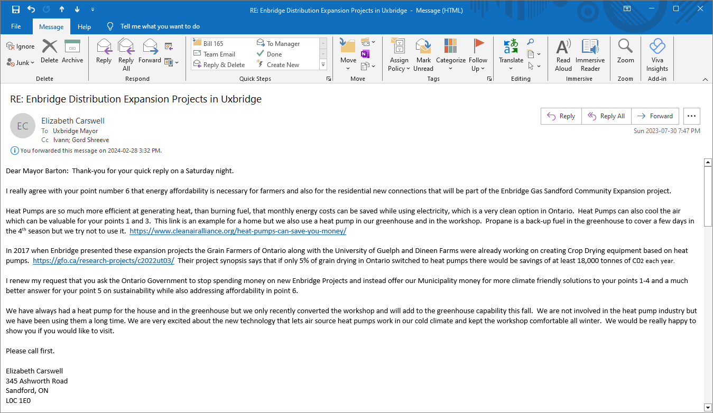

#4 Share the link