October 22, 2008

Ms. Kirstin Walli
Board Secretary
Ontario Energy Board
P.O. Box 2319
2300 Yonge Street, 27th Floor
Toronto, ON M4P 1E4

Re: EB-2008-0155 Chatham-Kent Hydro and Middlesex Power Distribution Corp. Smart Meter Rate Application

Dear Ms. Walli:

Chatham-Kent Hydro Inc. (“CKH”) and Middlesex Power Distribution Corp. (“MPDC”) has requested an updated Smart Meter Permanent Adder and Smart Meter Rider to cover the investment in capital from May 1 2007 to December 31, 2007 and ongoing capital investments for the general service smart meter installations.

CKH and MPDC has provide a table of the starting rates May 1, 2008 and proposed distribution of the rates May 1 2009 before the 2009 IRM inflator calculations.

Chatham-Kent Hydro Inc.

Middlesex Power Distribution Inc.

If you have any more concerns or questions, please be free to contact me at the number below.

Yours truly,
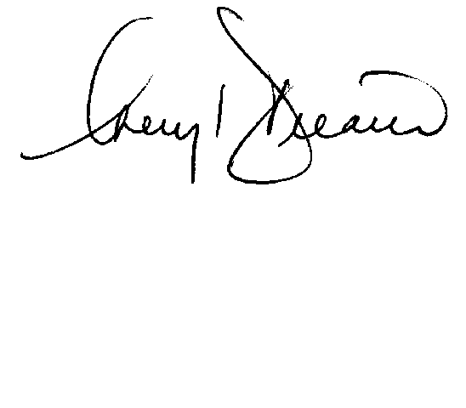

Cheryl Decaire
Co-ordinator of Regulatory and Rates
(519) 352-6300 ext 405
Email: cheryldecaire@ckenergy.com

CC: Dave Kenney, President of Chatham Kent Hydro
Jim Hogan, Chief Financial and Regulatory Officer

