**InnPower Corporation**

**EB-2024-0036**

**[October 1, 2024]**

Please note, InnPower Corporation (InnPower) is responsible for ensuring that all documents it files with the OEB, including responses to OEB staff questions and any other supporting documentation, do not include personal information as that phrase is defined in the *Freedom of Information and Protection of Privacy Act*, unless filed in accordance with rule 9A of the OEB’s *Rules of Practice and Procedure*.

**Staff Question-1**

**Ref: D24-23581 InnPower_2025 IRM_Rate Generator Model_20240815, Continuity Schedule, Tab 3**

On June 18, 2024, the OEB issued Filing Requirements for Electricity Distribution Rate Applications Filed for Rates taking effect in 2025.

**Question:**

1. InnPower is seeking disposition of the 1595 account in the amount of ($200,082) for the residual 2018 DVA account balance approved for disposition. The disposition of the residual balances is requested two years after the expiry of the rate rider. Please advise on why was this not requested in previous (2023) applications?

**Staff Question-2**

**Ref: D24-23581 InnPower_2025 IRM_Rate Generator Model_20240815, Continuity Schedule, Tab 3**

On June 18, 2024, the OEB issued Filing Requirements for Electricity Distribution Rate Applications Filed for Rates taking effect in 2025. As per the screenshot below, data for columns 2020 and onwards has been input into the row for 2018.

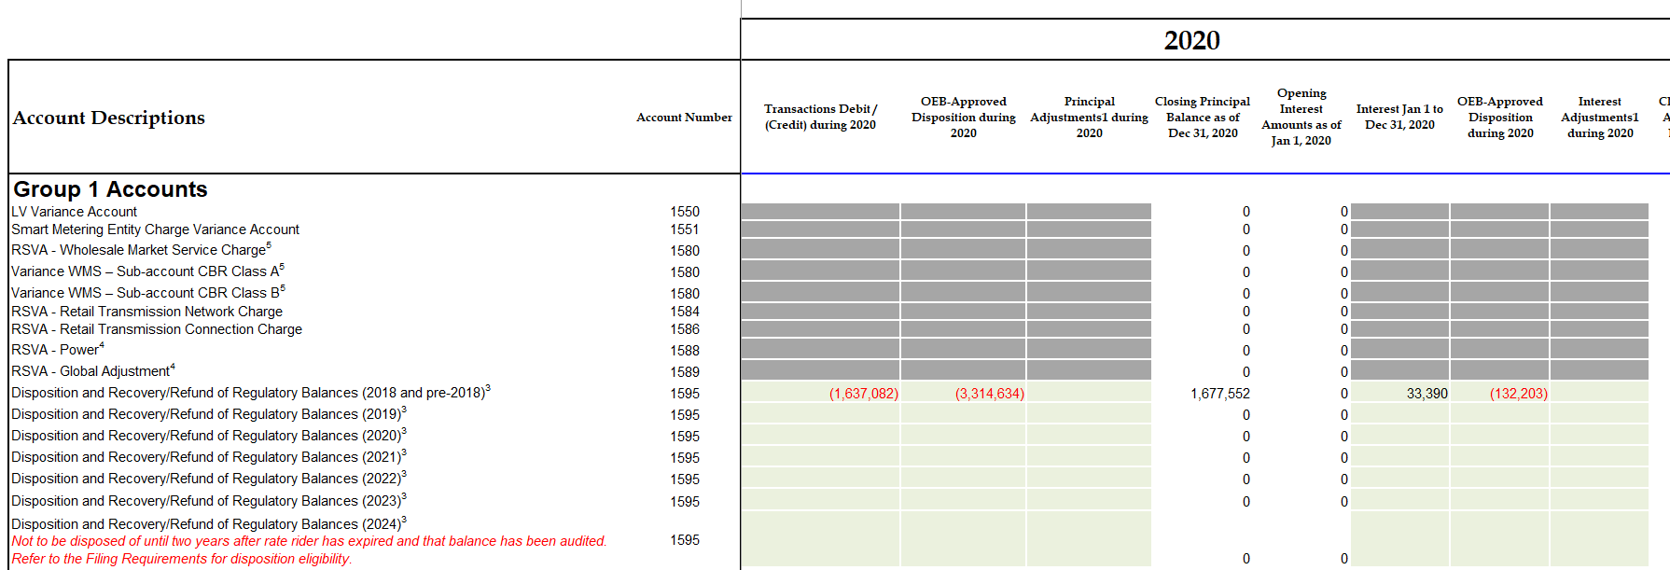

**Question:**

1. Please adjust to reflect information on the row for the respective years.

**Staff Question-3**

**Ref: D24-23581 InnPower_2025 IRM_Rate Generator Model_20240815, Continuity Schedule, Tab 3**

As per the screenshot below, 2021 OEB approved disposition has been allocated entirely to principal balance and not for interest balance.

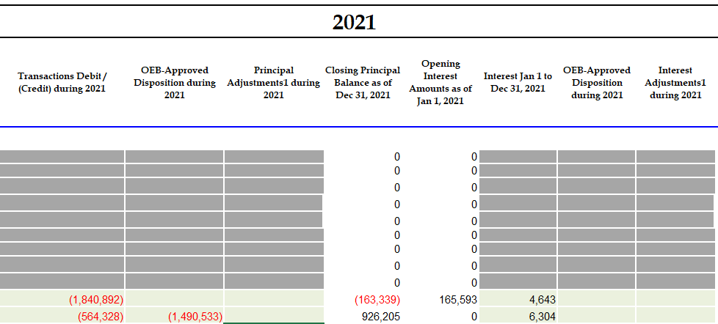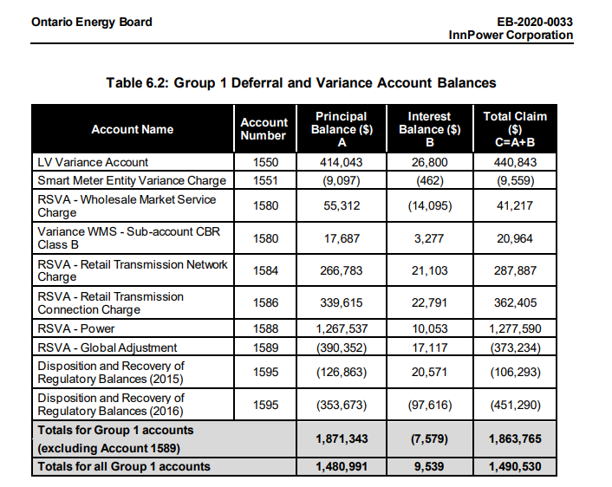

**Question:**

1. Please adjust the information to correctly allocate the approved principal and interest disposition balances.

**Staff Question-4**

**Ref: D24-23581 InnPower_2025 IRM_Rate Generator Model_20240815, Continuity Schedule, Tab 3**

As per the screenshot below, 2022 OEB approved disposition has been allocated entirely to principal balance and not for interest balance.

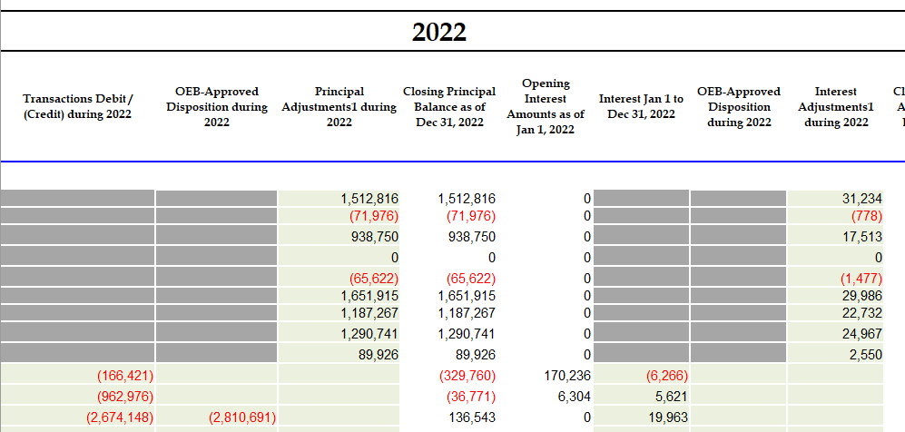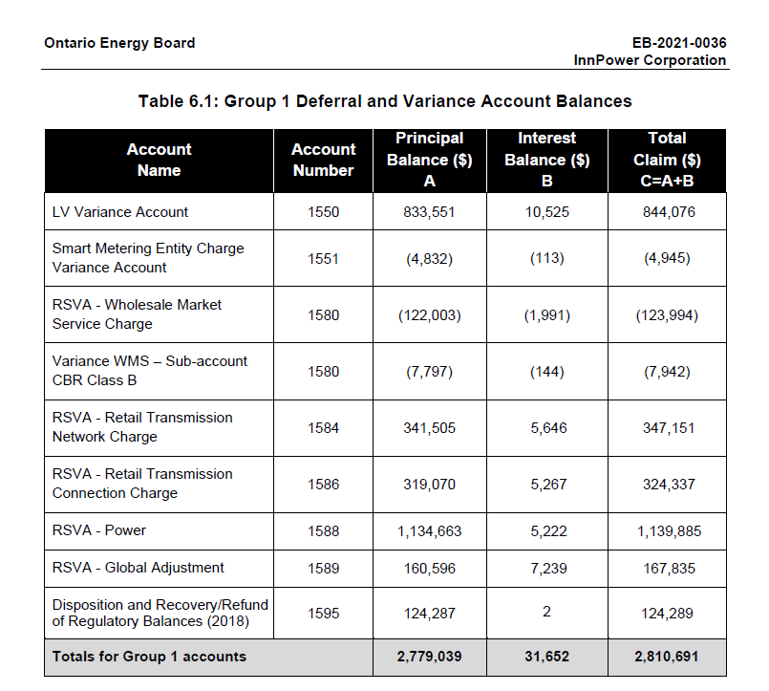

**Question:**

1. Please adjust the information to correctly allocate the approved principal and interest disposition balances.

**Staff Question-5**

**Ref: D24-23581 InnPower_2025 IRM_Rate Generator Model_20240815, Continuity Schedule, Tab 3**

As per the screenshot below, 2023 OEB approved disposition for interest disposition balances is different from what was approved in EB-2022-0043 Table 6.1.

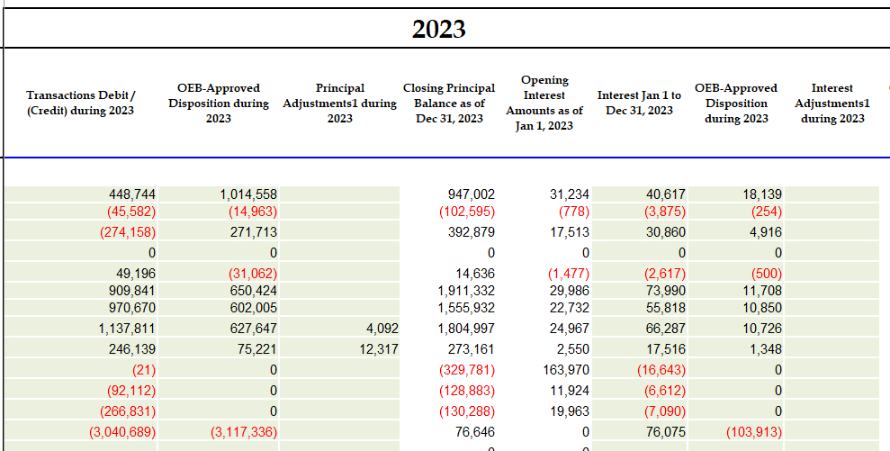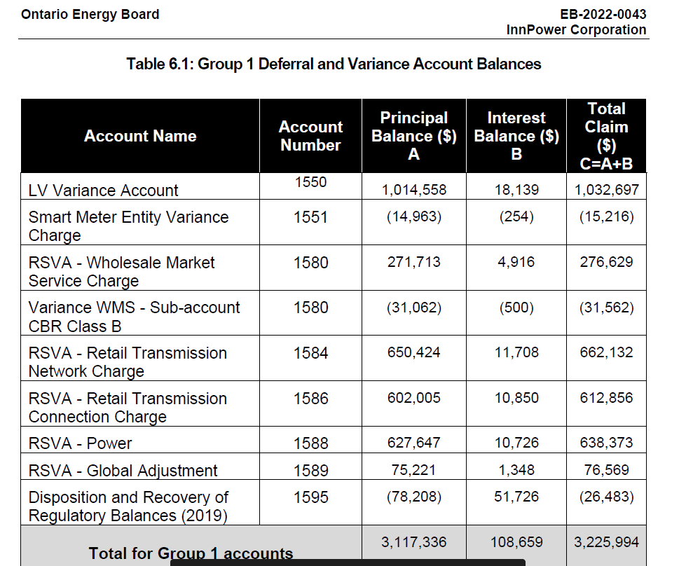

**Question:**

1. Please update the rate generator model with the correct information.

**Staff Question-6**

**Ref: D24-23581 InnPower_2025 IRM_Rate Generator Model_20240815, STS - Tax Change, Tab 8**

On Tab 8, InnPower has not provided an inputs in the requested fields.

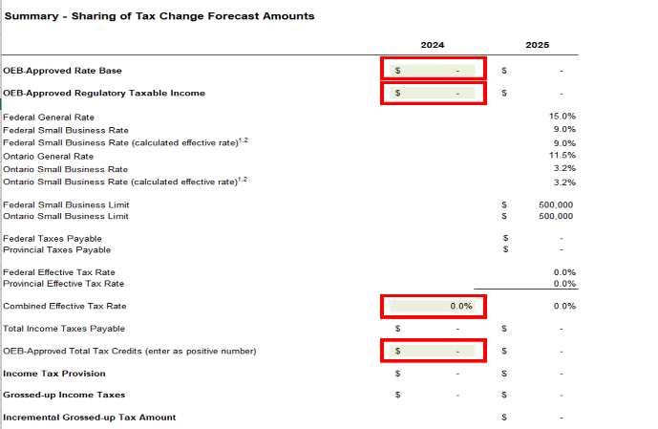

**Question:**

1. Please fill out the missing information in this tab.

**Staff Question-7**

As per your email on September 17, 2024, InnPower indicated that an error was identified in the application, “As the Embedded Distributor rate class is new as of January 1, 2024, we were unable to use historical 2023 RRR data for the cost allocations.  Rather, we had to manually pull the information from the customer's account, add it to the Embedded Distributor rate class and deduct it from the GS>50 rate class (the customer's previous rate class reported in 2023 RRR).

The correction should increase the GS>50 demand and decrease the Embedded Distributor demand.  It should not effect any other rate class and would likely eliminate the need to spread the GS>50 rate rider over a 24-month period.”

**Question:**

1. Please make the updates to rectify the error identified by InnPower, as well as indicate where the updates have been made. Additionally, please explain how this update has impacted the model (e.g., changes in rate rider period from 24 to 12 months).

**Staff Question-8**

**Ref: D24-23581 InnPower_2025 IRM_Rate Generator Model_20240815, Billing Det. For Def-Var, Tab 4**

|  |  |  |  |
| --- | --- | --- | --- |
| The OEB approved Account 1509 Allocation ($ distribution revenue from last Cost of Service) amount is different from what is currently in the rate generator model. | **OEB Decision & Rate Order (EB-2023-0033) Pg 88** | **Billing Det. For Def-Var (EB-2024-0036; Rate Generator Model)** | **Variance**  **(OEB Staff Calculation)** |
| RESIDENTIAL SERVICE CLASSIFICATION | $ 10,972,014 | $ 11,400,476 | -$428,462 |
| GENERAL SERVICE LESS THAN 50 KW SERVICE CLASSIFICATION | $ 1,358,579 | $ 1,157,610 | $ 200,969 |
| GENERAL SERVICE 50 to 4,999 kW SERVICE CLASSIFICATION | $ 1,346,890 | $ 1,050,041 | $ 296,849 |
| EMBEDDED DISTRIBUTOR SERVICE CLASSIFICATION | $ 23,484 | $ 13,475 | $ 10,009 |
| UNMETERED SCATTERED LOAD SERVICE CLASSIFICATION | $ 165,477 | $ 20,503 | $ 144,974 |
| SENTINEL LIGHTING SERVICE CLASSIFICATION | $ 16,300 | $ 29,594 | -$13,294 |
| STREET LIGHTING SERVICE CLASSIFICATION | $ 11,527 | $ 211,849 | -$200,322 |
| **Total** | $ 13,894,270 | $ 13,883,549 | $ 10,721 |

**Question:**

1. Please explain the reasoning for the difference in the amounts reported and update the information, as appropriate, to reflect the approved numbers.

**Staff Question-9**

**Ref 1: Manager’s Summary, Page 13**

**Ref 2: 2025 IRM Rate Generator Model**

In Reference 1, InnPower states that given the total bill impact is greater than 10% for the GS 50 to 4,999 kW rate class, a two-year disposition on the Group 1 deferral and variance accounts is proposed for this rate class.

In Reference 2, OEB staff notes InnPower applied 12 month disposition period for all rate classes.

**Question(s):**

1. Please confirm the OEB staff’s observation.
2. If confirmed, please clarify the intended Group 1 accounts disposition period for this specific rate class.
3. Please update the Rate Generator Model as applicable.

**Staff Question-10**

**Ref 1: 2025 GA Analysis Workform, GA 2023 Tab**

**Ref 2: InnPower’s 2024 cost of service application EB-2023-0033, GA Analysis Workform, GA**

In Reference 1, InnPower reports the following reconciling items in the GA 2023 Tab:

* A credit amount of $72,890 is reported for item 5a - significant prior period billing adjustments recorded in the current year
* A debit amount of $114,319 is reported for item 8 – unbilled revenue amount

Additionally, InnPower explains under item 8 that “unbilled revenue from December 2022 ($264,223) and unbilled revenue from December 2023 $378,551 - would be adjusted in table above, however, does not use the same method as GA Analysis Workform.” OEB staff notes that the sum of these two unbilled revenue amounts equal to $114,319.

In Ref 2, OEB staff notes that InnPower did not report anything on the GA analysis workform for GA 2022 for the reconciling items 2a and 2b, as shown below:

|  |  |  |
| --- | --- | --- |
| 2a | Remove prior year end unbilled to actual revenue differences |  |
| 2b | Add current year end unbilled to actual revenue differences |  |

**Question(s):**

1. Please confirm that a credit amount of $264,223 for unbilled revenue from December 2022 is recorded in 2023 rather than 2022 and should have been recorded in last year’s GA analysis workform.
2. If so, please address the rates retroactivity issue, given that the 2022 balance was final disposed of in the 2024 proceeding.
3. If not, please explain in detail of this credit amount.
4. Please clarify how the unbilled revenue amounts are derived.
5. Please clarify what you mean by InnPower “does not use the same method as GA Analysis Workform”? Additionally, please elaborate on the reasons for this difference.
6. Please itemize and provide a detailed explanation of what the prior period billing adjustments of 72,890 relate to.

**Staff Question-11**

**Ref 1: 2025 GA Analysis Workform, Account 1588 Tab**

**Ref 2: 2024 GA Analysis Workform, Account 1588 Tab**

In Reference 1, the total activity reported for 2023 is a debit balance of $1,141,903, which includes principal adjustments of a debit balance of $4,092. This amountrepresents 4.7% of the cost of power purchased. InnPower states that the loss factor of 1.0604 as approved in its 2017 Cost of Service (COS) proceeding, is understated. In 2023, Innpower has not collected enough funds to recover losses, resulting in an accumulated balance in Account 1588. The understated loss factor has been approved to increase to 1.0821 in the 2024 COS application. Consequently, InnPower expects this issue to be resolved in the 2026 IRM submission.

OEB staff notes that the total activity reported for 2022 in Reference 2 is a debit balance of $663,094, including principal adjustments of a debit balance of $178,078, representing 2.4% of the cost of power purchased.

**Question(s):**

1. Please further explain the significant increase in Account 1588 activity in 2023, considering it more than doubled compared to 2022, despite both years having the same loss factor of 1.0604.
2. Please quantify the impact of the understated loss factor of 1.0604 on Account 1588 for 2023.

**Staff Question-12**

**Ref 1: Chapter 3 - Filing Requirement for Electricity Distribution Rate Applications Filed in 2024 for Rates Taking Effect in 2025, June 18, 2024, Pg. 16**

**Ref 2: 2025 IRM Rate Generator Model**

**Ref 3: EB-2022-0043, Decision and Rate Order, December 8, Page 9**

Chapter 3 of the Filing Requirements in Reference 1 specifies that, when the OEB approves the disposition of Deferral and Variance Account (DVA) balances, the approved principal amounts and carrying charges are to be transferred to Account 1595 for the applicable rate year.

OEB staff observes that the principal and interest amounts in Sub-account 1595 (2024) in Reference 2 do not include the total amounts approved by the OEB for disposition.

Additionally, OEB staff notes that the approved disposition for Sub-account 1595 (2019), as outlined in Reference 3, is not reflected in Cells BE32 and BJ32.

**Question(s):**

1. Please confirm OEB staff’s observations and revise the schedule as applicable.

**Staff Question-13**

**Ref: Rate Generator Model, Tab 3, Continuity Schedule**

On September 13, 2024, the OEB published the 2024 Quarter 4 prescribed accounting interest rates applicable to the carrying charges of deferral, variance and construction work in progress (CWIP) accounts of natural gas utilities, electricity distributors and other rate-regulated entities.

**Question:**

1. Please update Tab 3 (Continuity Schedule) as necessary to reflect the Q4 2024 OEB-prescribed interest rate of 4.40%.