**Niagara Peninsula Energy Inc**

**EB-2024-0043**

**[October 1, 2024]**

Please note, Niagara Peninsula Energy Inc. (Niagara Peninsula Energy) is responsible for ensuring that all documents it files with the OEB, including responses to OEB staff questions and any other supporting documentation, do not include personal information as that phrase is defined in the *Freedom of Information and Protection of Privacy Act*, unless filed in accordance with rule 9A of the OEB’s *Rules of Practice and Procedure*.

**Staff Question-1**

**Ref: D24-23663 NPEI_2025-IRM-Rate-Generator-Model_V3_NPEI_20240815, Continuity Schedule, Tab 3**

On June 18, 2024 the OEB issued Filing Requirements for Electricity Distribution Rate Applications Filed for Rates taking effect in 2025.

Questions:

1. The OEB-approved disposition amount for 2020 for Account 1595 is different from what is currently in the continuity schedule. The signs are also different. Please update the information to reflect the approved numbers and signs.

|  |  |  |  |
| --- | --- | --- | --- |
|  | **OEB Decision & Rate Order (EB-2019-0054; Table 6.2)** | **Continuity Schedule**  **(EB-2024-0043; Rate Generator Model)** | **Variance**  **(OEB Staff Calculation)** |
| **Principal Approved** | $ 1,377,507 ​ | - $ 1,119,747 | $ 257,760 ​ |
| **Interest Approved** | $ 85,838 ​ | - $ 85,389 ​ | $ 449 |
| **Total** | $ 1,463,345 ​ | - $ 1,205,136 ​ | $ 258,209 |

1. The rate riders for 2020 were effective from May 1, 2020 to April 30, 2021. The amounts recorded are:

|  |  |
| --- | --- |
|  | **Continuity Schedule**  **(EB-2024-0043; Rate Generator Model)** |
| **Transactions Debit/ (Credit) during 2020** | $ 31, 943 |
| **Transactions Debit/ (Credit) during 2021** | - $ 1,202,779 |
| **Transactions Debit/ (Credit) during 2022** | - $ 2,663 |

Please explain the reason for the maximum principal transaction recorded in 2021 versus 2020 which had more months. Also, please explain the reason for recording the amount in 2022.

1. Please fill out the attached 1595 Analysis workform for the requested disposition in Account 1595 sub-account 2020.

**Staff Question-2**

**Ref: D24-23663 NPEI_2025-IRM-Rate-Generator-Model_V3_NPEI_20240815, RTSR – Historical Wholesale, Tab 12**

OEB staff has noted differences in the Network Rates reported on Tab 12.

Question:

1. Please explain the reason for using a Network Rate of $5.66 in May and $5.23 in December. Please update the values as necessary.

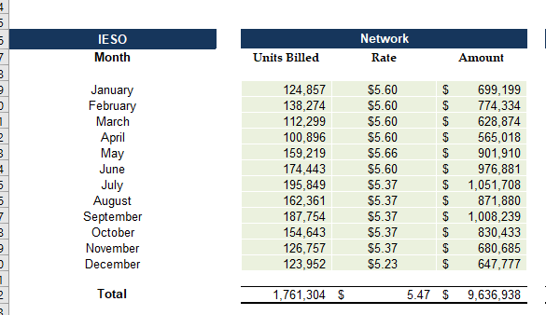

**Staff Question-3**

On June 18, 2024, the OEB issued Filing Requirements for Electricity Distribution Rate Applications Filed for Rates taking effect in 2025.

**Ref: D24-23663 NPEI_2025-IRM-Rate-Generator-Model_V3_NPEI_20240815, Continuity Schedule, Tab 3**

Questions:

1. The OEB-approved disposition signs for 2022 for Account 1595 are different. Please update the information to reflect the approved signs.

|  |  |  |
| --- | --- | --- |
| **Year 2022** | **OEB Decision & Rate Order (EB-2021-0043; Table 6.1)** | **Continuity Schedule**  **(EB-2024-0043; Rate Generator Model)** |
| **Principal Approved** | $ 691,995 | - $ 691,995 |
| **Interest Approved** | $ 38,429 | - $ 38,429 |
| **Total** | $ 730,424 | - $ 730,424 |

b) The OEB-approved disposition signs for 2023 for Account 1595 are different. Please update the information to reflect the approved signs.

|  |  |  |
| --- | --- | --- |
| **Year 2023** | **OEB Decision & Rate Order (EB-2022-0051; Table 6.1)** | **Continuity Schedule**  **(EB-2024-0043; Rate Generator Model)** |
| **Principal Approved** | $ 1,632,107 | - $ 1,632,107 |
| **Interest Approved** | $ 1,057,976 | - $ 1,057,976 |
| **Total** | $ 2,690,083 | - $ 2,690,083 |

**Staff Question-4**

**Ref: 2025 IRM Rate Generator, Tab 11, 15 and 20**

On June 27, 2024 the OEB issued a Decision and Rate Order regarding 2024 Uniform Transmission Rates (UTRs).[1] Any further updates will be reflected in the final Rate Generator Model.

**UTRs**

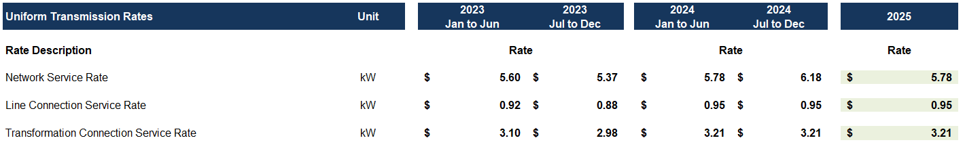

**Questions:**

1. Please explain why Niagara Peninsula Energy has a Network Service Rate of 6.18 for the July to December 2024 period. Please correct as necessary. Any questions or issues related to the Rate Generator Model can be directed to [ratemodels@oeb.ca](mailto:ratemodels@oeb.ca) with a copy to the case manager.
2. Please update the 2024 UTRs for the 2025 year and confirm the accuracy of the resulting Retail Transmission Service Rates following this update.

**Staff Question-5**

**Ref: Rate Generator Model, Tab 3, Continuity Schedule**

On September 13, 2024, the OEB published the 2024 Quarter 4 prescribed accounting interest rates applicable to the carrying charges of deferral, variance and construction work in progress (CWIP) accounts of natural gas utilities, electricity distributors and other rate-regulated entities.

**Question:**

1. Please update Tab 3 (Continuity Schedule) as necessary to reflect the Q4 2024 OEB-prescribed interest rate of 4.40%.

1. EB-2024-0183, Decision and Rate Order, June 27, 2024