**Cooperative Hydro Embrun Inc.**

**EB-2024-0014**

**October 4, 2024**

Please note, Cooperative Hydro Embrun Inc. (Cooperative Hydro) is responsible for ensuring that all documents it files with the OEB, including responses to OEB staff questions and any other supporting documentation, do not include personal information as that phrase is defined in the *Freedom of Information and Protection of Privacy Act*, unless filed in accordance with rule 9A of the OEB’s *Rules of Practice and Procedure*.

**Staff Question-1**

**Ref: Manager Summary Pg 5 and Pg 7**

**Ref: Rate Generator Model Tab 17**

On Page 5 of the Managers Summary Cooperative Hydro states “CHEI notes that it is not the Price Cap Incentive Rate-Setting (“Price Cap IR”) option to adjust its 2024 rates.” Then on Page 7 of the Managers Summary Cooperative Hydro states “CHEI is seeking a Price Cap adjustment in 2024 rates.”

**Question:**

Please confirm Cooperative Hydro is applying for the Price Cap Increase.

**Staff Question-2**

**Ref: Rate Generator Model, Tab 3, Continuity Schedule**

On September 13, 2024, the OEB published the 2024 Quarter 4 prescribed accounting interest rates applicable to the carrying charges of deferral, variance and construction work in progress (CWIP) accounts of natural gas utilities, electricity distributors and other rate-regulated entities.

**Question:**

Please update Tab 3 (Continuity Schedule) as necessary to reflect the Q4 2024 OEB-prescribed interest rate of 4.40%.

**Staff Question-3**

**Ref: 2025 IRM Rate Generator, Tab 11, 15 and 20**

On June 27, 2024 the OEB issued a Decision and Rate Order regarding 2024 Uniform Transmission Rates (UTRs).[1] Any further updates will be reflected in the final Rate Generator Model.

OEB staff has updated Cooperative Hydro’s Rate Generator Model with the 2024 UTRs for the 2025 year:

**UTRs**

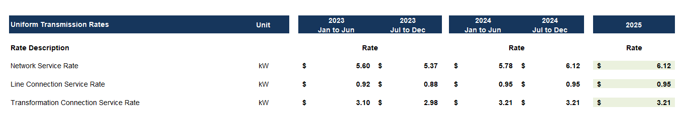

**Question:**

Please confirm the accuracy of the Rate Generator Model update, as well as the accuracy of the resulting Retail Transmission Service Rates following this update.

**Staff Question-4**

**Ref: 2025 IRM Rate Generator, Tab 16.1**

The monthly Meter Charge and Monthly Service Charge for February is inconsistent with every other month.

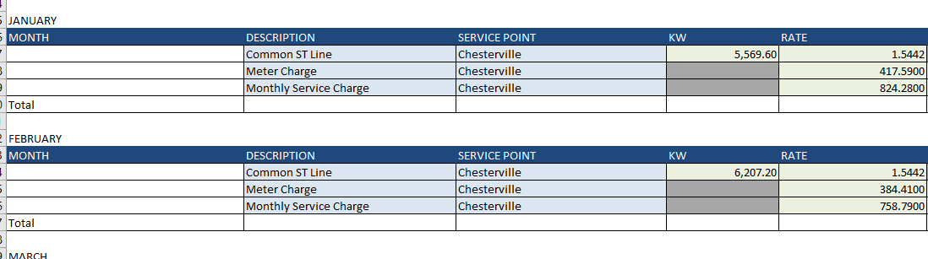

**Question:**

Please explain why the monthly Meter Charge and Monthly Service Charge for February is inconsistent with every other month or update Rate Generator model.

**Staff Question-5**

**Ref: Manager Summary Page 17**

**Ref: 2025 IRM Rate Generator, Tab 3 and Tab 5**

In the Manager Summary on page 17 Cooperative Hydro states “CHEI is not proposing to dispose of Account 1580 sub-account CBR class B as its balances have not met the threshold.

OEB staff agrees that the balance of ($383) does not meet the threshold to create separate rate riders for each class, but notes that the balance has been rolled up into Account RSVA - Wholesale Market Service Charge for a total balance to be disposed of ($23,674) on Tab 5.

**Question:**

Please confirm OEB staff’s explanation is correct.

1. EB-2024-0183, Decision and Rate Order, June 27, 2024