**Grimsby Power Incorporated**

**EB-2024-0027**

**October 1, 2024**

Please note, Grimsby Power Incorporated (Grimsby Power) is responsible for ensuring that all documents it files with the OEB, including responses to OEB staff questions and any other supporting documentation, do not include personal information as that phrase is defined in the *Freedom of Information and Protection of Privacy Act*, unless filed in accordance with rule 9A of the OEB’s *Rules of Practice and Procedure*.

**2025 IRM question**

**Staff Question-1**

**Ref 1: 2024 IRM Rate Generator Model, Continuity Schedule, Tab 3**

**Ref 2: IRM Rate Generator – DVA Tabs Instructions ‐ 2024 Rates**

**Ref 3: OEB Guidance for Electricity Distributors with Forgone Revenues Due to Postponed Rate Implementation from COVID-19, August 6, 2020, page 5**

On July 18, 2023, the OEB issued the DVA Tabs Instructions for the 2024 IRM Rate Generator Model. Pages 1 and 3 noted that Account 1509 - Impacts Arising from the COVID-19 Emergency, Subaccount Forgone Revenues from Postponing Rate Implementation was added to the model. A separate rider is calculated for this account in Tab 7, if the disposition is approved.

Regarding Account 1509, Impacts Arising from the COVID-19 Emergency Account, Sub-account Forgone Revenues from Postponing Rate Implementation, the following steps are noted in the August 6, 2020 guidance:

1. Upon implementation of the forgone revenue rate rider that is calculated from the Forgone Revenue Model, the rate rider transactions will be recorded in the same Forgone Revenues Sub-account. This will draw down the accumulated balance of actual forgone revenues/amounts.
2. Any residual balance after the expiry of the rate riders should be requested for final disposition in a future rate application (cost of service or IRM), once the balance has been audited in accordance with normal deferral and variance account disposition practices.
3. If disposition is approved, the residual balance in the Forgone Revenues Sub-account should be disposed proportionately by customer class and the residual balance will be transferred to Account 1595.

**Question(s):**

1. Please update Tab 3 (Continuity Schedule) and Tab 4 as necessary to reflect a balance in Account 1509 – Impacts Arising from the COVID-19 Emergency, Subaccount Forgone Revenues from Postponing Rate Implementation. Please complete the above-noted steps #1, #2, #3.
2. If this balance is not applicable, please explain.

**Staff Question-2**

**Ref: Rate Generator Model, Tab 3, Continuity Schedule**

On September 13, 2024, the OEB published the 2024 Quarter 4 prescribed accounting interest rates applicable to the carrying charges of deferral, variance and construction work in progress (CWIP) accounts of natural gas utilities, electricity distributors and other rate-regulated entities.

**Question:**

1. Please update Tab 3 (Continuity Schedule) as necessary to reflect the Q4 2024 OEB-prescribed interest rate of 4.40%.

**Staff Question-3**

**Ref: Rate Generator Model, Tab 12, RTSR – Historical Wholesale**

On Tab 12 of the Rate Generator Model, OEB staff notes that for the month of July, Grimsby Power has reported the January-June IESO Network and Line Connection rates.

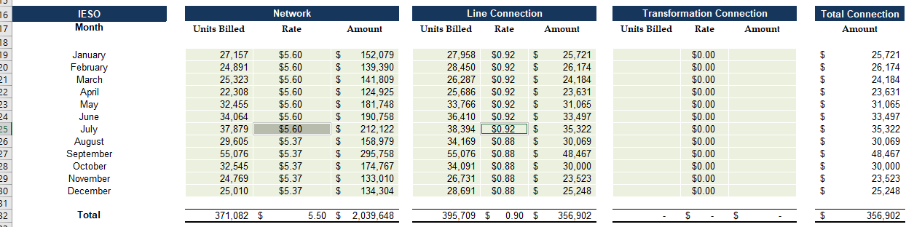

**Question:**

1. Please update the Rate Generator Model for the month of July to reflect the July-December Network and Line Connection values.

**Staff Question-4**

**Ref 1:** EB-2024-0027, Grimsby Power Incorporated, Tab 3, Continuity Schedule, Columns BM and BN

**Ref 2**: EB-2023-0025, 2024 Rates Application, Decision and Order, Issued January 1, 2024

**Ref 3:** EB-2022-0035, 2023 Rates Application, Decision and Order, Issued January 1, 2023

**Ref 4:** EB-2021-002, 2022 Rates Application, Decision and Order, Issued January 13, 2022

**Ref 5**: Chapter-3-Filing-Requirements-20240618, page. 14

Chapter 3 of the Filing Requirements in Reference 3 specifies that, when the OEB approves the disposition of Deferral and Variance Account (DVA) balances, the approved principal amounts and carrying charges are to be transferred to Account 1595 for the applicable rate year.

OEB staff notes that the transfer of OEB approved disposition amounts from 2022 to 2024 rate applications are not reflected in Account 1595, Sub-account (2024), (2023), (2022) for the respective rate years in Ref. 1.

**Question(s):**

1. OEB staff requests that Grimsby Power explain why the transfer of OEB-approved disposition amounts is not reflected in Sub-account 1595 (2024) in Ref. 1