**GrandBridge Energy Inc.**

**EB-2024-0025**

**October 3, 2024**

Please note, GrandBridge Energy Inc. (GrandBridge) is responsible for ensuring that all documents it files with the OEB, including responses to OEB staff questions and any other supporting documentation, do not include personal information as that phrase is defined in the *Freedom of Information and Protection of Privacy Act*, unless filed in accordance with rule 9A of the OEB’s *Rules of Practice and Procedure*.

**Staff Question-1**

**Ref 1:**2025 Rate Generator Model (BPI), Tab 3, Continuity Schedule

**Ref 2:** 2025 Rate Generator Model (EPLUS), Tab 3, Continuity Schedule

**Preamble:**

On September 13, 2024, the OEB published the 2024 Quarter 4 prescribed accounting interest rates applicable to the carrying charges of deferral, variance and construction work in progress (CWIP) accounts of natural gas utilities, electricity distributors and other rate-regulated entities.

**Question(s):**

1. Please update Tab 3 (Continuity Schedule) as necessary to reflect the Q4 2024 OEB-prescribed interest rate of 4.4%.

**Staff Question-2**

**Ref 1:** 2025 IRM Rate Generator Model (BPI), Continuity Schedule, Tab 3

**Ref 2:** 2025 IRM Rate Generator Model (EPLUS), Continuity Schedule, Tab 3

**Ref 3:** Chapter 3 - Filing Requirement for Electricity Distribution Rate Applications Filed in 2024 for Rates Taking Effect in 2025, June 18, 2024, Page. 14

**Preamble:**

Chapter 3 of the Filing Requirements in Ref. 1 specifies that when the OEB approves the disposition of Deferral and Variance Account (DVA) balances, the approved principal amounts and carrying charges are to be transferred to Account 1595 for that rate year. OEB staff notes that the transfer of OEB approved disposition amounts are not reflected in Account 1595 (2024) in Ref. 1 and Ref. 2.

**Question(s):**

1. Please explain why the transfer of OEB-approved disposition amounts is not reflected in Sub-account 1595 (2024) in Ref. 1 and Ref 2.

**Staff Question-3**

**Ref 1:** 2024 IRM Rate Generator Model, Continuity Schedule, Tab 3

**Ref 2:** IRM Rate Generator – DVA Tabs Instructions ‐ 2024 Rates

**Ref 3:** OEB Guidance for Electricity Distributors with Forgone Revenues Due to Postponed Rate Implementation from COVID-19, August 6, 2020, Page 5

**Preamble:**

On July 18, 2023, the OEB issued the DVA Tabs Instructions for the 2024 IRM Rate Generator Model. Pages 1 and 3 noted that Account 1509 - Impacts Arising from the COVID-19 Emergency, Subaccount Forgone Revenues from Postponing Rate Implementation was added to the model. A separate rider is calculated for this account in Tab 7, if the disposition is approved.

Regarding Account 1509, Impacts Arising from the COVID-19 Emergency Account, Sub-account Forgone Revenues from Postponing Rate Implementation, the following steps are noted in the August 6, 2020 guidance:

1. Upon implementation of the forgone revenue rate rider that is calculated from the Forgone Revenue Model, the rate rider transactions will be recorded in the same Forgone Revenues Sub-account. This will draw down the accumulated balance of actual forgone revenues/amounts.
2. Any residual balance after the expiry of the rate riders should be requested for final disposition in a future rate application (cost of service or IRM), once the balance has been audited in accordance with normal deferral and variance account disposition practices.
3. If disposition is approved, the residual balance in the Forgone Revenues Sub-account should be disposed proportionately by customer class and the residual balance will be transferred to Account 1595.

**Question(s):**

1. Please update Tab 3 (Continuity Schedule) and Tab 4 as necessary to reflect a balance in Account 1509 – Impacts Arising from the COVID-19 Emergency, Subaccount Forgone Revenues from Postponing Rate Implementation. Please complete the above-noted steps #1, #2, #3.
2. If this balance is not applicable, please explain.

**Staff Question-4**

**Ref 1:** 2025 IRM Rate Generator Model (BPI), Bill Impacts, Tab 21

**Ref 2:** 2025 IRM Rate Generator Model (EPLUS), Bill Impacts, Tab 21

**Preamble:**

The percentage change/impact percentage between current OEB approved and proposed charges of CBR Class B Rate Riders is -200% for consumption at 750 kWhs and 2,000 kWhs. Similar number of impacts on other consumption level.

**Question(s):**

1. Please provide an explanation for the change.

**OEB Staff Questions - Brantford Power Rate Zone (GBE BPI)**

**Staff Question-1**

**Ref 1:** 2025 IRM Rate Generator Model (BPI), UTRs and Sub-TX, Tab 11.

**Ref 2:** 2025 IRM Rate Generator Model (BPI), RTSR Historical Wholesale, Tab 12.

**Preamble:**

OEB staff notes an inconsistency in the values reported in Tab 12, with respect to the values that are provided on Tab 11 “UTRs and Sub-TX”.

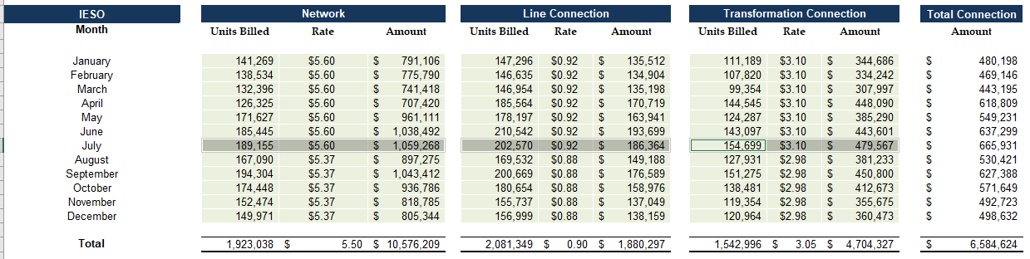

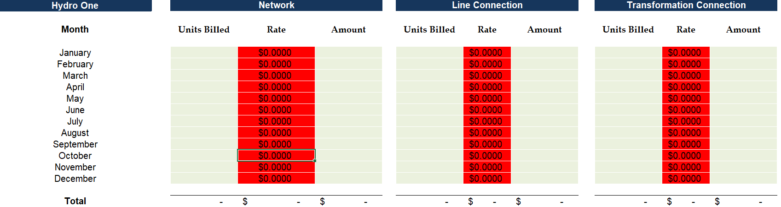

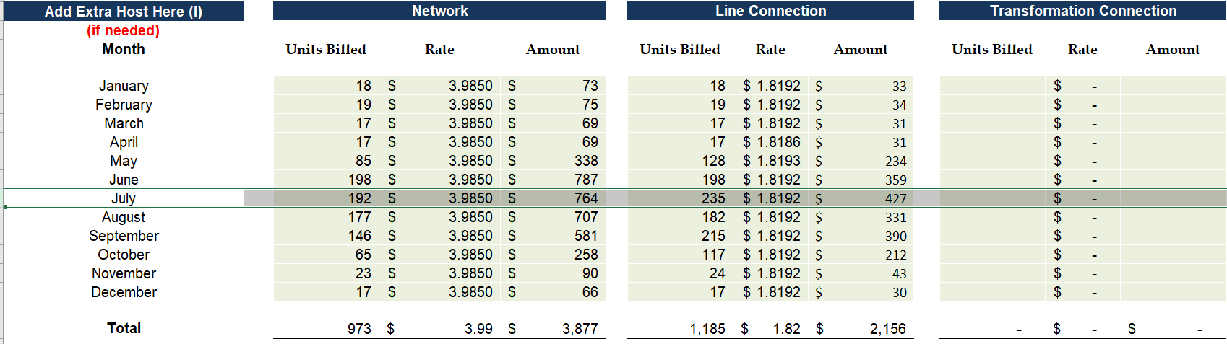

**Question(s):**

1. Please explain the inconsistency in IESO, Hydro One Networks Inc. and the Extra host rates between Tab 11 and Tab 12.

**Staff Question-2**

**Ref 1:** 2025 IRM Rate Generator Model (BPI), Bill Impacts, Tab 21

**Preamble:**

For the residential rate class the applicant must provide a scenario for consumption at 750 kWhs and at its 10th percentile.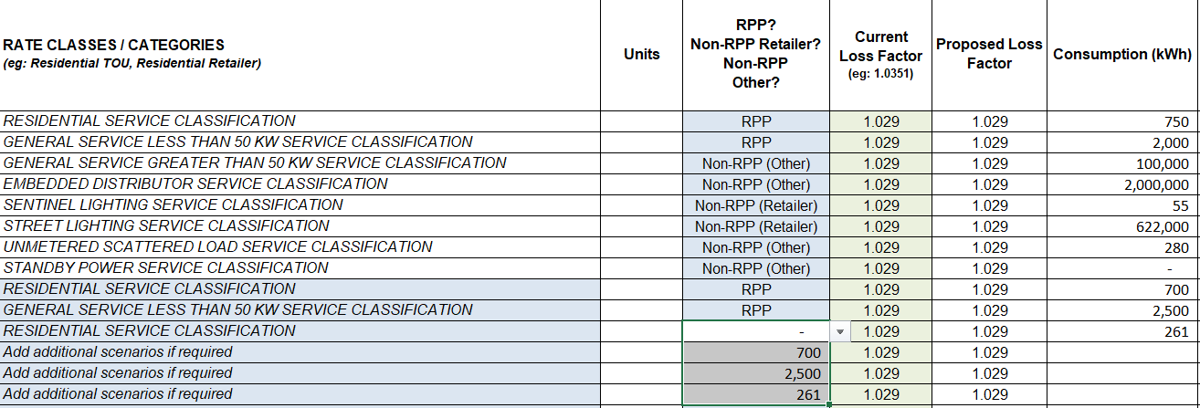

**Question(s):**

1. Please confirm the numbers on Tab 21, Bill Impacts., Table 1 H40-H43. Please label and explain the numbers.

**OEB Staff Questions - Energy+ Rate Zone (GBE+)**

**Staff Question-1**

**Ref 1:** 2025 Rate Generator Model (EPLUS), Tab 3, Continuity Schedule

**Ref 2**: EB-2024-0025, 2025 IRM application, Page 22

**Preamble:**

The last disposition of Group 1 account balances occurred in the 2024 IRM Application for the GBE(E+) Rate Zone where 2022 balances were approved on interim basis. GrandBridge is requesting final disposition of 2022 and 2023 balances for the GBE(E+) Rate Zone.

**Question(s):**

1. Please confirm the disposition request for Account 1595, Sub-account 1595 (2020-2023).

**Staff Question-2**

**Ref 1:** 2025 IRM Rate Generator Model (EPLUS), UTRs and Sub-TX, Tab 11.

**Ref 2:** 2025 IRM Rate Generator Model (EPLUS), RTSR Historical Wholesale, Tab 12.

**Preamble:**

OEB staff notes an inconsistency in the values reported in Tab 12, with respect to the values that are provided on Tab 11 “UTRs and Sub-TX”.

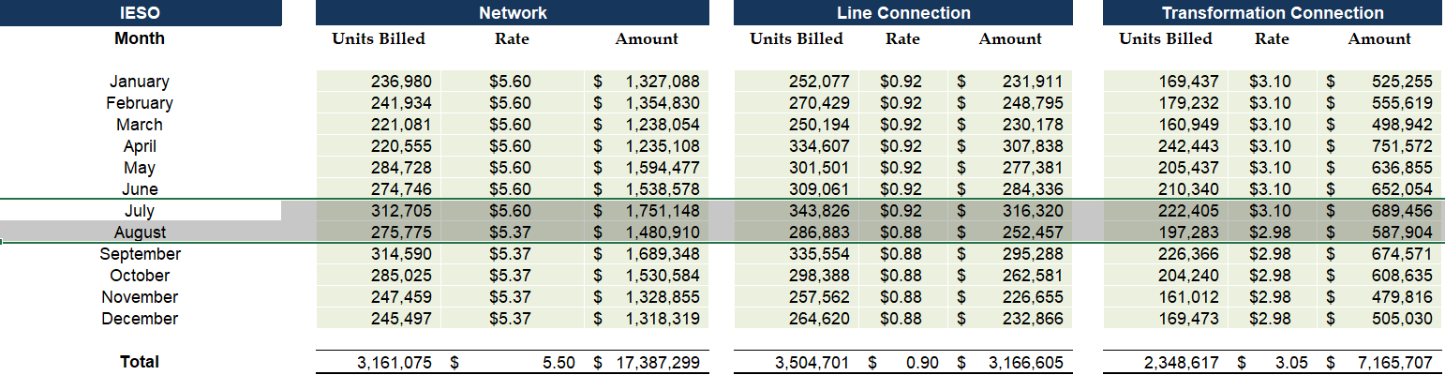

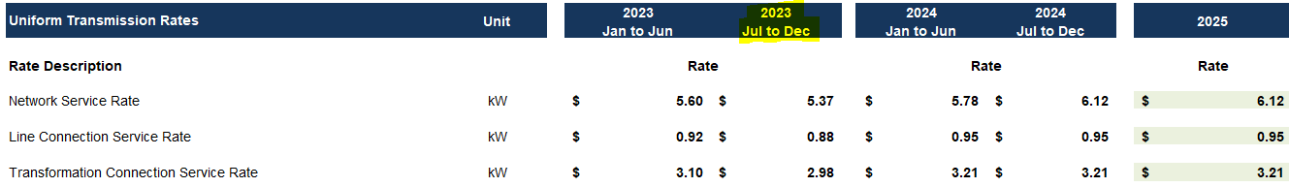

**Question(s):**

1. Please explain the inconsistency in the IESO rates between Tab 11 and Tab 12.

**Staff Question-3**

**Ref 1:** GBE(EPLUS)2025 Generic LRAMVA Workform, Tab 1

**Preamble:**

Cell H22 contains a balance of $75,959. It appears that Cells H19-H20 only includes 2023 actual and forecast lost revenues and not 2024 actuals and forecast.

**Question(s):**

1. Please confirm that 2024 actuals and forecast have not been included.
2. If confirmed, please input the correct balance and refile the GBE(EPLUS)2025 Generic LRAMVA Workform.

**Staff Question-4**

**Ref 1:**GBE(EPLUS)2025 Generic LRAMVA Workform, Tab 6

**Preamble:**

The OEB has recently published its prescribed interest rate for deferral and variance account balances for Q4.

**Question:**

1. Please update Tab 6, Carrying Charges, Cell C70 to 4.55%. Please include this update when GrandBridge is refiling the GBE(EPLUS)2025 Generic LRAMVA Workform as requested in question 3.

**Staff Question-5**

**Ref 1:** Section 4.3.7 (Lost Revenue Adjustment Mechanism Variance Account), page 39; 2024 LRAMVA Workform; IRM Rate Generator Model, Tab 19;

[Guidance on Prospective LRAM Amounts – 2024 Rates](https://www.oeb.ca/sites/default/files/LRAMVA-Workform-Instructions%20-%20Prospective%20Lost%20Revenues.pdf)

**Preamble:**

As per the Guidance on Prospective LRAM Amounts, distributors should propose rate riders to recover each annual LRAM-eligible amount in the corresponding rate year, beginning with the application for 2024 rates, and continuing each rate year until all amounts shown in Table 1- C of the LRAMVA Workform have been recovered.

**Question(s):**

1. For the prospective disposition, please explain why GrandBridge has not proposed rate riders to recover the 2025 LRAM-eligible amount.
2. If prospective disposition is being sought, please provide the calculation of the resulting rate riders for the EPLUS Rate Zone, including the inflation minus X-factor adjustment.
3. Please input those riders into Tab 19 of the IRM Rate Generator Models for the EPLUS Rate Zone.

**Staff Question-6**

**Ref 1:** Section 4.3.7.2 (Lost Revenue Adjustment Mechanism Variance Account), Page 38-39

**Preamble:**

GrandBridge notes that it is seeking recovery of lost revenues for persistence savings from CDM programs implemented in 2017 to 2022 and incremental savings and persistence savings from CDM programs implemented in 2023. GrandBridge notes that it has utilized the IESO’s Process and Systems Upgrades Initiative (PSUI) Measurement and Verification Report to determine the incremental 2023 savings. For all claimed CDM savings, GrandBridge seeks approval of LRAM-eligible amounts through 2031.

**Questions:**

1. Please confirm the source(s) of the persistence assumptions for programs implemented in 2017 to 2022. Did this source(s) provide complete information for GrandBridge to calculate persistence of savings from these programs through 2031, or did GrandBridge need to make any assumptions regarding persistence of these CDM savings? If the latter, please describe.
2. Please file the noted PSUI Measurement and Verification Report.
3. Does the PSUI Measurement and Verification Report provide any information regarding the expected persistence of savings from this project through 2031? If so, please describe.

**Staff Question-7**

**Ref 1:** Section 4.3.7.2 (Lost Revenue Adjustment Mechanism Variance Account), Page 38, Table 27; 2024 LRAMVA Workform, Tab 1, Cell G31

**Preamble:**

The two sources indicate different values for the LRAMVA balance for the GS<50 rate class ($377,004 and $396,129, respectively).

**Questions:**

1. Please reconcile the difference.
2. If necessary, please update the resulting LRAMVA rate rider calculation.

**Staff Question-8**

**Ref 1: Manager Summary, p 25-26; p 34, 43-44**

**Ref 2: GA Analysis Workform, EPLUS RZ**

GrandBridge Energy last received approval for disposition of Account 1588 and Account 1589’s 2022 balances on an interim basis in the Energy Plus (GBE(E+)) Rate Zone and Accounts 1588 and 1589’s 2022 balances on a final basis in the GBE(BPI) Rate Zone. GrandBridge Energy is proposing a principal adjustment to the E+ Rate Zone 2022 Account 1588 balance therefore the GA Workform has been prepared for 2022 and 2023 in the E+ Rate Zone.

In Section 5.1 of the Manager Summary, GrandBridge Energy discusses their investigation of the accuracy of the 2022 balances in Account 1588 and Account 1589, focusing on the impact of GrandBridge Energy’s actual losses compared to its approved loss factor. The primary emphasis was on these accounts given that uplifted consumption is the primary billing determinant for both cost and revenue. Through this investigation, GrandBridge Energy completed an in depth review of its account balances, commodity analysis and impact of loss factors. The review identified an adjustment of $260,913 required to complete a true-up of the Account 1588 balances that was not recorded at 2022 year-end. GrandBridge Energy has included the principal adjustment in the DVA Continuity Schedule and GA Workform for the GBE(E+) Rate Zone and has recorded the correcting entry in 2024.

OEB staff notes the corresponding entry in the GA Workform for the GBE(E+) Rate

Zone in the amount of $260,913 for Account 1588.

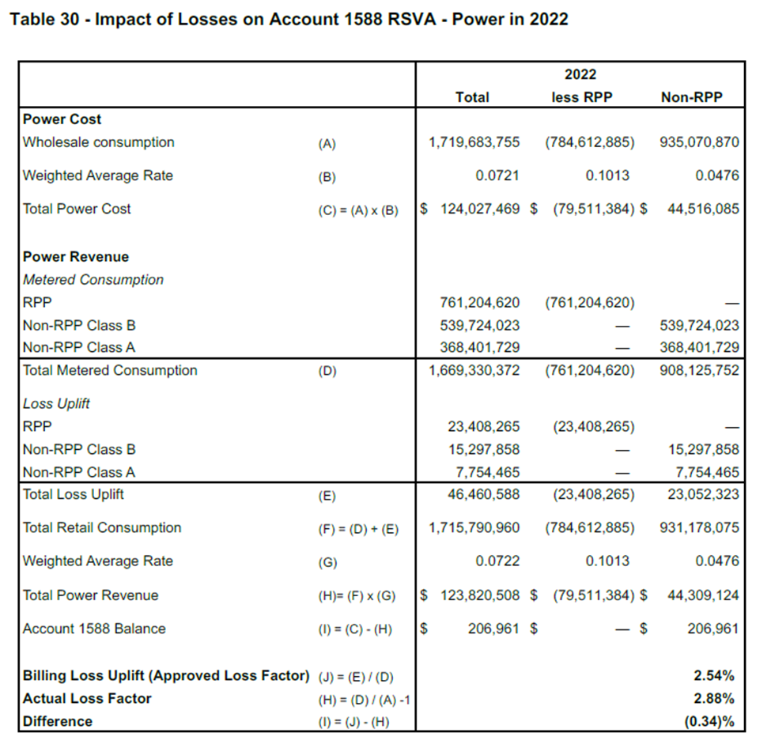

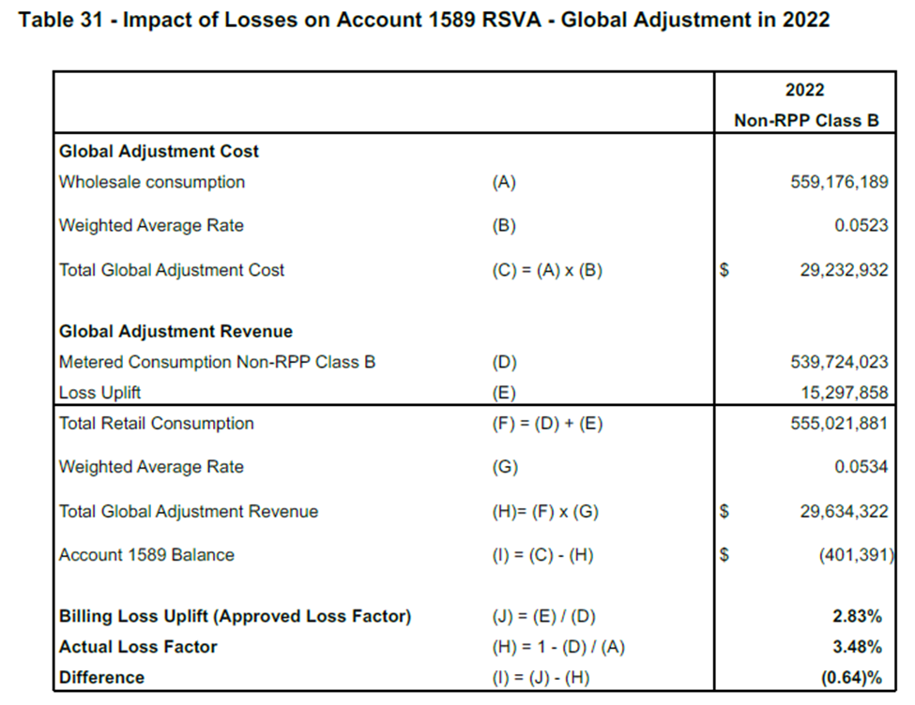

On the GA 2023 Tab, the 2023 expected GA volume variance is calculated as:

|  |  |
| --- | --- |
| **Weighted Average GA Actual Rate Paid ($/kWh)\*\*** | **Expected GA Volume Variance ($)** |
| **R** | **P= Q*R** |
| 0.01923 | $ 43,002 |

**Question(s):**

1. Please describe how the weighted average rates (b) and (g) in Table 30 and 31 above were calculated and the basis of this information.
2. Please confirm that Table 31 is to calculate the actual volume variance from the line losses. If so, please explain why the rate used in Table 31 and the resulting variance is significantly different than what was calculated on the GA 2023 Tab for expected GA volume variance.
3. Please explain the relationship between the Account 1588 and 1589 balances noted in the tables and what is being requested for disposition.

**Staff Question – 9**

**Ref 1: Manager Summary, p 34**

**Ref 2: GA Analysis Workform, GBE(E+) RZ**

**Ref 3: OEB Updated Accounting Guidance Illustrative Commodity Accounting Example June 12, 2024, tab Final RSVA balance**

In reference 1, OEB staff notes that Table 24 includes all the principal adjustments for the GBE(E+) Rate Zone. In the tab GA 2023 of the GA Analysis Workform for GBE(E+), OEB staff notes that a principal adjustment relating to the reversal of unbilled to actual revenue differences of ($50,582) is missing on Tab GA 2023. OEB staff also notes other missing information, for example, the column for the principal adjustment on the DVA continuity schedule for all reconciling items listed in Note 5 are not filled by “Yes, or “No”.

In reference 2 of the GA Analysis Workform for GBE(E+), OEB staff notes that the correction related to line losses for 2022 is recorded in the principal adjustments tab in the amount of $260,913 to Account 1588.

As shown in the OEB Accounting Guidance for Commodity Accounts Illustrative Example from the OEB Website, the impacts of line losses are already included in the general ledger when the distributor makes its journal entries for revenue and cost of power to Account 1588 and Account 1589. The variances resulting from the line losses are captured in the volume variances, which is illustrated in Table 40 and 41 of the Final RSVA balance tab, denoted as “UFE differences.”

**Question(s):**

1. Please review the GA 2022 and GA 2023 tabs and ensure that the principal adjustments noted in the principal adjustments tab, including the missing adjustment noted in the preamble, are included in the table for Note 5.
2. Please use the dropdown list in Note 5 to indicate whether the item is a principal adjustment or not and include explanations of items where needed.
3. Please explain why the incremental line loss of $260,913, which Grandbridge calculated as part of its investigation into line losses, is debited to Account 1588 when the line loss has already been accounted for in the volume variance entry.
4. Please confirm Grandbridge’s understanding of whether the line losses as newly investigated by Grandbridge for GBE(E+) impact Account 1588 and Account 1589, or only Account 1588.
5. Please update and refile the GA Analysis workform and DVA continuity schedules.