**Enova Power Corp. (Enova)**

**Staff Questions**

**October 1, 2024**

Please note, that Enova is responsible for ensuring that all documents it files with the OEB, including responses to OEB staff interrogatories and any other supporting documentation, do not include personal information (as that phrase is defined in the Freedom of Information and Protection of Privacy Act), unless filed in accordance with rule 9A of the OEB’s Rules of Practice and Procedure.

**Staff Question – 1**

**Ref 1: 2024 IRM Rate Generator Model, Continuity Schedule, Tab 3**

**Ref 2: IRM Rate Generator – DVA Tabs Instructions ‐ 2024 Rates**

**Ref 3: OEB Guidance for Electricity Distributors with Forgone Revenues Due to Postponed Rate Implementation from COVID-19, August 6, 2020, page 5**

On July 18, 2023, the OEB issued the DVA Tabs Instructions for the 2024 IRM Rate Generator Model. Pages 1 and 3 noted that Account 1509 - Impacts Arising from the COVID-19 Emergency, Subaccount Forgone Revenues from Postponing Rate Implementation was added to the model. A separate rider is calculated for this account in Tab 7, if the disposition is approved.

Regarding Account 1509, Impacts Arising from the COVID-19 Emergency Account, Sub-account Forgone Revenues from Postponing Rate Implementation, the following steps are noted in the August 6, 2020 guidance:

* Upon implementation of the forgone revenue rate rider that is calculated from the Forgone Revenue Model, the rate rider transactions will be recorded in the same Forgone Revenues Sub-account. This will draw down the accumulated balance of actual forgone revenues/amounts.

1. Any residual balance after the expiry of the rate riders should be requested for final disposition in a future rate application (cost of service or IRM), once the balance has been audited in accordance with normal deferral and variance account disposition practices.

1. If disposition is approved, the residual balance in the Forgone Revenues Sub-account should be disposed proportionately by customer class and the residual balance will be transferred to Account 1595.

**Question(s):**

1. Please update Tab 3 (Continuity Schedule) and Tab 4 as necessary to reflect a balance in Account 1509 – Impacts Arising from the COVID-19 Emergency, Subaccount Forgone Revenues from Postponing Rate Implementation. Please complete the above-noted steps #1, #2, #3.
2. If this balance is not applicable, please explain.

**Response:**

The continuity schedule has been updated.

**Staff Question – 2**

**Ref1: KWRZ Rate Generator Model, Tab 3, Continuity Schedule**

**Ref2: WNRZ Rate Generator Model, Tab 3, Continuity Schedule**

On September 13, 2024, the OEB published the 2024 Quarter 4 prescribed accounting interest rates applicable to the carrying charges of deferral, variance and construction work in progress (CWIP) accounts of natural gas utilities, electricity distributors and other rate-regulated entities.

**Question:**

1. Please update Tab 3 (Continuity Schedule) as necessary to reflect the Q4 2024 OEB-prescribed interest rate of 4.40%.

**Response:**

The continuity schedule has been updated.

**Staff Question – 3**

**Ref 1: KWRZ_2025 IRM Rate Generator Model, Tab 3_Continuity Schedule**

**Ref 2: KWRZ_2024 IRM Rate Generator Model, Tab 3_Continuity Schedule**

In its Account 1580- RSVA Wholesale Market Service Charge, Enova recorded a transaction debit during 2023 of $(1,947,740). OEB staff noted in Enova-WNH’s 2024 IRM rate application, the same account had a transaction debit during 2022 of $3,961,621.

**Question(s):**

1. For Account 1580- RSVA Wholesale Market Service Charge, please explain the factors that have resulted in a substantial difference in transactions between 2022 and 2023.

**Response:**

The UTR billed by the IESO was significantly less in 2023 compared to 2022 resulting in the significant change in the transactions between 2022 and 2023.

**Staff Question – 4**

**Ref 1: WNRZ_2025 IRM Rate Generator Model, Tab 17, Column B**

MFC Adjustment from R/C Model for each rate class under Column B is not completed.

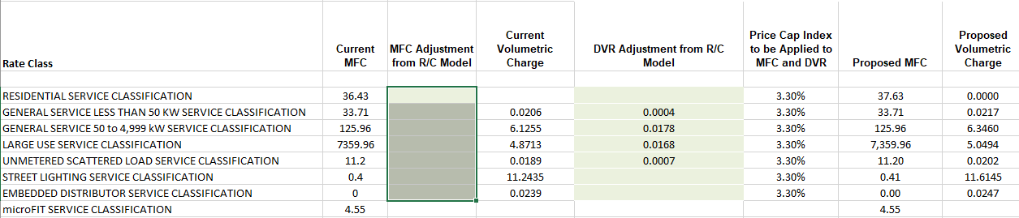

**Question(s):**

1. Please update Tab 17_Rev2Cost_GDPIPI.

**Response:**

This is not required. Enova requested Board staff to update the rate generator model for WNRZ so there would be no changes to fixed rates for GS<50, GS>50, LU, and USL. As a result, no changes were reflected in WNRZ_2025 IRM Rate Generator Model, Tab 17, Column B.

**Staff Question – 5**

**Ref 1:** **WNRZ_2025 IRM Rate Generator Model, Tab 3_Continuity Schedule**

**Ref 2: WNRZ_2024 IRM Rate Generator Model, Tab 3_Continuity Schedule**

In its Account 1589 - RSVA Global Adjustment, Enova recorded a transaction debit during 2023 of $1,447,687. OEB staff noted in Enova-WNH’s 2024 IRM rate application, the same account had a transaction during 2022 of $(1,255,102).

In its Account 1580- RSVA Wholesale Market Service Charge, recorded a transaction debit during 2023 of $(1,566,980). OEB staff noted in Enova-WNH’s 2024 IRM rate application, the same account had a transaction debit during 2022 of $3,201,897.

**Question(s):**

* 1. For Account 1589- RSVA Global Adjustment, please explain the factors that have resulted in a substantial difference in transactions between 2022 and 2023.

**Response:**

Enova bills its customers GA using the first estimate rate and the IESO uses the GA posted rate (final rate) to bill LDC. In 2023, GA posted rates were more than the first estimate which resulted in a debit balance accruing in 1589 and impacting the ending balance for 2023. This can also be seen in KWRZ continuity schedule**.**

* 1. For Account 1580- RSVA Wholesale Market Service Charge, please explain the factors that have resulted in a substantial difference in transactions between 2022 and 2023.

**Response:**

The UTR billed by the IESO was significantly less in 2023 compared to 2022 resulting in the significant change in the transactions between 2022 and 2023.

**Staff Question – 6**

**Ref 1: WNRZ_2025 GA Analysis Workform**

In Tab – Principal Adjustments, Under Note 8 – Breakdown of principal adjustments included in last approved balance, Account 1589 has the last approved balance of $1,447,687. However, the adjustment description and other information are not completed.

In Tab – Principal Adjustments, Under Note 8 – Breakdown of principal adjustments included in last approved balance, Account 1588 has a Settlement True-Ups. However, the amount and other information are not completed.

**Question(s):**

Please complete the two tables under Note 8. If not the case, please explain.

**Response:**

The GA workform has been updated.