**Hearst Power Distribution Co. Ltd.**

**EB-2024-0029**

**December 11, 2024**

Please note, Hearst Power Distribution Co. Ltd. (Hearst Power) is responsible for ensuring that all documents it files with the OEB, including responses to OEB staff questions and any other supporting documentation, do not include personal information as that phrase is defined in the *Freedom of Information and Protection of Privacy Act*, unless filed in accordance with rule 9A of the OEB’s *Rules of Practice and Procedure*.

**Staff Question-**

**Ref. 1: HPDCL 2025-IRM-Rate-Generator-Model 20241028, Tab 1 Information Sheet**

**Preamble:**

The green shaded cells are input fields and have not been filled out by Hearst Power.

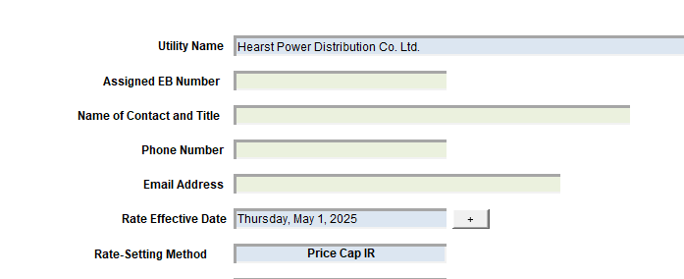

**Question(s):**

1. Please fill out the details for the above fields.

**Staff Question-**

**Ref. 1: HPDCL 2025-IRM-Rate-Generator-Model 20241028, Tab 3, Continuity Schedule**

**Preamble:**

On September 13, 2024, the OEB published the 2024 Q4 prescribed accounting interest rates applicable to the carrying charges of deferral, variance and construction work in progress (CWIP) accounts of natural gas utilities, electricity distributors and other rate-regulated entities.

**Question(s):**

1. Please update Tab 3 (Continuity Schedule) as necessary to reflect the Q4 2024 OEB-prescribed interest rate of 4.40%.

**Staff Question-**

**Ref. 1: HPDCL 2025-IRM-Rate-Generator-Model 20241028, Tab 4 Billing Det. For Def-Var**

**Preamble:**

The blue shaded cells are drop-down input fields and have not been filled out by Hearst Power.

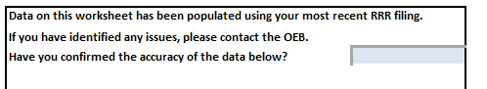

**Question(s):**

1. Please fill out the details for the above fields.

**Staff Question-**

**Ref. 1: HPDCL 2025-IRM-Rate-Generator-Model 20241028, Tab 5 Allocating Def-Var Balances**

**Preamble:**

In the Continuity schedule, there are three rows that reference 1580 Account.

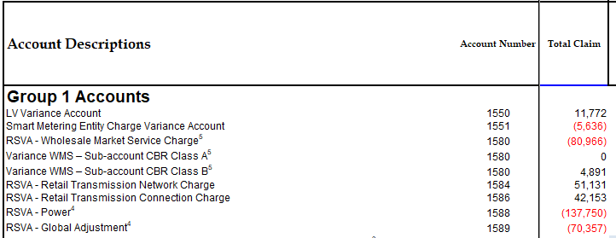

During the Allocation of Balances on Tab 5, only the first amount of (80,966) has been taken into account and not the other amount of 4,891.

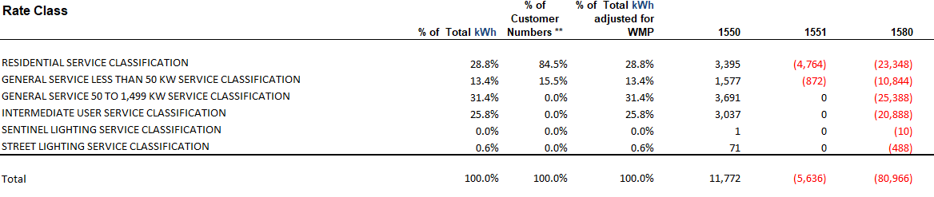

**Question(s):**

1. Please update the 1580 allocation on Tab 5 to account for all three rows of balances from the Continuity Schedule. If not, please provide reasoning for why the amount of 4,891 was not included.

**Staff Question-**

**Ref. 1: HPDCL 2025-IRM-Rate-Generator-Model 20241028, Tab 8 STS Tax Change**

**Preamble:**

The values in the tab are to align with the previous cost of service[1] application. For Hearst Power, its last cost of service application was for the rebasing year of 2021.

**Question(s):**

1. Please confirm the reason for the values not aligning with Hearst Power’s last cost of service application.
2. During the kick off meeting, Hearst Power indicated that the there should be another tax rate applicable. Please provide what Hearst Power believes is the tax rate that should be applicable, and provide reasoning for why this tax rate should apply.

**Staff Question-**

**Ref. 1: HPDCL 2025-IRM-Rate-Generator-Model 20241028, Tab 12 RTSR – Historical Wholesale**

**Preamble:**

The values for the “Rate” column do not align with the Historical Uniform Transmission Rates (UTRs).

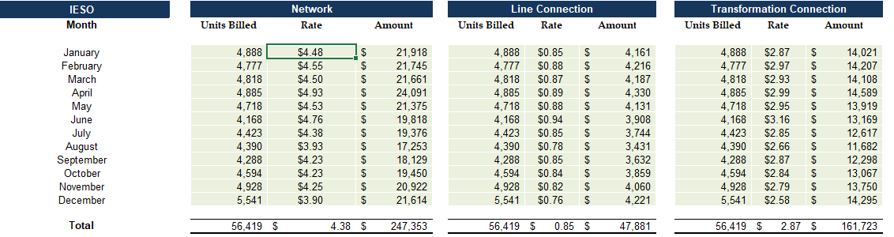

**Question(s):**

1. Please explain the discrepancy between the historical and what is reported in Tab 12.

**Staff Question-**

**Ref. 1: HPDCL 2025-IRM-Rate-Generator-Model 20241028, Tabs 11, 15, and 20**

**Preamble:**

On November 1, 2024, the OEB issued a letter regarding 2025 Preliminary UTRs and Hydro One Sub-Transmission Rates. The OEB determined to use preliminary UTRs to calculate 2025 Retail Service Transmission rates (RTSR) to improve regulatory efficiency, allowing for this data to feed into the rate applications including annual updates for electricity distributors on a timelier basis. The OEB also directed distributors to update their 2025 application with Hydro One Networks Inc.’s proposed host RTSRs. Any further updates to Hydro One’s proposed host RTSR will be reflected in the final Rate Generator Model.

On November 19, 2024, the OEB issued a letter outlining that the fixed microFIT Generator Service Classification charge (microFIT charge) would be increased from $4.55 to $5.00 for the 2025 rate year.

OEB staff has updated Hearst Power’s Rate Generator Model with the preliminary UTRs, proposed host RTSR for Hydro One, and microFIT charge as follows:

**UTRs**

**Hydro One Sub-Transmission Rates**

**microFIT Charge**

**Question(s):**

1. Please confirm the accuracy of the Rate Generator Model updates, as well as the accuracy of the resulting RTSRs following these updates.

**Staff Question-**

**Ref. 1: HPDCL 2025-IRM-Rate-Generator-Model 20241028, Tab 16.1 LV Expense**

**Preamble:**

For “Deferred Tax Fixed” and “Deferred Tax Var”, no values have been provided for the months of July to December.

**Question(s):**

1. Please confirm that this is accurate. If not, please update the Rate Generator Model, as necessary, and provide commentary for the updates made.

**Staff Question-**

**Ref. 1: HPDCL 2025-IRM-Rate-Generator-Model 20241028, Tabs 18 and 21**

**Preamble:**

On October 18, 2024 the OEB issued a letter regarding updated Regulated Price Plan (RPP) prices effective as of November 1, 2024. Also, effective November 1, 2024, the Ontario government’s Ontario Electricity Rebate (OER) was changed to 13.1%.

On December 10, 2024, the OEB set its new Rural or Remote Rate Protection (RRRP) rate. There was no changes to the Wholesale Market Service rate and the RRRP rate was updated to $0.0015 kWh.

OEB staff has updated Hearst Power’s Rate Generator Model with the updated RRRP, RPP, and OER values as follows:

**Question(s):**

1. Please confirm the accuracy of the Rate Generator Model updates for the RRRP, RPP, and OER values.

**Staff Question-**

**Ref. 1: HPDCL 2025 IRM Manager Summary 20241028, p. 11**

**Preamble:**

Under the Low Voltage Rate section, Hearst Power states “The following tables show five historical years of actual charges from Hydro One….”.

OEB staff notes that only one table is provided, and there are no other tables detailing the five historical year of actual charges.

**Question(s):**

1. Please provide tables detailing the five historical years of actual charges from Hydro One. Within each table, please provide the actual charge for each month and a total charge for each value (i.e., like the format currently provided in Table 4 on p. 11 of the Manager’s Summary).

**Staff Question-**

**Ref. 1: 2025 GA Analysis Workform, Account 1588 Tab**

**Ref. 2: HPDCL 2025-IRM-Rate-Generator-Model 20241028, Tab 3, Continuity Schedule**

**Preamble:**

In Reference 1, the total transaction reported for 2023 is a debit balance of $124,839. This amount represents 2.7% of the cost of power purchased. Hearst Power states that the supply facility loss factor (SFLF) approved in its 2021 cost of service proceeding is overstated. Hearst Power further states “In EB-2020-007, the Board approved line loss was set at 5.98% but when considering the actual SFLF paid to Hydro One, it should have represented 4.60%”.

OEB staff notes that the total activity reported for 2023 in Reference 2 is a credit balance of $124,839.

**Question(s):**

1. Please confirm the total transaction amount for 2023 and update the applicable model accordingly.
2. Please complete and file the attached Line Loss Analysis worksheet to provide more information on the impact of the overstated line loss on Account 1588. OEB staff has prepared the worksheet based on Hearst Power’s statement that the actual SFLF paid to Hydro One is 4.6%.

**Staff Question-**

**Ref. 1: 2025 GA Analysis Workform, GA 2023 Tab**

**Ref. 2: 2024 GA Analysis Workform, GA 2022 Tab**

**Preamble:**

In Reference 2, Hearst Power reported a debit of $10,952 for the difference between the retail Global Adjustment (GA) price billed and the wholesale GA actual price paid to IESO.

OEB staff observes that there is no variance reported in Reference 1 for 2023.

**Question(s):**

1. Please explain why there is no amount reported in 2023 for the difference between the retail GA price billed and the wholesale GA actual price paid.

**Staff Question-**

**Ref. 1: 2025 GA Analysis Workform, GA 2023 Tab**

**Preamble:**

In Reference 1, Hearst Power reported a debit of $38,794 for the difference between the retail and the wholesale GA volume (UFE differences) in Note 5.

**Question(s):**

1. Please explain in detail why the retail vs. wholesale volume variance is included in the table to reconcile with the expected GA variance, given that the expected GA variance is comprised of price and volume variances.

1. EB-2020-0027