**PUC Distribution Inc.**

**EB-2024-0051**

**December 11, 2024**

Please note, PUC Distribution Inc. (PUC Distribution) is responsible for ensuring that all documents it files with the OEB, including responses to OEB staff questions and any other supporting documentation, do not include personal information as that phrase is defined in the *Freedom of Information and Protection of Privacy Act*, unless filed in accordance with rule 9A of the OEB’s *Rules of Practice and Procedure*.

**Staff Question-1**

**Ref 1: IRM Rate Generator Model, Tab** **11 RTSR – UTRs & Sub Tx and EB-2024-0244, Letter for 2025 Preliminary Uniform Transmission Rates and Hydro One Sub-Transmission Rates, November 1, 2024, p. 2, Appendix B**

**Ref 2: IRM Rate Generator Model, Tab 18 Regulatory Charges, Tab 21 Bill Impacts and Time of Use (TOU) prices set by the OEB for** [**November 1, 2024**](https://www.oeb.ca/newsroom/2024/ontario-energy-board-announces-changes-electricity-prices-households-small-businesses)

**Ref 3: IRM Rate Generator Model, Tab 20 Final Tariff Schedule and Letter regarding Review of Fixed Monthly Charge for microFIT Generator Service Classification, November 19, 2024**

**Ref 4: IRM Rate Generator Model, Tab 19 Regulatory Charges, Tab 21 Bill Impacts and Decision and Order Regulatory charges effective January 1, 2025, for the Wholesale Market Services rate and the Rural or Remote Electricity Rate Protection charge, EB-2024-0282, December 10, 2024**

**Preamble:**

Distributors must enter the applicable rates in the Rate Generator Model for the preliminary Uniform Transmission Rates (UTRs), Hydro One Sub-Transmission Rates, microFIT charge, TOU prices, Ontario Electricity Rebate (OER), Wholesale Market Services (WMS) and the Rural or Remote Electricity Rate Protection Charge (RRRP). These rates must align with the most recent rates and charges issued by the OEB.

**Question(s):**

1. OEB staff has updated Tab 11 RTSR – UTRs & Sub TxUTRs. Please confirm the updates and ensure that all tabs are updated accordingly.
2. OEB staff has updated the latest TOU prices and OER in Tab 19 Regulatory Charges and Tab 21 Final Tariff Schedule. Please confirm the updates and ensure that all tabs are updated accordingly.
3. OEB staff has updated the microFIT charge. Please confirm the microFIT charge on Tab 20 Final Tariff Schedule of the Rate Generator Model has been updated correctly.
4. OEB has updated the RRRP rate rider. Please confirm the RRRP rate on Tab 19 Regulatory Charges has been updated correctly.

**Staff Question-2**

**Ref 1: IRM Rate Generator Model, Tab 11 RTSR – UTRs & Sub Tx and Tab 12 Historical Wholesale**

**Preamble:**

The OEB set a new Network Service Rate for July to December 2023.

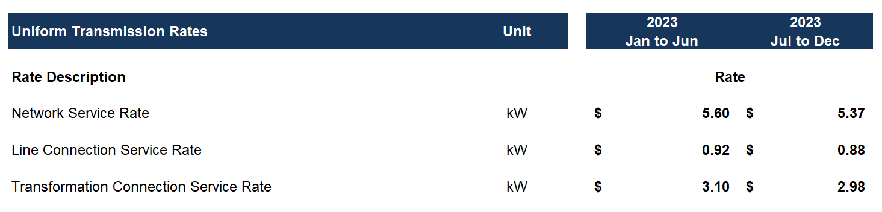

**Question(s):**

1. PUC Distribution is using a Network Service Rate of $5.60 for July. If this is correct, please explain why the value of $5.60 was used instead of $5.37, otherwise please update Tab 11.

**OEB Staff-3**

**Ref 1: IRM Rate Generator Model, Tab 1, Information Sheet**

**Preamble:**

On Tab 1 (Information Sheet), PUC Distribution has not provided responses for Questions 2 and 3 – the year the balances for Account 1588 and 1589 were last disposed and the year the remaining Group 1 DVA balances were last disposed, respectively.

**Question(s):**

1. Please update the Rate Generator Model with the respective dates for the two cells denoted in the preamble above on Tab 1.