October 27, 2008

Ms. Kirstin Walli
Board Secretary
Ontario Energy Board
P.O. Box 2319
2300 Yonge Street, 27th Floor
Toronto, ON M4P 1E4

Re: EB-2008-0155 Chatham-Kent Hydro and Middlesex Power Distribution Corp. Smart Meter Rate Application

Dear Ms. Walli:

Chatham-Kent Hydro Inc. (“CKH”) and Middlesex Power Distribution Corp. (“MPDC”) has requested an update to their Smart Meter rates, specifically the Funding Adder and the Disposition Rider to cover the investment in capital from May 1 2007 to December 31, 2007 and ongoing capital investments for the general service smart meter installations.

CKH and MPDC are providing the following table to assist the Ontario Energy Board (“Board”) panel in their deliberations. The table demonstrates the rate for the residential class for both Utilities at May 1, 2008, November 1, 2008 and May 1, 2009 (before Incentive Rate Mechanism (IRM) adjustment). Similar rate changes are being requested for the other rate classes.

Chatham-Kent Hydro Inc.

Middlesex Power Distribution Inc.

CKH and MPDC would like to point out that the change in rates being requested for approval is strictly for the Smart Meter funding adder and the disposition rider; all other distribution rates will be treated under the IRM model. Also, the Smart Meter rate process being applied for is similar to the process approved by the Board in 2007.

If you have any more concerns or questions, please be free to contact me at the number below.

Yours truly,

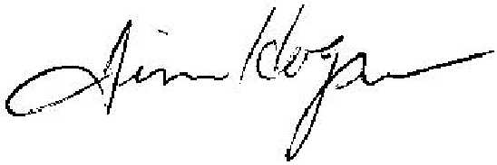

Jim Hogan
Chief Financial and Regulatory Officer
(519) 352-6300 ext 277
Email: jimhogan@ckenergy.com

CC: Dave Kenney, President of Chatham Kent Hydro
Cheryl Decaire, Co-ordinator of Regulatory and Rates

