**Fort Frances Power Corporation**

**EB-2024-0024**

**January 10, 2025**

Please note, Fort Frances Power Corporation (Fort Frances) is responsible for ensuring that all documents it files with the OEB, including responses to OEB staff questions and any other supporting documentation, do not include personal information as that phrase is defined in the *Freedom of Information and Protection of Privacy Act*, unless filed in accordance with rule 9A of the OEB’s *Rules of Practice and Procedure*.

**Staff Question-**

**Ref. 1: Decision and Rate Order EB-2023-0022, Table 6.1**

**Ref. 2: 2025-IRM-Rate-Generator-Model_V4_FF_20241120, Tab 3 Continuity Schedule**

**Preamble:**

The Principal and Interest Disposition during 2024 (Columns BM and BN, respectively) should align with OEB-approved 2024 Decision & Rate Order.

The below snapshot is from the 2024 Decision & Order (Ref. 1).

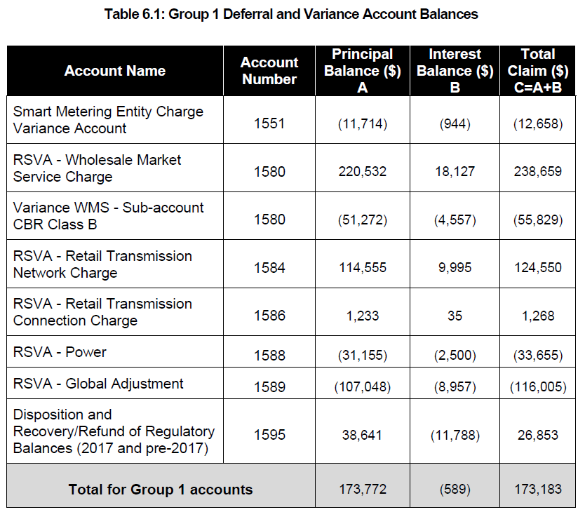

The below snapshot is from Tab 3 Continuity Schedule (Ref. 2).

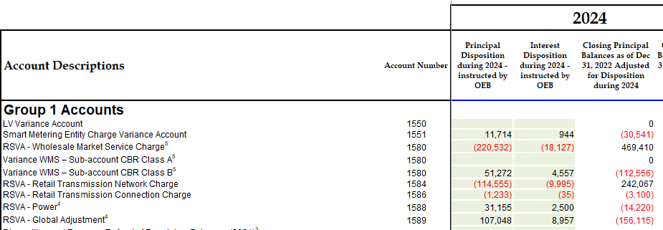

**Question(s):**

1. Please explain the reason for using opposite signs as approved by the OEB and update the Rate Generator Model as necessary.

**Staff Question-**

**Ref. 1: 2025-IRM-Rate-Generator-Model_V4_FF_20241120, Tab 3 Continuity Schedule**

**Preamble:**

On September 13, 2024, and December 11, 2024, the OEB published the Q4 2024 and Q1 2025 prescribed accounting interest rate applicable to the carrying charges of deferral, variance and construction work in progress (CWIP) accounts of natural gas utilities, electricity distributors and other rate-regulated entities.

**Question(s):**

1. Please update Tab 3 (Continuity Schedule) as necessary to reflect the Q4 2024 and Q1 2025 OEB-prescribed interest rates of 4.40% and 3.64% for the Rate Generator Model.

**Staff Question-**

**Ref. 1: 2025-IRM-Rate-Generator-Model_V4_FF_20241120, Tab 4 Billing Det. For Def-Var**

**Preamble:**

The blue shaded cell is a drop-down input field and has not been filled out by Fort Frances.

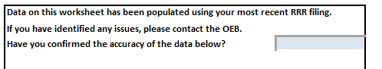

**Question(s):**

1. Please fill out the details for the above field.

**Staff Question-**

**Ref. 1: 2025-IRM-Rate-Generator-Model_V4_FF_20241120, Tabs 11, 15, 17, and 20**

**Preamble:**

On November 1, 2024, the OEB issued a letter regarding 2025 Preliminary UTRs and Hydro One Sub-Transmission Rates. The OEB determined to use preliminary UTRs to calculate 2025 Retail Service Transmission rates (RTSR) to improve regulatory efficiency, allowing for this data to feed into the rate applications including annual updates for electricity distributors on a timelier basis. The OEB also directed distributors to update their 2025 application with Hydro One Networks Inc.’s proposed host RTSRs. Any further updates to Hydro One’s proposed host RTSR will be reflected in the final Rate Generator Model.

On November 19, 2024, the OEB issued a letter outlining that the fixed microFIT Generator Service Classification charge (microFIT charge) would be increased from $4.55 to $5.00 for the 2025 rate year.

OEB staff has updated Fort Frances’ Rate Generator Model with the preliminary UTRs, proposed host RTSR for Hydro One, and microFIT charge as follows:

**UTRs**

**Hydro One Sub-Transmission Rates**

**microFIT Charge**

**Question(s):**

1. Please confirm the accuracy of the Rate Generator Model updates, as well as the accuracy of the resulting RTSRs following these updates.

**Staff Question-**

**Ref. 1: 2025-IRM-Rate-Generator-Model_V4_FF_20241120, Tabs 18 and 21**

**Preamble:**

On December 10, 2024, the OEB set its new Rural or Remote Rate Protection (RRRP) rate. There was no changes to the Wholesale Market Service rate and the RRRP rate was updated to $0.0015 kWh.

OEB staff has updated Fort Frances’ Rate Generator Model with the updated RRRP value as follows:

**Question(s):**

1. Please confirm the accuracy of the Rate Generator Model updates for the RRRP value.

**Staff Question-**

**Ref. 1: 2025-IRM-Rate-Generator-Model_V4_FF_20241120, Tab 3 Continuity Schedule**

**Ref. 2: IRM Rate Generator – DVA Tabs Instructions ‐ 2025 Rates**

**Ref. 3: OEB Guidance for Electricity Distributors with Forgone Revenues Due to Postponed Rate Implementation from COVID-19, August 6, 2020, page 5**

**Preamble:**

On July 18, 2023, the OEB issued the DVA Tabs Instructions for the 2024 IRM Rate Generator Model. Pages 1 and 3 noted that Account 1509 - Impacts Arising from the COVID-19 Emergency, Subaccount Forgone Revenues from Postponing Rate Implementation was added to the model. A separate rider is calculated for this account in Tab 7, if the disposition is approved.

Regarding Account 1509, Impacts Arising from the COVID-19 Emergency Account, Sub-account Forgone Revenues from Postponing Rate Implementation, the following steps are noted in the August 6, 2020 guidance:

1. Upon implementation of the forgone revenue rate rider that is calculated from the Forgone Revenue Model, the rate rider transactions will be recorded in the same Forgone Revenues Sub-account. This will draw down the accumulated balance of actual forgone revenues/amounts.

1. Any residual balance after the expiry of the rate riders should be requested for final disposition in a future rate application (cost of service or IRM), once the balance has been audited in accordance with normal deferral and variance account disposition practices.

1. If disposition is approved, the residual balance in the Forgone Revenues Sub-account should be disposed proportionately by customer class and the residual balance will be transferred to Account 1595.

**Question(s):**

1. Please update Tab 3 (Continuity Schedule) and Tab 4 as necessary to reflect a balance in Account 1509 – Impacts Arising from the COVID-19 Emergency, Subaccount Forgone Revenues from Postponing Rate Implementation. Please complete the above-noted steps #1, #2, #3.
2. If this balance is not applicable, please explain.

**Staff Question-**

**Ref. 1: FFPC_Application_2025 IRM_20241120**

**Preamble:**

For an Annual IR, the stretch factor to be used is 0.60%.

In the IRM application filed by Fort Frances, Section 4 on page 8 states the following:

“The calculation is based on the annual percentage change in the inflation factor (currently set at 3.6%) less an X-Factor comprised of a productivity factor (currently set at 0.0%) and the stretch factor, currently set at **0.060%**. The Annual IRM Adjustment Mechanism is therefore set to 3.0% by default in the model.”

OEB staff notes that for the Rate Generator Model a stretch factor of 0.60% has been used.

**Question(s):**

1. Please confirm that the 0.060% noted in Section 4 on page 8 was a typographical error and that the correct stretch factor of 0.60% has been used in the Rate Generator Model.